# **Practical 9: Containerizing a Full-Stack Application with Docker**

## **Code:**

### **1) Jenkins Pipeline Configuration (Jenkinsfile)**

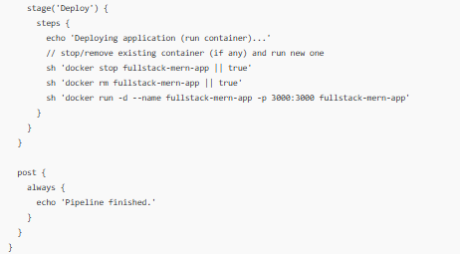

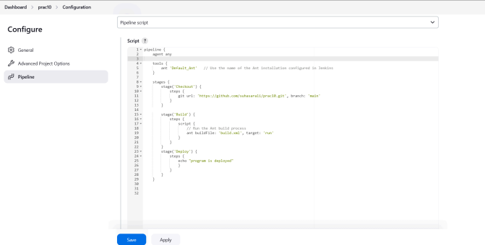

### **2) Docker Configuration (Dockerfile + commands)**

**Commands (run on the host / CI agent)**

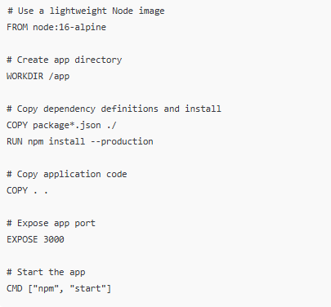

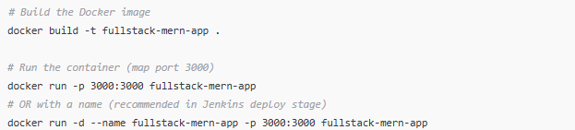

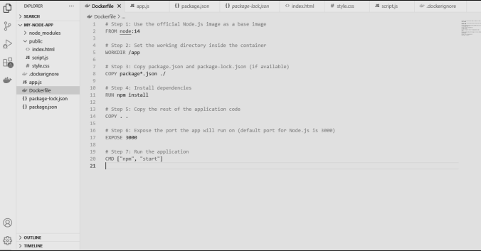

## 

## 

## 

## 

## 

## 

## 

## 

## 

## 

## **Output:**

### **1) Jenkins Build Pipeline**

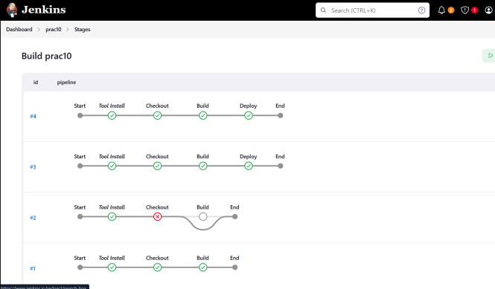**Fig 1.1:** Jenkins Automated Build Pipeline Stages

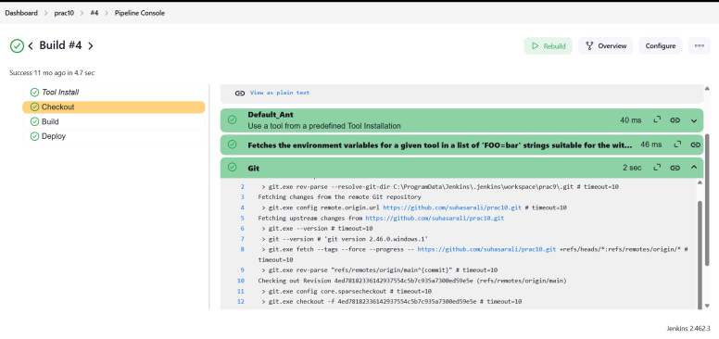  
**Fig 1.2:** Jenkins Pipeline Console Output

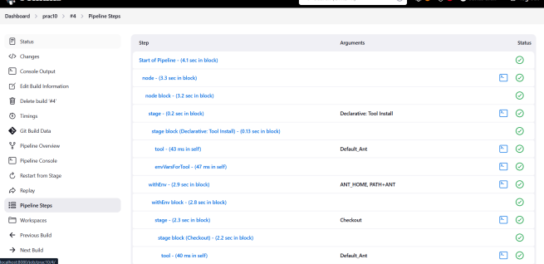

**Fig 1.3:** Jenkins Pipeline Execution Steps (visual stage timeline)

### **2) Docker Containerization**

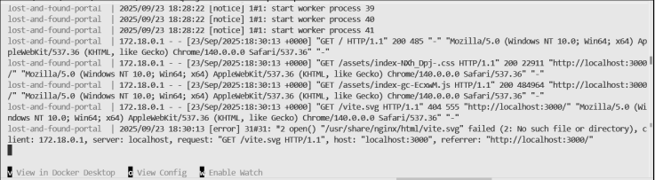

* **Fig 2.1:** Docker Build Command Execution (terminal showing docker build logs)

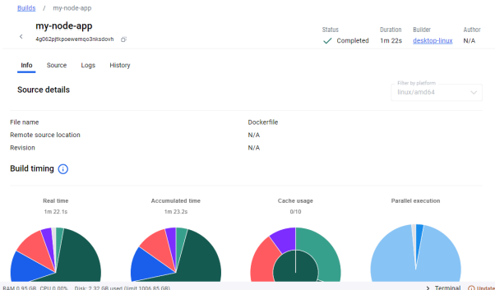

**Fig 2.2:** Docker Desktop / docker ps output showing running container(s)

### **3) Deployed Application**

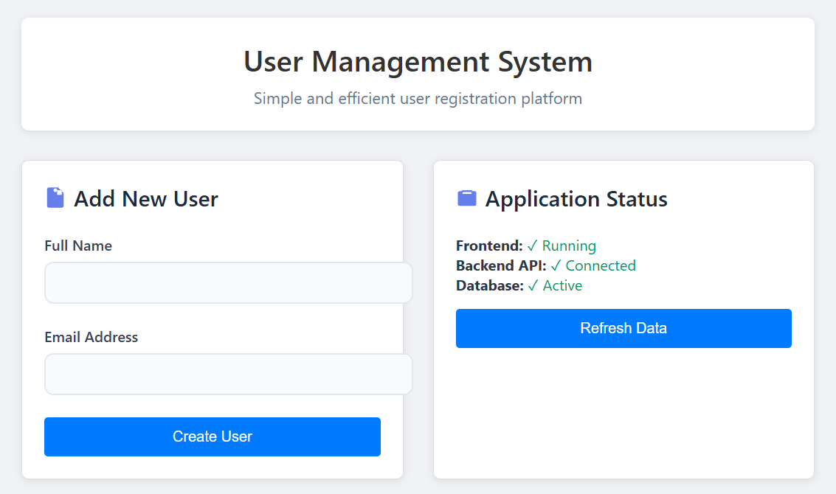

* **Fig 3.1 : User interface for a User Management System.**

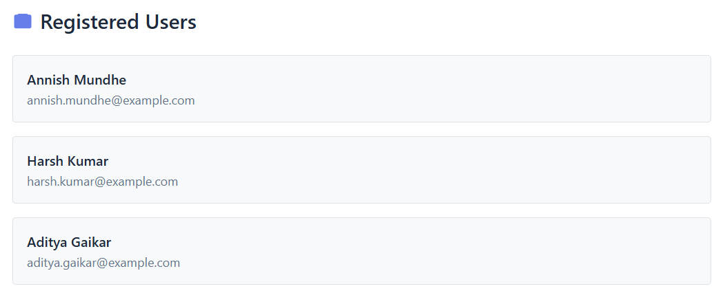

* **Fig 3.2 : List of registered users**