Login Page

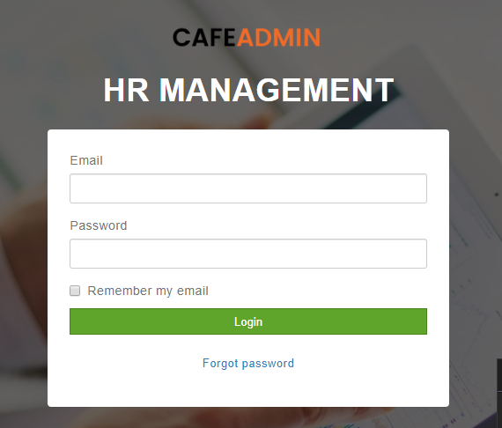

- Email and Password should be bold and big font
- Login Button in black and bit font
- Forgot Password? With underline

Branches Page as shown below
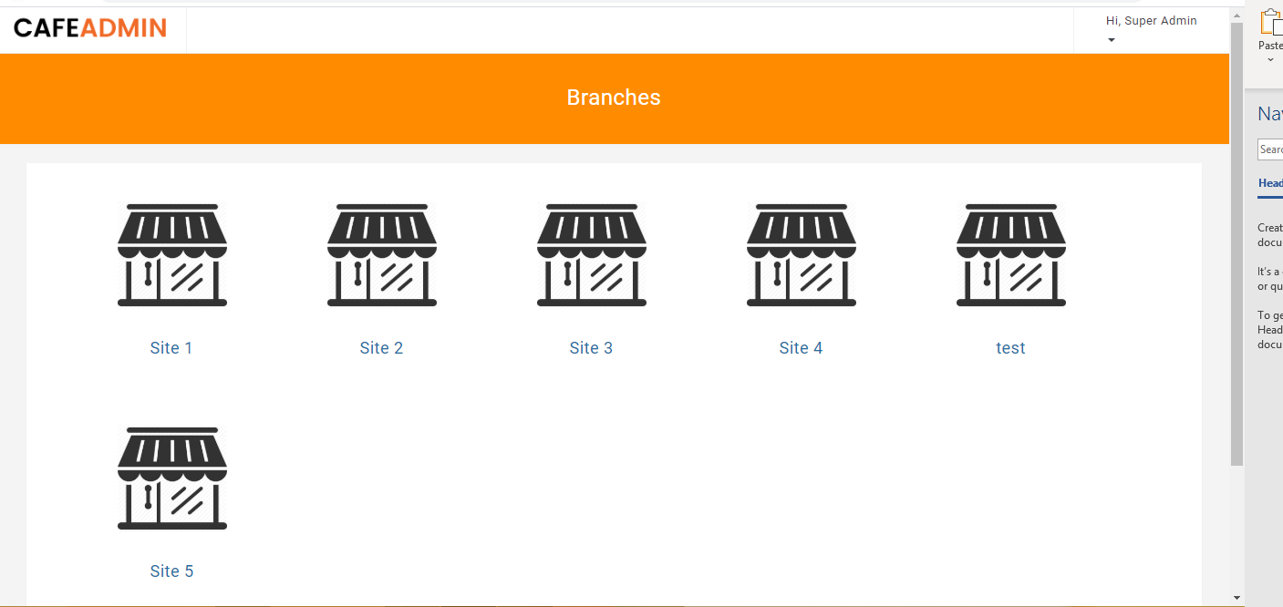

- Heading should be Café Locations
- Top right hand side – My details page is navigating to Page not found
- Footer to be in Orange too
Dashboard of Manager
- Menu Top – Options should be Employee, Leave, Roster – All in uppercase and big font
- Super admin account should have Users, Sites pages with full functionality
- Dashboard Heading to be Bold
- Leave, Roster – No drop down option
- On dashboard – no need of search
- Only last 5 leave and last three rosters to be shown in dashboard
- Graph showing the money spent on roster every week in a month
Employee of Manager Portal
- Add Employee button in black, bold and big font
- Heading should be Employee Details
- Colours to be changed – Pending in Orange bright, Not Started in red, Completed in proper green
- Status in the list – S must be upper case
- When deleting the employee – it should say – Are you sure you want to delete the employee details
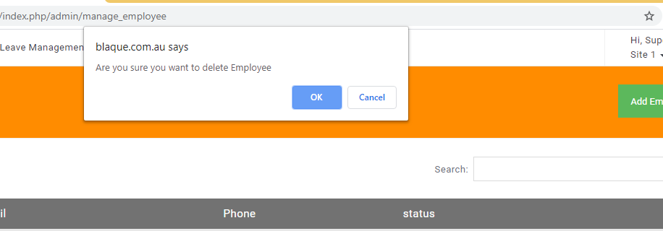
- Delete should still keep a record in the database even though it is deleted from the view
Add Employee page Manager Portal
- It should be employee details not info
- Hourly Rate of the employee should be recorded here
- Department drop down must be alphabetical order
- Role must be alphabetical order and also all first letters must be upper case
- When there is a user with the same email id – Validation fires as shown below. That message should be changed to “Another user exists with the same email id”
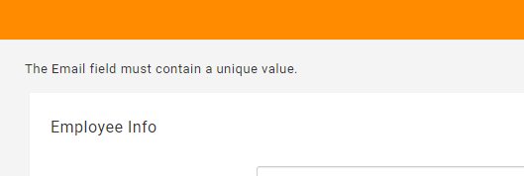
- Save button should be changed to Add Employee and this button must be below the job field.
- Footer in orange.

Employee Inner page Manager Portal
- When clicked on the employee name – automatically a file downloads – this shouldn’t happen
- All heading must be bold in the employee page
- Training Dates must be in dd/mm/yyy format
- Job description should show same like company policies
- It should be Roles and Responsibilities
- Files that are uploaded are not showing
- Uniform still not showing

Leave Management Manager Portal
- Status – S in upper case
- Leave Type – It should be Annual Leave, Sick Leave, Long Service Leave
- Headings must be bold
- Colours of Status same as employee
- Leave must be sorted based on future and past – All future leaves must be displayed on the top and old leaves at the bottom based on the dates
- Search filter – Based on Employee name, start date, status
Leave Management Inner Page manager portal
- Medical Certificate should open like company policies
- Status must be alphabetical order
- Save button must be below the leave info
- Leave info must Leave Details
- Footer to be in orange

Create Roster Manager Portal
- Start and End date fields must be bold
- Employee to be bold aswell
- Below is what the inner field name must be
MON Start TUE Start WED THU FRI SAT SUN
MON End TUE End
Break Break
- Publish button must be below the page awell
- It should be in black background like employee
- Employee Details – In alphabetical order of the drop down

List Roster Manager Portal
- Ensure the start and end date are displaying correctly
- Ensure the newest roster displays on the top
- Ensure an email goes to all employees once published or republished

View Roster Manager Portal

- Ensure view roster displays like the way we discussed.
- All heading must be middle aligned
Employee Side

