HR issues
Full date should show.
Heading should be Start date of the week, End date of the week.

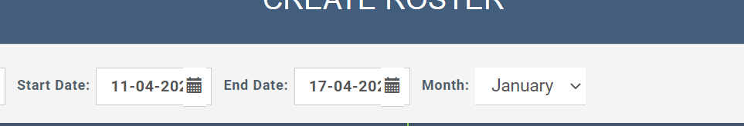

Drop down below should be left aligned
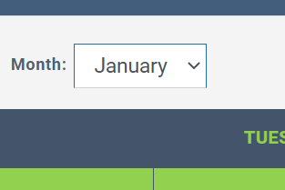

When we create by default it should show disabled
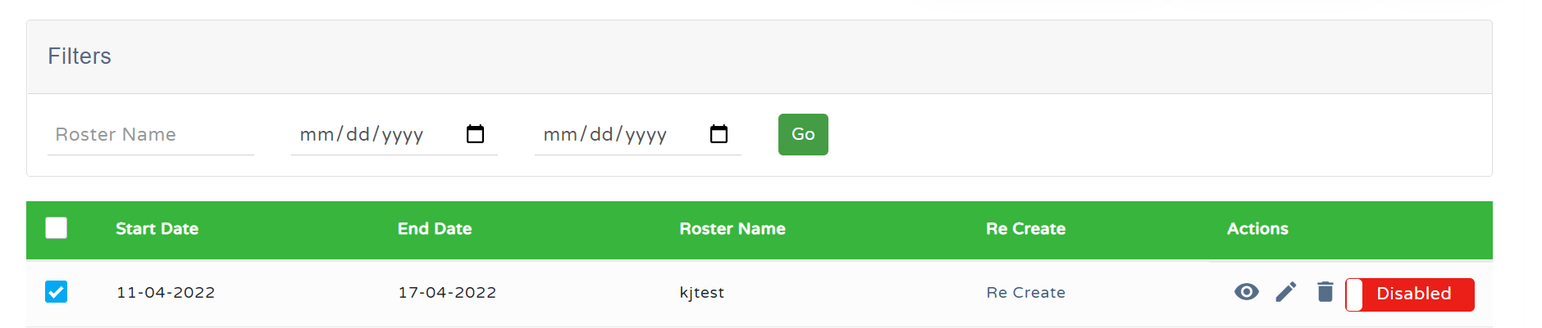

Can the view be shown without scrolling
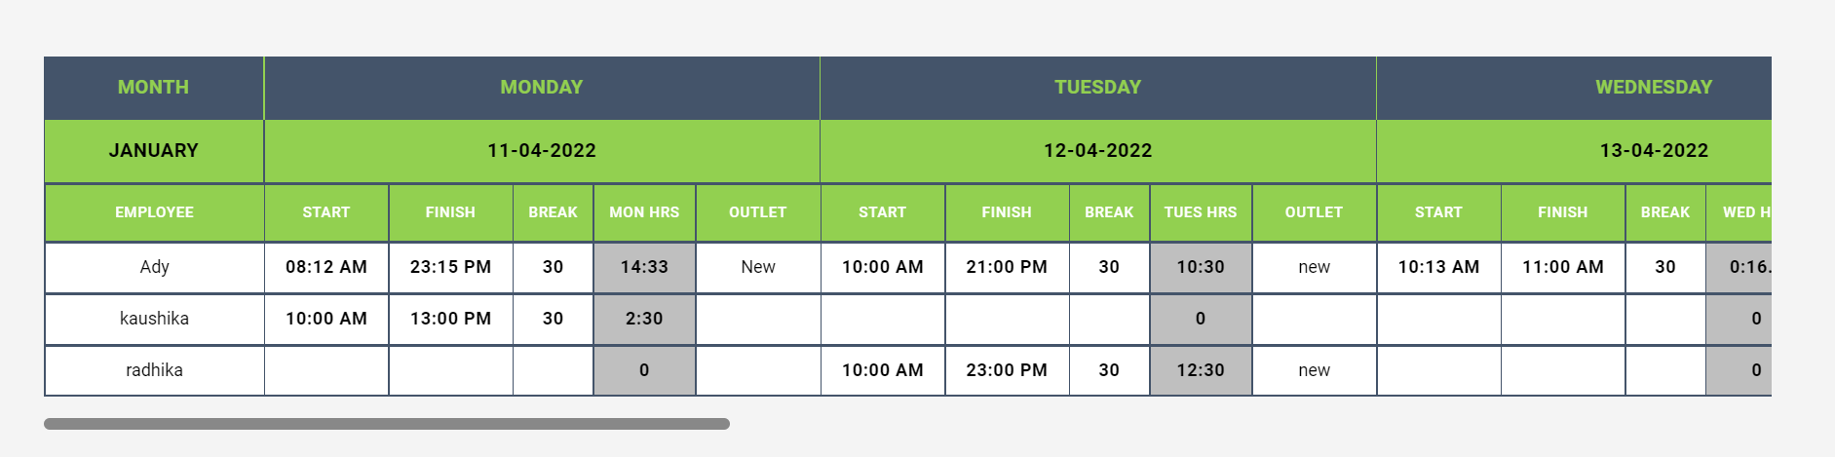

Can the view be grouped based on the department?

Recreate – I cant choose different date…icons disappearing
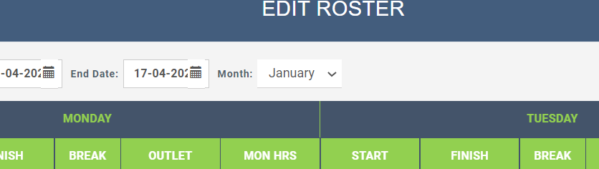

Recreate month also should match
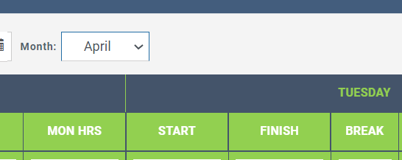

Why the recreate view is like this???
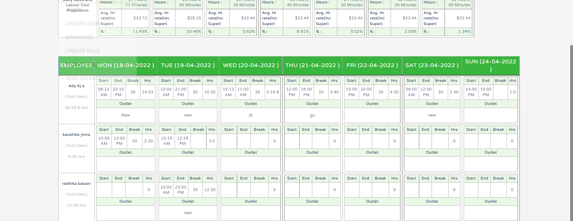

Can we put download to excel in roster?

