HR Testing

Please hide timesheets for now from both Manager and Employee Portal

Manager Portal

- Graph on the dashboard to display the roster costs for each week
Branches
- Unable to delete the branches that says Site…please delete them
- Not able to see new branches in the list
Employee
- Upload the actual induction and company policies document.
- Able to add more files if needed.
- Submit button should be at the bottom of the page.
- Employees of one location is showing in another location
- Php error
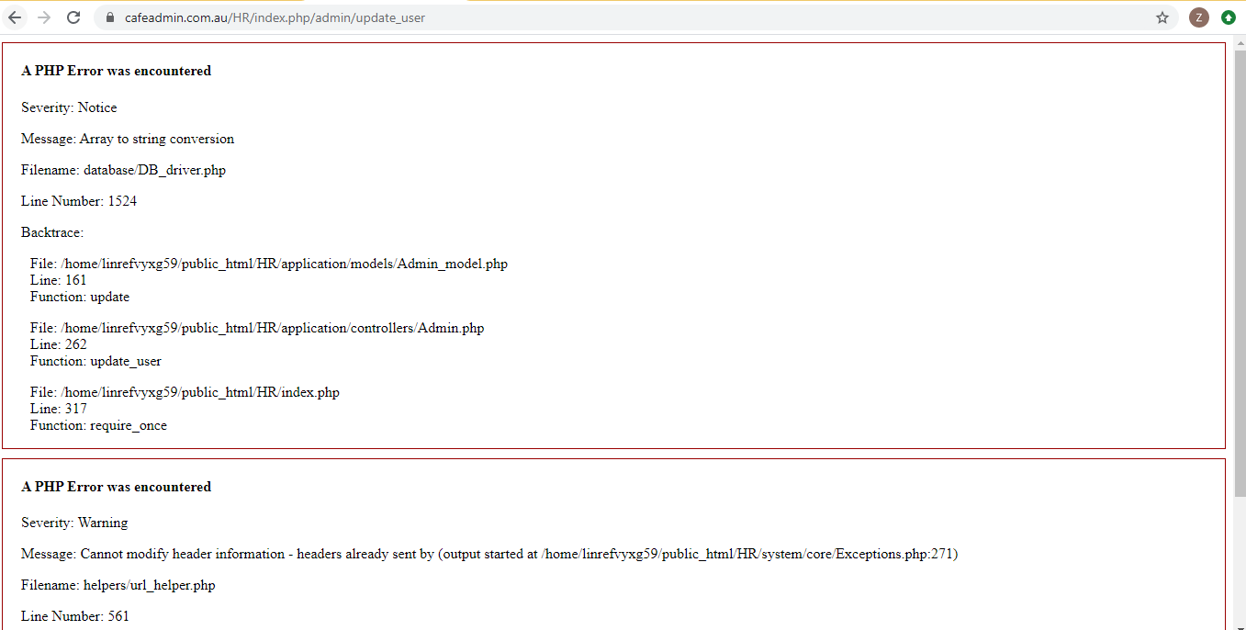
Leave Management
Roster management
- Drop down not necessary
- Break time – shouldn’t be time icon and it not saving
View Roster
- Hours are calculating wrongly
- Break time is wrong
- Export to excel – View roster
- Able to Print.
- Update and Publish is giving php error.
- Recreate is not working as expected either. It should display the values as it is.
- Send Email button should be there.
Email Texts

- Email should go to activate the account when manager sends an email.
- Email should go to the employee when there is an update in the leave status
- Email should go to the manager when there is a new leave
- Email should go to the employee when manager clicks on Send Email button there is a roster
- Email should go to the employee when the roster is updated and send email button is clicked.
- Email should go for forgot password.

Employee Portal

Employee Dashboard
- Latest Roster of the employee should display
- Leave Should display
- Number of hours they get every week should be displayed.
Employee
- Submit button on the bottom of the page.
- When all mandatory fields are filled then the status should change to completed.
Leave
- Leave button should be at the bottom
- When clicked on Save. Validation message is wrong, and it should navigate to the dashboard.
- Your Leave Request has been sent to the manager.
- The leave request should be sent to the user in charge of the branch.

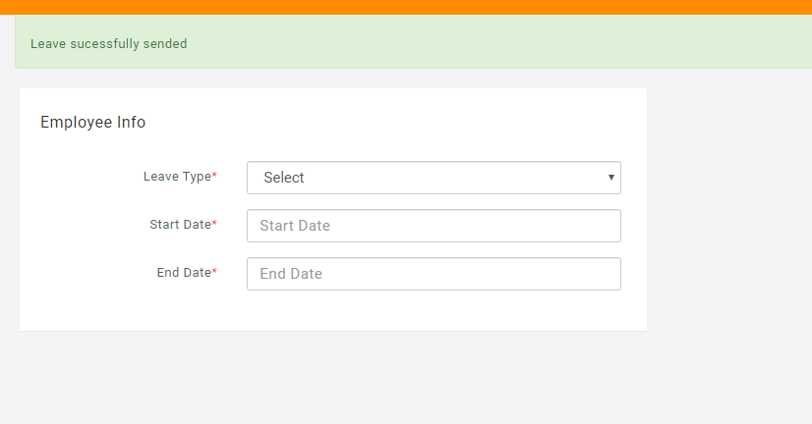
Leave History
- Status – s should be Captial
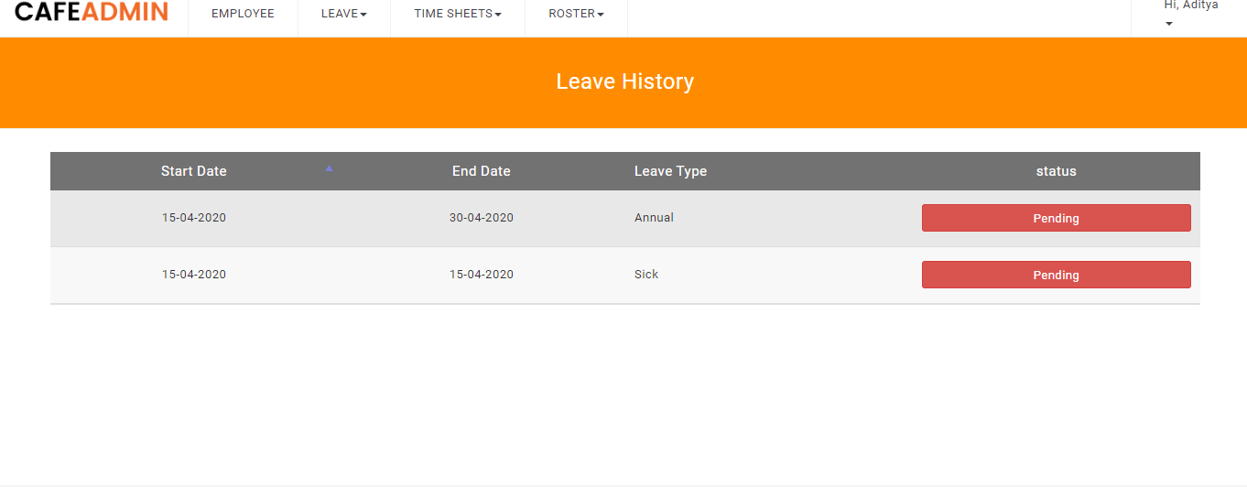
- Status should be Approved, Rejected, Added Comments.

Roster
- Create Roster shouldn’t be in employee portal
- Recreate shouldn’t be in employee portal
- Edit Roster shouldn’t be there
- View Roster is wrong same like manager portal.
- Export to excel and print button should be there.

Login Page.
- Account is Inactive. I should be capital letter.
- When password is reset, I am unable to login.

-

The whole site should be responsive.

