Customers page

- Footer needs to be changed 2020 @Iconcandles
- Remove MYOB orders
- Pick up location drop down needs to have some test address now…Will give final once we make It live.
- All footers need to be changed
- All products needs to be deleted in candle.
- Add product – Categories to be removed in the drop down.
- From view order page remove – Payment Buttons
- Product Comments
- View Order Page – Company name and ABN should be changed.
- Remove from tab
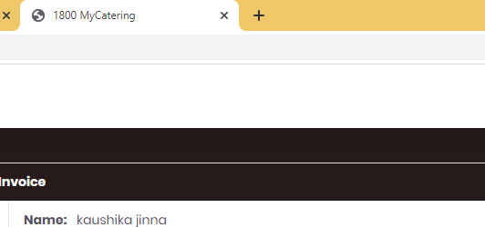
- Download pdf is not working
- Modal title heading should be Email.
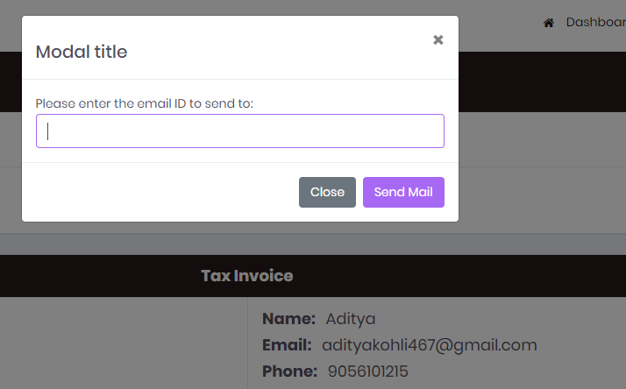
- Reports
Status to remove MYOB orders

- Remove all test orders
- Remove all coupns

