Modules to test
- Login
- Location Creation
- Employee details page – manager
- Employee details page – employee
- Leave – manager
- Leave – employee
- Task – manager
- Task – employee
- Super admin
- Compliance
- Email templates
- Dashboard

Login

- Login Page can be made more attractive. This is the main impression page and I think we should make it bit more attractive with colours.

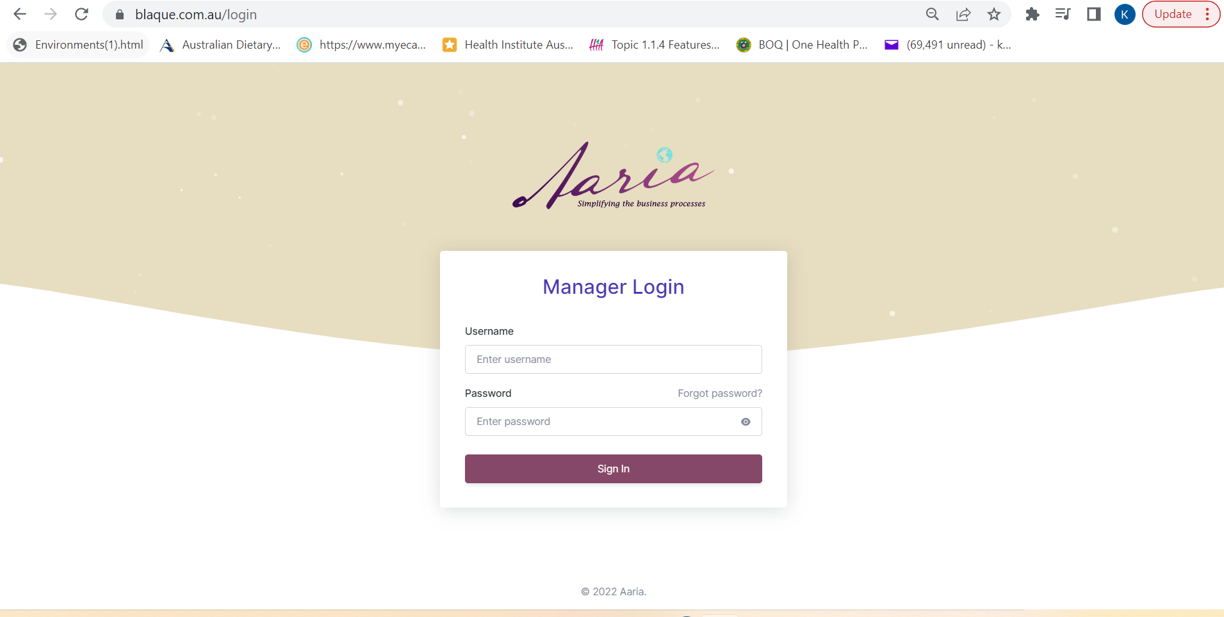

- Login details – put a stronger password. Please make this a habit.
- Forgot password doesn’t work

Manager Portal
Dashboard and Main Menu
- Dashboard should be attractive. Dash board items in manager portal – Upcoming tasks, Leave
- Dashboard of manager site should have notifications to give latest updates.
- Menu can be attractive. Mainly the font should be black. The colour on the right side is not looking nice.
- Profile of login user should just have their contact details and ability to change their password. Nothing else.
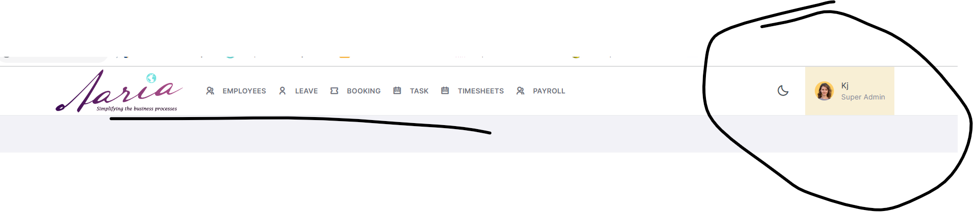

- Main menu options – Employee, Leave, Tasks, Timesheets, Payroll
- Main menu on the top should have the location name or the company name or if company has multiple locations like zouki it should be clearly mentioned.
Employee
- The font is displaying very thin across the pages. Have something that is nice like calibri font.
- Headings are repeating and the heading should be Employee Information. I think it should have a small (i) like a information snippet that tells the user what all info they can see. It makes the system self-explanatory for new users.
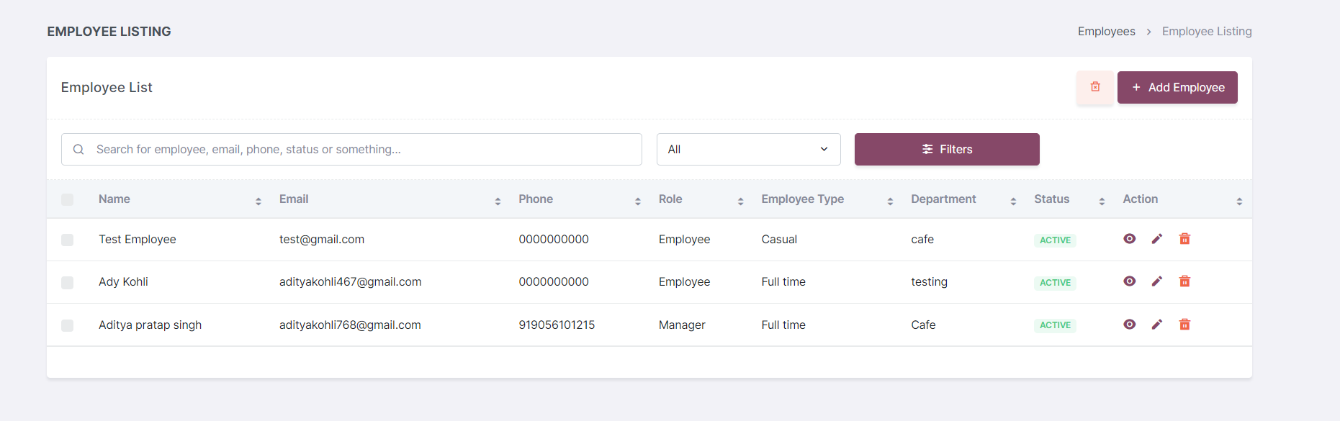
- When a employee is deleted it should be visible in the ex employees tab. In case they would like to access ex employee information.
- Where can I create roles of an employee?
- Add employee mandatory fields should be – Name , email, Employee type. Shouldn’t allow them to create employee without this info.
- Add employee popup should have facility to upload job description, induction and company policies that will display in their onboarding.
- Users to login as a manager should be different to employee – same like café admin
- If the manager is also the employee – in the user creation page there should be check box that can link both.
- Effective start date should be there in the add employee popup.
- How can I send onboarding email to the new employee?
- We should be able to download the employee info to the excel sheet.
- Not able to sort in the employee listing page using name.
- The employee manager portal should have fields to capture the hourly rates – same like cafeadmin – copy it.
- Unit number and street number shouldn’t be mandatory in address. Sometimes they have only one.
- First field should be street number and then street name.
- In the employee view page they should be able to navigate to the tabs like café admin without having to click next button multiple times.
- Bank details – branch name shouldn’t be mandatory.
- TFN – tax file number field by default showing my name. it should be empty by default.
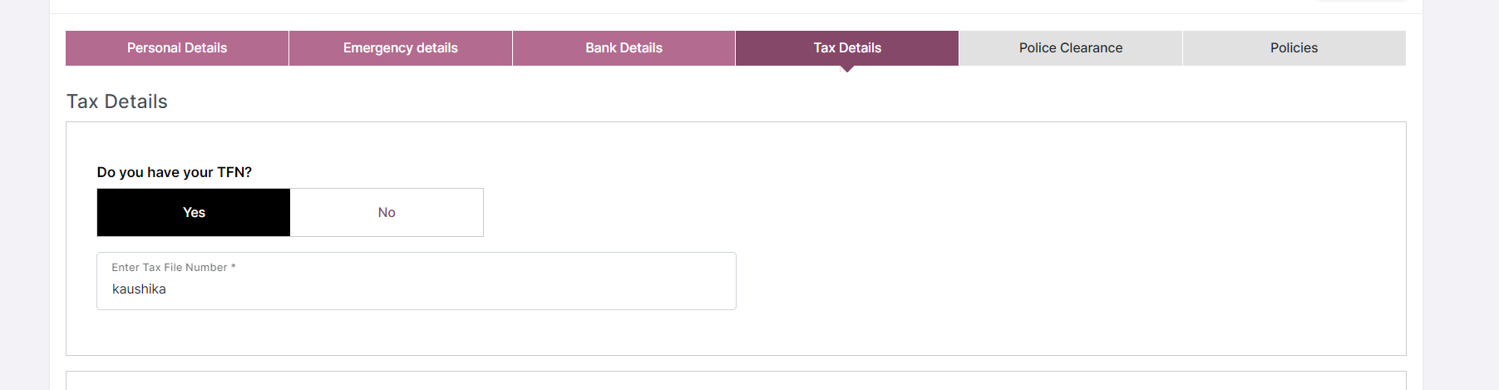
- Make sure onboarding steps cannot be skipped on the phone.
- Below green is too dul. Make it darker
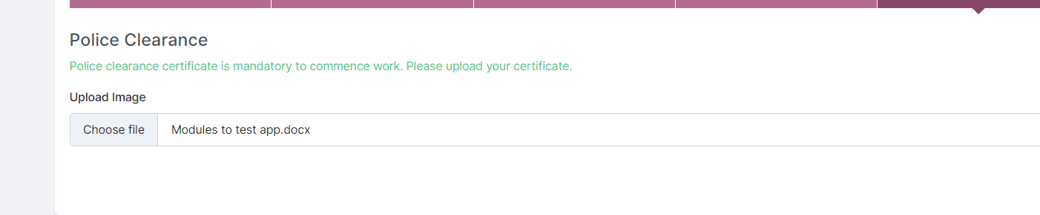
- When I click on save button in policies page. It should take me back to the listing page with popup details successfully uploaded.
- Even employee edit in manager page – able to navigate to the tabs without having to click next button multiple times.
- We need additional tabs in the employee manager portal and employee portal where they can submit following details
- Visa status
- Document uploads
- Medical history
- Vaccination certificate
- Super annuation.
- Instead of heading employee details in view – say Employee Information.
- What is status active? – it should be like cafeadmin – inprogress not started or completed
- The listing page should have vaccaction yes or no, email view yes or no, effective start date like café admin.

Leave management
- Manager should be able to apply for leave of an employee. In trading sector sometimes injury might cause them to leave the place. In this case, manager should be able to create leave record.
- Leave should have add comments like cafeadmin.
- View yearly leave should have leave types – like annual leave, sick leave and other leave types ask me will provide you.
- How can I enter new nominated person?
- Not able to download the documents.
- How can I configure leaves for an employee?

Task
- They cannot have duplicate task names.
- Bulk delete not working in task.
- Count not working – there are 10 tasks when I tested and it is showing 11. Also there should be something count for new tasks in the pipeline, instead of pending say in progress tasks and completed tasks.
- In the listing page there should be another coloum for department. In a company we have different departments like marketing, production, development and the tasks should be allocated in different departments.
- In creation as well it should be there.
- Create task issues below
- Create task popup end date not working
- Should we capture also time in creation date ? like 8-10 on 2nd painting task. 11-12- cleaning task.
- I should be able to create multiple tasks for the 2nd august. I am unable to do that.
- When I tried to do that by clicking on 2nd august calender I am getting something went wrong message.
- How can I create common tasks?
- The way you are displaying tasks based on day, week, month, there should be another button to display tasks based on the employees. For example I want to see what ady has been assigned for that month.
- If the task description is long it is not displaying full content.
- If I edit the content it is repeating the edited info. Something is not right.
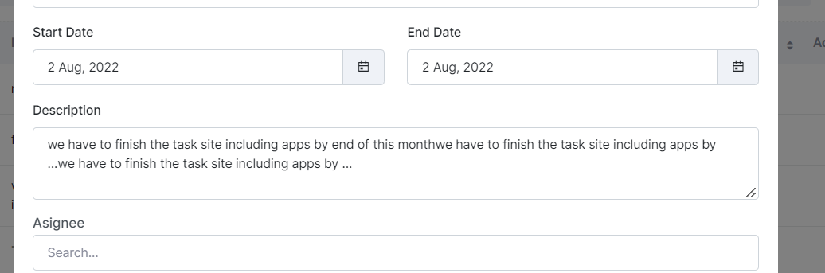
- When I updated assigned to info it is not reflecting correctly in the list page. For example I removed kaushika from a task but in the list it is still showing as it is assigned to kaushika.
- Manager should be able to complete the task from his end in case it is needed
- Add manual hours should be in timesheets page.

In addition we need to finish the following
- Create timesheets page where manager can see the timesheet info.
- Compliance pages to be completed.
- Overall site look and feel improvement.
- Create app pages for this.
- Accounts menu same like café admin where you can create users, roles, modify, able to send emails to employees etc.
- Able to add other managers and also control the menu options like cafeadmin
- Able to see employee availability while creating tasks like café admin.
- In the manager portal we should be able to enter employee availability in the employee page and also employee can enter their availability from their employee portal.

Employee portal.

- Why there is manager login when employee can also login from this page?
- Where is employee page in the employee portal?????
- What is this ady? Why you keep telling me to test when it is all incomplete?
- Again main menu to be updated like the way

-

