Hi Ady

There is a problem with reports in 1800.

Go to 1800 manager portal foostcray location
User name footscray
Password footscray123$

Go to Past orders and search for dates 29/08/2022 -11/09/2022 and following results came in the paid orders tab

Order 5207 is showing
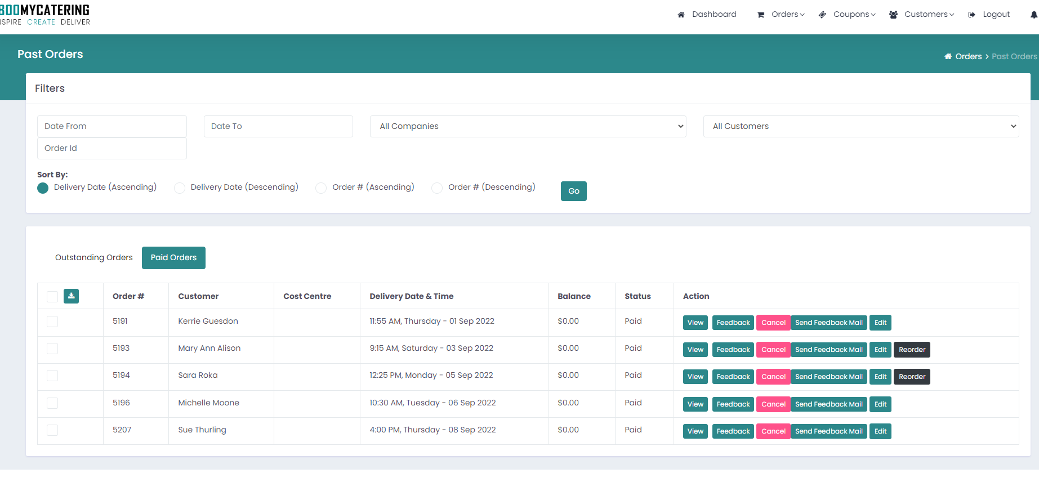

However now go to reports and define filters like below screenshot

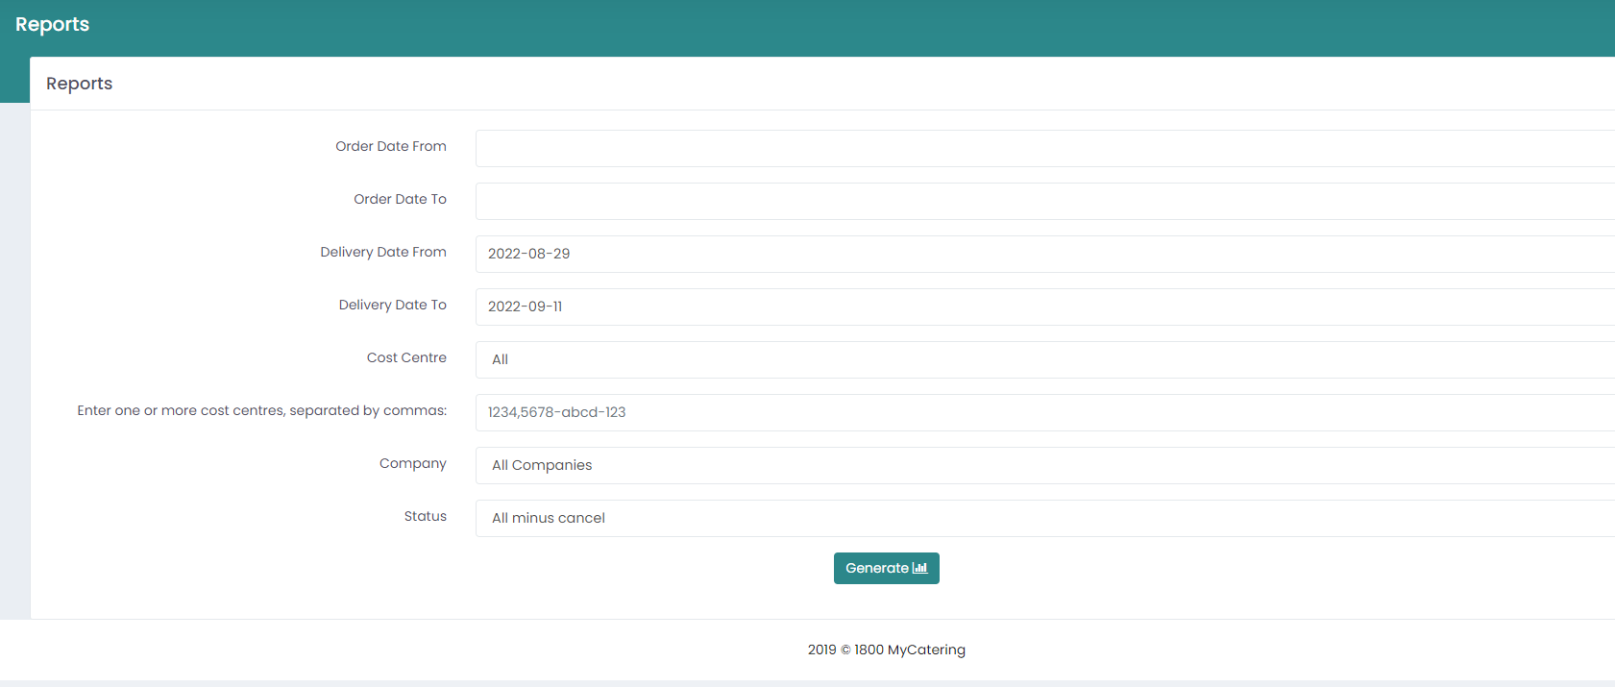

Order 5207 which is in above screenshot 1 is not there in reports screenshot 3.

