Employee Portal:
Where is employee page in the employee portal????? DONE

- why we need this employee tab in employee portal. As it can be only accessed by the particulr employee.
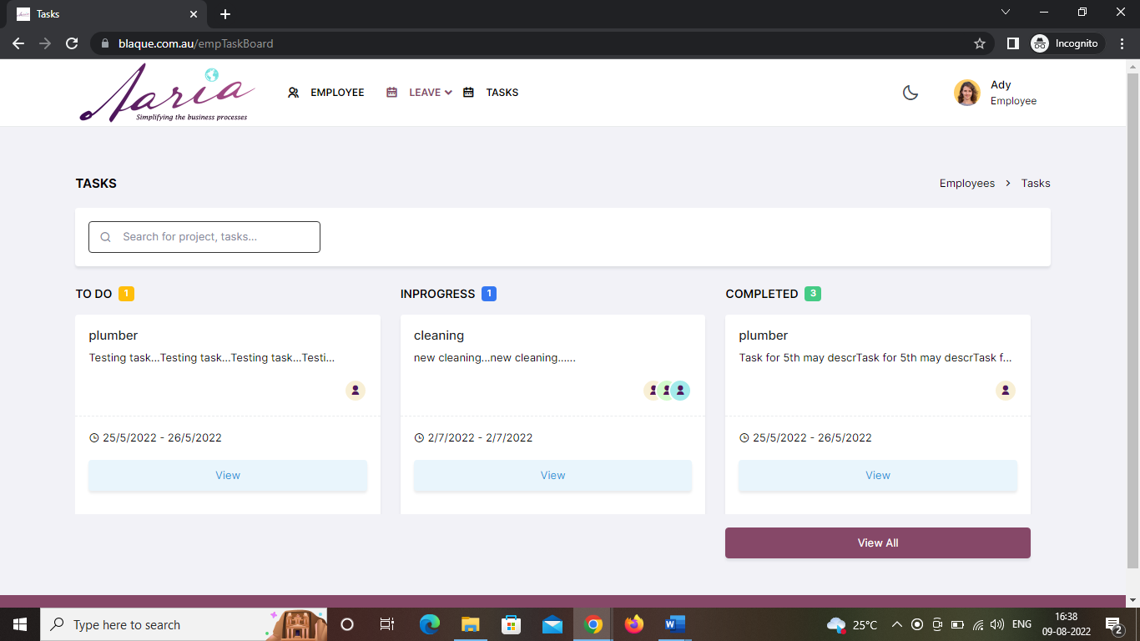
Leave
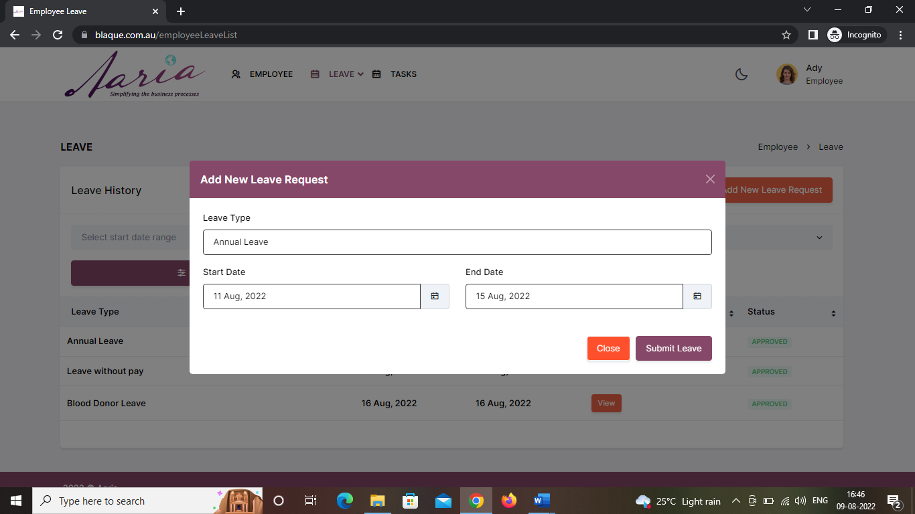

We Can’t access calendar by clicking this symbol.. this is sth diff from others.. we are getting calendar by clicking with in the tab itself…

- Based on leave type they should be able to search DONE
This is not working
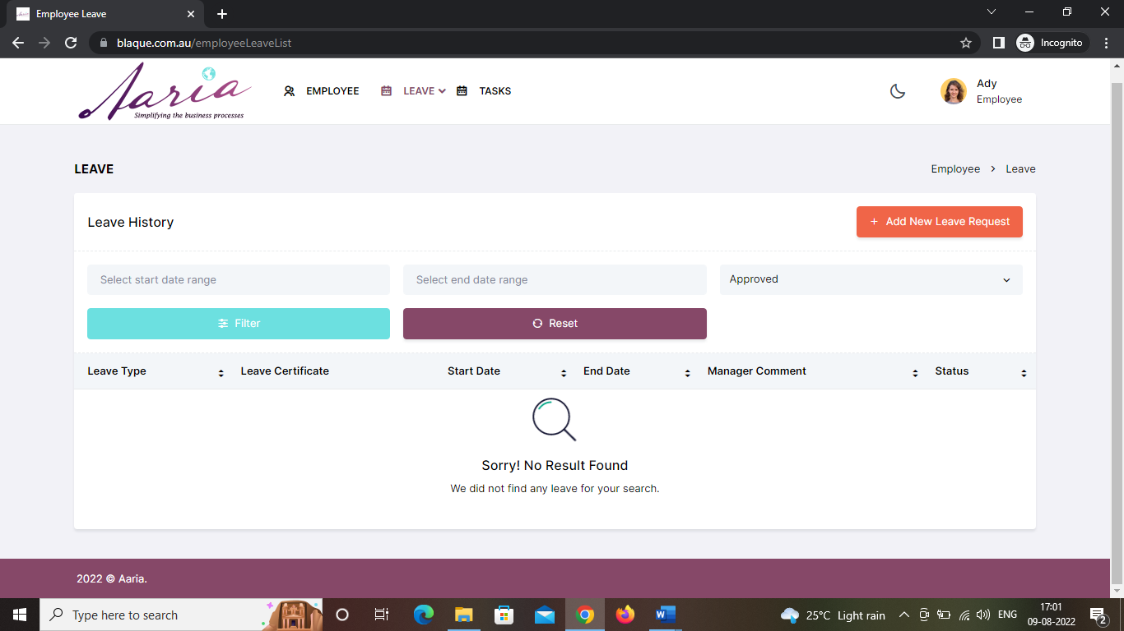
- Leave files not uploaded. FIXED
Where to upload this file
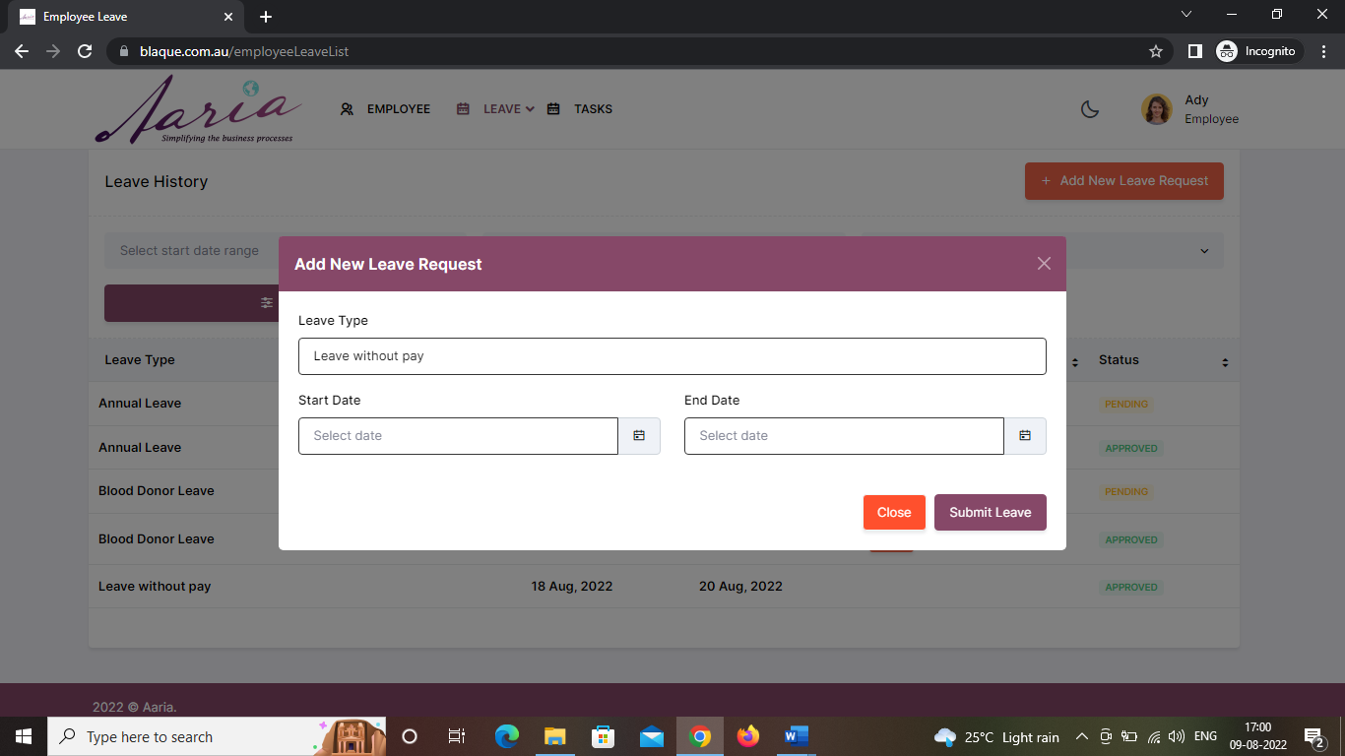

Tasks
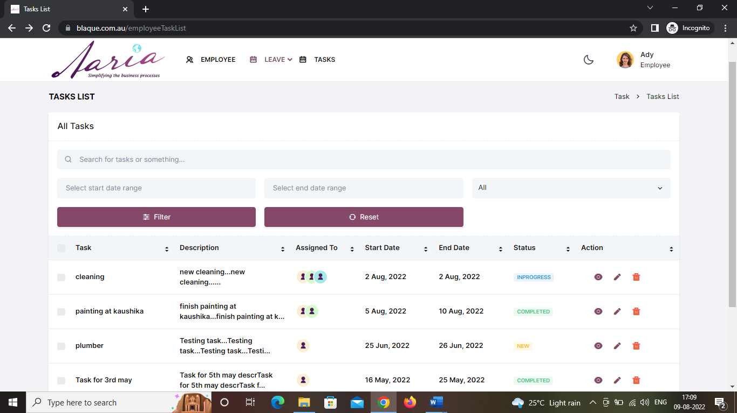
When we click on view task and then
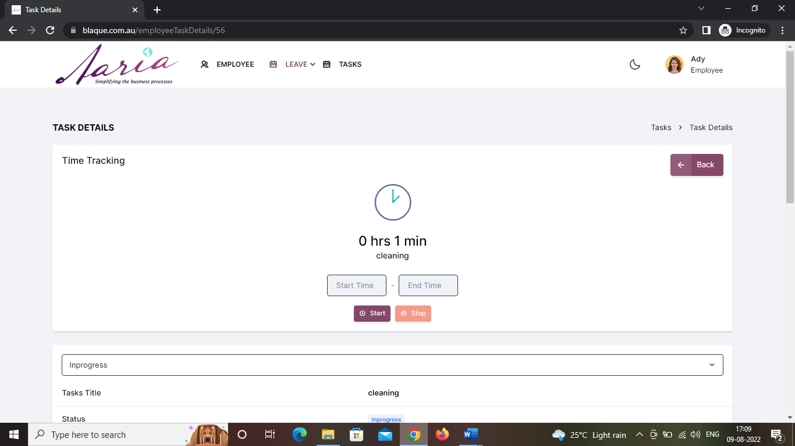
Again press on back button it is showing only completed tasks.
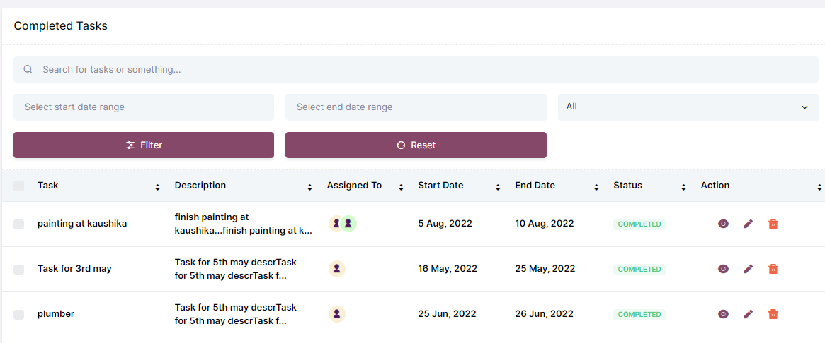
In Dashboard :
- Date should be in dd/mm/yy format DONE
Here ,I thought month should be 07 instead of 7..that looks good I think so..
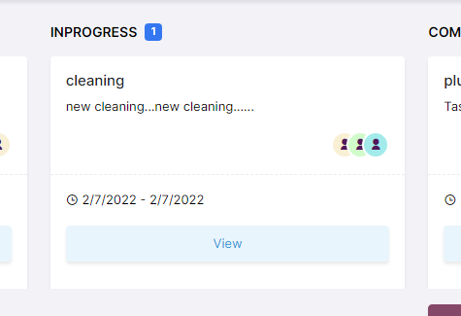
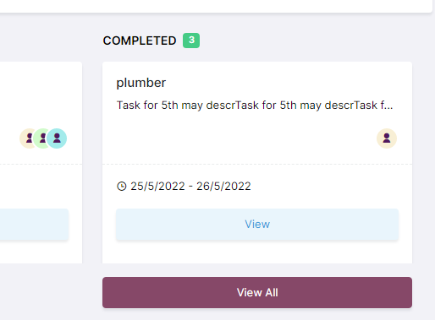
Here view all shows only the completed tasks.

Manager Portal
When we want to create an employee in manager portal we are getting like this
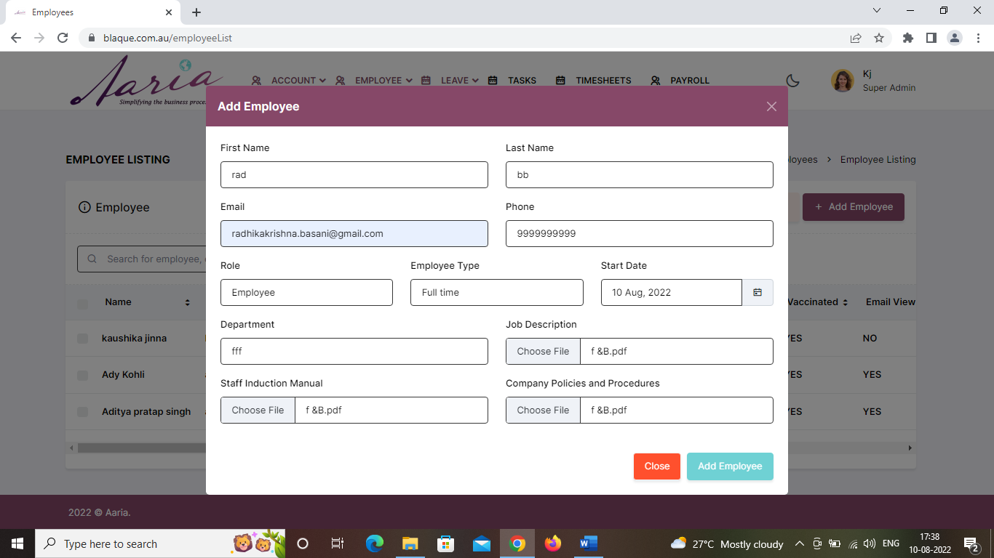
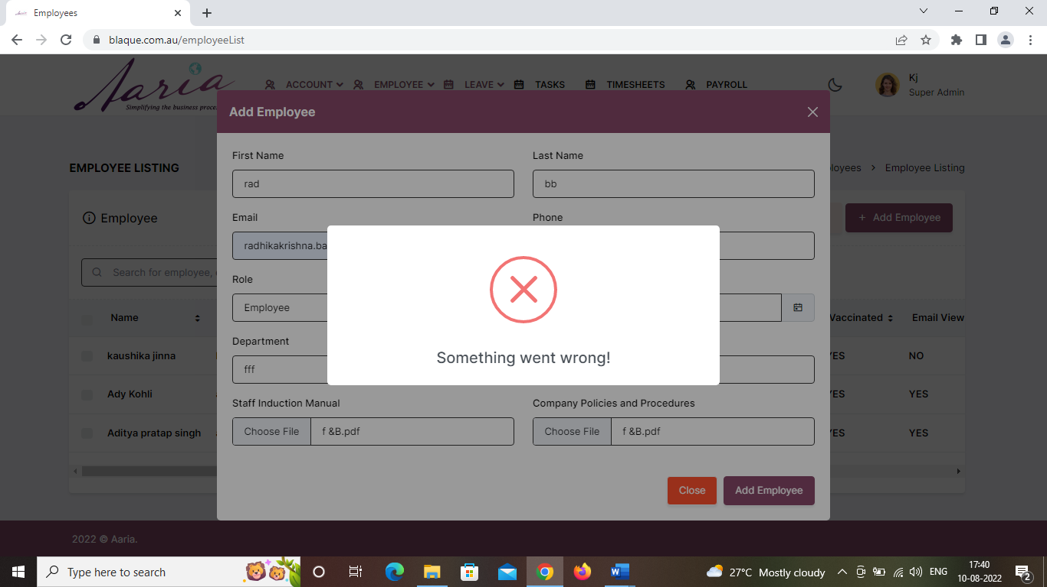

- Add employee mandatory fields should be – Name , email, Employee type. Shouldn’t allow them to create employee without this info. DONE not done

