Ady
- Should we just show three buttons here
Manager, Employee, Timesheet (manager user only). Also remove orange and put our Biz admin theme colour on the main page.
Admin portal – I am thinking we have a button somewhere in the page small as it will be just me using this button so lets not make it big deal?

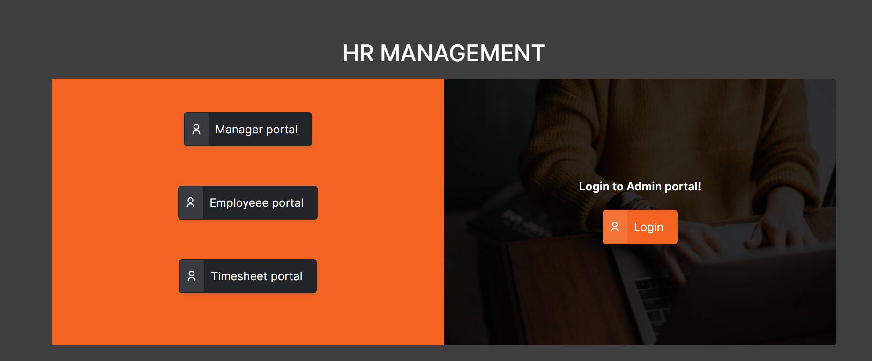

Heading should be BIZADMIN HR

- Login – Colours again
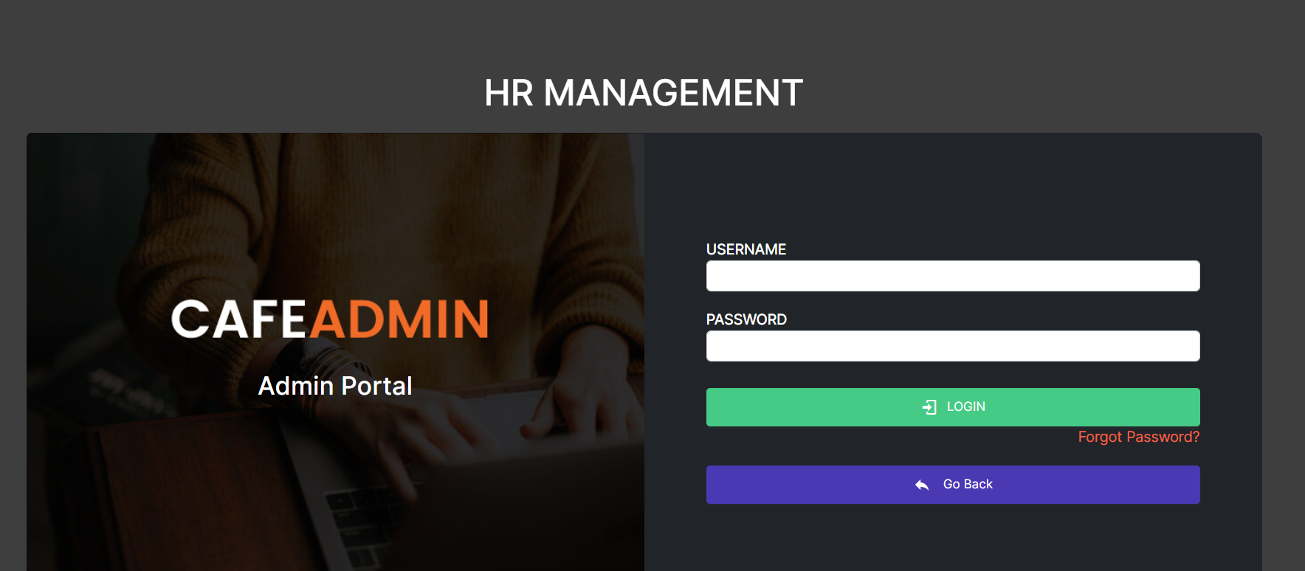

- Tab should be BIZadmin
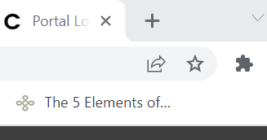

Add Employee Page
No | Requirement | Screenshot | Status
1 | Add all pay rates field in add employee page  Weekday  Saturday  Sunday  Public Holiday
2. | If the department is not there in the drop down they should be able to add a new one | 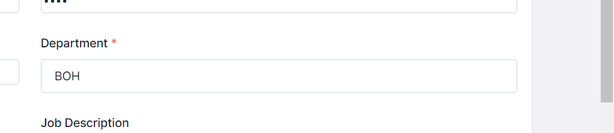
3 | Role as well they can add it from here if it is not there | 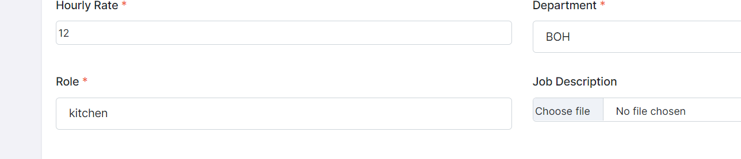
4 | Below additional Fields should be added in the Add Employee Page  - Effective Start Date  - Employee Type  - Full Time  - Part Time  - Casual
Employee Listing Page
1 | Heading should be Employee
2 | In listing page, remove their email and contact fields, make the listing page look nice. | 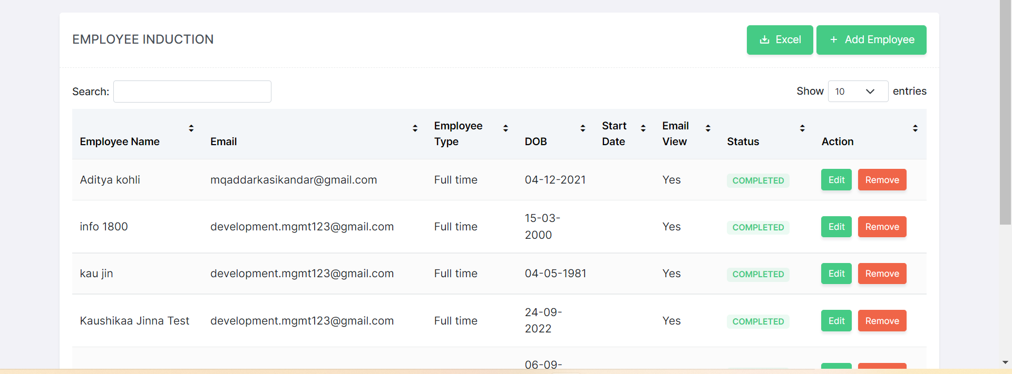
3 | Add an addition column called Stress Profile  As per the bday if they are younger than 17yrs old, it should say 17yrs or younger. If they are casual employees then we should show their availability info as shown below. If they are full time then we should just show available full time. | Stress profile  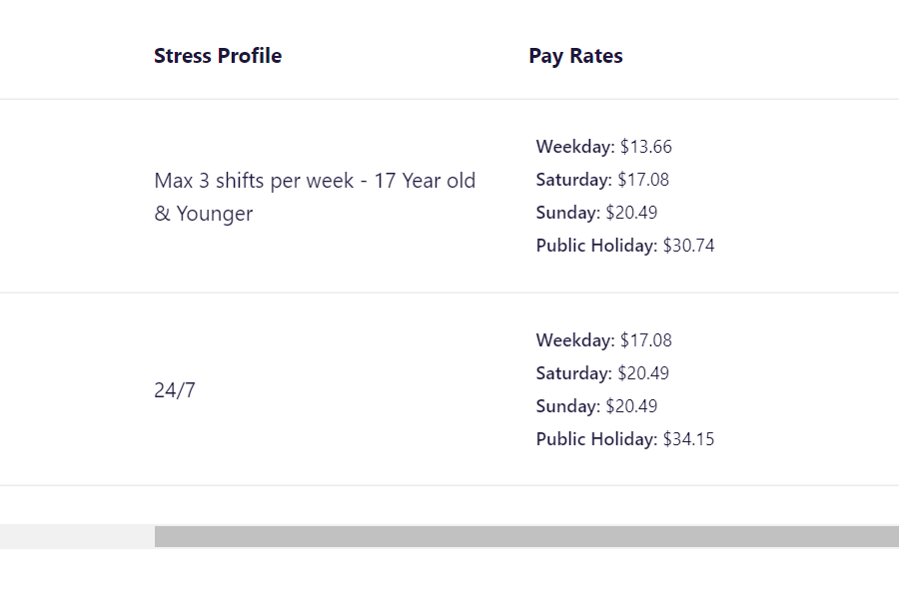
4 | Entries by default should show 100 | 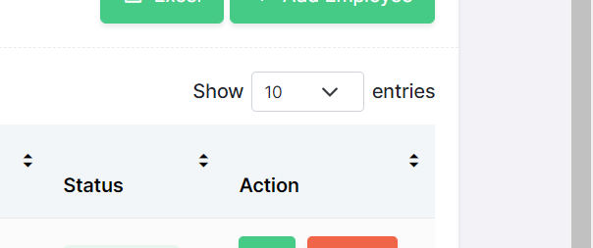
5 | Download Excel not working
6 | When I click on remove, it removes only after I refresh. It should auto refresh and remove it.
Employee Inner Page
 | Send Onboarding Email should be in the inner page itself for that selected employee so we can send onboarding email from here itself
 | All field name heading should be black in colour not grey.
Tab names should be as follows and these are only needed. The inside fields of each of tabs is given below.
- Personal
- Emergency
- General
- Bank
- Tax
- Super
- Pay (this tab should show only for manager portal not employee)
- Police
- Medical
- Vaccination
- Training
- Additional Docs
- Polices

Personal
- Title
- First Name
- Last Name
- Email
- Phone
- Date of Birth
- Address Line 1
- Suburb
- Post Code
- State
- Password
- Pin – able to have eye icon to view pin.
Emergency
- Name
- Email
- Phone
- Relationship
- Address Line 1
- Suburb
- Post Code
- State
General
- Visa Status
- Highest Academics
- Employment History
- Effective Start Date
- Role
- Employee Type
Bank

No change. UI can be better
Tax
Please fix the alignment
Super
No change – but alignment can be better
Pay
- Weekday
- Saturday
- Sunday
- Public Holiday
- Uniform Allowance
Police
- Able to view the police uploaded in Onboarding.
- If there is certificate – please make the view button as View Certificate.
Medical
No change
Training
No change
Vaccination
No change
Additional Docs
Instead of required file tab, have additional docs where they can add multiple docs
Fields are
- Doc name
- Upload
- View
- Delete
Policies
- Please combine – Policies, Job description, staff induction into one tab.
 | When the manager or employee is navigating away from this page without saving the info, please prompt them to save the page. Say something like “The changes made are not saved, please click on Save button to save changes”  Submit button to be changed to Save. | 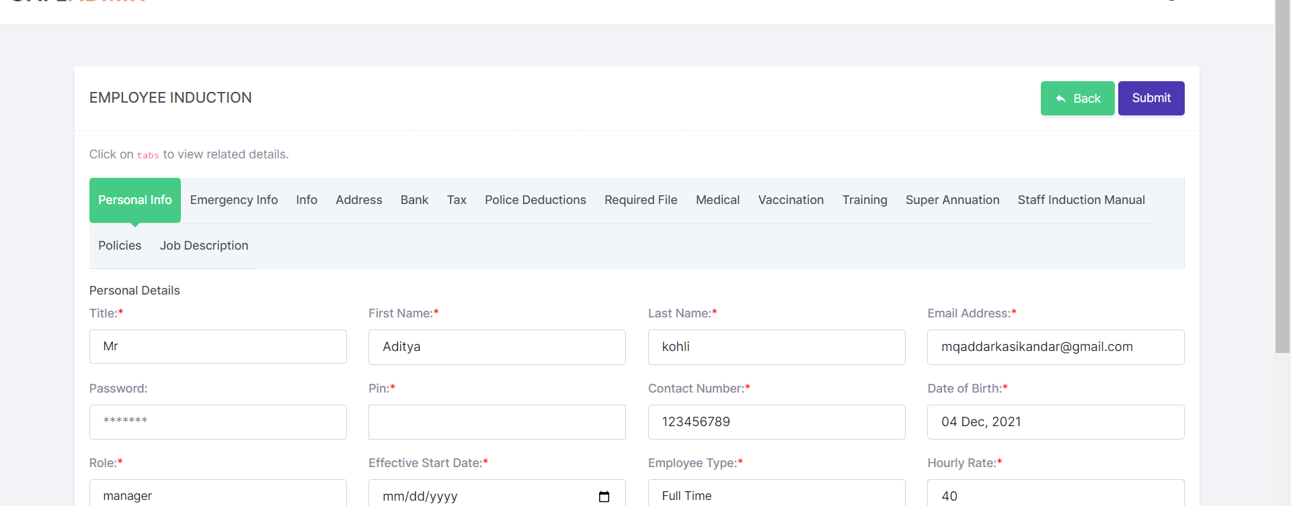
Onboarding –
1 | Unable to send onboarding email so not able to test further.
Leave
1 | Alignment of view leave listing page is not proper. Header should be in our blue | 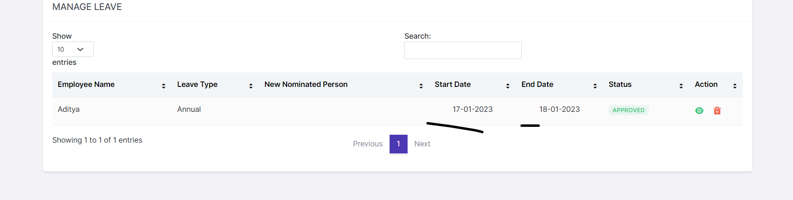
2 | Manager should be able to add leave for an employee. So need add button
3 | In view/edit leave inner page,  Nominated person is not mandatory so * is not necessary  There should be comments Box to just add any info.  When the manager or employee is navigating away from this page without saving the info, please prompt them to save the page. Say something like “The changes made are not saved, please click on Save button to save changes”  Submit button to be changed to Save
Rosters
1 | Status toggle is misaligned. Can be better | 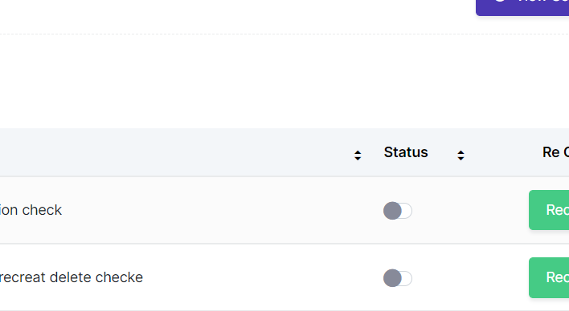
Add Roster
1. | Main header missing in add roster page. Everything should be consistent.
 | Display Availability word only once. Just the one in the below. Show the … | 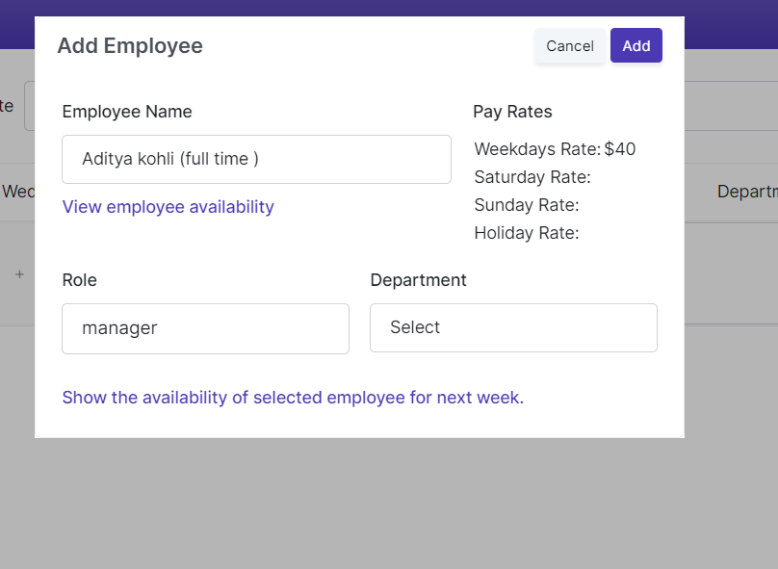
3 | Department field not necessary here.
4 | Adding hours.  Ady drop down is good but I also prefer to have something where I can just enter the value in field it automatically update like our current roster.  I just want to enter 10 in the field instead of using the drop down. | 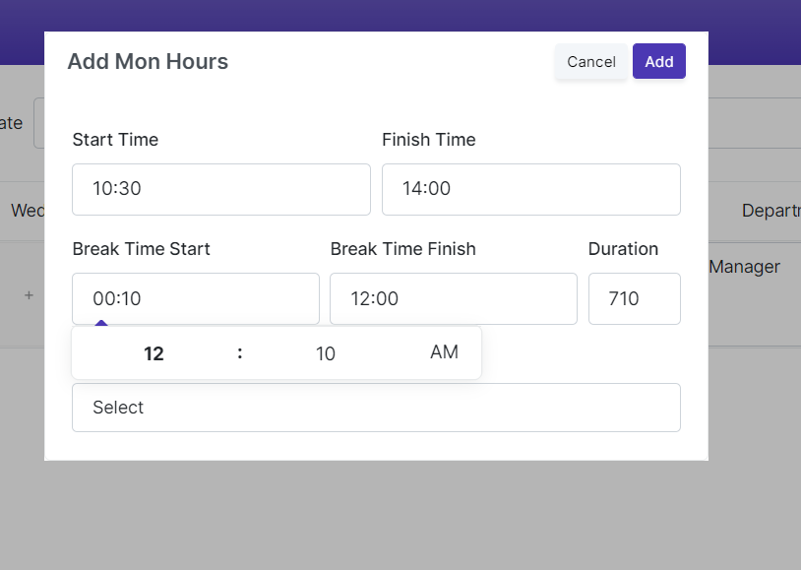
5 | Availability drop down should be here too in adding hours.
6 | While adding roster is below possible  - A validation message if the employee is on leave on that day  - A validation message if the person is not available on the times entering ?
View Roster
1 | Unable to search employee – not working that button
2 | Remove proj sales and Cost from here | 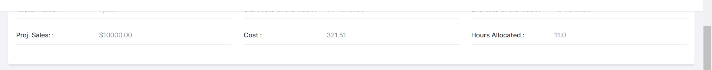
3 | Remove department field | 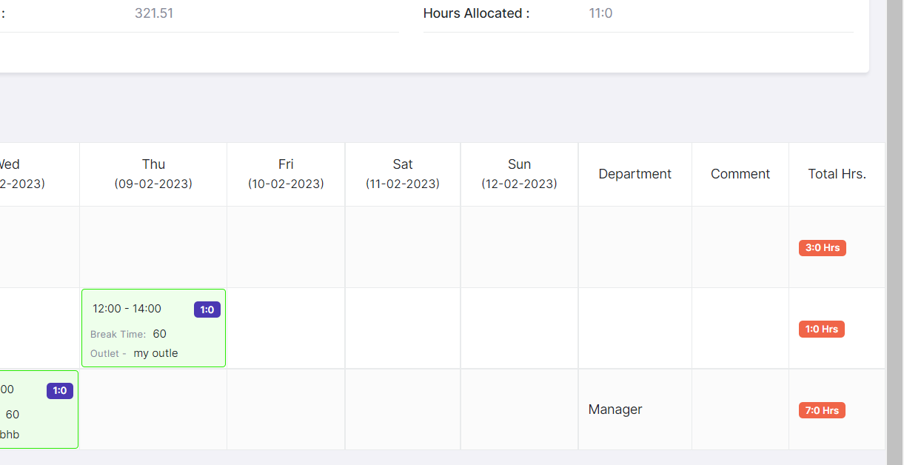
4 | Ady these tabs are not working | 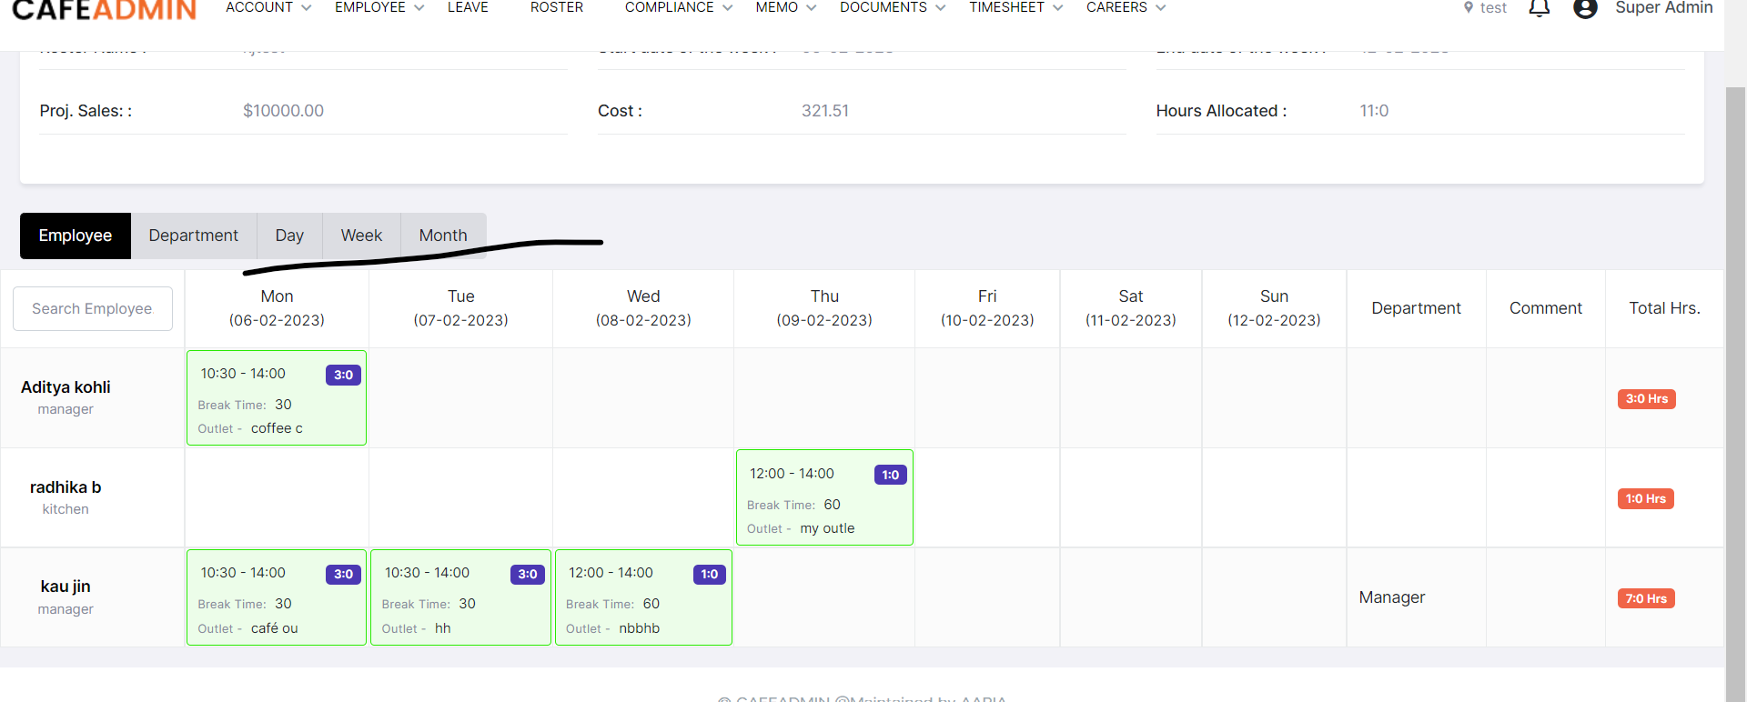
5 | Managers should be able to view based on outlets  When you click outlet tab  Employees should be arranged based on outlets – See Deputy – Area Name view
6 | Day, Month – should show like deputy.

