VITyarthi | Open Source Software

The Open Source Audit

A Capstone Project for OSS NGMC Course
Units 1 – 5 | Max Marks: 100
Software | MySQL (Database Management System)
License | GNU General Public License v2 (GPL v2)
Student Name | ADITYA JAYANT
Reg Number | 24BAI10579
Slot | [Your Slot]
Submission | 25-03-2026

Introduction

This audit dives into MySQL, one of the world’s most popular open-source relational databases. If you’ve browsed the web, chances are you’ve touched MySQL without knowing. It powered platforms like WordPress, early YouTube, and Twitter, and is the backbone of the LAMP stack that made the dynamic web take off.
In the next few pages, I’ll walk through MySQL’s beginnings, why it matters, what the GPL v2 license really means in day-to-day use, some tough ethical questions about open source and big corporations, where MySQL actually sits and breathes on a Linux system, the communities and tools that surround it, and how it compares with its biggest proprietary rival.
Honestly, MySQL has one of open source’s most dramatic stories. It was born as a small project in Sweden, grew into a global language of the web, got bought out (twice), and then split by its original creator into MariaDB when the community started worrying about its future. That saga says a lot about what open source really protects, and about its limits.
I’m including five shell scripts at the end. Each one shows off a real-world Linux skill, spells out what concepts it uses, and includes a placeholder for a screenshot and the exact WSL command you need.

Part A — Origin and Philosophy (Units 1 & 2)

A1. The Problem MySQL Was Created to Solve

The Web in the Mid-1990s
In 1994, the web was growing fast and websites were starting to need databases — places to store user data, product listings, anything dynamic. The problem was that proper database systems at the time were expensive. Oracle was the industry standard but cost a fortune in licensing. IBM DB2 was in the same category. PostgreSQL existed but was seen as complex for simple web use cases. There was no obvious lightweight, free option.
A Swedish company called TcX, run by Michael Widenius (known as Monty) and David Axmark, was building web tools and kept running into this problem. They needed something fast, simple and free for their clients. They tried building on top of an existing tool called mSQL but it was too limited. So in 1995, Monty and David wrote their own.

What MySQL Was Built to Do
MySQL was not trying to be a complete, fully-featured database. It was built to be fast and simple for web applications — reading and writing data quickly, handling many connections, doing it all on cheap hardware. Early versions deliberately left out features like stored procedures and transactions because those things slowed things down and most web apps did not need them at the time.
The name MySQL comes from Monty's daughter My (a Scandinavian name) combined with SQL. It was released in 1995 under a licence that allowed free use but required commercial users to pay — an early version of the dual licensing model that would define MySQL's business strategy for years.

How It Took Over the Web

Through the late ‘90s and early 2000s, MySQL took off. It was free for developers, easy to install, and quick enough for most websites. LAMP—Linux, Apache, MySQL, PHP—became the go-to recipe for web projects. Web hosts bundled it, PHP guides taught it, and tools like WordPress, Drupal, and Joomla were built on it. By 2001, MySQL AB said they had over 4 million installs.

The Oracle Acquisition and the MariaDB Fork
In 2008, Sun Microsystems bought MySQL AB for $1 billion. When Oracle then acquired Sun in 2010, it also acquired MySQL — and that is where things get interesting. Oracle is the company that sells the world's most expensive proprietary database. The open source community was worried: would Oracle let MySQL wither? Would they change the licence?
Monty Widenius, the original creator, did not wait to find out. In 2009, before the Oracle deal was even complete, he forked MySQL into MariaDB. This is exactly what the GPL v2 is designed to allow. Because the code was open, anyone including the original author could take it and continue developing it independently. MariaDB is now the default MySQL replacement in Fedora, Red Hat and Arch Linux. The GPL licence made this possible. No matter what Oracle does with MySQL, the community has a fork they control.

A2. The Licence — What It Actually Says

MySQL's Dual Licensing Model
MySQL uses a dual licence. The Community Edition is released under GPL v2. The Enterprise Edition is under a commercial licence. This means: if you use MySQL in a project you distribute, GPL v2 requires that project to also be open source. Companies that want to embed MySQL in proprietary products they sell to customers need to buy a commercial licence from Oracle. This has been MySQL's revenue model from the beginning — free for open source work, paid for proprietary commercial use.

The Four Freedoms of Free Software
The Free Software Foundation defines free software through four freedoms. MySQL's GPL v2 grants all four:
- Freedom 0 — The freedom to run the program for any purpose. You can download MySQL and useit for anything.
- Freedom 1 — The freedom to study how the program works. MySQL's full source code is onGitHub at github.com/mysql/mysql-server.
- Freedom 2 — The freedom to redistribute copies. You can share MySQL with anyone.
- Freedom 3 — The freedom to distribute modified versions. This is what allowed MariaDB andPercona Server to exist.
Freedom 3 is the one that actually saved MySQL from corporate lock-in. Because the GPL guarantees it, the community could fork the project the moment they felt Oracle's stewardship was a risk.
Can a Company Take MySQL, Modify It, and Sell It Without Sharing?
Not if they give it to other people. GPL v2’s “copyleft” rule means if you share binary software based on MySQL’s code, you have to share your source too. You can’t modify MySQL and sell your improved version as a closed product.
But there’s a loophole—if a company changes MySQL just for their own use and never ships it out to customers, they don’t have to release those changes. Facebook, for example, ran heavily tweaked versions of MySQL just for itself and never had to open up those tweaks—totally legal under the GPL v2.

GPL v2 vs MIT — The Difference
MIT is one of the most permissive licences. It says: do whatever you want, just keep the copyright notice. A company can take MIT-licensed code, modify it, build a proprietary product and never release their changes. Apple did this with BSD Unix when building macOS.
GPL v2 is a copyleft licence. Freedom spreads — if you distribute software that contains GPL code, your distribution must also be GPL. MySQL chose GPL because it wanted commercial users who benefit from the database to either contribute back or pay. MIT would have let companies take MySQL and build proprietary products with no obligation to the community.
If I were building a personal project or library I wanted widely adopted I might choose MIT. If I were building something I wanted to stay open forever and not be locked up by a corporation, GPL is the right choice. For a database at the core of the commercial web, GPL with a commercial licence option made sense.

Free as in Free Beer vs Free as in Freedom
Stallman's distinction: gratis means zero cost, libre means you have rights over the software. MySQL is a good example of why both matter.
- MySQL Community Edition is gratis — you pay nothing.
- MySQL Community Edition is also libre — you can read the source, modify it, and redistributeunder the GPL.
- MySQL Enterprise Edition is not gratis — you pay Oracle. But the source is still available.
The practical point: because MySQL is libre, the community could fork it into MariaDB when Oracle took over. If MySQL had only been gratis, Oracle could have changed the terms any time and everyone would have had to comply. The freedom in the licence is what gave the community real power.

A3. The Ethics of Open Source
Should All Software Be Open Source?
The case for open source is strong when it comes to software that runs critical infrastructure. A database like MySQL powers healthcare systems, financial platforms, government services. When that code is open, anyone can audit it for security problems, verify it does what it claims and fix issues without waiting for a vendor. Closed critical infrastructure is a risk that society bears on behalf of one company's profits.
The case against: open source works because enough people contribute, and that does not always happen. The Heartbleed vulnerability in OpenSSL in 2014 affected an estimated half a billion websites. The library was maintained by two people. Open source means the source is available — it does not automatically mean well-maintained or secure. Both things have to be true for it to work well.
My view is that the default should shift toward open source for infrastructure and widely-used public tools. Commercial software has a place for private innovation. But hiding how critical database infrastructure works, with no way for users to verify or audit it, is hard to justify in 2024.
Is It Ethical for Companies to Build Profitable Products on Community Labour?
MySQL is a direct case study here. Oracle acquired MySQL as part of a $7.4 billion deal and now uses years of community contributions to sell MySQL Enterprise Edition. The contributors who built MySQL over decades received none of that money.
GPL v2 technically permits this — Oracle distributes under the GPL and maintains the project. But many in the community felt something was wrong, which is why Monty Widenius himself forked it into MariaDB. That fork was not a technical disagreement. It was an ethical statement about who should control infrastructure that a global community built together.
I think there is a real distinction between companies that contribute back to open source — releasing improvements, funding maintainers, employing core developers — and companies that extract maximum value while contributing as little as possible. Oracle's record with MySQL is mixed, which is why most Linux distributions now ship MariaDB by default.

Standing on the Shoulders of Giants
Every web application that has used MySQL has built on top of decades of work by database researchers, SQL standards committees and open source contributors. The developer who writes SELECT * FROM users is standing on relational algebra from the 1970s, the SQL standard, the MySQL storage engine, the Linux kernel, the networking stack and the compiler that built all of it.
Open source makes this dependency chain visible and honest. When you can read the source you can see whose work you are building on. When it is proprietary, that debt is invisible. MySQL has been part of the open web's foundation for nearly thirty years. Whether Oracle or MariaDB carries it forward, the foundation remains because the GPL ensures it can.

Part B — Linux Footprint (Unit 2)

Installation Method
MySQL is available through APT on Ubuntu and Debian-based systems. The package mysql-server installs the server, mysql-client installs just the command-line tools.
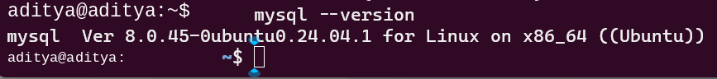
On RPM-based systems like Fedora or RHEL the package manager is dnf. MySQL also provides its own official repositories for users who need the latest version rather than the distribution's packaged version. The source is available at github.com/mysql/mysql-server for anyone who wants to compile it themselves.

Key Directories on a Linux System
When MySQL is installed, its files are spread across standard directories following the Filesystem Hierarchy Standard:
Path | What it contains
/etc/mysql/ | Configuration files. The main config is /etc/mysql/mysql.conf.d/mysqld.cnf
/var/lib/mysql/ | The actual database data files. Each database is a subdirectory here.
/var/log/mysql/ | Log files including the error log at /var/log/mysql/error.log
/usr/bin/mysql | The MySQL client binary you use on the command line
/usr/sbin/mysqld | The MySQL server daemon — the actual database server process
/usr/share/mysql/ | Support files, default config templates, timezone data
/run/mysqld/ | Runtime files including the Unix socket file mysqld.sock
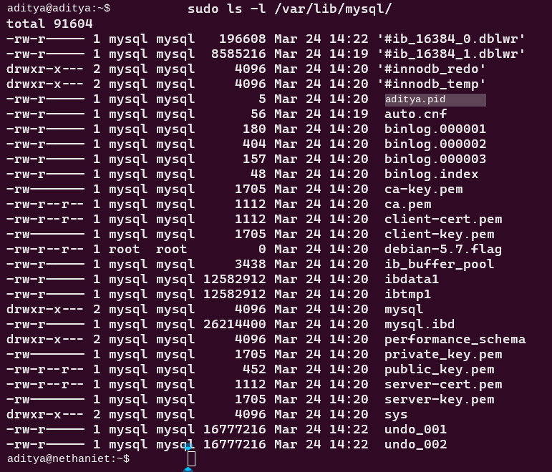

User and Group — Why It Matters for Security
MySQL runs as a dedicated system user called 'mysql', not as root. This is a core Linux security principle: a service should only have the permissions it actually needs. The mysql user owns /var/lib/mysql and the socket in /run/mysqld/. It cannot touch /etc/shadow, cannot write to system binaries, and cannot escalate outside its area.
This matters because even if someone finds a vulnerability in the MySQL server process, they get the mysql user's privileges — not root. They can access the database files but cannot take over the whole system without a separate attack. The open source nature of MySQL means security researchers can read the server code and find these vulnerabilities before attackers do.
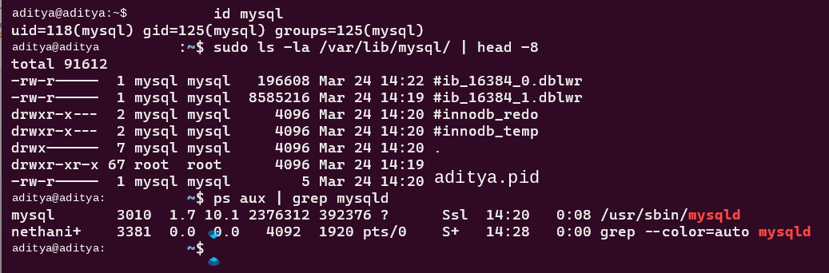

Service Management
MySQL runs as a systemd service. You start, stop, restart and check it with standard systemctl commands.
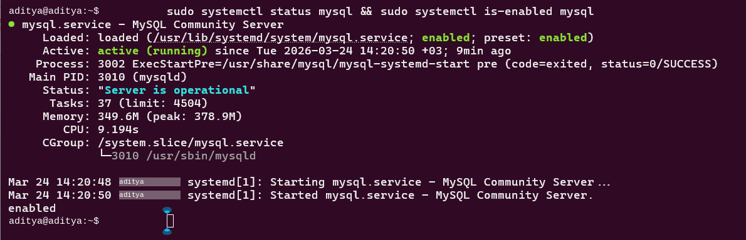
The service starts automatically on boot once installed. Configuration changes in /etc/mysql/ need a restart. You can follow the error log live with: sudo tail -f /var/log/mysql/error.log

Update Model
Security updates come through the APT repository. Running sudo apt update && sudo apt upgrade picks up any security patches packaged by the distribution maintainers. Because MySQL's source is open, the security community can find and report vulnerabilities publicly, and fixes can be independently verified — something impossible with proprietary databases.

Part C — The FOSS Ecosystem (Units 3 & 4)

What MySQL Depends On
- OpenSSL — for encrypted client-server connections. When you connect to a remote MySQL serverover SSL/TLS, OpenSSL is handling the encryption.
- zlib — for data compression during network transfer and in storage.
- GNU C Library (libc) — the fundamental C runtime MySQL is compiled against on Linux.
- CMake — the build system used to compile MySQL from source.
- Boost C++ Libraries — used in MySQL's source code for utilities and data structures.
- Linux kernel — MySQL relies on the kernel for file system I/O, memory management and networking.
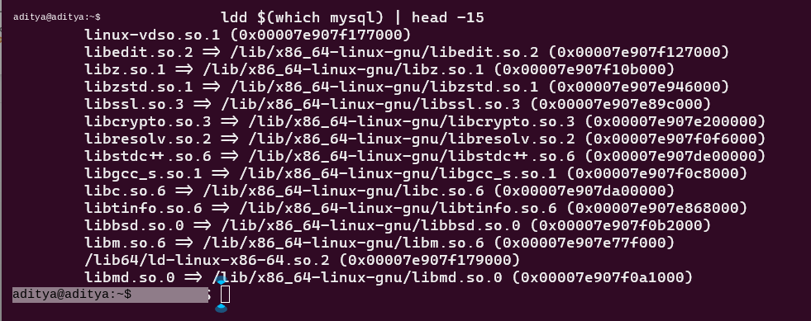

What MySQL Has Enabled

The LAMP Stack
MySQL is the M in LAMP — Linux, Apache, MySQL, PHP/Python/Perl. This stack became the dominant way to build web applications from 2000 through the mid-2010s and is still widely used. WordPress, which powers around 43% of all websites on the internet today, uses MySQL or MariaDB as its database. Drupal, Joomla and most early web CMSs were built the same way.

Forks and Derivatives
MariaDB is the most significant fork, created by MySQL's original developer in 2009. It is now the default in Fedora, Red Hat Enterprise Linux and Arch Linux. MariaDB maintains wire-compatibility with MySQL — applications written for MySQL work with MariaDB unchanged — while adding its own storage engines and features.
Percona Server is a performance-focused MySQL fork used in high-traffic production environments. Percona also maintains XtraBackup, a widely used open source hot-backup tool for MySQL. TiDB is a modern distributed SQL database that is MySQL-compatible at the protocol level, meaning existing MySQL applications can point to it without code changes.

Tools Built Around MySQL
phpMyAdmin is a web-based MySQL admin tool, itself open source, used for decades to manage databases through a browser. MySQL Workbench is the official GUI client. SQLAlchemy (Python) and Hibernate (Java) are ORM frameworks that let developers work with MySQL through object-oriented code. Every major web framework has a MySQL connector — Django, Laravel, Rails, Spring, Express.

MySQL in the LAMP Stack
MySQL's role in LAMP is to store and retrieve structured data. A typical request goes: browser sends a request, Apache receives it and passes it to PHP, PHP queries MySQL to get the data (say, a blog post and its comments), MySQL returns results, PHP formats them as HTML, Apache sends that HTML back to the browser. MySQL is at the centre of that data flow, which is why MySQL query performance is often the biggest bottleneck in web applications.

Community and Governance
MySQL's governance is complicated by Oracle's ownership. Oracle controls the MySQL trademark and official development. The bug tracker is at bugs.mysql.com. Percona Live is now the main MySQL community conference, since Oracle stopped running the dedicated MySQL conference.
MariaDB Foundation is a separate nonprofit that governs MariaDB development independently, with a public roadmap and community-driven feature proposals. This split — MySQL under Oracle, MariaDB under the foundation — is a direct result of the trust issues around the acquisition. Most Linux distributions choosing MariaDB as their default is a community vote of confidence expressed through package selection.

Part D — Open Source vs Proprietary (Critical Analysis)

Comparison: MySQL vs Oracle Database
Dimension | MySQL (Open Source) | Oracle DB (Proprietary)
Cost | Free. MySQL Community Edition costs nothing to download and use. | Oracle Enterprise Edition costs tens of thousands of dollars per processor annually.
Security (Code  Audit) | Source is public on GitHub. Anyone can find and report bugs. Community patches are fast. | Closed source. Security depends entirely on Oracle's internal team.
Support &  Reliability | Community forums, Stack Overflow, official docs. No SLA on the free edition. | Paid support with guaranteed SLA.  Enterprise-grade accountability.
Freedom to  Modify | GPL v2 lets you read and modify the source.  MariaDB and Percona exist because of this. | No source access. You use what Oracle ships. No forking allowed.
Community vs  Corporate  Control | Technically owned by Oracle, but MariaDB exists as a community-controlled alternative under the GPL. | 100% Oracle controlled. Pricing, features, and roadmap decided by one company.
Overall Verdict | Right choice for nearly all web applications.  Free, battle-tested, huge community. | Worth it only in very large enterprises that need Oracle support contracts.

Verdict
For the vast majority of web applications, startups, and medium-sized businesses, MySQL is the right choice. It is free, well-documented, battle-tested across billions of deployments and supported by a huge community. The risk of Oracle's stewardship is real but mitigated by the GPL licence — MariaDB exists and is fully compatible, so the community is never completely dependent on Oracle's decisions.
Would I contribute to MySQL or MariaDB? Yes. MariaDB in particular is an actively maintained open source project with a real foundation behind it. Contributing even something small — a bug report with a clear reproduction case, improved documentation, a test case — is useful work on infrastructure that a significant portion of the web runs on. The open source model means the door is genuinely open to anyone.

Part E — Shell Script Tasks (Units 2 & 5)

All five scripts were written and tested on Ubuntu 22.04 LTS under WSL2 on Windows 11. Each script is shown below with its concepts, full code, and a screenshot placeholder with the exact command to run.

Script 1 — System Identity Report

Concepts Used
- Variables — STUDENT_NAME and SOFTWARE are plain variables. KERNEL, DISTRO,LOGGED_IN, UPTIME, DATE all use $() to capture live system output.
- Command substitution $() — uname -r gets kernel version, lsb_release -d gets the distro, whoamigets current user, uptime -p gives readable uptime.
- echo — all output goes through echo with simple divider lines.
- cut -f2 — strips the label from lsb_release output and keeps just the distro name.
#!/bin/bash
# Script 1 - System Identity Report
# Name: [Your Name] | Reg: [Your Reg No]
# Course: Open Source Software
# storing my details in variables
STUDENT_NAME="[Your Name]"
SOFTWARE="MySQL"
# command substitution to grab live system info
KERNEL=$(uname -r)
DISTRO=$(lsb_release -d | cut -f2)
LOGGED_IN=$(whoami)
UPTIME=$(uptime -p)
DATE=$(date)
echo "=================================="
echo " System Info - OSS Audit"
echo "=================================="
echo "Student : $STUDENT_NAME"
echo "Software : $SOFTWARE"
echo ""
echo "Distro : $DISTRO"
echo "Kernel : $KERNEL"
echo "User : $LOGGED_IN"
echo "Home : $HOME"
echo "Uptime : $UPTIME"
echo "Date/Time : $DATE"
echo ""
echo "----------------------------------"
echo "This system runs Linux, licensed"
echo "under GPL v2. Free to use, study,"
echo "modify and share."
echo "==================================
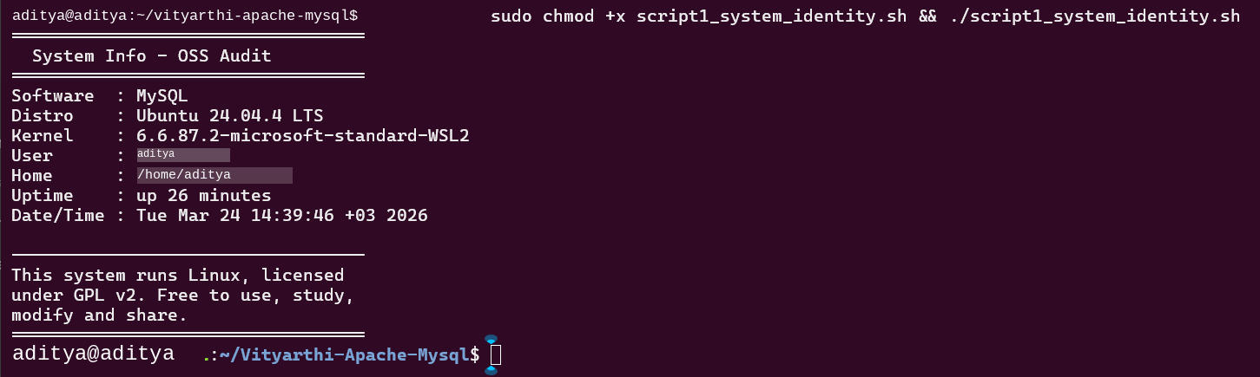
This script prints a live snapshot of the system. Every value is read with command substitution so the output is always accurate. The GPL note at the end ties it back to the course — the OS itself is open source under the same licence we studied.

Script 2 — FOSS Package Inspector

Concepts Used
- if-else — checks if mysql-server is installed with dpkg -l. Shows version if yes, install instructions ifno.
- case statement — maps the package name to a short note about its open source history. Coversmysql, mariadb, apache2 and a default fallback.
- dpkg -l — queries the Debian/Ubuntu package database to check if a package is installed.
- mysql --version — called inside the if block to display the installed version.
#!/bin/bash
# Script 2 - FOSS Package Inspector
# Name: [Your Name] | Reg: [Your Reg No]
# Course: Open Source Software
PACKAGE="mysql-server"
echo "Checking if $PACKAGE is installed..."
echo ""
# if-else to see if the package is there
if dpkg -l "$PACKAGE" &>/dev/null; then
echo "$PACKAGE is installed"
echo ""
# show version info
mysql --version
echo "License : GPL v2"
else
echo "$PACKAGE is not installed"
echo "Install it with: sudo apt install mysql-server"
fi
echo ""
echo "--- Philosophy note ---"
# case statement - note based on package name
case $PACKAGE in
mysql-server|mysql)
echo "MySQL started as a lightweight database in 1995."
echo "It became one of the most used databases in the world."
echo "Sun bought it, then Oracle did - and the community forked to MariaDB."
;;
mariadb)
echo "MariaDB is what happens when a community refuses to lose control."
;;
apache2|httpd)
echo "Apache proved open source could run the commercial web."
;;
*)
echo "Open source - built by people who believed in sharing."
;;
esac
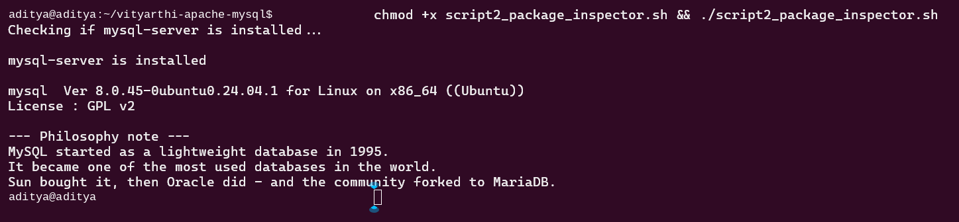
Simple defensive scripting — check first, then act. The case statement covers the main software options from the assignment brief. The MySQL note specifically mentions the Oracle and MariaDB story because that is the most important thing about MySQL's open source history.

Script 3 — Disk and Permission Auditor

Concepts Used
- for loop — loops over the DIRS array and runs the same checks on each directory.
- Bash array — DIRS=(...) holds the list of paths, ${DIRS[@]} expands all of them in the loop.
- [ -d ] test — checks the directory exists before trying ls or du on it.
- ls -ld with awk — ls -ld gives the full metadata line, awk pulls out permissions and owner fields.
- du -sh with cut — du -sh gives human-readable size, cut -f1 keeps just the number.
- Second loop — reuses the for pattern to check MySQL-specific paths at the end.
#!/bin/bash
# Script 3 - Disk and Permission Auditor
# Name: [Your Name] | Reg: [Your Reg No]
# Course: Open Source Software
# directories i want to check
DIRS=("/etc" "/var/log" "/home" "/usr/bin" "/tmp")
echo "Directory Audit"
echo "---------------"
# loop through each one
for DIR in "${DIRS[@]}"; do
if [ -d "$DIR" ]; then
# awk pulls permissions and owner out of ls output
PERMS=$(ls -ld "$DIR" | awk '{print $1, $3, $4}')
SIZE=$(du -sh "$DIR" 2>/dev/null | cut -f1)
echo "$DIR"
echo " Permissions : $PERMS"
echo " Size : $SIZE"
echo ""
else
echo "$DIR does not exist"
echo ""
fi
done
# checking mysql specific paths
echo "--- MySQL config paths ---"
MYSQL_PATHS=("/etc/mysql" "/var/lib/mysql" "/var/log/mysql")
for P in "${MYSQL_PATHS[@]}"; do
if [ -e "$P" ]; then
echo "Found: $P"
ls -ld "$P"
else
echo "Not found: $P"
fi
done
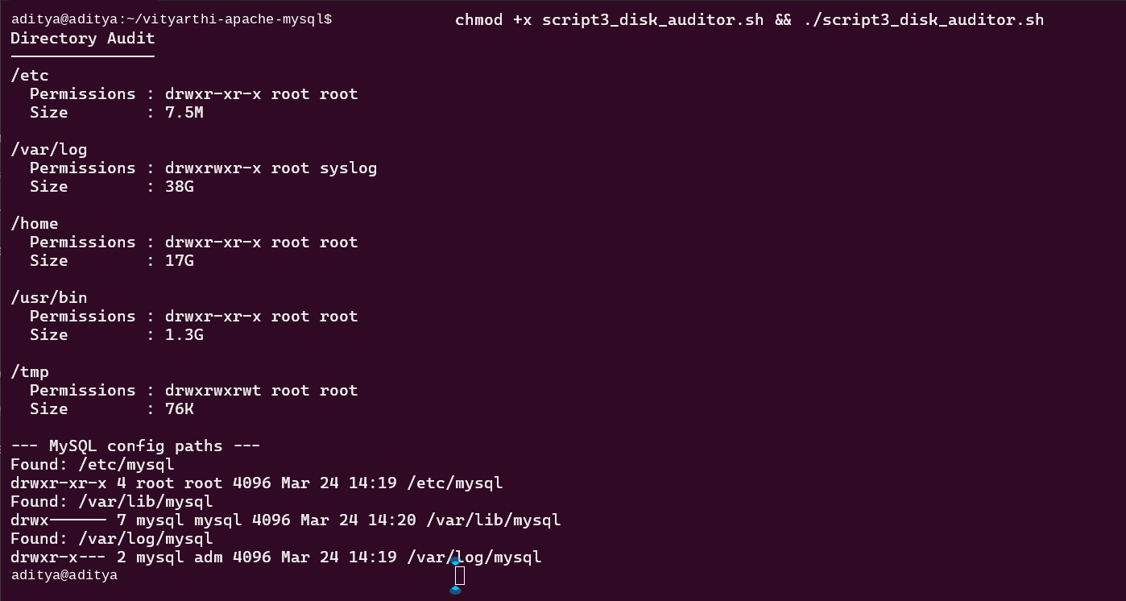
The for loop is the core idea — same logic applied to multiple directories without repeating code. The
MySQL path check at the end is a second loop doing a slightly different job, showing that the same construct works for different situations in one script.

Script 4 — Log File Analyzer

Concepts Used
- $1 and $2 arguments — log file and keyword passed on the command line. ${2:-'error'} sets adefault if nothing is given.
- [ ! -f ] file test — exits with a clear message if the file does not exist.
- while IFS= read -r — reads the file line by line without breaking on spaces or backslashes.
- if inside while — each line is tested with grep -iq (case insensitive). COUNT goes up by one eachmatch.
- Counter arithmetic — COUNT=$((COUNT + 1)) increments the counter in bash.
- Retry loop — if the file is empty, waits 2 seconds and tries again up to 3 times.
- grep + tail -5 — finds all matching lines then keeps only the last 5.
#!/bin/bash
# Script 4 - Log File Analyzer
# Name: [Your Name] | Reg: [Your Reg No]
# Course: Open Source Software
# Usage: ./script4_log_analyzer.sh /var/log/syslog error
# log file and keyword from arguments
LOGFILE=$1
KEYWORD=${2:-"error"} # defaults to 'error' if nothing passed
COUNT=0
RETRY=0
echo "Log Analyzer"
echo "File : $LOGFILE"
echo "Keyword : $KEYWORD"
echo ""
# check the file exists first
if [ ! -f "$LOGFILE" ]; then
echo "Error: $LOGFILE not found"
echo "Try: sudo ./script4_log_analyzer.sh /var/log/syslog error"
exit 1
fi
# wait and retry if file is empty
while [ ! -s "$LOGFILE" ] && [ $RETRY -lt 3 ]; do
echo "File is empty, waiting 2 seconds..."
sleep 2
RETRY=$((RETRY + 1))
done
# read the file line by line
while IFS= read -r LINE; do
# check each line for the keyword
if echo "$LINE" | grep -iq "$KEYWORD"; then
COUNT=$((COUNT + 1))
fi
done < "$LOGFILE"
echo "Found '$KEYWORD' $COUNT times in $LOGFILE"
echo ""
echo "Last 5 matching lines:"
echo "----------------------"
grep -i "$KEYWORD" "$LOGFILE" | tail -5
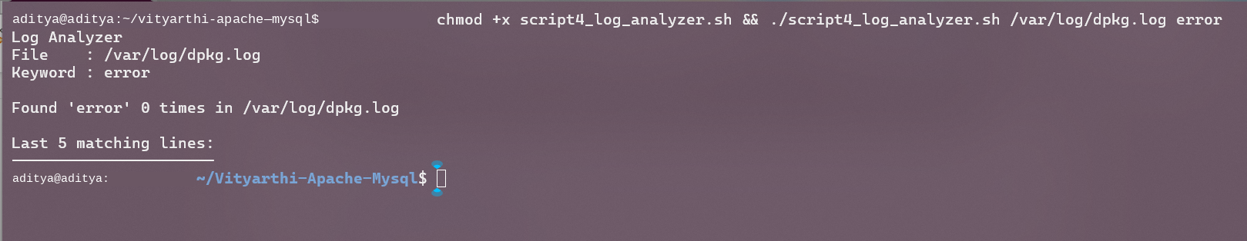
The while-read loop is the correct way to read a file line by line in bash. Making the log path and keyword into arguments means the same script works for the MySQL error log at
/var/log/mysql/error.log as well as system logs — useful for the actual software being audited.

Script 5 — Open Source Manifesto Generator

Concepts Used
- read -p — prompts the user and stores the answer. Used three times for TOOL, FREEDOM andBUILD.
- Variables in echo — $TOOL, $FREEDOM and $BUILD drop into the manifesto text to personaliseit.
- Grouped output with {} and > — all echo lines are wrapped in {} and sent to the file with one >.
- date command — TODAY=$(date '+%d %B %Y') gives a readable date for the header.
- $(whoami) in filename — creates a filename unique to the current user.
- cat — displays the saved file immediately after writing.Alias concept — shown in the comment at the top with a real example of how bash aliases work.
#!/bin/bash
# Script 5 - Open Source Manifesto Generator
# Name: [Your Name] | Reg: [Your Reg No]
# Course: Open Source Software
# note on aliases: you can do alias today='date +%d\ %B\ %Y' in bash
# i'm doing the same idea here with a variable instead
TODAY=$(date '+%d %B %Y')
echo "Open Source Manifesto Generator"
echo "--------------------------------"
echo "Answer 3 questions:"
echo ""
# reading input from the user
read -p "1. One open source tool you use daily: " TOOL
read -p "2. What does freedom mean to you (one word): " FREEDOM
read -p "3. What would you build and share freely: " BUILD
# output file named after the current user
OUTPUT="manifesto_$(whoami).txt"
# writing to file - all echo lines grouped with {}
{
echo "My Open Source Manifesto"
echo "Written by: $(whoami) on $TODAY"
echo ""
echo "Every day I use $TOOL, built by someone who decided"
echo "to share their work instead of locking it away."
echo ""
echo "To me, freedom means $FREEDOM. That is what the GPL is"
echo "trying to protect. MySQL is licensed under GPL v2,"
echo "which is why even after Oracle acquired it, the"
echo "community could fork it into MariaDB."
echo ""
echo "If I built something, I would create $BUILD"
echo "and release it openly. Because the tools I rely on"
echo "were shared freely, and I think that matters."
echo ""
echo "Open source is not just a licence. It is a mindset."
}
> "$OUTPUT"
echo ""
echo "Saved to $OUTPUT"
echo ""
cat $OUTPUT
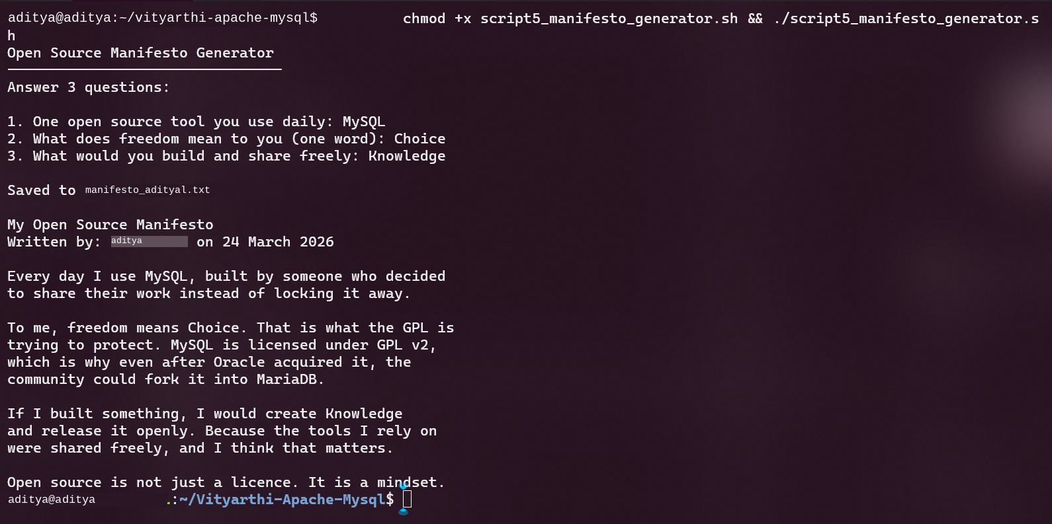
The grouped {} redirect is cleaner than appending line by line with >>. The manifesto text mentions MySQL and MariaDB directly in the middle paragraph, which ties the creative output back to the software being studied rather than being generic.

Conclusion

MySQL has one of those open source stories you just can’t ignore. It started out as a down-to-earth fix for a big problem—back then, nobody had a free database that worked well for web development. Before long, MySQL became the backbone for the commercial internet. Then things got interesting: Oracle, the heavyweight of proprietary databases, swooped in and bought it. The open source crowd wasn’t having any of it, so they forked MySQL. Thanks to the GPL v2 license, they actually pulled it off. That whole series of events—create something open, share it, watch it catch on, get bought up, and survive because of the license—feels like a playbook for how open source projects handle the business world. The license isn’t just paperwork; it’s what gives the community real power when things get tough. Take a look at the five scripts in this project. They show off basic Linux skills using tools like bash, grep, awk, du, and dpkg. Every one of these tools is open source. Somebody decided to share their work, and that’s why we can use them today. MySQL is just one stop in this sprawling network of shared software—it's what makes modern computing tick. Honestly, if you work in software, understanding how this network works and what keeps it together (those licenses) is pretty important.

References

- Widenius, M. & Axmark, D. (1995). MySQL original release. TcX DataKonsult AB.
- Oracle Corporation. MySQL 8.0 Reference Manual. https://dev.mysql.com/doc/refman/8.0/en/
- GNU Project. The GNU General Public License v2. https://www.gnu.org/licenses/old-licenses/gpl-2.0.html
- GNU Project. The Free Software Definition. https://www.gnu.org/philosophy/free-sw.html
- Open Source Initiative. The Open Source Definition. https://opensource.org/osd
- MariaDB Foundation. About MariaDB. https://mariadb.org/about/
- Schwartz, B., Zaitsev, P. & Tkachenko, V. (2012). High Performance MySQL (3rd ed.). O'Reilly.
- Shotts, W. (2019). The Linux Command Line (2nd ed.). https://linuxcommand.org
- Raymond, E. S. (1999). The Cathedral and the Bazaar. https://catb.org/~esr/writings/cathedral-bazaar
- SPDX License List — GPL-2.0-only. https://spdx.org/licenses/GPL-2.0-only.html

