**MP1**

**Algorithm Description:**

Algorithm used for labeling is called “Sequential Solution to CCL” described by professor in the lecture.

The algorithm basically says that firstly pass by each pixel of the image (left to right and up to down) and label according to below condition:

1. If the pixel value is 0 then label will be 0.
2. If the pixel value is not 0 then we perform below conditions:
   1. If pixel value of up = pixel value of left and pixel value of up != 0 and pixel value of left != 0 then we label either (up or left) pixel value to current pixel.
   2. If pixel value of up != pixel value of left and either (up or left) of the pixel is not equal to 0 then we label max (basically which is not 0) among these two to the current pixel.
   3. If pixel value of up != pixel value of left and both (up and left) pixel value is greater than 0 then we label the min value among these two (up and left ) to the current pixel and update the equivalence table.
   4. Else we increase the count of the current label and update the current pixel with this label.

For running the notebook please put all images in the same folder where the jupyter notebook resides.

For more details about each function, please refer to the documentation described in the jupyter notebook above all the functions.

**Result Analysis:**

Threshold value for removing the noise, used is “50”.

1. Test.bmp: Total number of connected components in the “test.bmp” is 1. There is no noise in the image.

 Without filter. With filter with threshold value defined above.

1. Face.bmp: Total number of connected components in the “face.bmp” is 6. There is no noise in the image.

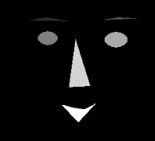 Without filter.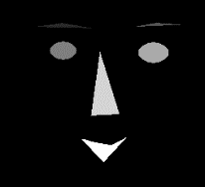 Without filter with threshold value defined above.

1. Gun.bmp: Total number of connected components in the “gun.bmp” is 4. Out of 4, we can say that 2 of them is a noise for threshold value of “50”.

 Without filter.  With filter with defined threshold value.