Algorithm:

1. Downloaded many pictures of skin from the Internet for performing the training.
2. Used OpenCV to read those training images. Then I use the transforming formula in the lecture to transform the RGB value into HS value based on color type.
3. Store the value of different H and S values in a dictionary.
4. Perform normalization on the histogram values.
5. Plot the histogram image.
6. Perform the skin color segmentation using this histogram dictionary. If the value is found in the dictionary and it is above given threshold then we keep the value of RGB on test image, else we made it to zero.

For running the notebook please put all images in the same folder where the Jupyter notebook resides.

For more details about each function, please refer to the documentation described in the Jupyter notebook above all the functions.

Results:

I have trained on the various skin toned images and saved the histogram values. Please find the histogram area sum in below image.

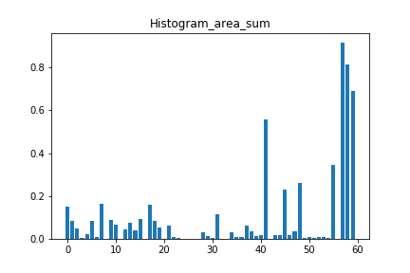

Please find result images below:

Images without segmentation: Images after skin color segmentation:

