Algorithm:

1. Downloaded many pictures of skin from the Internet for performing the training.
2. Used 2 color space for the segmentation process: RGB and HSV.
3. Used OpenCV to read those training images. Then I use the transforming formula from the lecture to transform the RGB/HSV value into respective RG/HS value.
4. Store the value of different H/S and R/G values in different dictionary for RGB and HSV.
5. Perform normalization on the histogram values.
6. Plot the histogram images and find the threshold values.
7. Perform the skin color segmentation using this histogram dictionary created in previous steps. If the value is found in the dictionary and it is above given threshold then we keep the value of RGB/HSV on test image, else we made it to zero.

For running the notebook please put all images in the same folder where the Jupyter notebook resides.

For more details about each function, please refer to the documentation described in the Jupyter notebook above all the functions.

Results:

I have trained on the various skin toned images and saved the histogram values. Please find the histogram area sum in below image.

RGB Histogram HSV Histogram

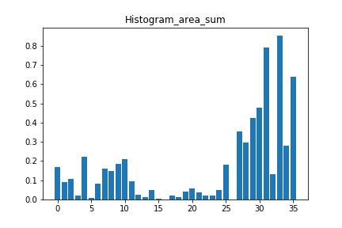 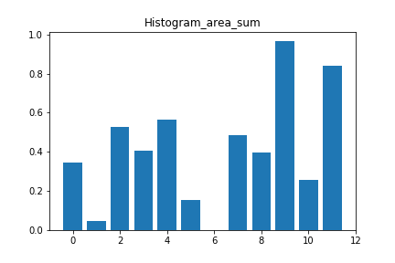

Please find result images below. We can see that the skin color segmentation for HSV is better than RGB.

Images without segmentation: Images after skin color segmentation for RGB

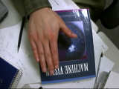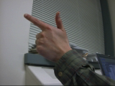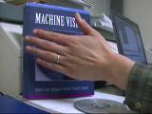 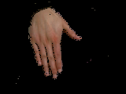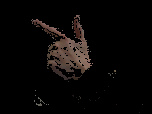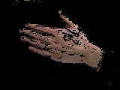

Images after skin color segmentation for HSV

