Quantum Stock Tracker
Project Documentation | Aditi Joshi

1. Overview
Quantum Stock Tracker is a MERN stack web application for tracking a personal stock portfolio. Users create a profile for each stock they hold. The app fetches the current price from the Alpha Vantage API and calculates the overall profit or loss.
Live demo: [add link] GitHub: github.com/adijoshi07/[repo-name]

2. Features
Stock profiles
- Create, view, edit, and delete stock holdings
- Each profile stores the stock name, symbol, quantity, buy price, and other relevant details
- Current price fetched from the Alpha Vantage API
Dashboard and analytics
- Total holdings: number of stocks in the portfolio
- Total invested amount: cost basis across all holdings
- Current portfolio value: calculated from live prices fetched from the API
- Profit / Loss: current value minus invested amount
- 30-day performance area chart (uses simulated data)
- Refresh button to pull the latest prices on demand

3. Application Flow
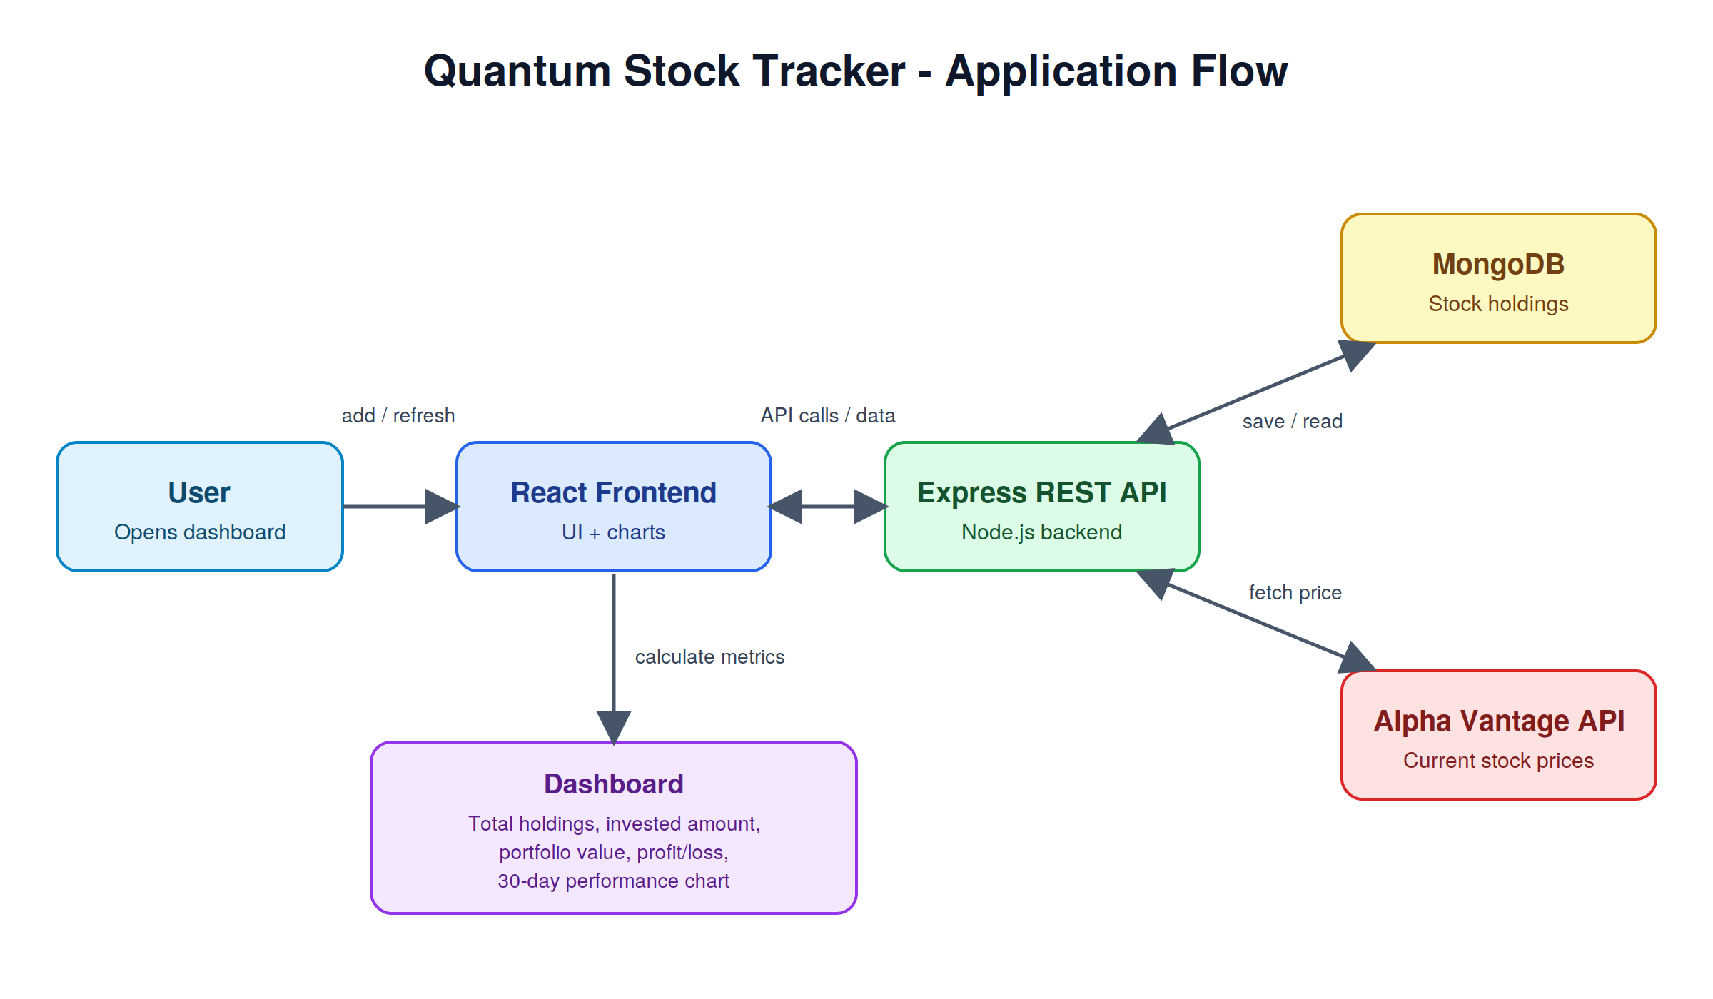

4. Tech Stack
Layer | Technology
Frontend | React, [charting library, e.g. Recharts]
Backend | Node.js, Express
Database | MongoDB (Mongoose)
External API | Alpha Vantage

5. Getting Started
Prerequisites: Node.js (v18 or later), MongoDB (local or Atlas), and a free Alpha Vantage API key.
Installation
git clone https://github.com/adijoshi07/[repo-name].git
cd [repo-name]
cd server && npm install
cd ../client && npm install
Environment variables (create a .env file in the server folder)
MONGO_URI=your_mongodb_connection_string
ALPHA_VANTAGE_API_KEY=your_api_key
PORT=5000
Run the app
cd server && npm start
cd client && npm start

6. API Endpoints
Update this table to match your actual routes.
Method | Endpoint | Description
GET | /api/stocks | Get all stock holdings
POST | /api/stocks | Add a new stock
PUT | /api/stocks/:id | Update a stock
DELETE | /api/stocks/:id | Delete a stock
GET | /api/stocks/refresh | Fetch latest prices from Alpha Vantage

7. Notes and Limitations
- The 30-day performance chart currently uses simulated data, not real historical prices.
- The Alpha Vantage free tier has request limits, so refreshing many stocks at once may hit the limit.

8. Future Improvements
- Replace simulated chart data with real historical prices from the API
- Cache prices on the backend to reduce API calls
- Add user authentication so each user has a private portfolio
- Add price alerts and a sector-wise portfolio breakdown

9. Author
Aditi Joshi
GitHub: github.com/adijoshi07
LinkedIn: linkedin.com/in/aditi-joshi-165ba0384

