BRANCH TABLE

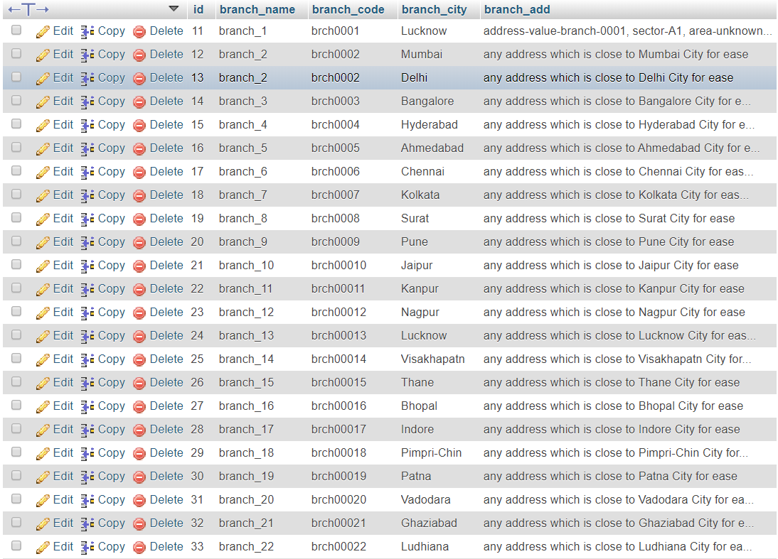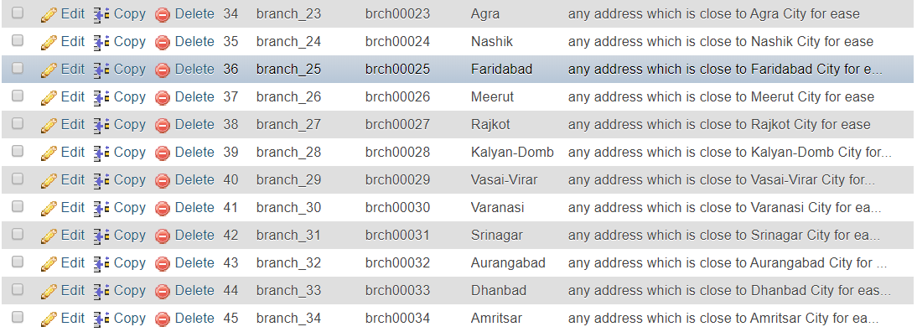

CUTOMER TABLE

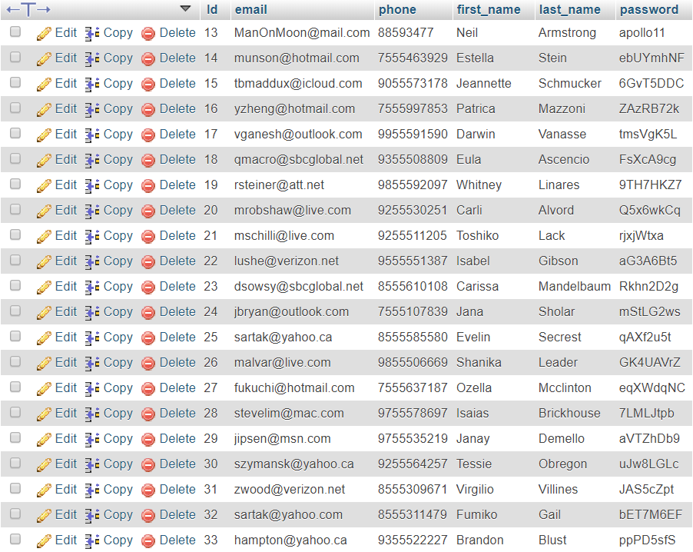

COMPLAIN TABLE

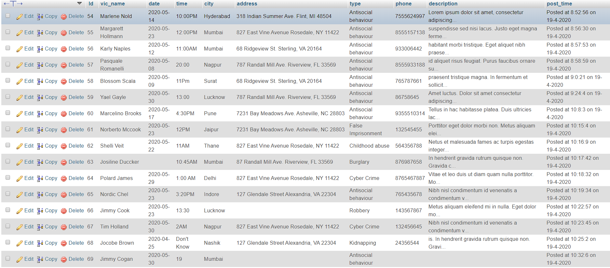

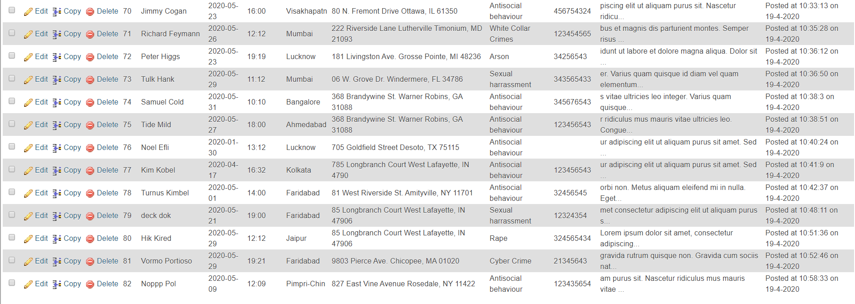

MANAGER TABLE

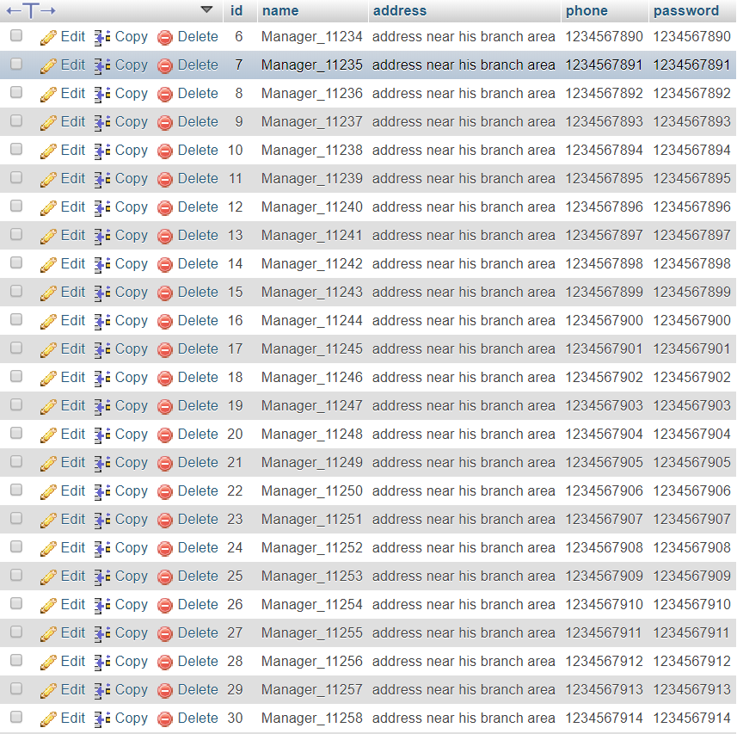

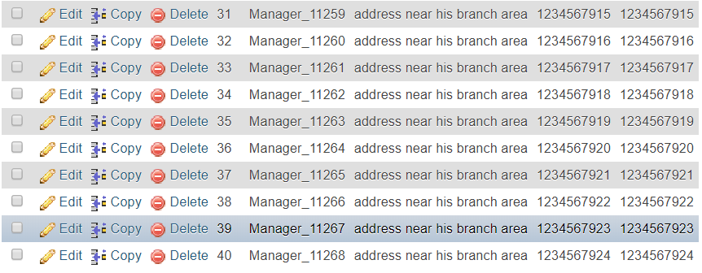

MANAGER-BRANCH RELATIONAL TABLE

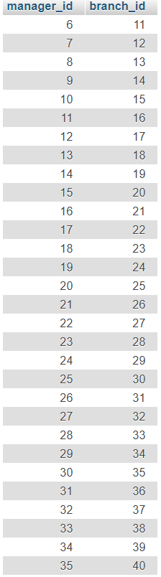

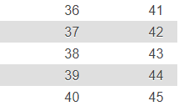

COMPLAIN-BRANCH RELATIONAL TABLE

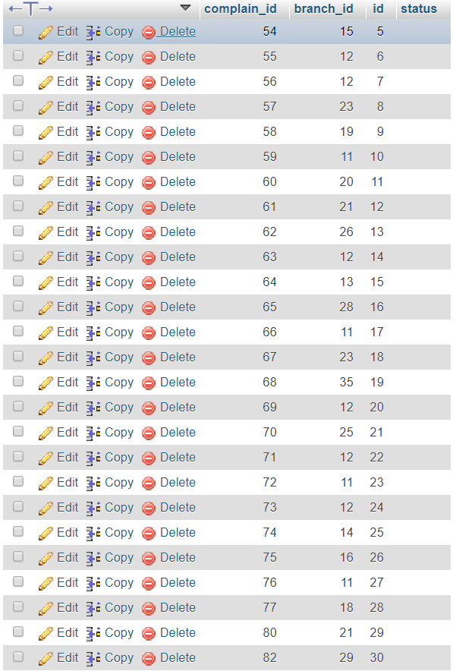

COUSTOMER-BRANCH RELATIONAL TABLE

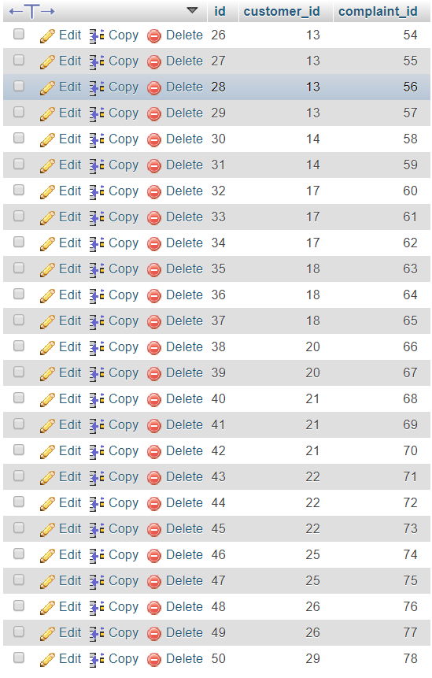

SQL QUERY

BRANCH_TABLE CREATING

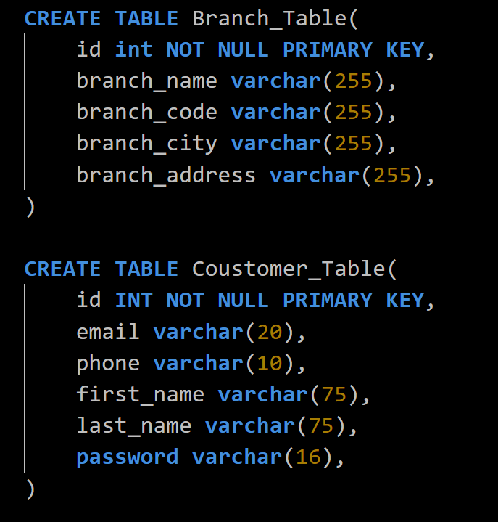



COUSTOMER_TABLE CREATING





MANAGER_TABLE CREATING

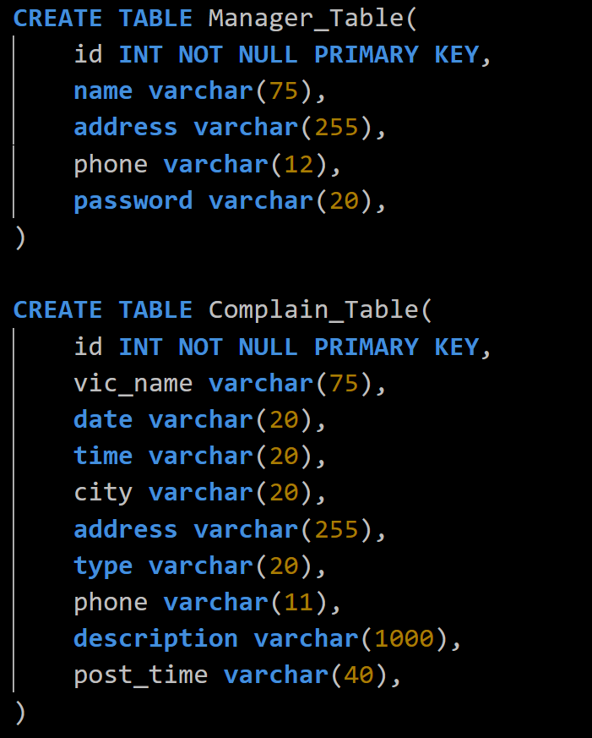

‘

COMPLAIN_TABLE CREATING





BRANCH_COMPLAIN_RELATION_TABLE CREATING

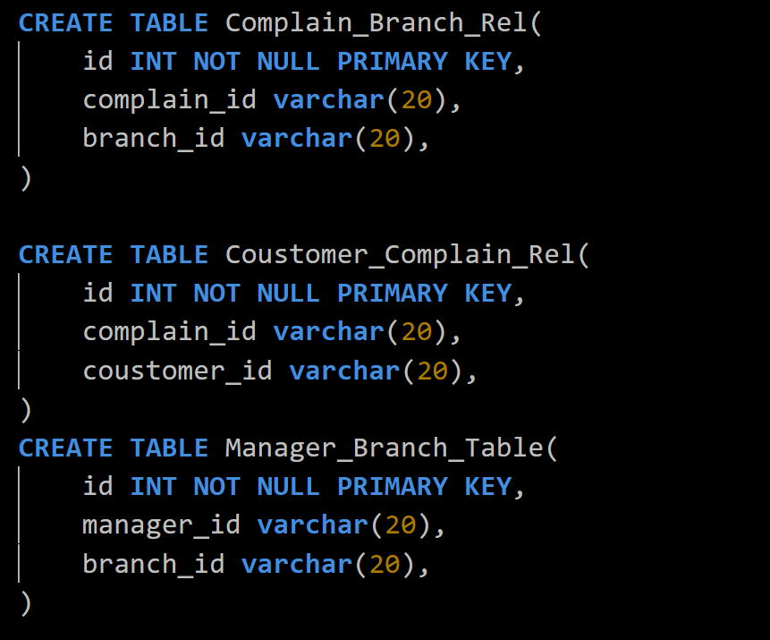



COUSTOMER_COMPLAIN_RELATION_TABLE CREATING





MANAGER_BRANCH_ RELATION _TABLE CREATING





