SOFTWARE ENGINEERING LAB – LAB 2
Agile Backlog Creation & Sprint Simulation in Jira
Section H | Scenario: Hospital Bed & ICU Allocation Dashboard
Student Name: Aditya A Kirankumar SRN: PES1UG24AM470
Date: 02 September 2026

1. Objective
The Lab 1 functional requirements for the Hospital Bed & ICU Allocation Dashboard were converted into Agile Epics and User Stories, prioritized and estimated using Story Points, organized into two simulated Scrum sprints, and tracked using Jira.

2. Epics
Epic | Description | Associated User Stories
Bed & Ward Management | Manage and display the current availability and status of hospital beds. | View Bed Availability; Update Bed Status
Triage & ICU Allocation | Support triage severity calculation and prioritization of ICU transfers. | Compute Triage Severity; Prioritize ICU Transfer
Ambulance Transfer Management | Manage ambulance transfers, monitor their progress, and handle escalation. | Initiate Ambulance Transfer; Track Ambulance Transfer; Escalate Transfer

3. User Stories, Priorities and Story Points
ID | User Story | Epic | Priority | Story Points
SL-4 | As a Triage Nurse, I want to view current hospital bed availability, so that I can identify suitable available beds for patients. | Bed & Ward Management | High | 3
SL-5 | As a Hospital Administrator, I want to update the status of hospital beds, so that the dashboard reflects current bed availability. | Bed & Ward Management | High | 3
SL-6 | As a Triage Nurse, I want the system to calculate a patient's triage severity from intake vital information, so that critical patients receive higher allocation priority. | Triage & ICU Allocation | High | 5
SL-7 | As a Triage Nurse, I want ICU transfer requests to be prioritized according to triage severity, so that patients requiring critical care are handled appropriately. | Triage & ICU Allocation | High | 5
SL-8 | As a Hospital Administrator, I want to initiate an ambulance transfer to another healthcare facility, so that patients can be transferred when required. | Ambulance Transfer Management | High | 8
SL-9 | As a Hospital Administrator, I want to track the status and destination of an ambulance transfer, so that I can monitor the patient's transfer. | Ambulance Transfer Management | Medium | 5
SL-10 | As a Hospital Administrator, I want to escalate an ambulance transfer when necessary, so that urgent transfer issues can receive additional attention. | Ambulance Transfer Management | Medium | 3
Total backlog estimate: 32 Story Points.

4. Sprint Plan
Sprint | User Stories | Total Points | Result
Sprint 1 | SL-6 Compute Triage Severity; SL-5 Update Bed Status; SL-7 Prioritize ICU Transfer; SL-4 View Bed Availability | 16 | Completed
Sprint 2 | SL-8 Initiate Ambulance Transfer; SL-9 Track Ambulance Transfer; SL-10 Escalate Transfer | 16 | Completed
Both sprints were configured as one-week sprints. Work was simulated by moving User Stories through To Do, In Progress, and Done, as required by the lab handout.

5. Jira Evidence
The following screenshots document the completed Jira workspace and sprint execution.

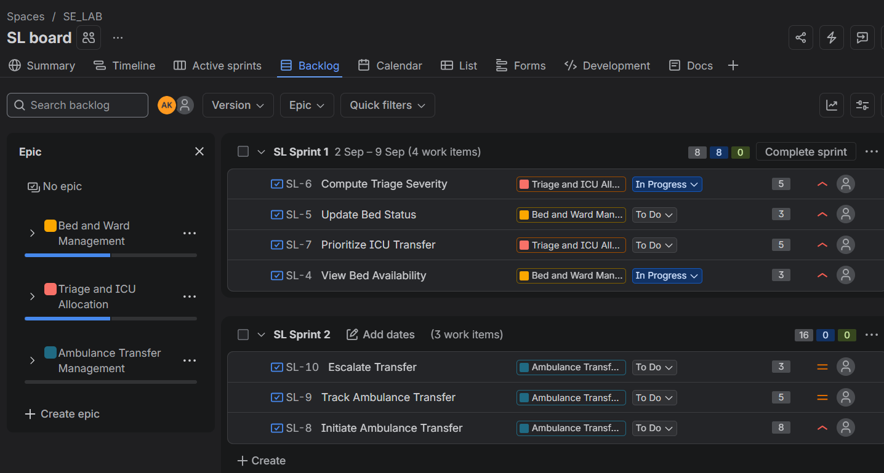
Figure 1. Jira backlog / sprint planning view showing the three Epics, seven work items, and Story Point estimates.

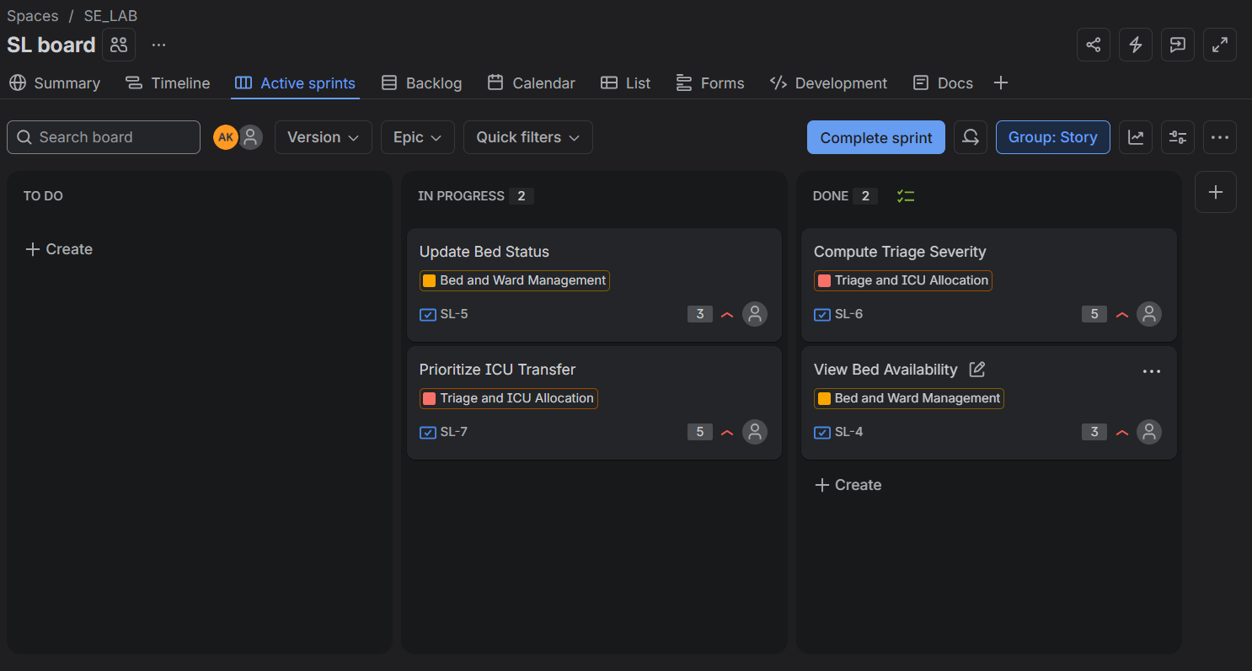
Figure 2. Sprint 1 Active Sprint view with work distributed between In Progress and Done.

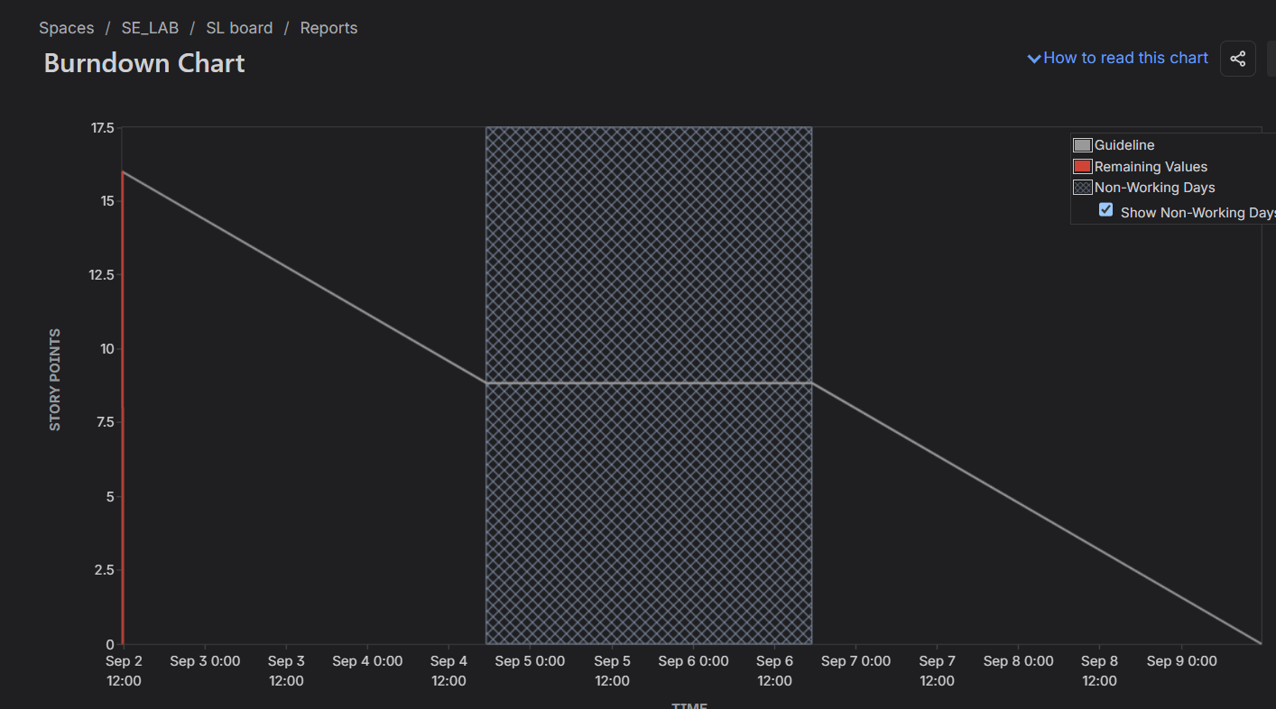
Figure 3. Sprint 1 Burndown Chart showing remaining Story Points against the guideline.

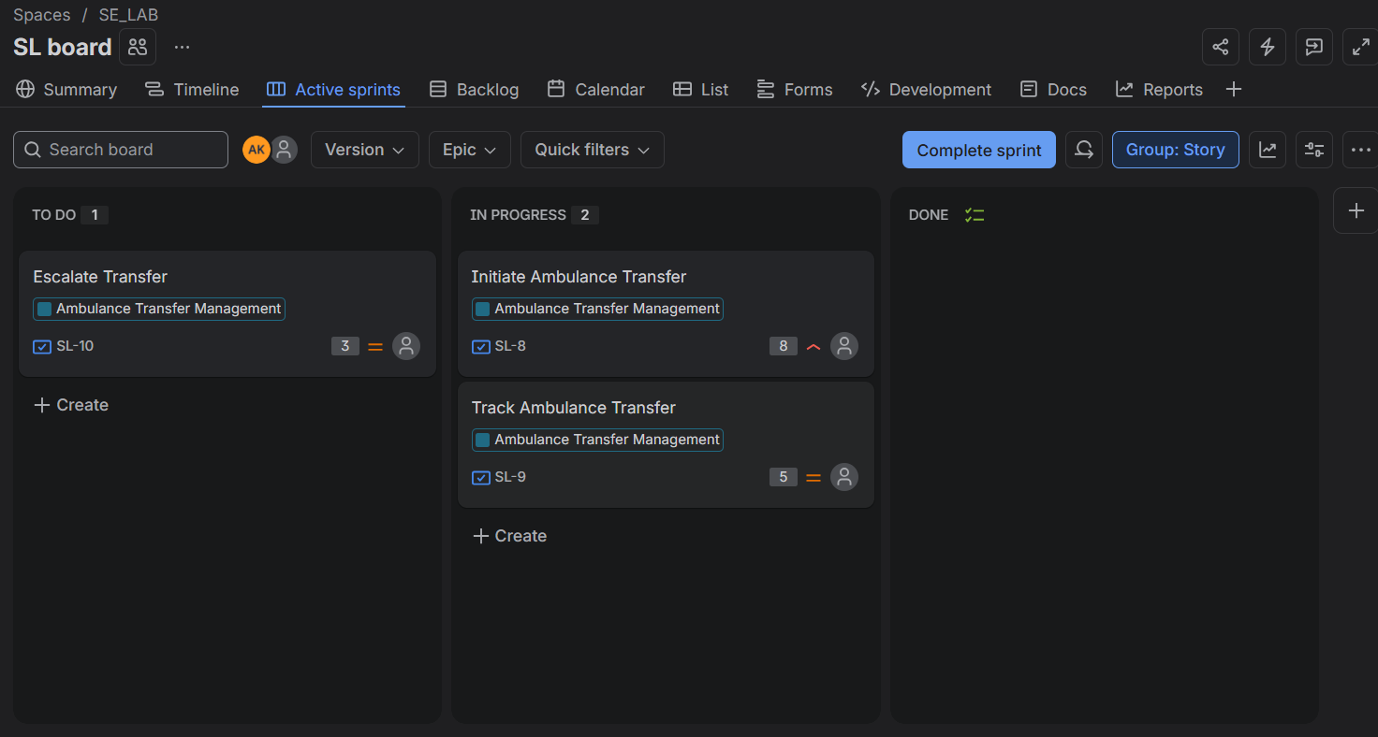
Figure 4. Sprint 2 Active Sprint view during execution.

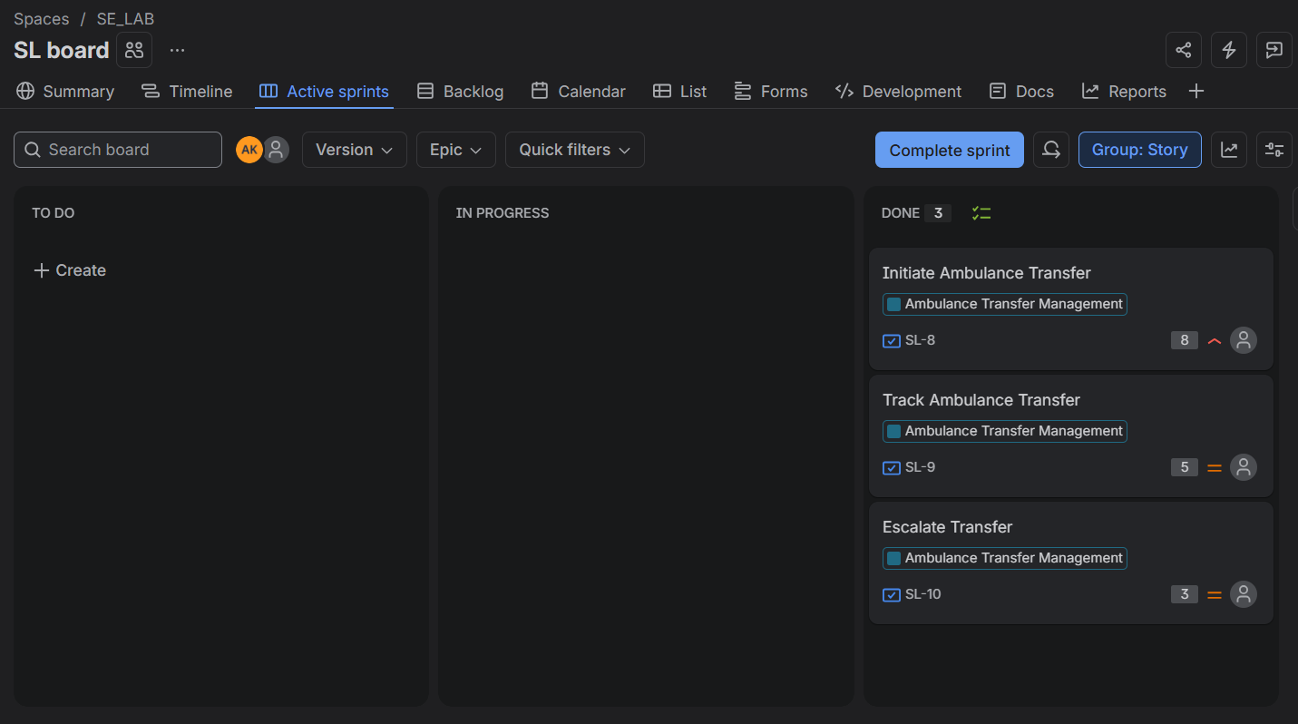
Figure 5. Sprint 2 completed with all three ambulance-transfer stories in Done.

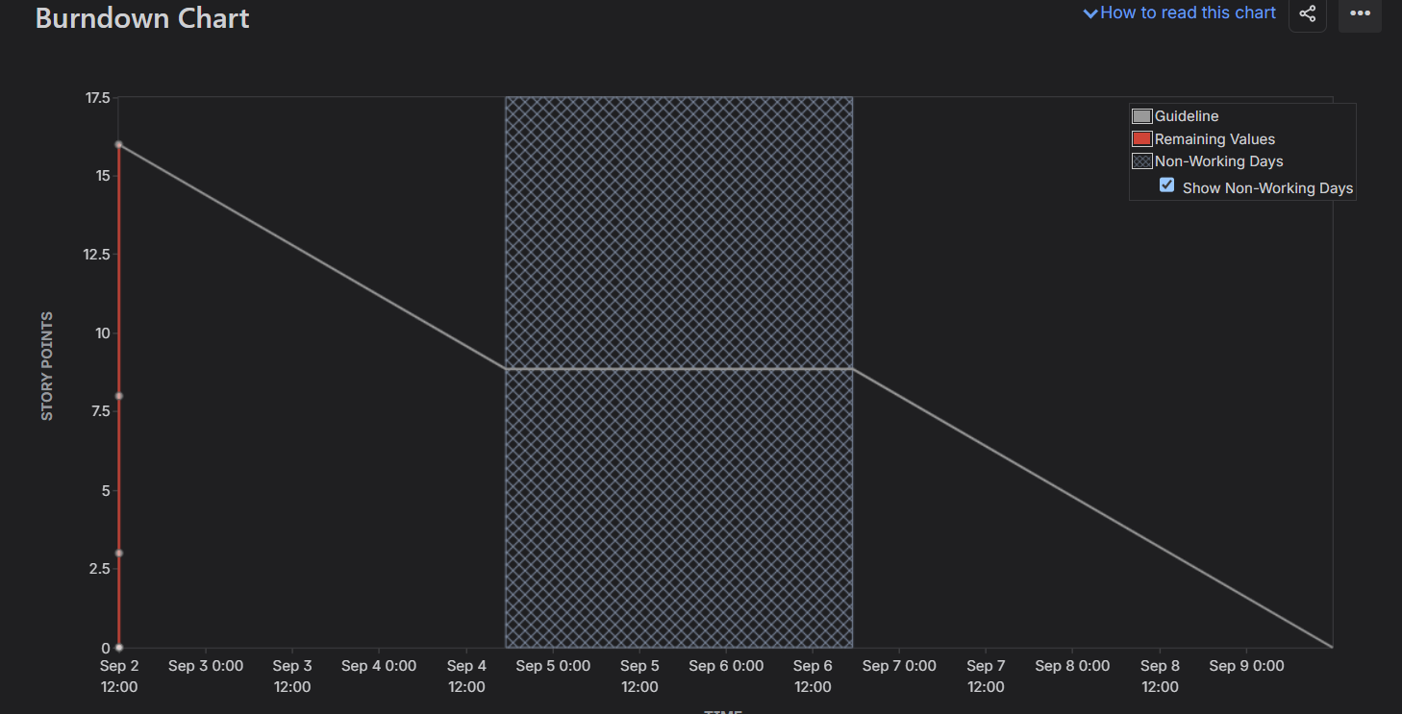
Figure 6. Burndown Chart after the sprint simulation.

6. Reflection
1. Did your estimations reflect the actual effort?
The estimations provided a reasonable relative representation of effort. Smaller activities such as View Bed Availability and Update Bed Status were assigned 3 Story Points, while Compute Triage Severity and Prioritize ICU Transfer were assigned 5 points. Initiate Ambulance Transfer received 8 points because it represents a comparatively larger and more complex workflow. In the simulated execution, the work was completed within the planned sprint structure, so the estimates were adequate for the exercise.
2. Was your backlog well-prioritized?
Yes. Functions directly associated with patient triage, ICU prioritization, bed availability, bed status, and initiating transfers were given High priority because they have a direct effect on patient allocation and operational decision-making. Tracking and escalation were assigned Medium priority because they support the transfer workflow after the primary transfer functionality is established.
3. How did your simulated sprint align with your plan?
The simulated execution aligned with the planned sprint structure. Sprint 1 contained 16 Story Points covering triage, ICU allocation, and bed management. Sprint 2 contained the remaining 16 Story Points covering ambulance transfer management. Stories were progressed through To Do, In Progress, and Done, and both sprints were completed.
4. What insights did the burndown chart give about your team's capacity?
The burndown chart showed the reduction of remaining Story Points over the sprint and provided a visual comparison with the expected linear guideline. It demonstrated how completion timing affects the shape of the remaining-work line. The chart is useful for judging whether the team is progressing consistently and whether the amount of work committed to a sprint is realistic. In this simulation, the completed work reached zero remaining Story Points by the end of the sprint.

