Software Engineering Lab 1
Requirements Engineering & UML Use-Case Modelling
Problem Statement #20 — Hospital Bed & ICU Allocation Dashboard
1. Requirements Table
Req ID | Type | Description | Priority | Acceptance Criteria | Rationale
FR-001 | Functional | The system shall compute triage severity scores from intake vitals and dynamically order the ER bed allocation waitlist. | High | Pass: A higher-acuity patient automatically moves ahead of a lower-acuity patient in the waitlist. Fail: A FIFO queue ignores a critical emergency. | Ensures critical patients receive higher allocation priority.
FR-002 | Functional | The system shall allow authorized staff to update the status of hospital beds as Occupied, Cleaning, or Available. | High | Pass: After an authorized user changes a bed status, the dashboard displays the new status. Fail: The old status remains displayed. | Keeps bed availability information current for allocation decisions.
FR-003 | Functional | The system shall display the current occupancy and availability of beds for each hospital ward. | High | Pass: The dashboard shows the current occupied and available beds for each ward. Fail: A ward's displayed status does not reflect its recorded bed status. | Provides visibility of real-time ward capacity.
FR-004 | Functional | The system shall allow authorized staff to initiate an ICU transfer request for a patient requiring critical care. | High | Pass: A valid ICU transfer request is created and appears in the ICU transfer queue with the patient's triage priority. Fail: The request is created without entering the queue. | Supports timely prioritization of patients requiring ICU care.
FR-005 | Functional | The system shall allow authorized staff to initiate and track an ambulance transfer request to another healthcare facility. | Medium | Pass: After a transfer is initiated, the dashboard displays the destination facility and current transfer status. Fail: The initiated transfer cannot be tracked. | Supports inter-facility ambulance transfer workflows.
NFR-001 | Nonfunctional | Bed status transitions (Occupied, Cleaning, Available) must propagate to all connected ER dashboard clients in under 1 second via WebSockets. | High | Pass: Benchmarking under simulated peak load confirms that bed-status updates reach connected clients in under 1 second while meeting the specified security standards. Fail: The target latency is exceeded. | Ensures timely visibility of bed-status changes during emergencies.
NFR-002 | Nonfunctional | The system shall require authenticated access before allowing users to view or modify patient bed-allocation information. | High | Pass: An unauthenticated user attempting to access patient or bed-allocation information is denied access. Fail: Unauthenticated access is permitted. | Protects sensitive patient and hospital allocation information.

2. UML Use-Case Model
Actors: Triage Nurse; Hospital Administrator; Ambulance Service
Primary Use Cases: UC-01 Compute Triage Severity; UC-02 View Bed Availability; UC-03 Update Bed Status; UC-04 Prioritize ICU Transfer; UC-05 Initiate Ambulance Transfer; UC-06 Track Ambulance Transfer; UC-07 Escalate Transfer
Relationships: UC-04 Prioritize ICU Transfer «include» UC-01 Compute Triage Severity; UC-07 Escalate Transfer «extend» UC-05 Initiate Ambulance Transfer.
ACTORS  Triage Nurse  Hospital Administrator  Ambulance Service | HOSPITAL BED & ICU ALLOCATION DASHBOARD  ( System Boundary )  UC-01 Compute Triage Severity  UC-02 View Bed Availability  UC-03 Update Bed Status  UC-04 Prioritize ICU Transfer  UC-05 Initiate Ambulance Transfer  UC-06 Track Ambulance Transfer  UC-07 Escalate Transfer | RELATIONSHIPS  UC-04 ── «include» ──> UC-01  UC-07 ── «extend» ──> UC-05

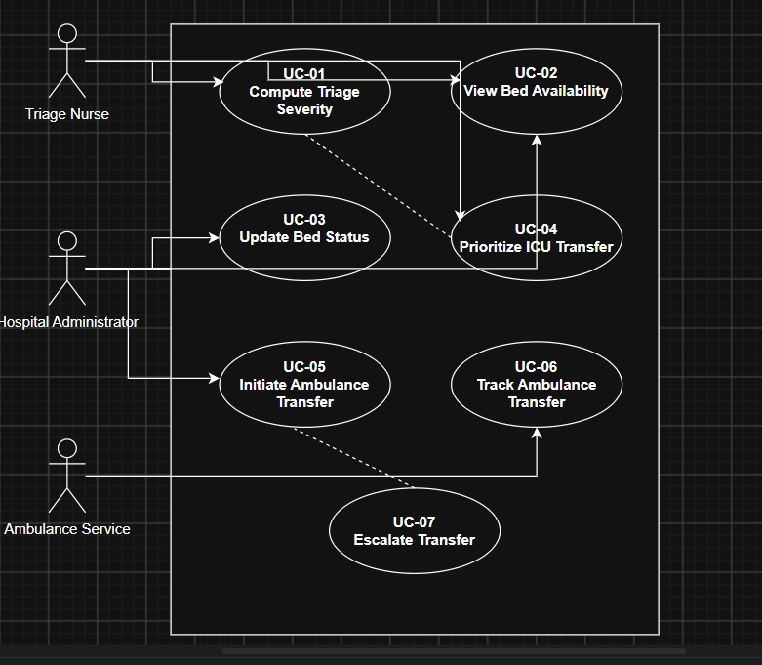
3. Use-Case Flow Specification
Use Case: UC-04 — Prioritize ICU Transfer
Primary Actor: Triage Nurse
Preconditions
The Triage Nurse is authenticated.
The patient's intake information and required vital information are recorded.
Current bed/ICU allocation information is available to the system.
Main Success Scenario
1. Triage Nurse selects the ICU transfer prioritization function.
2. System retrieves the patient's recorded intake vitals.
3. System computes the patient's triage severity score.
4. System checks the current ICU/bed allocation information.
5. System places the patient in the ICU transfer priority queue according to severity.
6. System displays the updated priority order to the Triage Nurse.
7. Use case ends successfully.
Alternate Flow — Missing or Invalid Vital Information
3a. System detects that required vital information is missing or invalid.
3a1. System displays an error message identifying the missing or invalid information.
3a2. System prompts the Triage Nurse to enter or correct the information.
3a3. Triage Nurse provides valid information.
3a4. System recomputes the triage severity score.
3a5. The main flow resumes at Step 4.
Postconditions
The patient's triage severity score has been computed.
The ICU transfer priority queue has been updated.
The Triage Nurse can view the patient's position in the priority queue.

