PC-ASPECTS

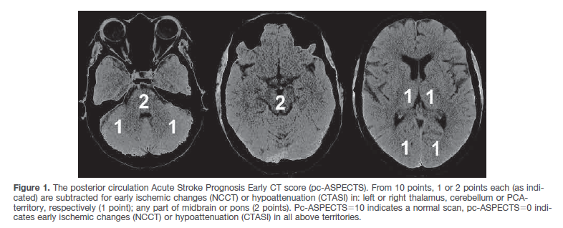

|  |  |  |  |  |
| --- | --- | --- | --- | --- |
| Lobes Atlas | | Volume (MNI) | PCASPECTS |  |
| 17 | cerebellum_L | 102137 | 5 | cerebellumL |
| 18 | cerebellum_R | 103009 | 6 | cerebellumR |
| 19 | pons | 21679 | 7 | pons |
| 20 | medulla | 5672 | 7 | pons |
| 31 | midbrain | 16860 | 8 | midbrain |
| 15 | Thalamus_L | 11100 | 3 | ThalamusL |
| 16 | Thalamus_R | 10077 | 4 | ThalamusR |
|  |  |  |  |  |
| Arterial Atlas | |  |  |  |
| 17 | temporal PCA L (PCATL) | 18945 | 1 | PCAL |
| 18 | temporal PCA R (PCATR) | 18972 | 2 | PCAR |
| 19 | occipital PCA L (PCAOL) | 104223 | 1 | PCAL |
| 20 | occipital PCA R (PCAOR) | 100037 | 2 | PCAR |

