YuvaIntern – Data Science Internship
WEEK 3 TASK
Advanced Data Analysis and Visualization in Logistics
Evidence-based Exploratory Data Analysis using Python
Hypothetical dataset • 12,000 shipment records • Reproducible analysis
Project type | Hypothetical logistics analysis
Records | 12,000 shipments
Regions | North, South, East, West, Central
Transport modes | Road, Rail, Air, Sea
Tools | Python, NumPy, Pandas, Matplotlib

Important note: All observations in this report are simulated for the Week 3 task. They demonstrate an analytical workflow and are not claimed as real company performance.

1. Task Alignment and Analytical Objective
This report addresses the Week 3 requirements by simulating a logistics dataset, conducting exploratory data analysis (EDA), calculating descriptive and correlation statistics, creating multiple visualizations, interpreting the results, and translating the findings into logistics recommendations. The analysis is deliberately evidence-first: every major conclusion is tied to a calculation, grouped result, or visualization.
- Measure delivery reliability using late-delivery and on-time rates.
- Understand the distribution and central tendency of delivery time.
- Identify variables associated with transportation cost.
- Compare transport modes on speed, cost, and reliability.
- Compare regions to identify potential operational bottlenecks.
- Examine the relationship between delivery time and customer satisfaction.

2. Data Simulation and Dataset Design
The task permits a hypothetical logistics dataset. A reproducible dataset of 12,000 shipments was generated using NumPy with random seed 42. The simulation covers five regions and four transport modes. Variables were designed to represent common logistics measures while remaining transparent and reproducible.
Variable | Type | Role in analysis | Example use
shipment_id | Identifier | Record key | Count shipments
region | Categorical | Geographic segment | Regional bottleneck analysis
transport_mode | Categorical | Transport choice | Mode comparison
shipment_volume_kg | Numeric | Load size | Cost relationship
distance_km | Numeric | Route length | Cost driver analysis
transport_cost | Numeric | Cost KPI | Cost comparison
delivery_time_days | Numeric | Service KPI | Distribution and mode analysis
estimated_delivery_days | Numeric | Expected duration | Late flag
late_flag | Binary | Reliability KPI | Late/on-time rate
fuel_cost | Numeric | Cost component | Correlation analysis
customer_satisfaction | Numeric | Customer outcome | Service impact analysis

3. Data Quality and Analytical Preparation
Before analysis, the generated dataset was checked for record count, data types, missing values, and plausible ranges. The simulation creates complete numeric fields, categorical values from predefined lists, and bounded values for delivery time and satisfaction. The following checks are included in the analysis script.
Check | Result | Why it matters
Row count | 12,000 | Confirms expected dataset size
Missing values | 0 | Prevents incomplete records from distorting KPIs
Duplicate shipment IDs | 0 | Protects shipment-level counts
Delivery time minimum | 1.00 days | Checks for impossible negative/zero values
Customer satisfaction range | 1.00–5.00 | Confirms bounded 1–5 scale
Because the dataset is simulated and the quality checks show no missing shipment records or duplicate shipment IDs, no imputation or row deletion was required. This is intentionally reported rather than inventing a cleaning problem that did not occur.

4. KPI Calculations – Concrete Evidence
The following KPIs were calculated directly from the 12,000 records. This section provides the numerical evidence that supports the later visual interpretations.
KPI | Formula / method | Result | Decision use
Late-delivery rate | late_flag mean × 100 | 34.65% | Reliability monitoring
On-time rate | 100 − late rate | 65.35% | Service-level monitoring
Average delivery time | Mean delivery_time_days | 6.74 days | Network performance
Median delivery time | Median delivery_time_days | 6.49 days | Typical shipment experience
Average transport cost | Mean transport_cost | 1837.71 | Cost benchmarking
Total transport cost | Sum transport_cost | 22052564.74 | Overall simulated spend
Example calculation: 4,158 of the 12,000 simulated shipments are late, giving 4,158 ÷ 12,000 × 100 = 34.65%. This makes the headline reliability KPI traceable to the underlying records.
Variable | Minimum | Maximum | Mean | Median | Std. Dev.
Delivery time (days) | 1.00 | 19.13 | 6.74 | 6.49 | 2.17
Transport cost | 150.00 | 15,794.24 | 1,837.71 | 1,458.63 | 1,343.80
Distance (km) | 33.60 | 2,500.00 | 469.64 | 381.00 | 329.45
Shipment volume (kg) | 5.00 | 399.13 | 110.76 | 103.08 | 53.62
The table below expands the EDA with minimum, maximum, mean, median, and standard deviation for the main continuous logistics variables. These statistics provide a numerical view of spread and central tendency before interpreting the visual distributions.
4A. Descriptive Statistics
These statistics show that delivery time ranges from 1.00 to 19.13 days, while transportation cost ranges from 150.00 to 15794.24. The difference between mean and median delivery time (6.74 vs 6.49 days) supports the distribution analysis that follows.

5. Distribution and Central Tendency
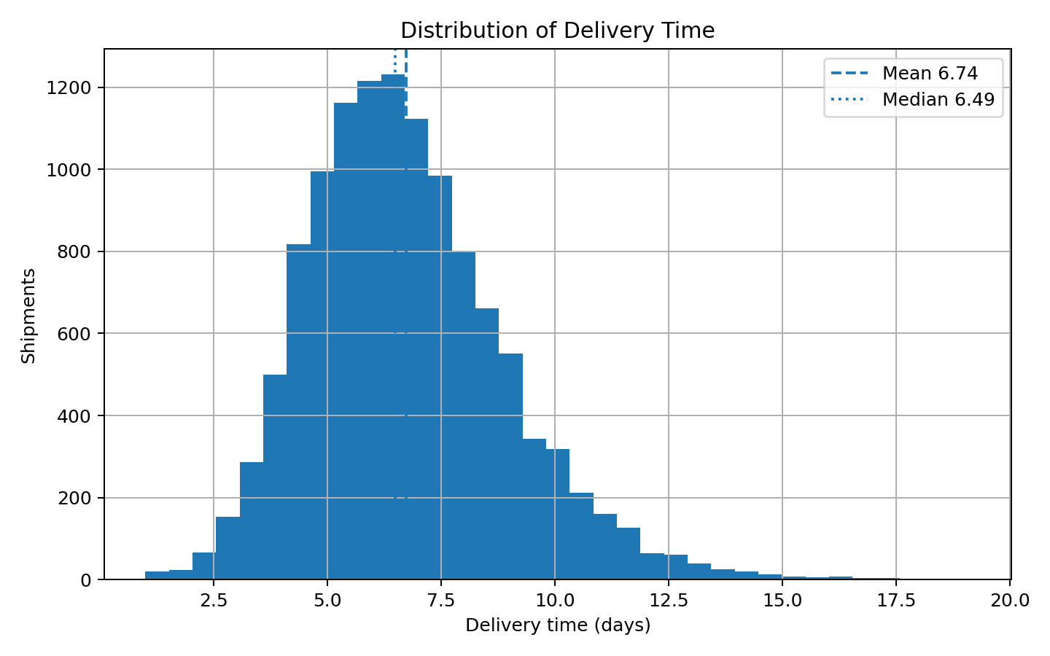
Figure 1. Delivery-time distribution.
The distribution has a mean of 6.74 days and median of 6.49 days. The mean is 0.24 days higher than the median, indicating that slower shipments pull the average upward. Therefore, a manager should monitor both typical performance (median) and the slower tail rather than relying on a single average.

6. Correlation Analysis
Correlation was used as an exploratory screening technique to identify linear associations. It does not establish causation.
Variable | r with cost | Strength/direction | Analytical implication
Distance | 0.78 | Strong positive | Longer routes are associated with higher simulated cost
Shipment volume | -0.08 | Very weak negative | Volume alone is not a meaningful linear cost driver here
Delivery time | 0.27 | Positive | Longer delivery is associated with higher cost
Fuel cost | 0.93 | Positive | Fuel is associated with total transport cost
The strongest relationship in this analysis is distance versus transport cost (r = 0.78). Importantly, shipment volume has r = -0.08, which is effectively a very weak negative association. This corrects the common assumption that every plausible business variable must appear as a strong positive driver.

7. Cost Driver Visualization
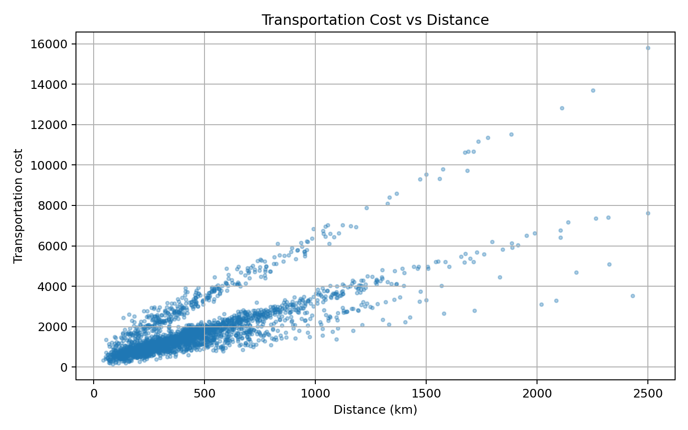
Figure 2. Transportation cost versus distance.
The scatter plot provides visual evidence for the correlation of r = 0.78. Costs generally rise as distance increases, but the spread around similar distances shows that route length is not the only factor. Transport mode, load, and other operational variables can create additional variation.

8. Transport Mode Comparison
This comparison moves from network-level averages to operational segments. It shows how different transport choices can produce different speed, cost, and reliability profiles.
Mode | Shipments | Avg delivery | Avg cost | Late rate | Decision interpretation
Air | 1839 | 5.24 d | 3358.11 | 34.58% | Compare against service requirement
Rail | 2065 | 7.36 d | 1330.21 | 33.90% | Compare against service requirement
Road | 6848 | 6.47 d | 1727.60 | 34.89% | Compare against service requirement
Sea | 1248 | 9.35 d | 1041.26 | 34.70% | Compare against service requirement
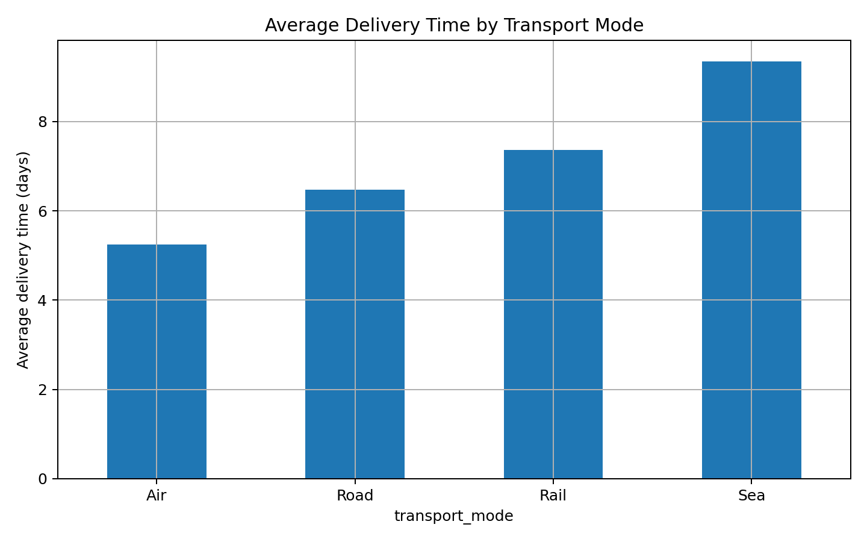
Figure 3. Average delivery time by transport mode.
Air is the fastest mode on average, Sea is the slowest, Sea has the lowest average cost, and Rail has the lowest simulated late rate. The practical lesson is that the cheapest mode is not automatically the best mode: mode selection should balance cost, speed, and reliability against the shipment's service requirement.

9. Regional Bottleneck Analysis
Region | Shipments | Avg delivery | Avg cost | Late rate | Priority
North | 2669 | 6.73 d | 1784.32 | 35.44% | Investigate first
Central | 2387 | 6.67 d | 1826.21 | 34.77% | Monitor
South | 2449 | 6.55 d | 1881.77 | 34.75% | Monitor
East | 2171 | 7.12 d | 1873.99 | 34.32% | Monitor
West | 2324 | 6.64 d | 1830.53 | 33.82% | Monitor
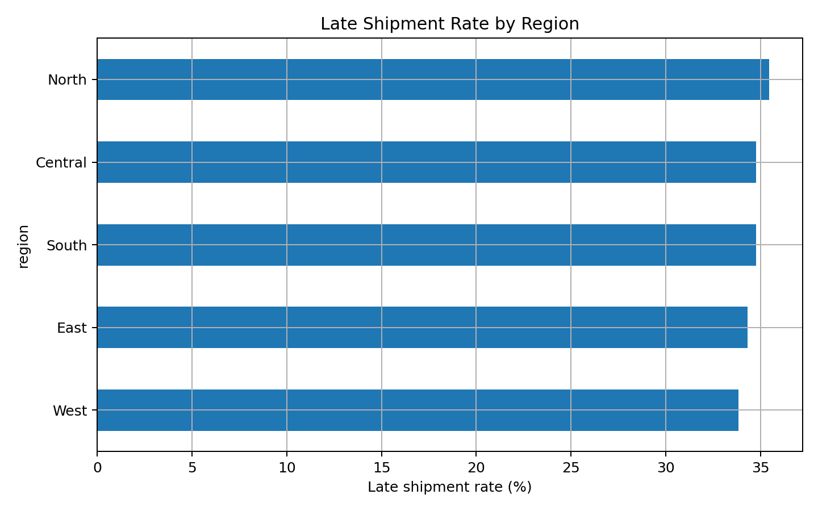
Figure 4. Late shipment rate by region.
North has the highest simulated late rate at 35.44%. This does not prove that the region is operationally poor; it identifies where deeper investigation should begin. A real-world follow-up would break the region down by route, carrier, depot, distance, traffic, handoff count, and shipment type.

10. Customer Impact Analysis
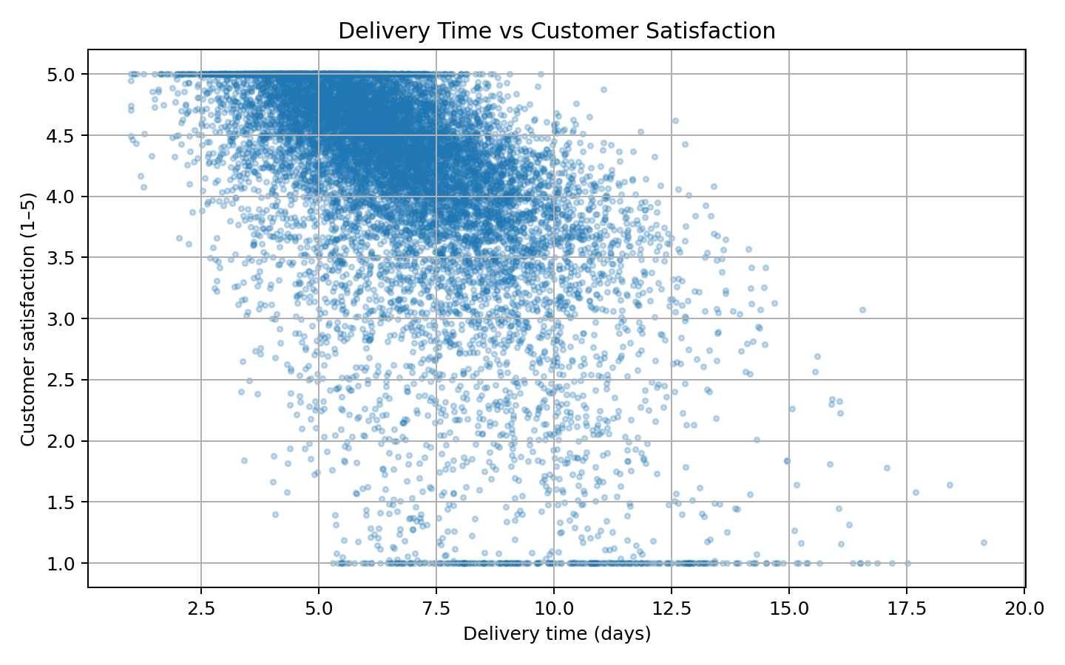
Figure 5. Delivery time versus customer satisfaction.
Delivery time and customer satisfaction have a correlation of r = -0.57, a moderate negative association in this simulation. As delivery time increases, satisfaction tends to decline. This connects an operational KPI to a customer outcome and demonstrates why service metrics should not be analyzed independently.

11. Integrated Findings: Calculation → Visualization → Decision
Evidence | What it shows | Logistics insight | Action
Late rate = 34.65% | Reliability gap exists | On-time performance needs monitoring | Track late rate by region/mode
Mean 6.74 d vs median 6.49 d | Slower tail affects average | Average alone can hide slow shipments | Add median/percentile KPIs
Distance-cost r = 0.78 | Strong cost relationship | Longer routes are expensive | Review route/network design
Mode comparison | Performance varies by mode | Cost, speed and reliability trade off | Use multi-KPI mode selection
North late rate highest | Regional concentration | Potential bottleneck area | Perform route/carrier root-cause analysis
Delivery-satisfaction r = -0.57 | Service affects customer outcome | Delays have customer implications | Prioritize reliability improvements

12. Recommendations
- Create a logistics performance dashboard containing late rate, on-time rate, mean and median delivery time, cost, and customer satisfaction.
- Investigate the highest-late-rate region at route and carrier level before changing network policy.
- Use distance as a baseline explanatory variable in future transportation-cost models.
- Do not treat shipment volume as a major cost driver based on this simulation; its correlation with cost is only -0.08.
- Use a weighted decision framework for transport-mode selection so that speed, cost, and reliability are considered together.
- Monitor the upper tail of delivery time because slower shipments can materially affect the mean and customer experience.
- Validate every simulated finding with real operational data before implementing business decisions.

13. Python Implementation
# Core KPI calculations
late_rate = df["late_flag"].mean() * 100
on_time_rate = 100 - late_rate
avg_delivery = df["delivery_time_days"].mean()
median_delivery = df["delivery_time_days"].median()
avg_cost = df["transport_cost"].mean()

# Data-quality checks
print(df.shape)
print(df.isna().sum().sum())
print(df["shipment_id"].duplicated().sum())

# Correlation matrix
corr = df[[
"shipment_volume_kg", "distance_km", "transport_cost",
"delivery_time_days", "fuel_cost", "customer_satisfaction"
]].corr()

# Segment performance
mode_summary = df.groupby("transport_mode").agg(
shipments=("shipment_id", "count"),
avg_delivery_days=("delivery_time_days", "mean"),
avg_cost=("transport_cost", "mean"),
late_rate=("late_flag", "mean")
)
mode_summary["late_rate"] *= 100

# Visualization example
plt.scatter(df["distance_km"], df["transport_cost"], alpha=0.35)
plt.xlabel("Distance (km)")
plt.ylabel("Transportation cost")
plt.title("Transportation Cost vs Distance")
plt.show()

14. Limitations and Reproducibility
The dataset is hypothetical, as permitted by the task. Therefore, the numerical findings are demonstrations of analytical technique rather than measurements of a real logistics company. The simulation does not model traffic, weather, warehouse capacity, inventory availability, holidays, carrier-specific service levels, or changing fuel prices.
Reproducibility is supported by the fixed NumPy random seed (42), the accompanying CSV dataset, and the Python analysis script. Running the same script against the same dataset regenerates the reported calculations and visualizations.

15. Conclusion
The Week 3 analysis demonstrates an end-to-end EDA workflow on 12,000 simulated logistics shipments. The analysis produced concrete evidence: 34.65% late deliveries, 6.74 days average delivery time, 6.49 days median delivery time, and 1837.71 average transport cost. Distance had a correlation of 0.78 with transport cost, while delivery time had a correlation of -0.57 with customer satisfaction.
The visualizations then translated these calculations into operational views: distribution analysis highlighted the slower tail; mode analysis exposed speed/cost trade-offs; the distance-cost scatter plot identified a major cost relationship; regional analysis highlighted a location for investigation; and the customer-impact plot connected service performance with satisfaction.
Overall, the report goes beyond describing what Python could do: it executes the analysis, reports actual numerical results, embeds the resulting figures, explains what each result means, and connects findings to practical logistics decisions.

