YuvaIntern – Data Science Internship
WEEK 4 TASK
Predictive Modeling and Optimization in Logistics Systems
Evidence-based delivery-time forecasting using Python
Simulated Logistics Dataset • 12,000 Shipment Records • Reproducible Analysis

Important note: The dataset is simulated for the internship task. Model metrics and recommendations demonstrate the analytical workflow and are not claimed as real company performance.

1. Executive Summary
This Week 4 project develops a predictive model for logistics delivery time. Using 12,000 simulated shipment records, three regression approaches—Linear Regression, Decision Tree, and Random Forest—were trained and evaluated using an 80/20 train-test split. MAE, RMSE, and R² were used to compare predictive accuracy, and the strongest model was tested with five-fold cross-validation. The analysis then converts predictive results into an operational prioritization strategy for potentially delayed shipments.
The best test-set model was Linear Regression, with MAE 0.8436 days, RMSE 1.0705 days, and R² 0.7600. Five-fold cross-validation produced mean MAE 0.8440, mean RMSE 1.0700, and mean R² 0.7575. These values provide concrete evidence for model selection rather than relying on a qualitative claim.

2. Problem Definition
Logistics teams need an early estimate of delivery duration so that potentially slow shipments can be reviewed before service failure occurs. The prediction problem is therefore defined as a supervised regression task: predict actual delivery time in days from shipment, route, transport, regional, fuel, and estimated-duration variables.
Item | Definition | Purpose
Target | delivery_time_days | Continuous value to forecast
Prediction type | Regression | Delivery time is numeric
Training data | 80% of records | Fit models
Testing data | 20% of records | Unseen evaluation
Random state | 42 | Reproducibility

3. Dataset and Features
The Week 4 analysis uses the same simulated logistics dataset developed for Week 3 so that the project forms a coherent analytical progression. The dataset contains 12,000 shipments and the prediction target is actual delivery time.
Feature | Type | Why included
shipment_volume_kg | Numeric | Represents load size
distance_km | Numeric | Captures route length
transport_mode | Categorical | Captures transport choice
region | Categorical | Captures geographic differences
fuel_cost | Numeric | Represents a transport cost component
estimated_delivery_days | Numeric | Represents expected duration available before actual delivery

4. Data Preparation
Numeric variables are median-imputed when necessary and categorical variables are most-frequent imputed followed by one-hot encoding. These transformations are placed inside a scikit-learn Pipeline/ColumnTransformer so that preprocessing is learned from the training data and applied consistently to the test data. This prevents preprocessing leakage.

5. Model Selection
Three models were selected to provide a meaningful progression from a simple baseline to non-linear and ensemble approaches. Linear Regression provides an interpretable baseline. A Decision Tree can capture non-linear patterns. Random Forest combines many trees to reduce the instability of a single tree and can model more complex relationships.

6. Model Training and Test Results
Model | MAE (days) | RMSE (days) | R²
Linear Regression | 0.8436 | 1.0705 | 0.7600
Random Forest | 0.8681 | 1.0975 | 0.7477
Decision Tree | 0.9111 | 1.1548 | 0.7206
On the held-out test set, Linear Regression achieved the lowest RMSE at 1.0705 days. Its MAE of 0.8436 days means the average absolute prediction error was approximately 20.25 hours. The R² value of 0.7600 indicates how much variance in the test-set target is explained by the model under this simulated setup.
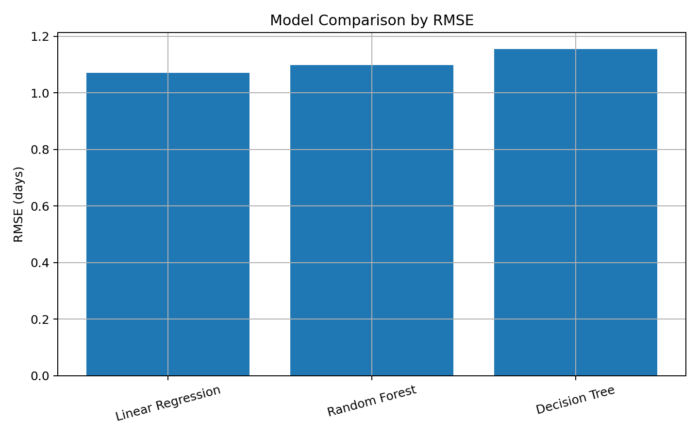
Figure 1. Model comparison by RMSE. Lower RMSE indicates smaller prediction error.

7. Prediction Accuracy Visualization
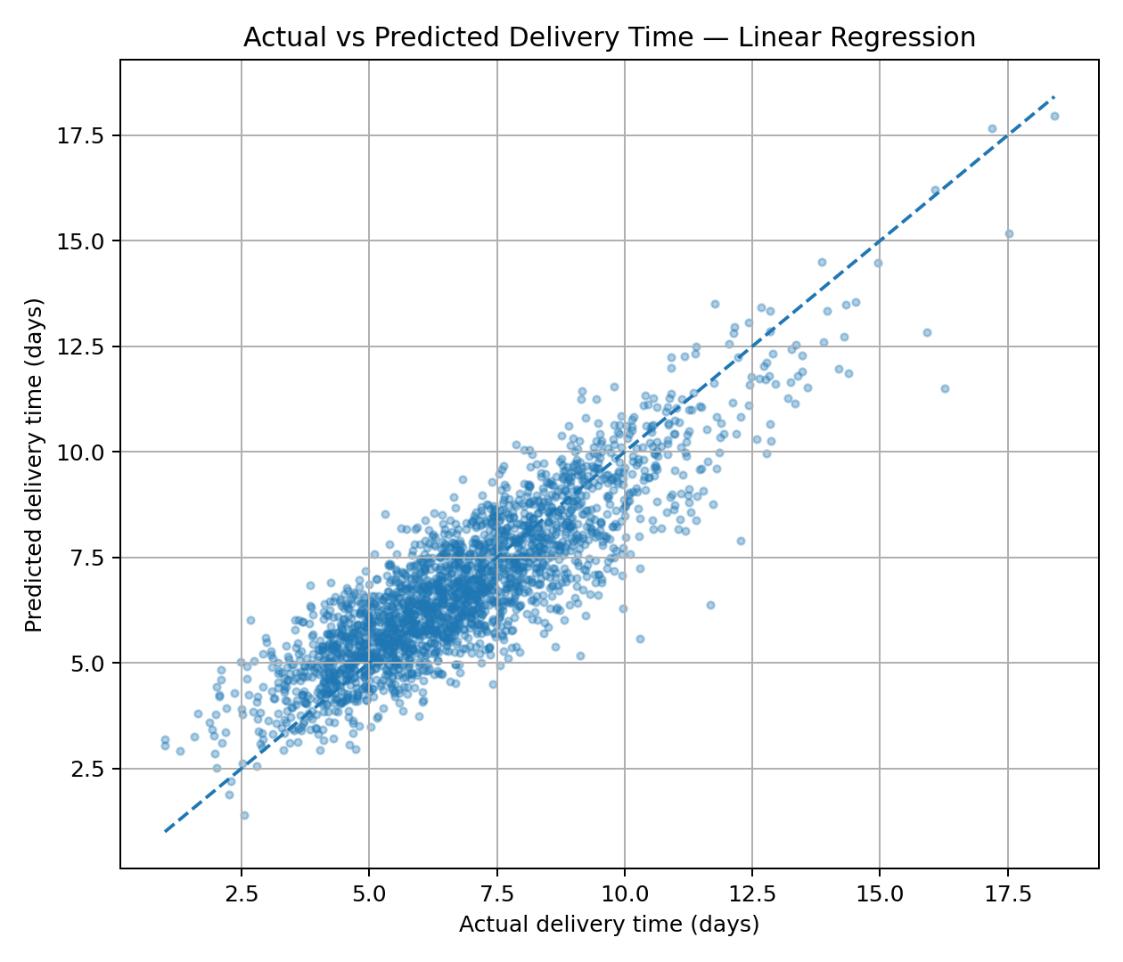
Figure 2. Actual versus predicted delivery time for the selected model. Points closer to the diagonal indicate smaller prediction error.
The plot is useful because a single accuracy metric can hide systematic errors. A model that performs well should produce points clustered around the diagonal rather than showing a strong curved or fan-shaped pattern.

8. Cross-Validation and Validation Strategy
The selected model was evaluated with five-fold cross-validation using shuffled folds and random state 42. Across the five folds, mean MAE was 0.8440 ± 0.0164 days, mean RMSE was 1.0700 ± 0.0201 days, and mean R² was 0.7575 ± 0.0136. Reporting the mean and standard deviation shows both typical performance and variation across folds.

9. Feature Importance
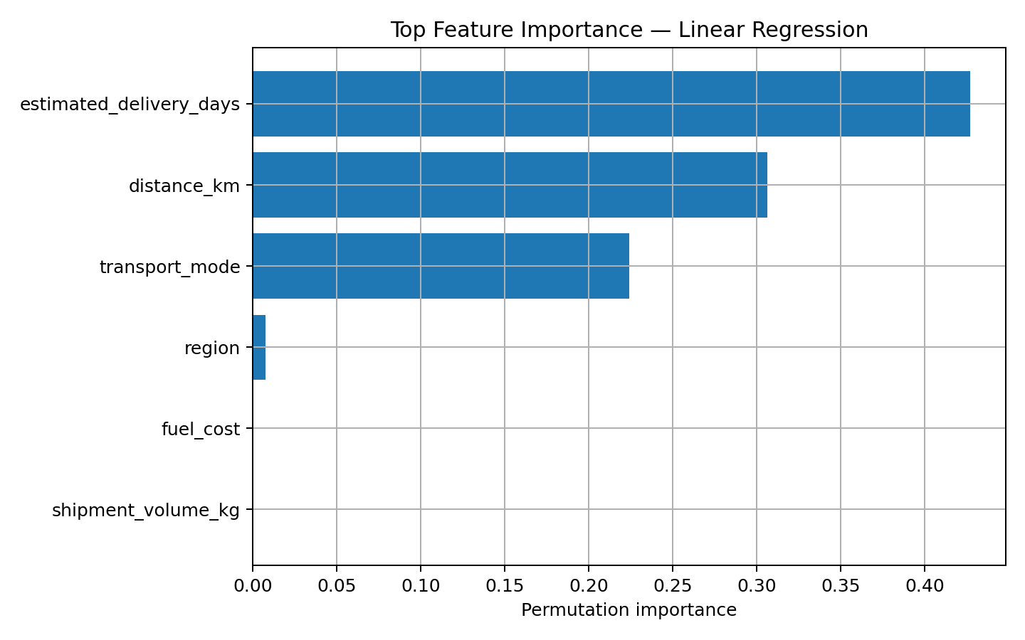
Figure 3. Permutation feature importance for the selected model. Higher values indicate a larger increase in prediction error when that feature is shuffled.
The three highest permutation-importance features in this run were estimated_delivery_days, distance_km, transport_mode. Feature importance should be interpreted as predictive contribution, not proof of causation. For example, a feature can be useful for prediction because it acts as a proxy for another operational factor.

10. Residual Analysis
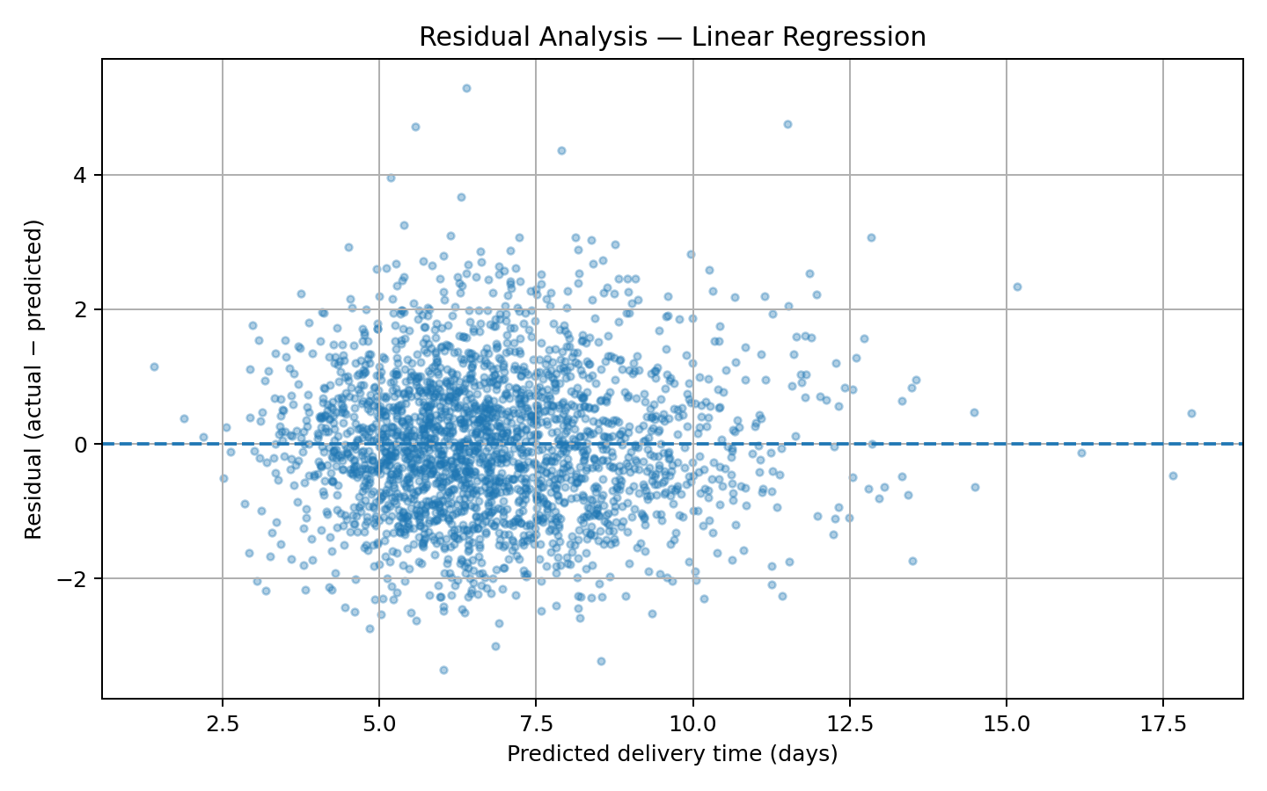
Figure 4. Residuals versus predicted delivery time. Residuals are actual minus predicted values.
Residual analysis helps identify whether the model systematically under-predicts or over-predicts certain ranges of delivery time. Large or structured residual patterns would indicate opportunities for further feature engineering or model refinement.

11. Optimization Strategy
The predictive model is converted into an operational early-warning mechanism. Shipments in the top 25% of predicted delivery times are flagged for proactive review. In the test set, the threshold is 7.87 days and 25.00% of test shipments are flagged. This does not claim that every flagged shipment will be late; it identifies shipments with comparatively high predicted delivery duration.
- Review route distance and alternative routing for high-risk shipments.
- Check transport-mode suitability against the required service level.
- Prioritize capacity or carrier review for high-risk shipments before dispatch.
- Use predicted delivery time to communicate realistic expectations to customers.
- Re-score shipments when new operational information becomes available.
- Measure the actual outcome after intervention so the optimization policy can be validated.

12. Decision Scenario
Using the 75th-percentile prediction threshold of 7.87 days creates a simple prioritization rule. The flagged group represents 25.00% of the test set. Within this high-risk group, 22.00% had actual delivery time greater than their estimated delivery time, compared with 34.92% across the full test set under the same definition. This demonstrates how predictions can be used to focus operational attention, while also showing why the rule should be validated with real outcomes before deployment.

13. Python Implementation
# Split
X_train, X_test, y_train, y_test = train_test_split(
X, y, test_size=0.20, random_state=42
)

# Train and evaluate
pipe = Pipeline([("prep", preprocess), ("model", RandomForestRegressor(...))])
pipe.fit(X_train, y_train)
pred = pipe.predict(X_test)

mae = mean_absolute_error(y_test, pred)
rmse = np.sqrt(mean_squared_error(y_test, pred))
r2 = r2_score(y_test, pred)

# 5-fold validation
kf = KFold(n_splits=5, shuffle=True, random_state=42)
cv_mae = -cross_val_score(pipe, X, y, cv=kf,
scoring="neg_mean_absolute_error")

14. Recommendations
- Deploy the model initially as a decision-support tool rather than an automatic dispatch decision-maker.
- Use predicted delivery time to create an early-warning queue for operational teams.
- Combine prediction with business rules such as customer priority, promised date, and shipment value.
- Review route and transport-mode choices for high-risk shipments before dispatch.
- Track model error by region and transport mode to detect performance drift.
- Retrain and validate the model periodically when real operational data becomes available.
- Test any intervention with before/after or controlled comparisons to verify that it actually reduces delays.

15. Limitations
The data is simulated and therefore cannot establish real-world model performance. The model also does not include potentially important real logistics variables such as traffic, weather, warehouse congestion, carrier-specific reliability, holidays, customs delays, or live route conditions. Correlation and feature importance do not establish causation. The optimization rule is a prioritization concept and should be validated experimentally before operational deployment.

16. Conclusion
This project completes the Week 4 predictive modeling workflow from problem definition through model evaluation and optimization. Three models were compared using actual test-set metrics, with Linear Regression selected as the strongest model by RMSE. The selected model achieved MAE 0.8436 days, RMSE 1.0705 days, and R² 0.7600. Five-fold cross-validation was used to assess stability, while prediction, feature-importance, and residual visualizations provided additional evidence.
The key business value is not simply predicting a number. The prediction can be used to prioritize shipments for proactive review, route or mode assessment, and customer communication. Because the underlying data is simulated, the next step in a real deployment would be to validate the model on historical operational data and measure whether interventions based on the predictions actually improve service performance.

