**Anisble Server**

In this /etc/ansible/hosts

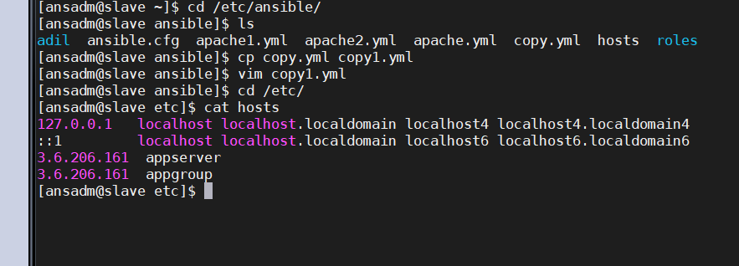

3.6.206.161 is Ansible client

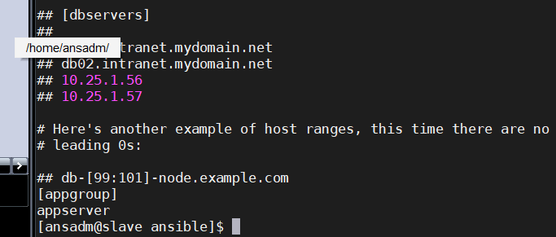

By running ansible appserver –m ping

To check connection

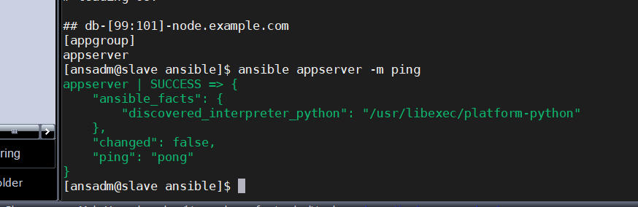

My Jenkins is install on ansible Client

Now install plugin Publish over SSH

Now manage Jenkins 🡪 configuration 🡪 publish over SSH 🡪 SSH server

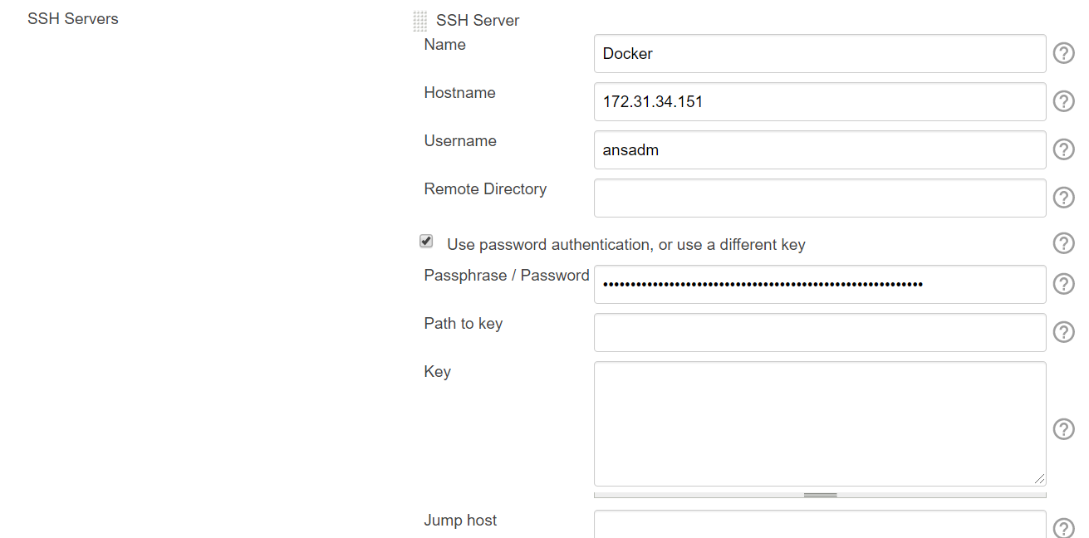

This 172.31.34.151 is private IP of Ansible Server

Now test it

In Ansible server

In /etc/ansible

Write playbook

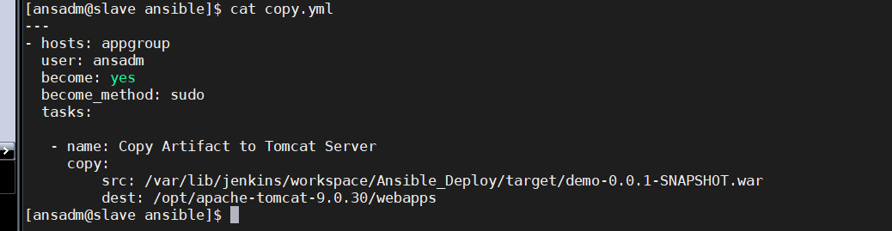

First we have to copy war/jar file to src path

i.e; from /var/lib/Jenkins/workspace/Ansible_Deploy/target/*.war(this is in jenkins server) to our src path in ansible server

using this

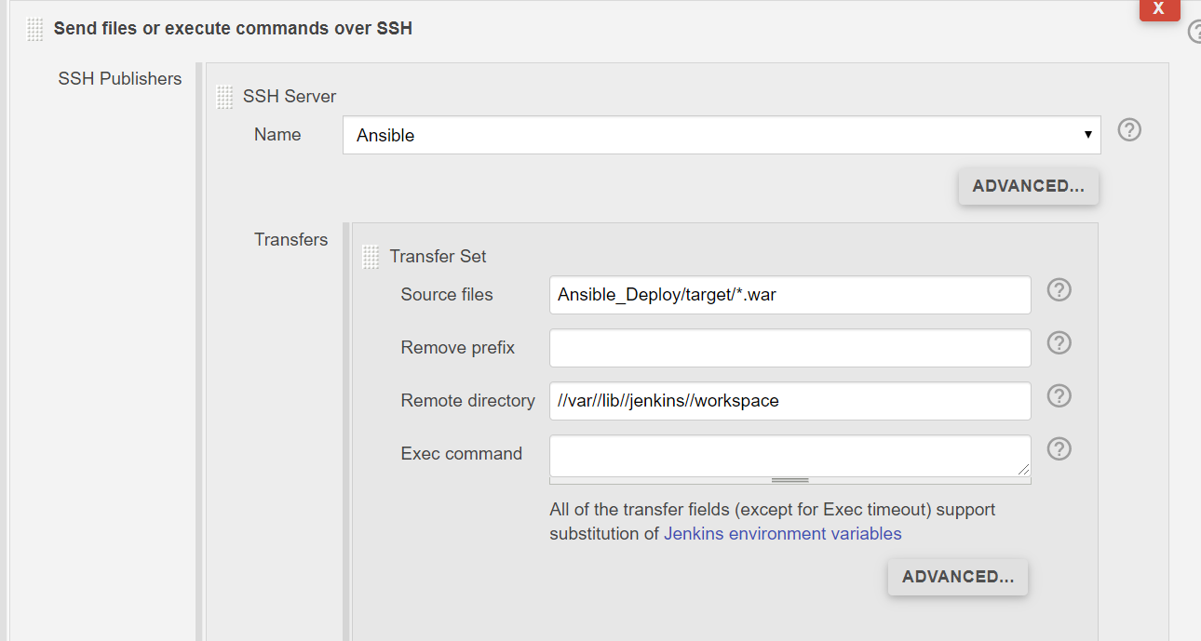

In remote directory this is ansible server path

And source files is Jenkins server path

When copied to ansible server path we use // instead of /

Now we copy war/jar file from Jenkins server to src path in ansible server.

Now to run our playbook

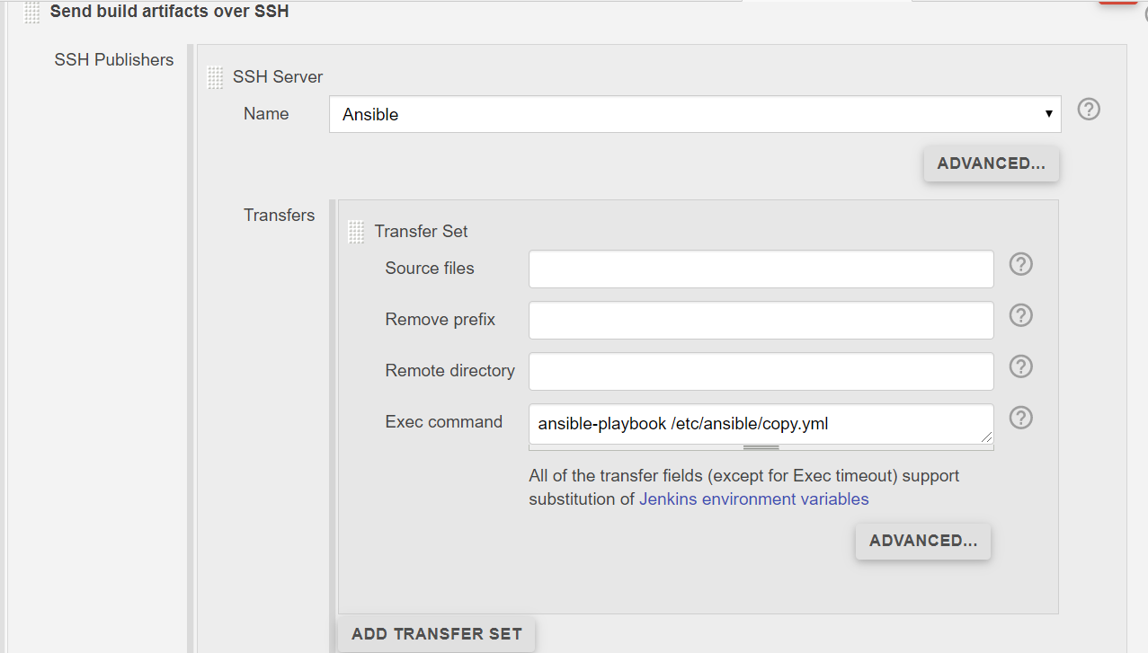

Specify the path of playbook.

Now run Jenkins job

In tomcat there is no war/jar file

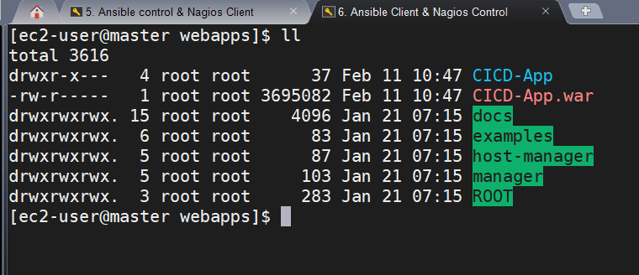

Jenkins build result

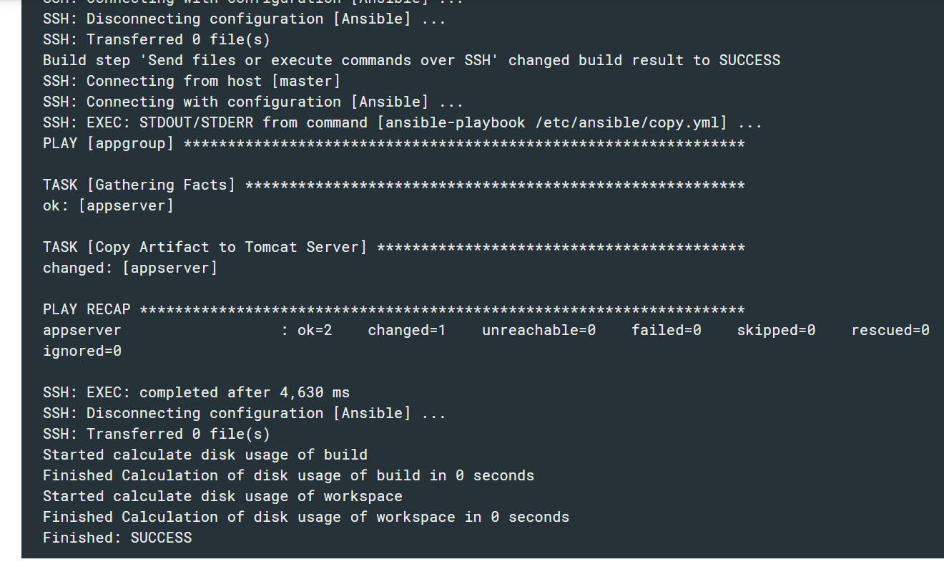

Lets see war/jar file is copied to tomcat or not

Yes it is copied using playbook

