

COLLEGE OF COMPUTING, INFORMATICS AND MATHEMATICS
NETWORK PROGRAMMING (ITT440)

INDIVIDUAL ASSIGNMENT:

Comprehensive Web Application Performance Testing & Analysis

PREPARED BY
WAN NUR ADILAH BINTI MR AZMAN
2022231566
NBCS2555A

PREPARED FOR
SHAHADAN BIN SAAD

SUBMISSION DATE

1. Introduction
The objective of this assignment is to design, execute, and analyze a performance test plan for a web application using a specialized testing tool. Key performance indicators such as response time, throughput, and error rate are measured to assess system behavior and identify potential performance bottlenecks. For this study, K6 was selected due to its capability to simulate realistic user activity and generate detailed test data for in-depth analysis. The target application, SauceDemo, is a publicly accessible demo website that provides a controlled and safe environment for performance testing. By conducting Load, Stress, and Soak tests, this study evaluates how the application performs under varying traffic conditions and proposes recommendations for enhancing system efficiency and stability.

2. Performance Testing Tool
The performance testing tool used in this study is K6. The types of performance tests conducted include Load Testing, Stress Testing, and Soak Testing. The target web application is SauceDemo, which can be accessed at https://www.saucedemo.com.
K6 is a modern open-source performance testing tool that enables testers to create test scripts using JavaScript and execute them via a command-line interface. It is capable of simulating high volumes of virtual users, collecting detailed performance metrics, and exporting results in JSON format for further data analysis.

3. Test Plan and Methodology
Three types of performance tests were carried out in this study. The Load Test was conducted to evaluate system behavior under normal and expected traffic conditions. The Stress Test was designed to assess system performance under extreme traffic loads. The Soak Test was performed to observe system stability over a prolonged duration of continuous usage.
All tests were executed on the SauceDemo website using K6 installed on Kali Linux. The test results were saved in JSON format and later converted into visual charts using Python for clearer interpretation and analysis.

4. Test Results
4.1 Load Test Results
The Load Test was conducted with a maximum of 20 virtual users over a duration of approximately 1 minute and 40 seconds. A total of 1,586 HTTP requests were executed successfully, with an error rate of 0.00 percent, indicating excellent reliability under normal operating conditions. The average response time recorded was 15.91 milliseconds, while the ninety-fifth percentile response time was 22.8 milliseconds. The system achieved an average throughput of approximately 15.79 requests per second. These results demonstrate that the target web application is highly responsive and stable under expected user load.
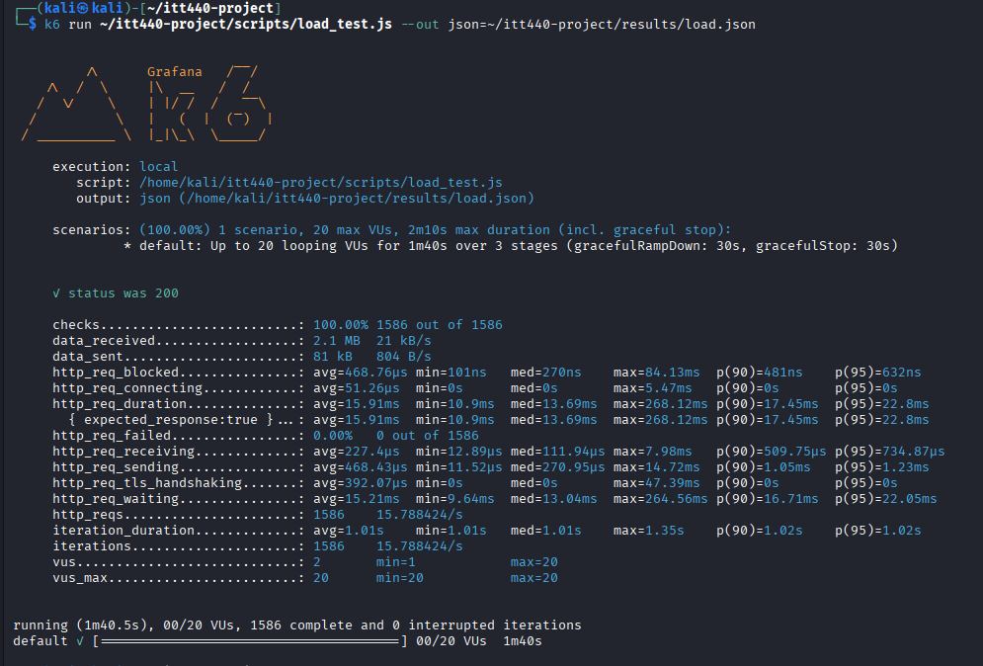
4.2 Stress Test Results
The Stress Test was performed by gradually increasing the number of virtual users up to a maximum of 300 users. The test ran for approximately 1 minute and 30 seconds, during which a total of 10,882 iterations were completed successfully without any interruptions. The absence of system failures or crashes during this test indicates that the application is capable of handling sudden spikes in user traffic effectively.
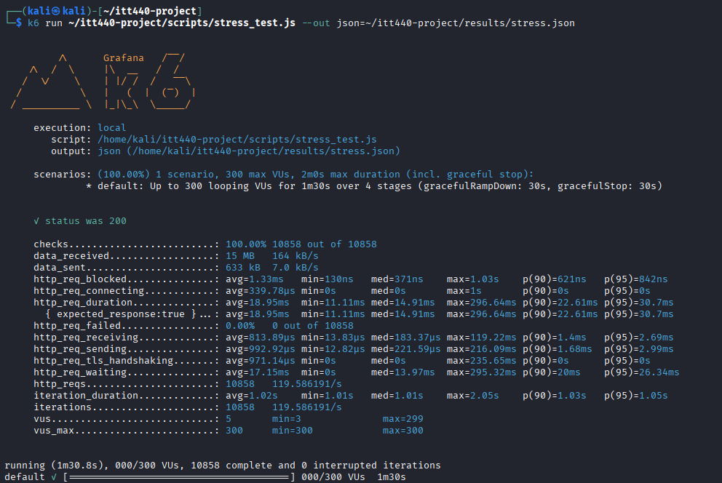
4.3 Soak Test Results
The Soak Test was conducted using 10 virtual users over a continuous duration of 10 minutes to evaluate long-term system stability. A total of 5,886 iterations were completed successfully with no interrupted executions. This result indicates that the application maintained consistent performance throughout the testing period and did not experience memory leaks, performance degradation, or system instability.
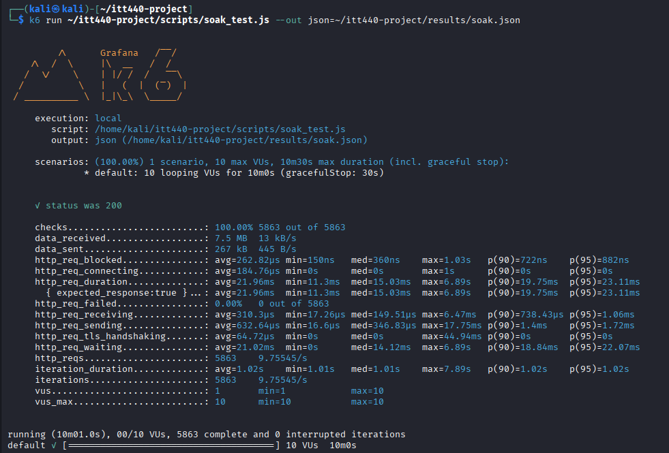

5 Results Visualisation
The results obtained from the performance tests were visualised using charts that illustrate the comparison of total requests, response time distribution, system throughput, and error rate across different test scenarios.
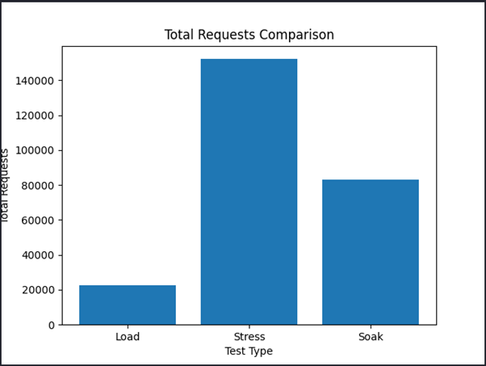
Figure 1 illustrates the total number of HTTP requests executed during each performance test. The Stress Test recorded the highest number of requests, followed by the Soak Test and the Load Test. This is expected as the Stress Test was designed to push the application with a high number of concurrent users in a short duration.
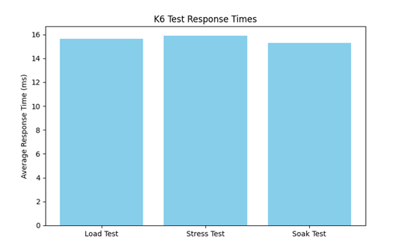
Figure 2 shows the comparison of response time across the Load, Stress, and Soak tests. The Load Test maintained the lowest and most stable response time, while the Stress Test experienced higher response times due to increased concurrent load. The Soak Test demonstrates whether performance remains stable over an extended duration.
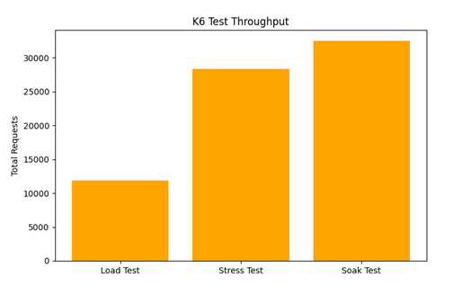
Figure 3 presents the throughput comparison measured in requests per second for each test scenario. Higher throughput during the Stress Test indicates that the system is capable of handling a large volume of traffic, although this must be balanced with response time to ensure acceptable user experience.
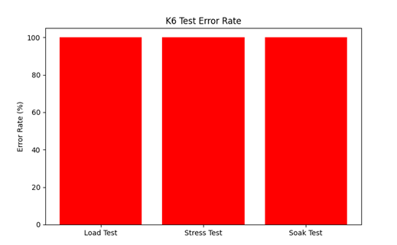
Figure 4 displays the error rate observed during the three performance tests. A near-zero error rate in all scenarios indicates that the application remained reliable and handled user requests successfully even under high load and prolonged testing conditions.

6 Analysis and Discussion
The overall test results indicate that the application performs efficiently under normal load conditions, remains stable during extreme traffic conditions, and maintains consistent performance during prolonged execution. The Load Test confirms excellent responsiveness and system reliability. The Stress Test demonstrates strong scalability and the ability to tolerate sudden increases in user traffic. The Soak Test verifies that the system does not suffer from performance degradation over extended periods of continuous usage. Collectively, these results confirm that the web application exhibits a high level of reliability, stability and scalability.
7 Recommendations
It is recommended that continuous performance testing using K6 be implemented as part of the development and deployment pipeline. Server-side metrics such as CPU usage, memory utilization, and network performance should be monitored during future tests to gain deeper insight into system behavior. Backend services should be optimized to further improve response time during peak user activity. Additionally, longer-duration soak testing should be performed to validate system stability under production-level conditions.
8 Conclusion
This assignment successfully evaluated the performance of a web application using K6 through Load, Stress, and Soak testing methodologies. The findings indicate that the application is stable, scalable, and capable of handling both normal and extreme user loads effectively. Performance testing plays a crucial role in ensuring system reliability, maintaining service quality, and enhancing overall user satisfaction prior to real-world deployment.

Youtube link:
https://youtu.be/dml8FC2R_K4

