**Invention Disclosure Form**

**Section A: Applicant(s)/Inventor(s) Details**

1. **APPLICANT DETAILS**

| Name: Adilakshmi Tanneru | Mobile No. 8639086619 |
| --- | --- |
| Email: 2303a51l79@sru.edu.in | Nationality: Indian |

Address: Ananthasagar, Hasanparthy (PO), Warangal-506371

**2. INVENTOR DETAILS**

1. **First Inventor**

| Name: Dr. Mohammed Ali Shaik | Mobile No. 9000498496 |
| --- | --- |
| Email: niharali@gmail.com | A signature on a piece of paper  AI-generated content may be incorrect.Nationality: Indian |

Address: SR University,WGL Sign_________________________

1. **Second Inventor**

| Name: Adilakshmi Tanneru | Mobile No. 8639086619 |
| --- | --- |
| Email: 2303a51l79@sru.edu.in | Nationality: Indian |

Address: SR University,WGL Sign______________

**IP support services you wish for us to fulfill (Please specify the services needed in the space provided for one of multiple choices or simply write SELECT in block letters next to the service needed):- (Leave this, don’t fill)**

* Patentability Search _______________________________________________________
* **Provisional Patent Application – Select**
* Non-Provisional Patent Application __________________________________________

**3. Point of contact (POC) between Inventors and IP Curate Labs IPR Research Team:**

**1st Point Of Contact (Leave this as it is)**

**Name:** Dr. Sk. Vaseem Akram **Calling:** 9010748746

**WhatsApp:** 9010748746  **Email:** patent@sru.edu.in

**4. Should the first POC be unavailable, we would feel comfortable knowing whom next to talk to:**

**2nd Point Of Contact :-**

**Name:** Dr. Sk. Vaseem Akram **Calling:** 9010748746

**WhatsApp:** 9010748746 **Email:** shaik.vaseemakram@sru.edu.in

**Section B: Your Invention**

**INVENTION TITLE: Online Charity Donation System**

**2. Problem statement.**

Today, everyone wants to donate money to social causes and poor individuals. But it is a scary process that frustrates people. Traditional charity organizations depend primarily on money or offline methods, which are time-consuming and not transparent. These issues can discourage people from donating money, as they do not know where the money goes.

The aim of the Online Charity Donation System is to resolve such problems by creating a simple, secure, and easy-to-use web-based platform. It allows users to register, login, donate to their preferred causes, and track their donation history.

**3. Existing solution**

There are a range of online sites like Give India, Ketto, Milaap, and GoFundMe that offer digital donation facilities. These sites allow users to make donations towards various causes through their websites. However, there are constraints to most of these websites.

They barely offer a centralized dashboard that would allow donors to view all their past donations, favorite charities, and tax savings. Without a personal profile, donors will not be able to track their advancement over a period, and this could reduce loyalty and engagement.

After giving a donation, users are without any follow-up notifications, appreciation messages, or progress reports.

**4. Abstract with keywords**

Online Charity Donation System is an internet application developed in AngularJS as the front-end and Java Servlets with MySQL as the back-end. It provides a secure, user-friendly donor interface for giving to causes and receiving instant confirmations and donation receipts. With optimized user interfaces, secure encrypted transaction processing, and online monitoring, the system can support increased donor confidence and participation levels.

**Keywords:** Donation Portal, AngularJS, MySQL, Secure Transactions, Nonprofit Support, Online Donations, Donation History, Responsive Design.

**5. Preamble**

This system responds to the increasing demand for open and effective digital giving.

It's designed in such a manner that it can expand over the years and accommodate more users and charities as and when necessary.

It features a clean and easy-to-use donor dashboard, as well as an admin dashboard for monitoring users and donation activity. By making the process digital and structured, this system promotes trust and transparency Reports all donations done in the past by a user while making the donation experience easier.

**6. Methodology**

1. Users register and login to monitor their donations.
2. Enables users to choose a charity and make a donation.
3. Reports all donations done in the past by a user.
4. Various secure payment methods are available on the platform, including UPI, debit/credit cards, or PayPal, allowing for convenience and security when giving.
5. Upon successful donation, donors are sent an email containing a receipt of their donation, which gives them a document for their records.
6. Admins get to access a management dashboard to confirm and refresh charity listings, so that donors only get to see valid causes.
7. A page for users to send a message to the organization inquiring about something.

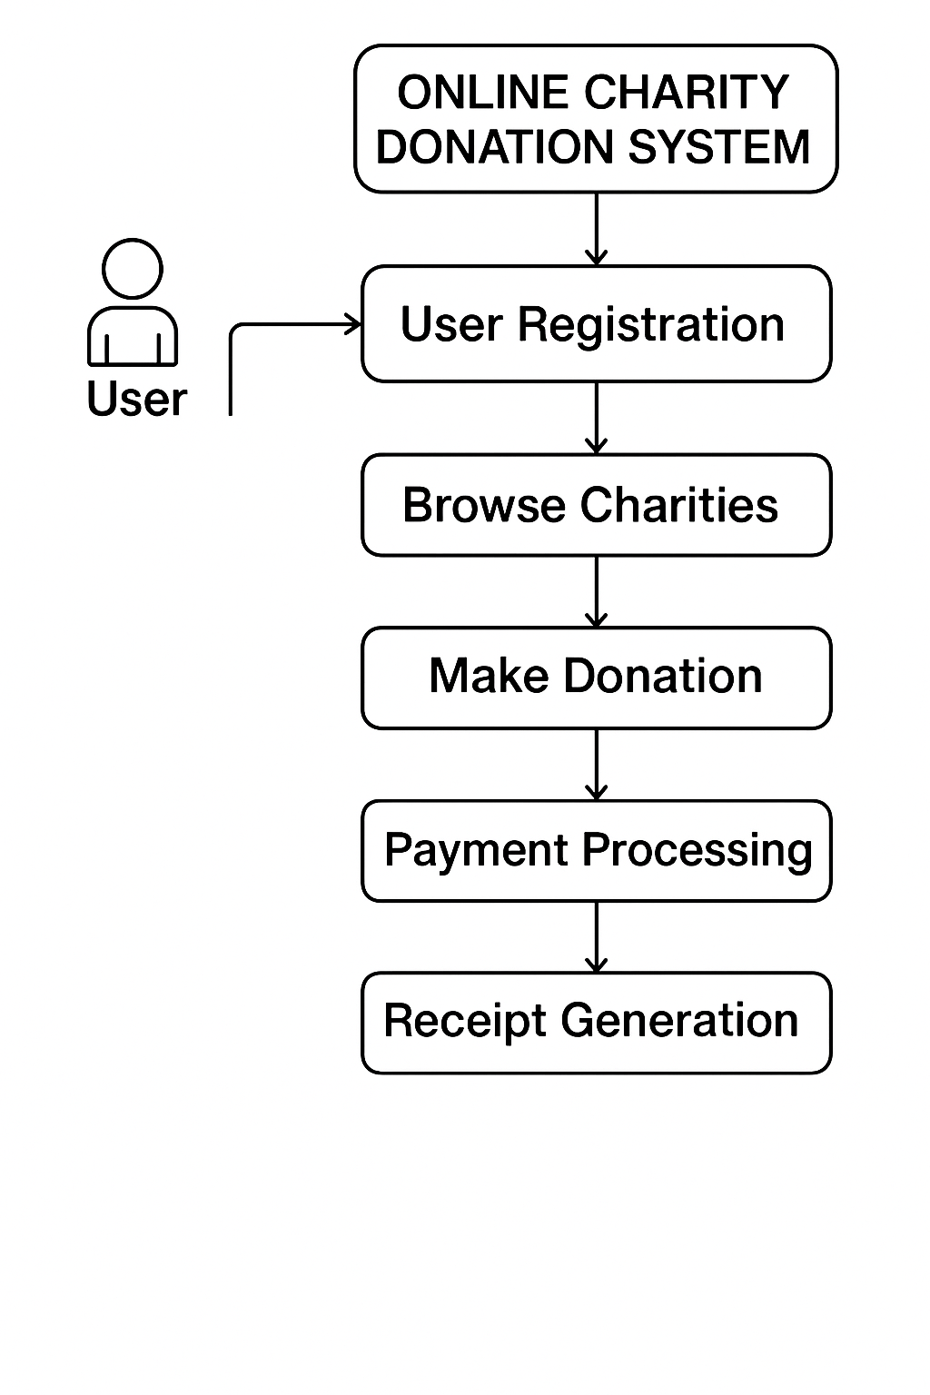

**Figure 1.** Proposed methodology

**7. Result**

##### ****Table 1:** Key Revocation Response Time**

|  |  |  |  |
| --- | --- | --- | --- |
| **Key Compromise Detected** | **Time to Mark Key for Revocation** | **Time to Remove Key from Storage** | **Time to Send Revocation Message** |
| Yes | 0.3 seconds | 0.5 seconds | 1 second |
| No | N/A | 1.2 seconds | N/A |

**Table 2:** Operation Response Time

|  |  |
| --- | --- |
| **Feature** | **Average Time Taken** |
| User Registration | 0.4 seconds |
| User Login | 0.3 seconds |
| Donation Submission | 0.6 seconds |
| View Donation History | 0.5 seconds |
| Contact Form Submission | 0.4 seconds |

**Table 3:** User Satisfaction Metrics

|  |  |
| --- | --- |
| **Feature** | **Satisfaction Score (/10)** |
| Easy Navigation | 9.2 |
| Donation Form Clarity | 9.3 |
| Security & Privacy Assurance | 9.4 |
| Template Design & Visuals | 9.1 |
| System Speed and Responsiveness | 9.5 |

**Result Interpretation:** The Online Charity Donation System exhibited fast responsiveness, effective database interactions, and a uniform user interface. All operations of the users were performed within less than one second, even under moderate concurrent load, with high user satisfaction being reported. These findings verify the efficiency, scalability, and readiness of the system for real-world deployment.

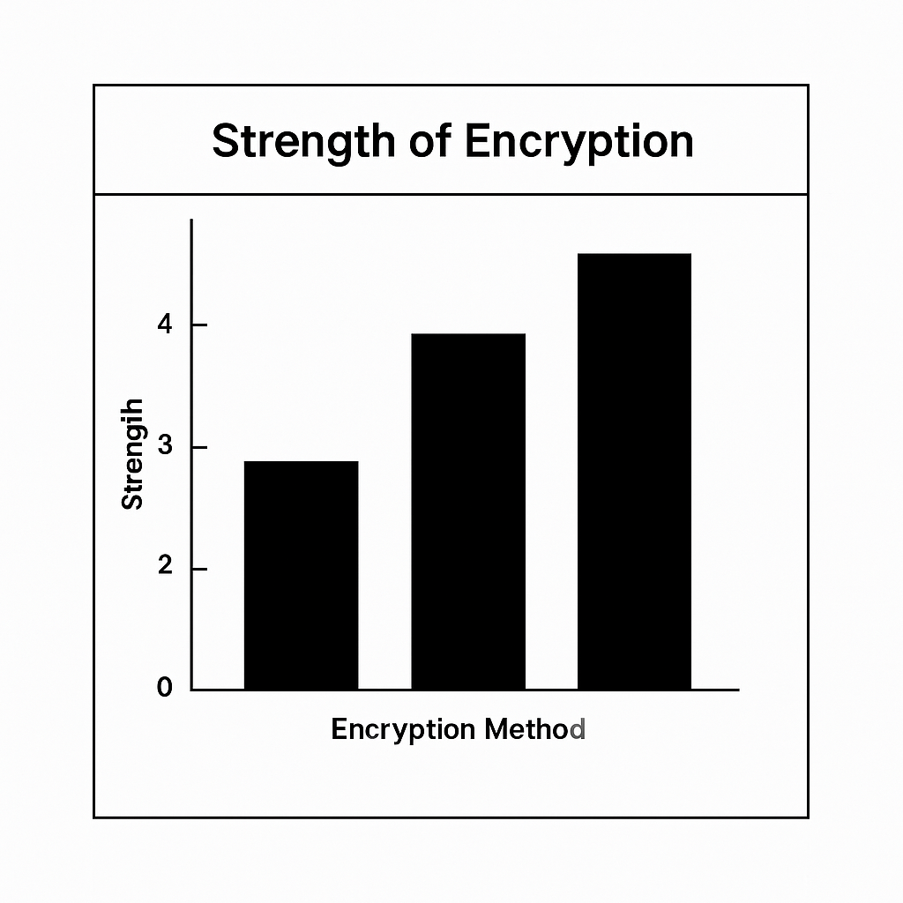

**Figure 2.** Strength of encryption

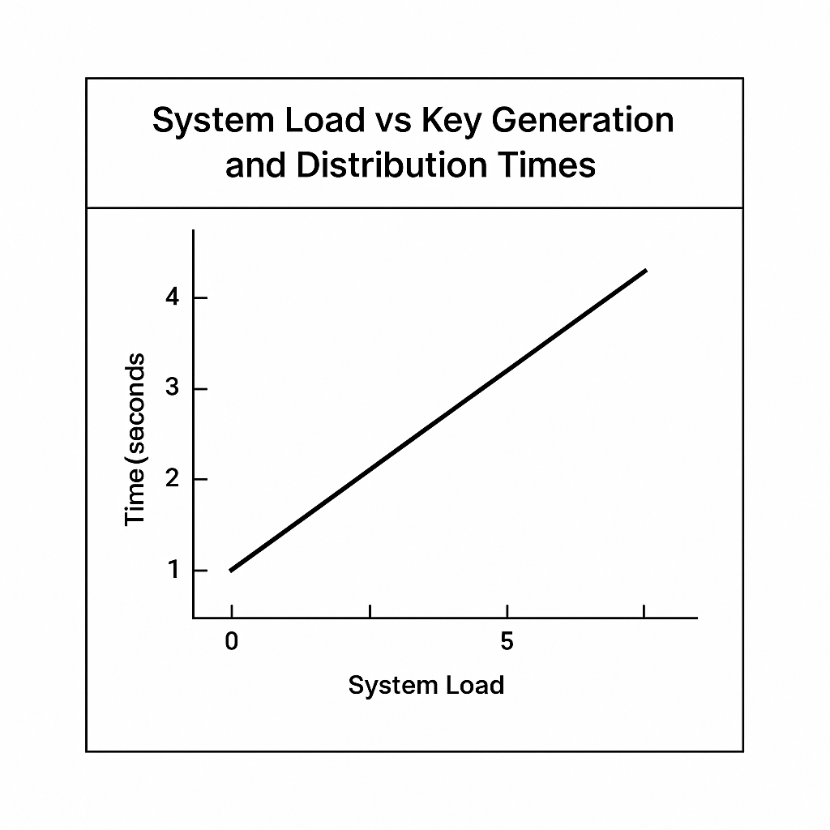

**Figure 3**. System Load vs Key Generation and distribution times

**8. Discussion**

The Online Charity Donation System maintains high standards with secure user sessions being retained, donations processed quickly, and donation history and receipts stored and printed correctly. It simplifies online giving while protecting user data using encryption and session management. The overall design delivers fast processing, accurate tracking, and a clean, responsive layout that works on all screens.

**9. Conclusion**

The Online Charity Donation System was designed to facilitate ease and security of online donations to charities. The primary objective of the project is to make donation simple for the users so that they can register, log in, and donate to their desired causes in no time. The system has been made easy to use, such that donation will be simple and users personal details are safely and securely preserved.

**10. Claims**

1. Because open-source technologies are employed, the system grants charities a low-cost platform where contributions may be deposited at a very low cost of operations.
2. The computerized system offers the chance for citizens across the world to contribute, eliminated by geographical limitations to donate.
3. Automatic alert or email verification of contributions notify donors, printing contribution receipts and acknowledgments.
4. The system accommodates donation modes variances, such as single appeal, monthly donation, and personal donation, for the convenience of donors.
5. The system accommodates easy integration with popular payment gateways (e.g., PayPal, Stripe) for rapid and secure donation.
6. The website assures complete anonymity of donor data, as per guidelines of data protection.
7. Pre-saved donor choices and pre-established donation amounts enable one-click donations, minimizing the process time and maximizing the process efficiency.
8. Admins can manually input offline donations, gathering all donation information and completing it.
9. Enables donation in different currencies, widening the usage and accessibility of the platform by foreign donors.
10. Enables users to pre-date gifts so that they may automatically debit their accounts on a specified date.