Assignment #3
Responsive Web Design
Topic: Discipline
Name | [Your Name]
Group | [Your Group]
GitHub repository | https://github.com/USERNAME/discipline-responsive-page

Task 1. Media queries by hand
For this task I used the “Useful habits” section. I made this section with my own CSS Grid and did not use Bootstrap classes inside it. The base layout is for a phone. It has one item in each row.
At 768px the grid changes to two columns. At 992px it changes to four columns. I also changed the heading alignment at the breakpoints, so the breakpoint changes more than only the item sizes.
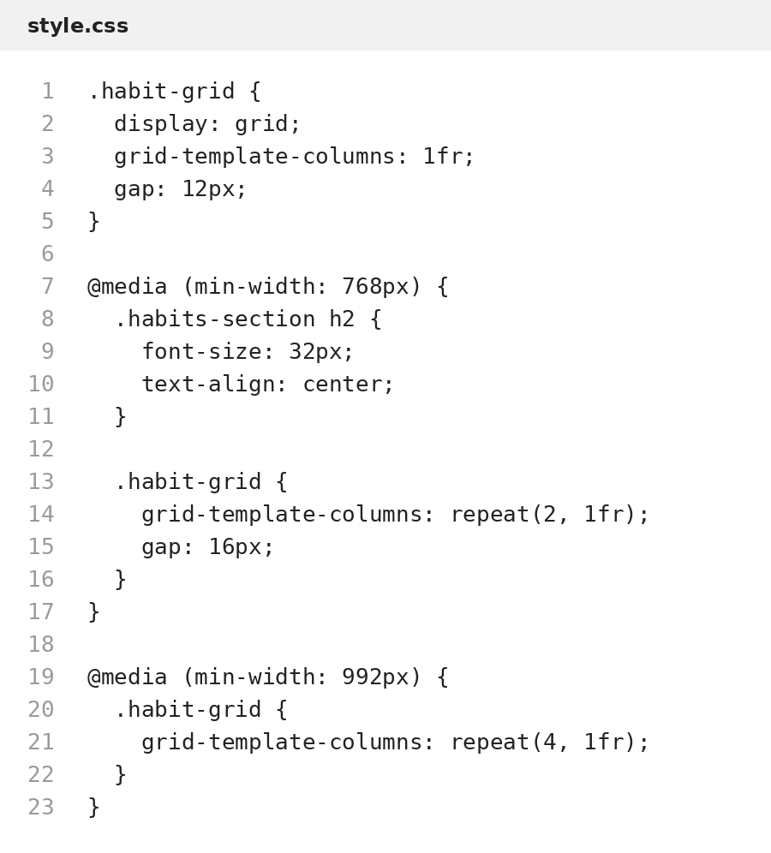
Figure 1. CSS Grid and mobile-first media queries used in Task 1.

Task 2. Bootstrap grid and components
I used Bootstrap for the other parts of the page. The page uses container, row, col-* breakpoints, order-* classes, utility classes and a responsive navbar. The “Three simple steps” cards are one per row on a phone, two on a tablet and three on a laptop.
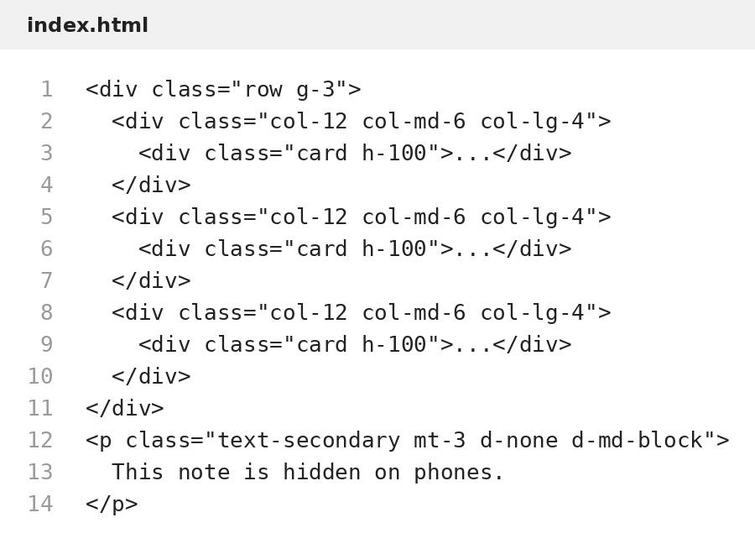
Figure 2. Bootstrap card grid and an element hidden on phones.
The navigation bar uses navbar-expand-lg and collapse. On a small screen it becomes a menu button. I also used an accordion as an additional Bootstrap component.
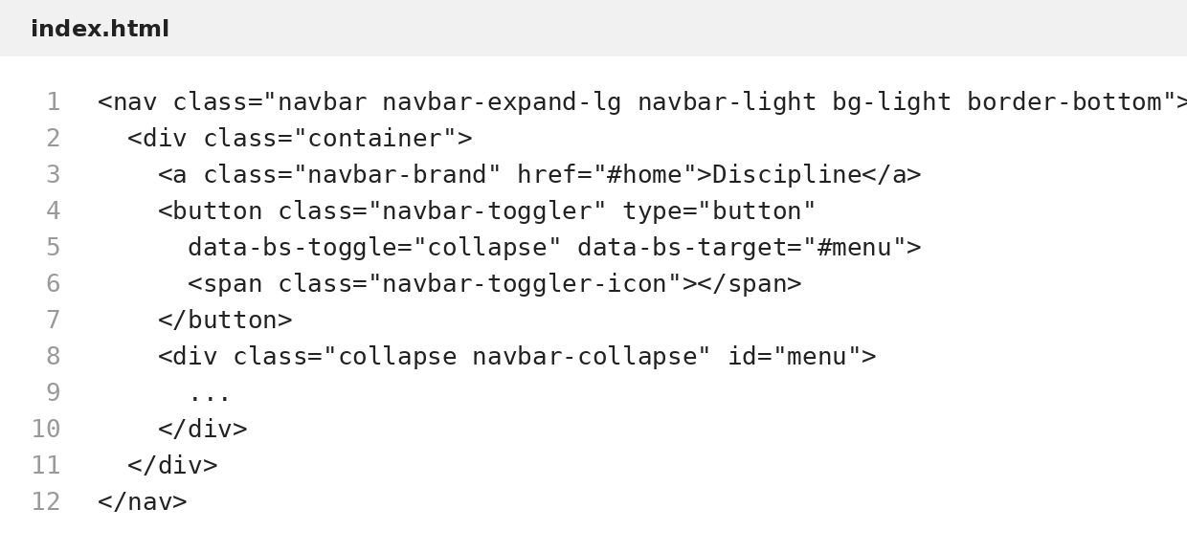
Figure 3. Responsive Bootstrap navbar.

Task 3. Comparison
Point | Media queries by hand | Bootstrap
Amount of code | I wrote the grid and breakpoints myself, so there is more CSS. | The responsive layout needs fewer custom CSS rules because the classes are ready.
Control | I can control the exact number of columns and alignment in the habits section. | The layout follows Bootstrap breakpoints and its grid system.
Speed | It takes more time because I need to write and test each breakpoint. | It is faster for cards, columns and the navbar.
Changes | I change the CSS rules directly. | I can often change the layout by changing col-* or utility classes.
I would choose my own media queries when I need more control over a special section. I would choose Bootstrap when I need to build a standard responsive layout faster, for example cards, columns and a navbar.

Responsive screenshots
The page was checked at the three required screen widths: 375px, 768px and 1280px.

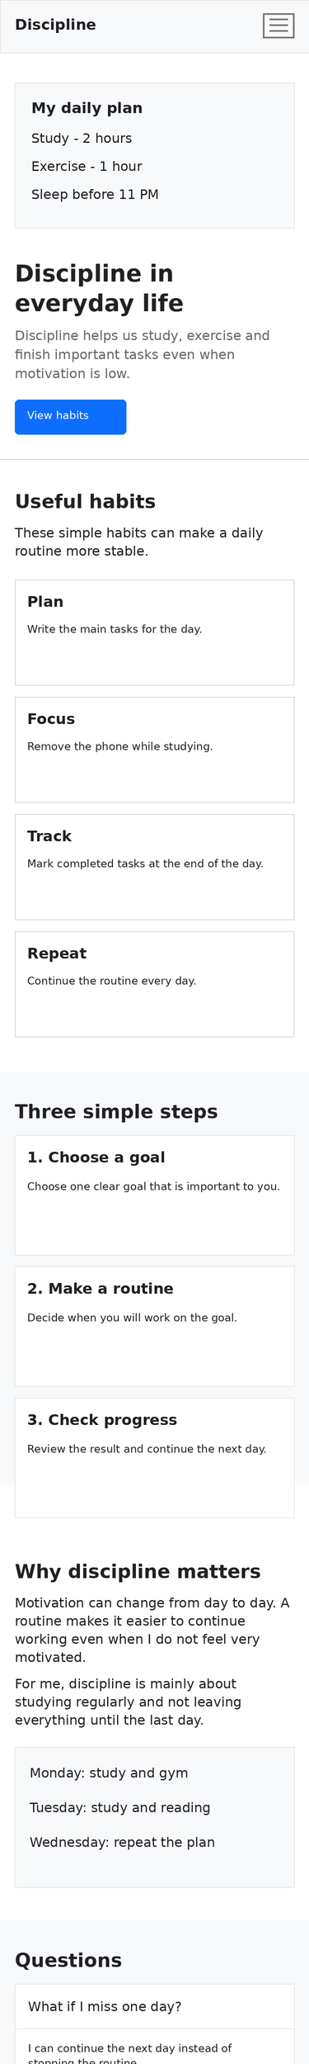
Figure 4. Full page at 375px.

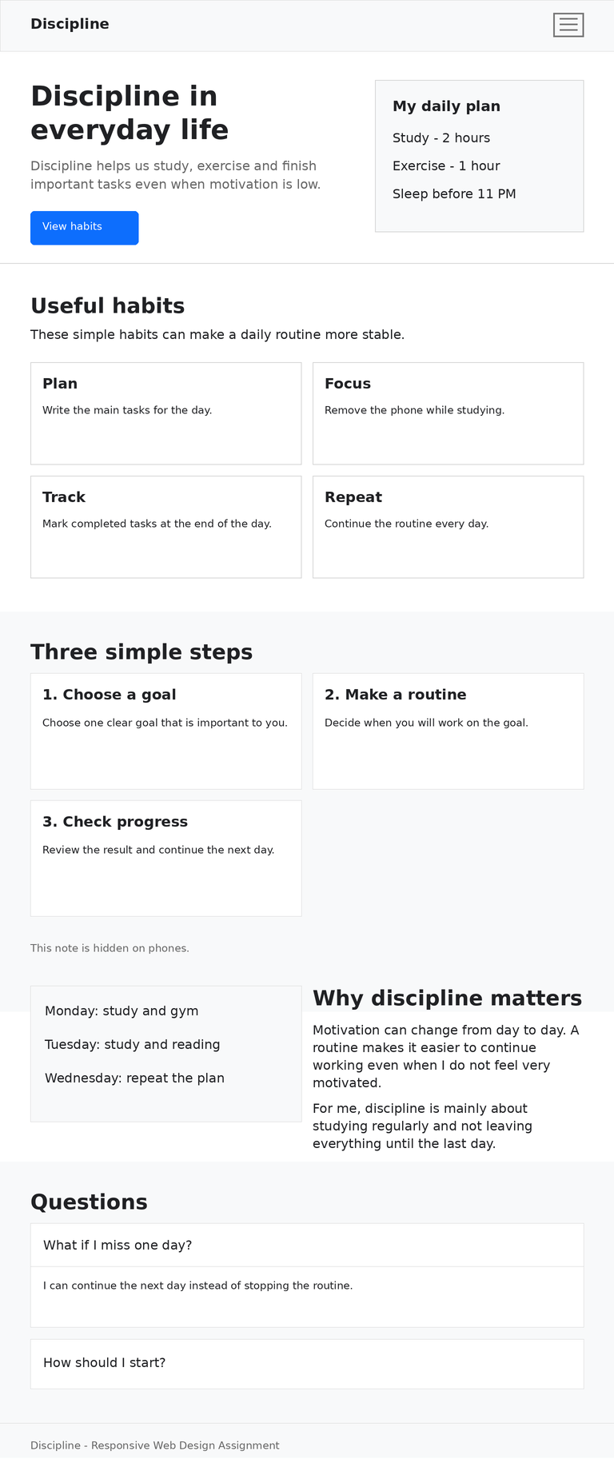
Figure 5. Full page at 768px.

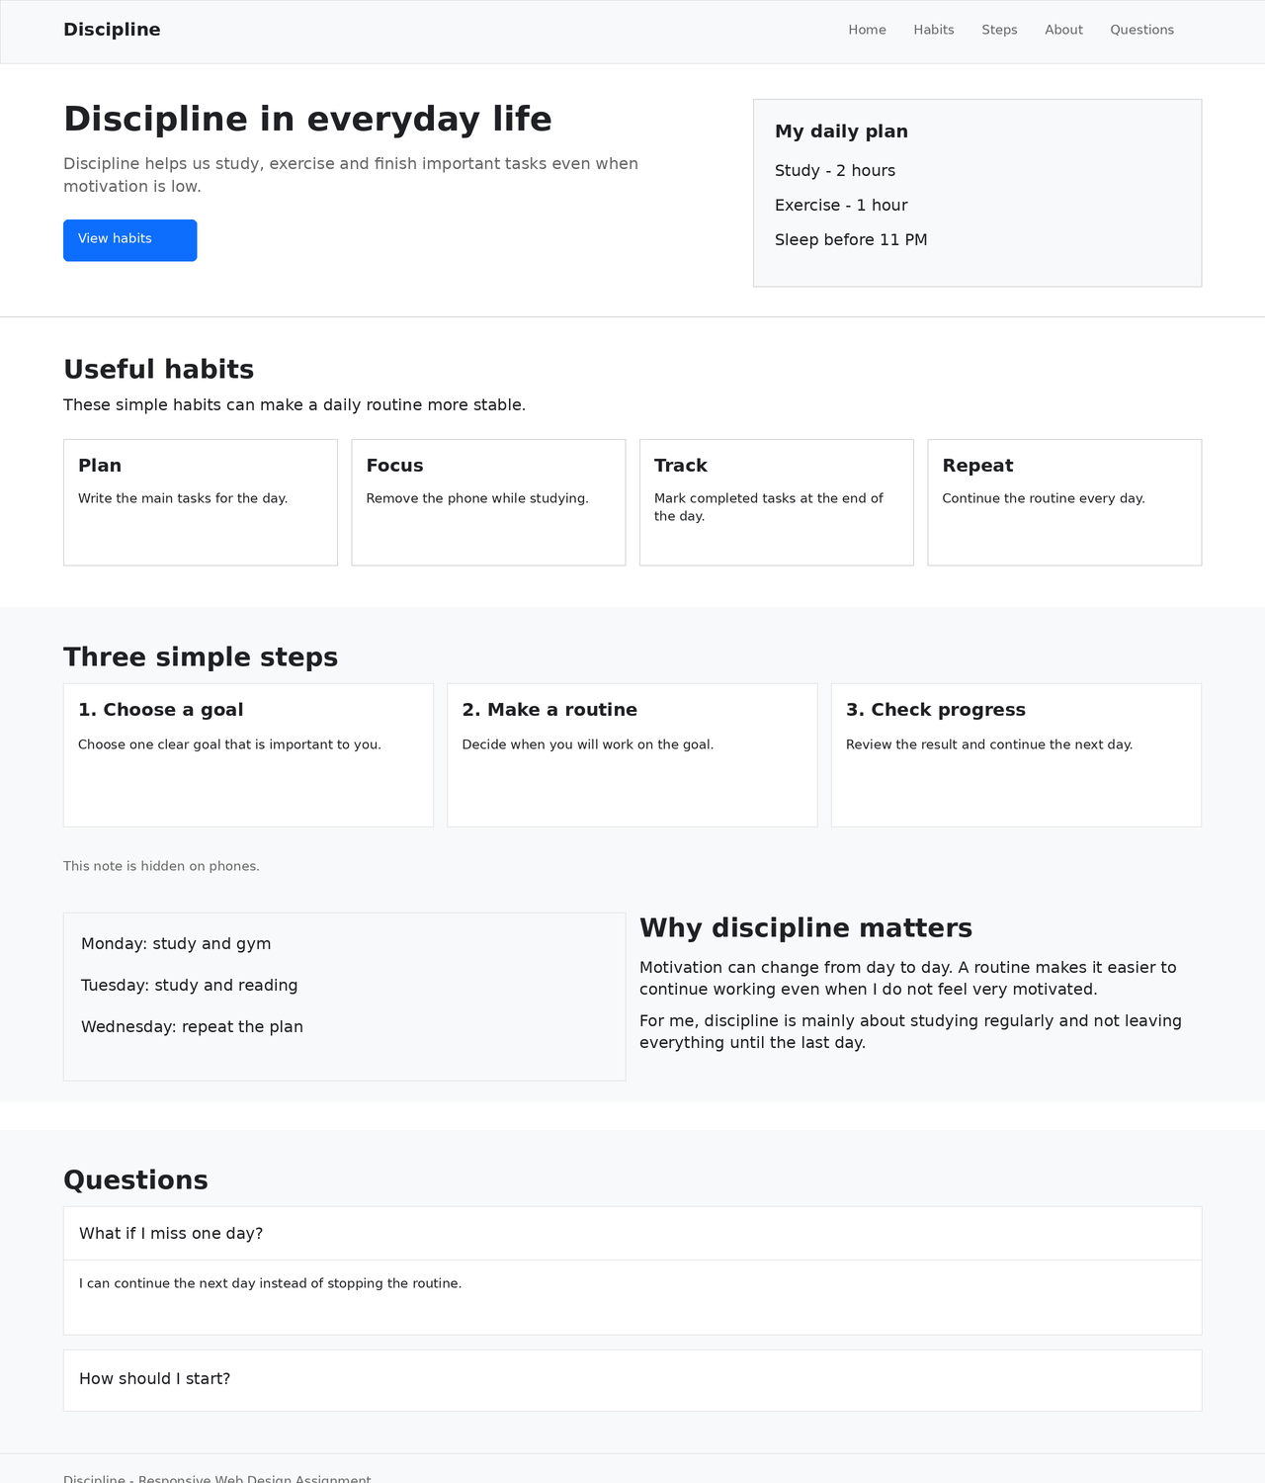
Figure 6. Full page at 1280px.

Conclusion
In this assignment I learned how to make a page responsive in two ways. I used mobile-first media queries with CSS Grid for one section and Bootstrap grid and components for the rest of the page. I also learned how the same content changes between phone, tablet and laptop screen sizes.

