Use conditional formatting to fill each cell in the outcome column with a different color, depending on whether the associated campaign was successful, failed,

canceled, or is currently live.

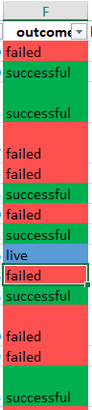

Use conditional formatting to fill each cell in the Percent Funded column according to a three-color scale. The scale should start at 0 with a dark shade of red,

and it should transition to green at 100 and blue at 200.

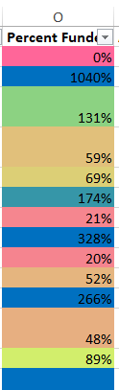

Create a new column called Average Donation that uses a formula to find how much each project backer paid on average.

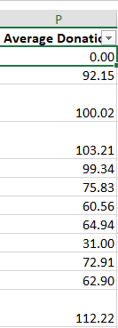

Create two new columns, one called Parent Category and another called Sub-Category, that use formulas to split the Category and Sub-Category column into the two new,

separate columns.

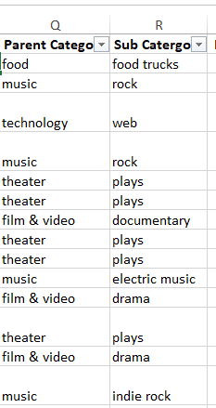

Create a new sheet with a pivot table that analyzes your initial worksheet to count how many campaigns were successful, failed, canceled, or are currently live per

category.

Create a stacked-column pivot chart that can be filtered by country based on the table that you created.

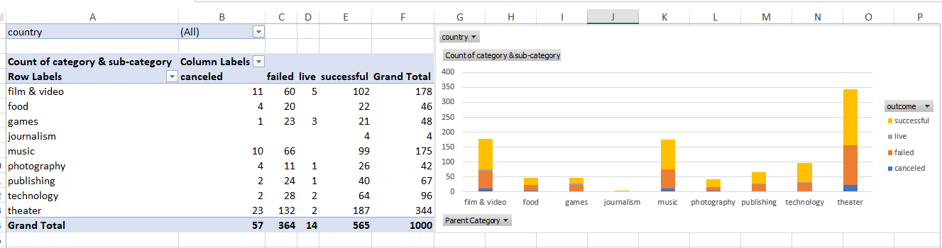

Create a new sheet with a pivot table that analyzes your initial sheet to count how many campaigns were successful, failed, or canceled, or are currently live per

sub-category.

Create a stacked-column pivot chart that can be filtered by country and parent category based on the table that you created.

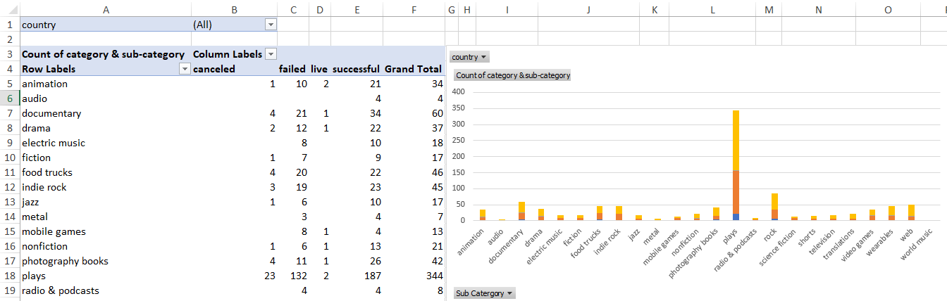

The dates in the deadline and launched_at columns use Unix timestamps. Fortunately for us, this formulaLinks to an external site. that can be used to convert

these timestamps to a normal date.

Create a new column named Date Created Conversion that will use this formulaLinks to an external site. to convert the data contained in launched_at into Excel's date

format.

Create a new column named Date Ended Conversion that will use this formulaLinks to an external site. to convert the data contained in deadline into Excel's date format.

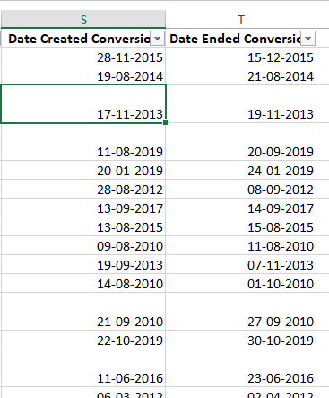

Create a new sheet with a pivot table that has a column of outcome, rows of Date Created Conversion, values based on the count of outcome, and filters based on parent

category and Years.

Now, create a pivot-chart line graph that visualizes this new table.

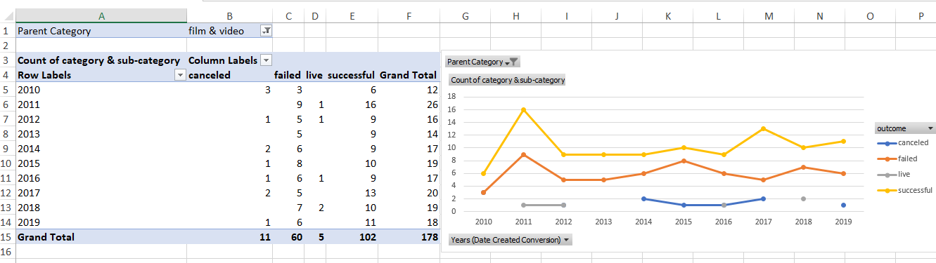

Crowfunding Goal Analysis

Create a new sheet with 8 columns:

Goal

Number Successful

Number Failed

Number Canceled

Total Projects

Percentage Successful

Percentage Failed

Percentage Canceled

In the Goal column, create 12 rows with the following headers:

Less than 1000

1000 to 4999

5000 to 9999

10000 to 14999

15000 to 19999

20000 to 24999

25000 to 29999

30000 to 34999

35000 to 39999

40000 to 44999

45000 to 49999

Greater than or equal to 50000

Using the COUNTIFS() formula, count how many successful, failed, and canceled projects were created with goals within the ranges listed above.

Populate the Number Successful, Number Failed, and Number Canceled columns with these data points.

Add up each of the values in the Number Successful, Number Failed, and Number Canceled columns to populate the Total Projects column.

Then, using a mathematical formula, find the percentage of projects that were successful, failed, or canceled per goal range.

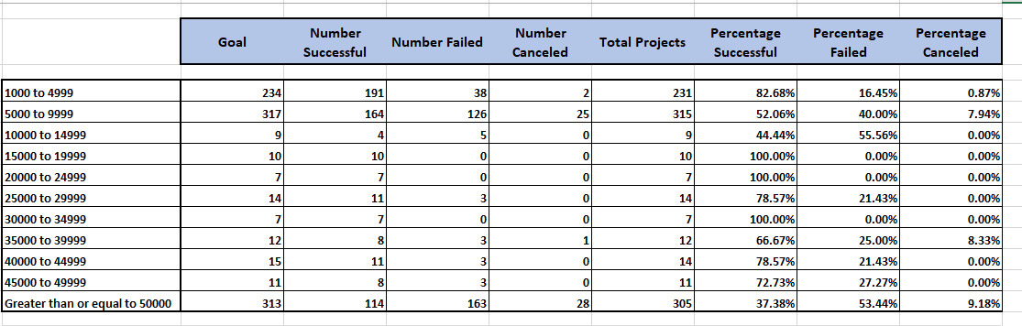

Create a line chart that graphs the relationship between a goal amount and its chances of success, failure, or cancellation.

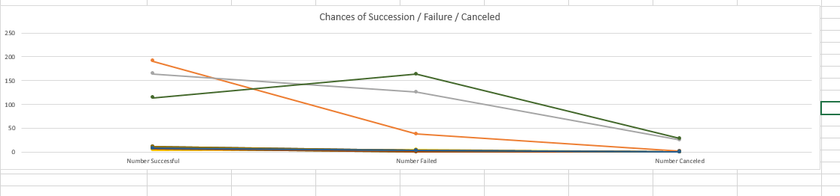

Statistical Analysis

Most people would use the number of campaign backers to assess the success of a crowdfunding campaign. Creating a summary statistics table is one of the most efficient ways that data scientists can characterize quantitative metrics, such as the number of campaign backers.

For gaining an in-depth understanding of campaign backers, evaluate the number of backers of successful and unsuccessful campaigns by creating your own summary

statistics table.

Create a new worksheet in your workbook, and create one column for the number of backers of successful campaigns and one column for unsuccessful campaigns.

Use Excel to evaluate the following values for successful campaigns, and then do the same for unsuccessful campaigns:

The mean number of backers

The median number of backers

The minimum number of backers

The maximum number of backers

The variance of the number of backers

The standard deviation of the number of backers

Use your data to determine whether the mean or the median better summarizes the data.

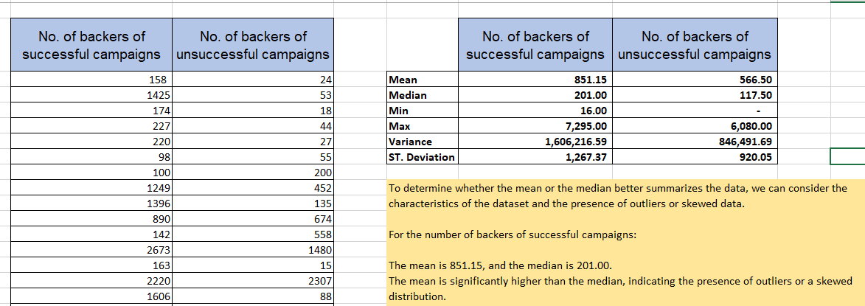

Use your data to determine if there is more variability with successful or unsuccessful campaigns. Does this make sense? Why or why not?

Create a script that loops through all the stocks for one year and outputs the following information:

The ticker symbol

Yearly change from the opening price at the beginning of a given year to the closing price at the end of that year.

The percentage change from the opening price at the beginning of a given year to the closing price at the end of that year.

The total stock volume of the stock. The result should match the following image:

Add functionality to your script to return the stock with the "Greatest % increase", "Greatest % decrease", and "Greatest total volume". The solution should match the following image:

Make sure to use conditional formatting that will highlight positive change in green and negative change in red.

Other Considerations

Use the sheet alphabetical_testing.xlsx while developing your code. This dataset is smaller and will allow you to test faster. Your code should run on this file in under 3 to 5 minutes.

Make sure that the script acts the same on every sheet. The joy of VBA is that it takes the tediousness out of repetitive tasks with the click of a button.

Requirements

Retrieval of Data (20 points)

The script loops through one year of stock data and reads/ stores all of the following values from each row:

ticker symbol (5 points)

volume of stock (5 points)

open price (5 points)

close price (5 points)

Column Creation (10 points)

On the same worksheet as the raw data, or on a new worksheet all columns were correctly created for:

ticker symbol (2.5 points)

total stock volume (2.5 points)

yearly change ($) (2.5 points)

percent change (2.5 points)

Conditional Formatting (20 points)

Conditional formatting is applied correctly and appropriately to the yearly change column (10 points)

Conditional formatting is applied correctly and appropriately to the percent change column (10 points)

Calculated Values (15 points)

All three of the following values are calculated correctly and displayed in the output:

Greatest % Increase (5 points)

Greatest % Decrease (5 points)

Greatest Total Volume (5 points)

Looping Across Worksheet (20 points)

The VBA script can run on all sheets successfully.

