**WIREFRAME**

E-COMM SALES ANALYSIS

Wireframe Document

|  |  |
| --- | --- |
| Written By | Adil Anwar |
| Document Version | 1.1 |
| Last Revised Date | 25-10-2022 |

**WIREFRAME**

**Document Change Control Record:**

|  |  |  |  |
| --- | --- | --- | --- |
| **Version** | **Date** | **Author** | **Comments** |
| 1.0 | 18th Oct 2022 | Adil Anwar | First Draft |
| 1.1 | 25th Oct 2022 | Adil Anwar | Final WFD |
|  |  |  |  |
|  |  |  |  |

**Reviews**

|  |  |  |  |
| --- | --- | --- | --- |
| **Version** | **Date** | **Reviewer** | **Comments** |
|  |  |  |  |

### **Approval Status:**

|  |  |  |  |  |
| --- | --- | --- | --- | --- |
| **Version** | **Review date** | **Reviewed By** | **Approved By** | **Comments** |
|  |  |  |  |  |

**HOMEPAGE**

As per the requirement of the Case Study, the problem statement has been divided into 4 parts:

**1. Sales Level of Detail Analysis – Yearwise -> Monthwise -> Weekwise -> Daywise**

**The below graph can be drilled down and up to include and exclude LODs**

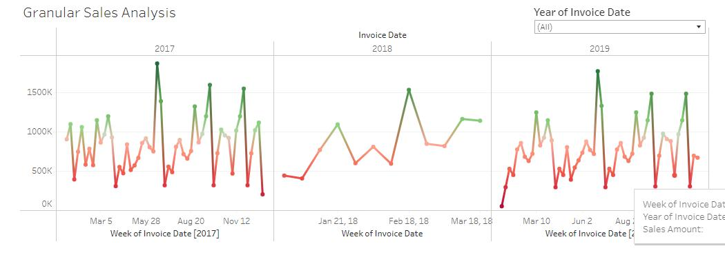

The below graph shows distribution of sales each Quarter in each Year:

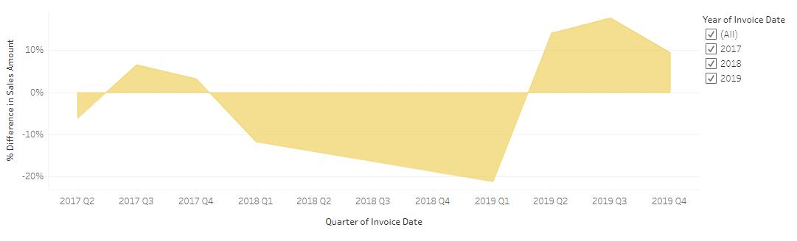

The below graph shows distribution of sales each month:

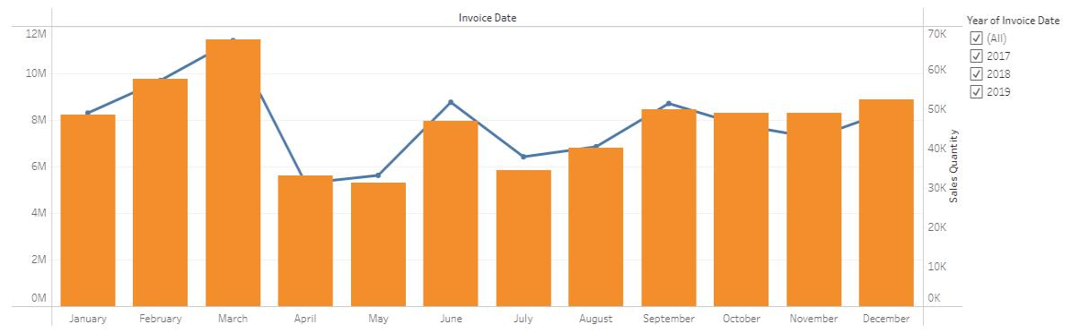

**WIREFRAME**

**2. Impact of Products on Sales**

The below graph shows the products with maximum profit margin:

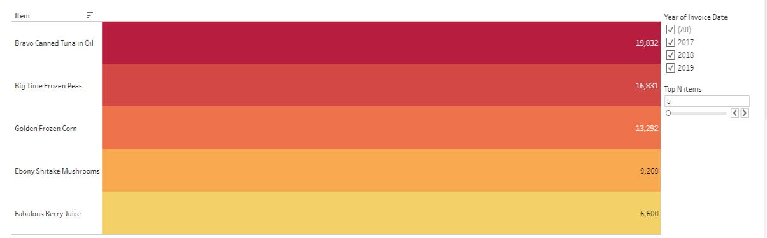

The below graph shows the most sold products yearwise:

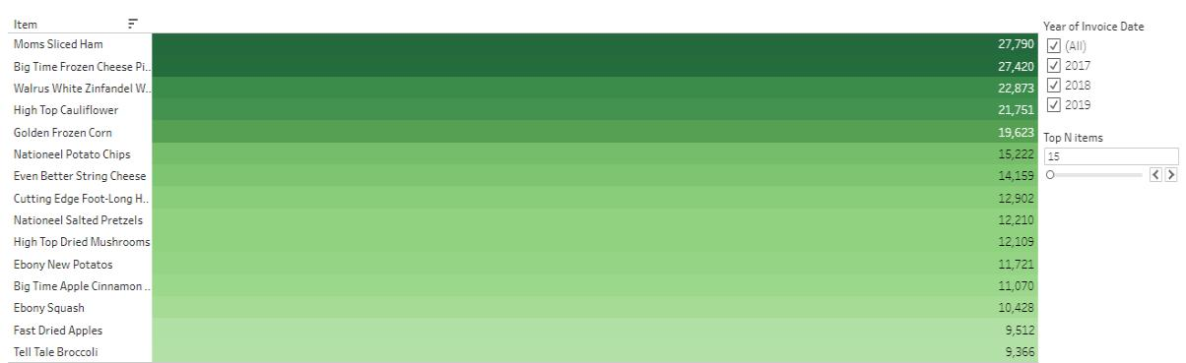

The below graph shows the least sold products each year/overall:

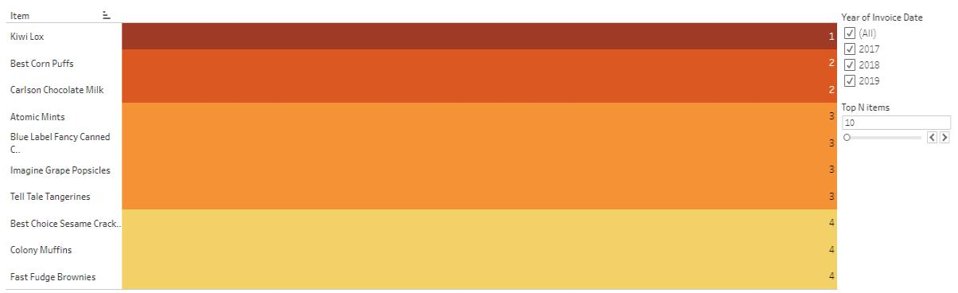

**WIREFRAME**

1. **Areawise Sales Analysis**

The below graph shows the areawise distribution of Sales

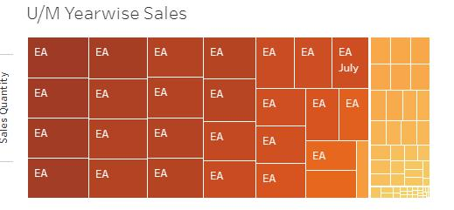

**4. Overall E-Commerce Dashboard**

**Part-1 of the overall Dashboard:**

The dashboard also has a quick summary section, which is dynamic and changes with the data

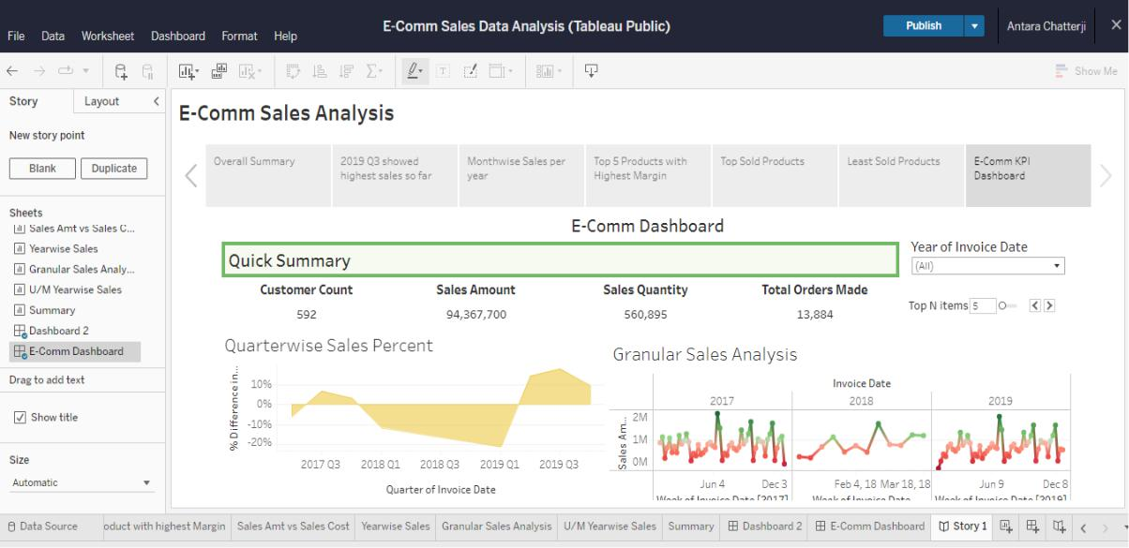

**WIREFRAME**

**Part-2 of the overall Dashboard:**

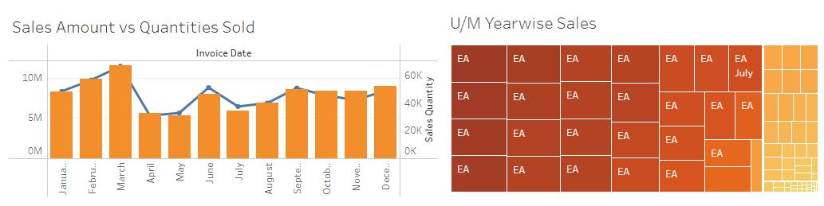

**Part-3 of the overall Dashboard:**

