**MINISTRY OF SCIENCE AND HIGHER EDUCATION OF THE REPUBLIC OF KAZAKHSTAN**



**International Information Technology University**

**Department of Cybersecurity**

**PROGRAMMING LANGUAGE PYTHON**

|  |  |
| --- | --- |
| **Student** | Adilet Karl |
|  | *(given name, surname) (фамилия, имя, отчество)* |
| **Group** | SIS-2214 |
| **Lecturer** | Nessibeli Askarbekova |
| **Аssessment** |  |

Almaty, 2024

**Week 2**

**Module 2. Python Data Types, Variables, Operators, and Basic I/O Operations**

**Task 1.** Log in <https://www.netacad.com/>

Please, use your login and password.

**Task 2.** Find Module 2. Python Data Types, Variables, Operators, and Basic I/O Operations

**Task 3.** Read Section 1, Section 2, Section 3, Section 4, Section 5, Section 6

**Task 4.** Please, complete the following LABS and paste screenshot(s) for each LAB of your completed task:

* 2.1.5 LAB Working with the print() function

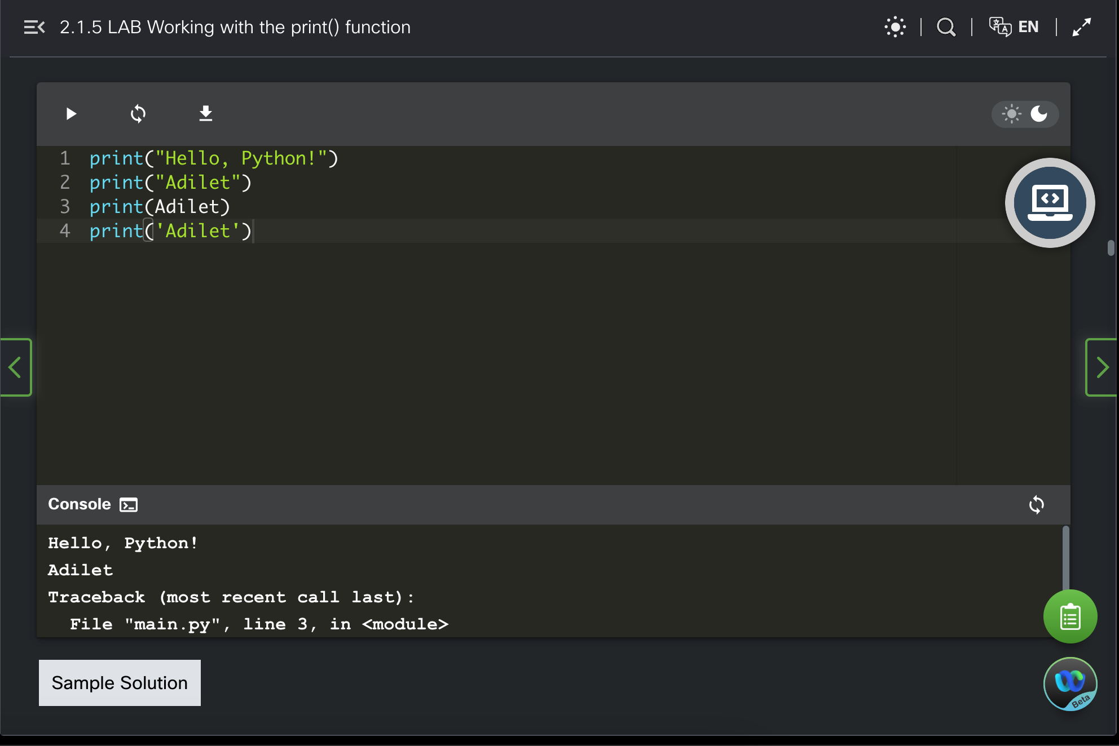

* 2.1.12 LAB The print() function and its arguments

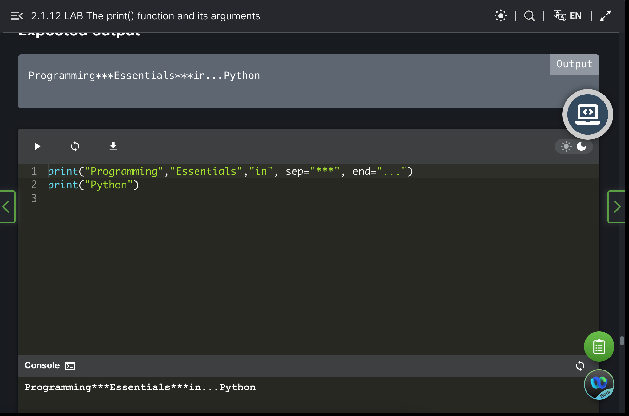

* 2.1.13 LAB Formatting the output

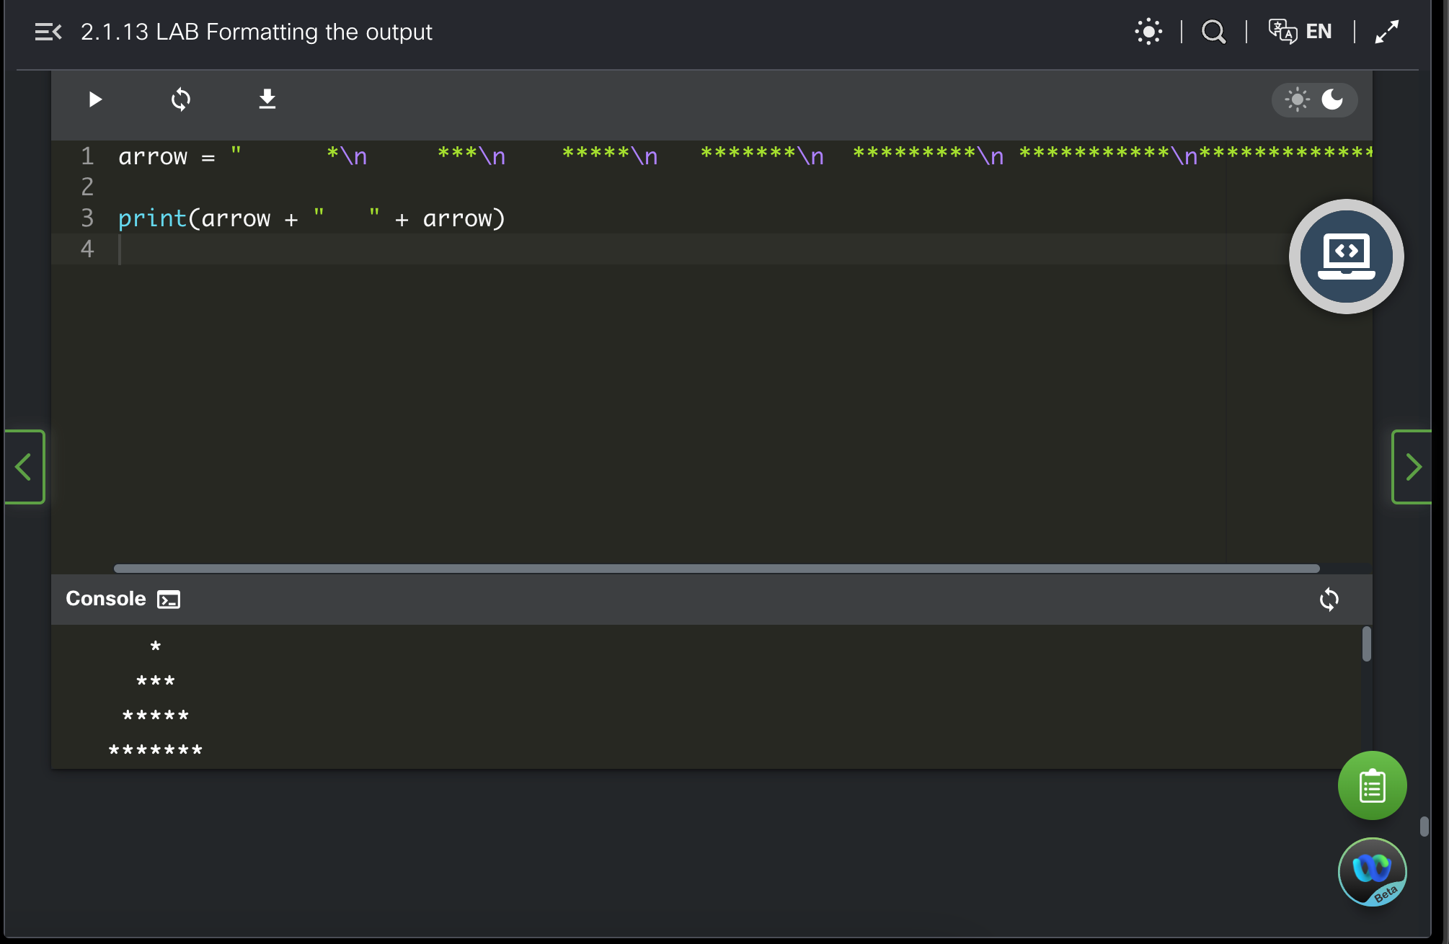

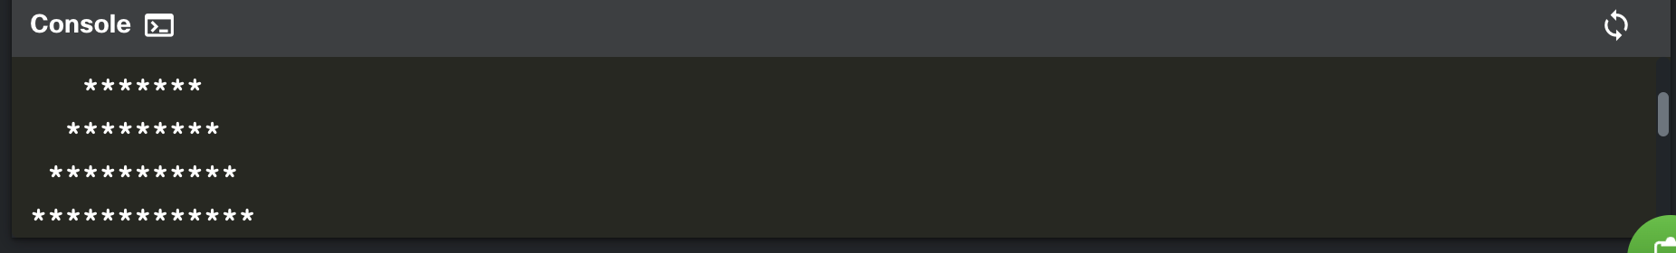  
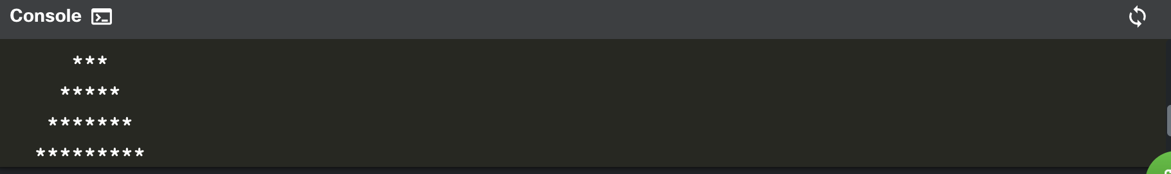

* 2.2.6 LAB Python literals – strings

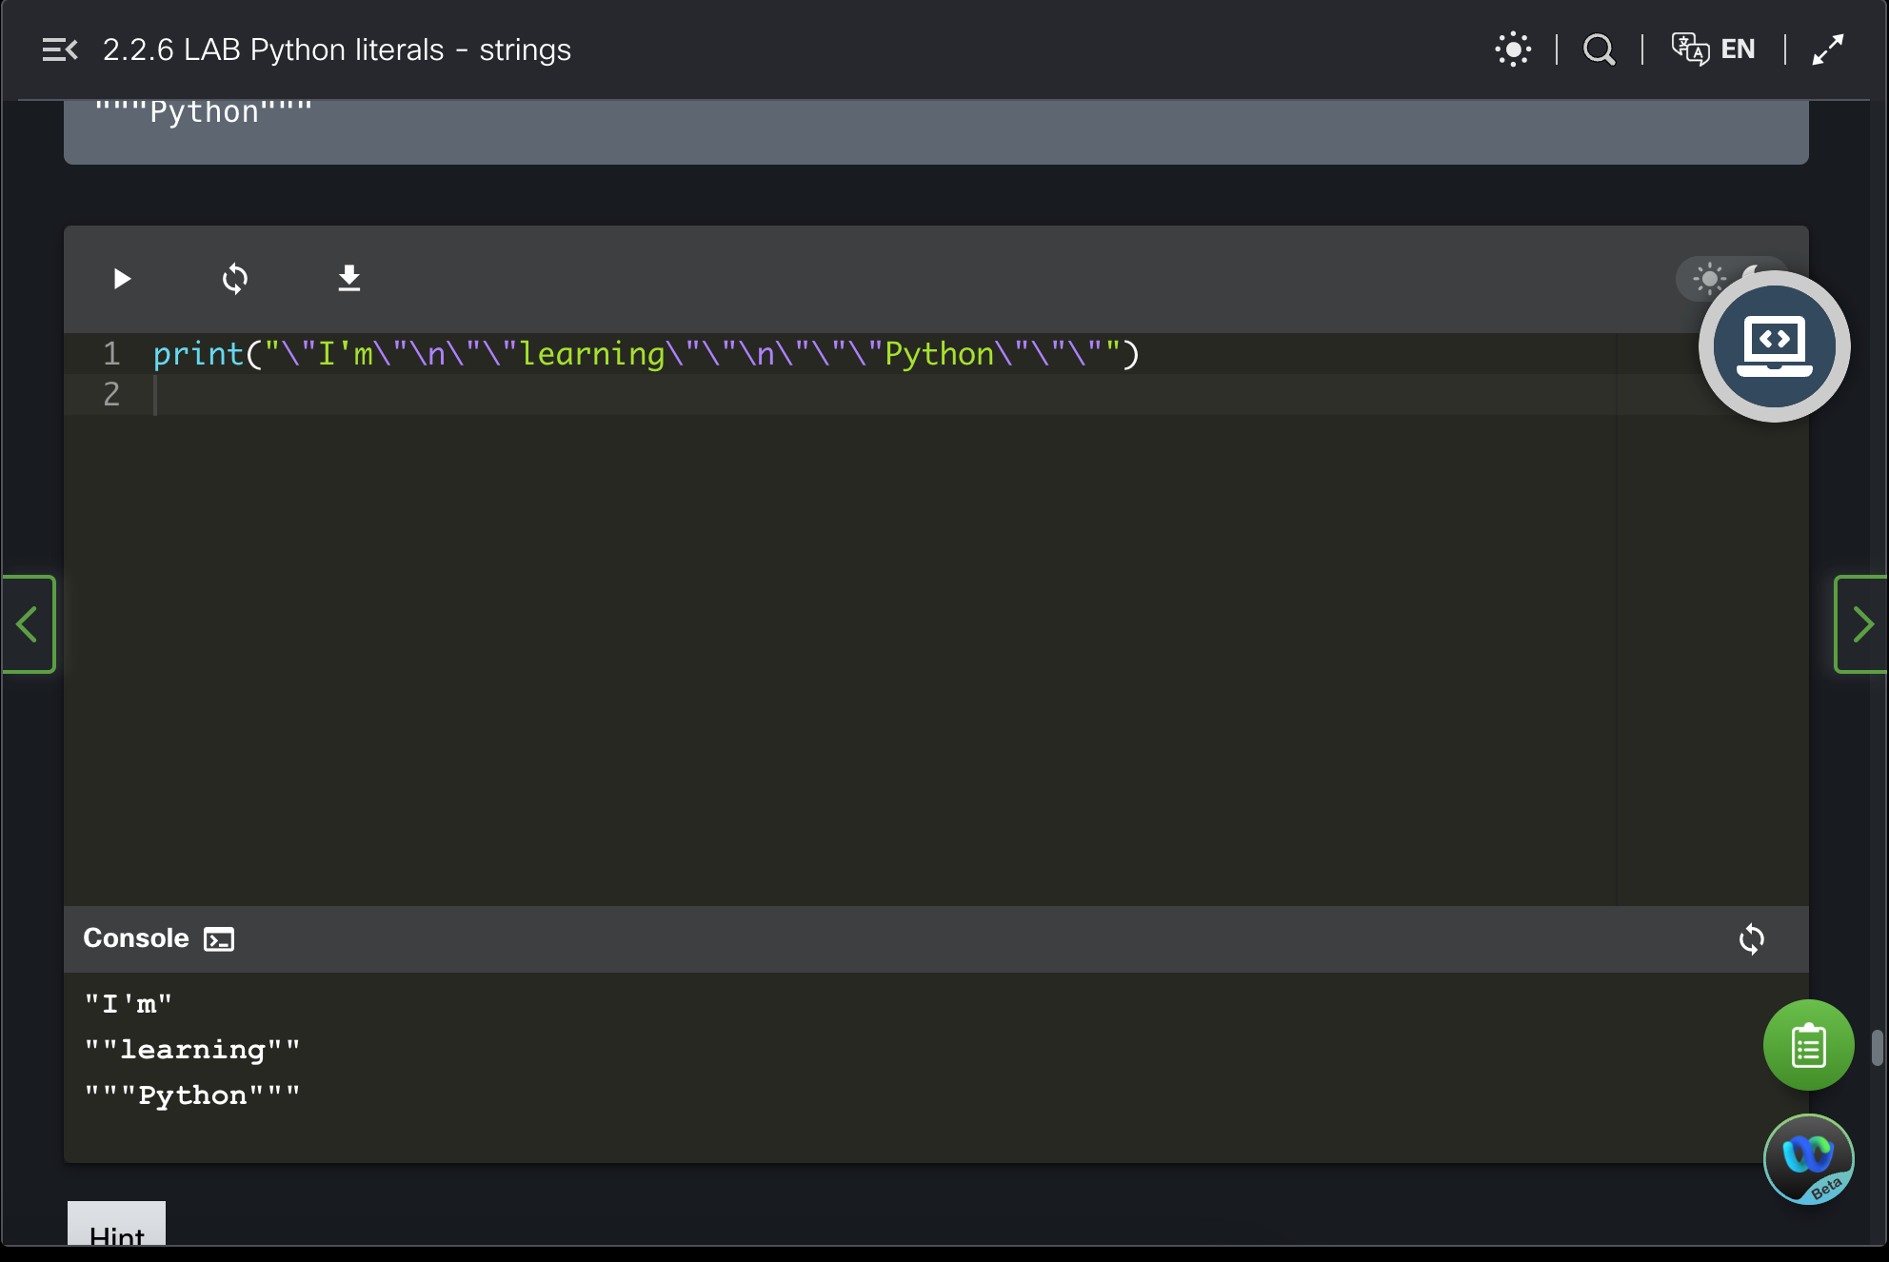

* 2.4.7 LAB Variables

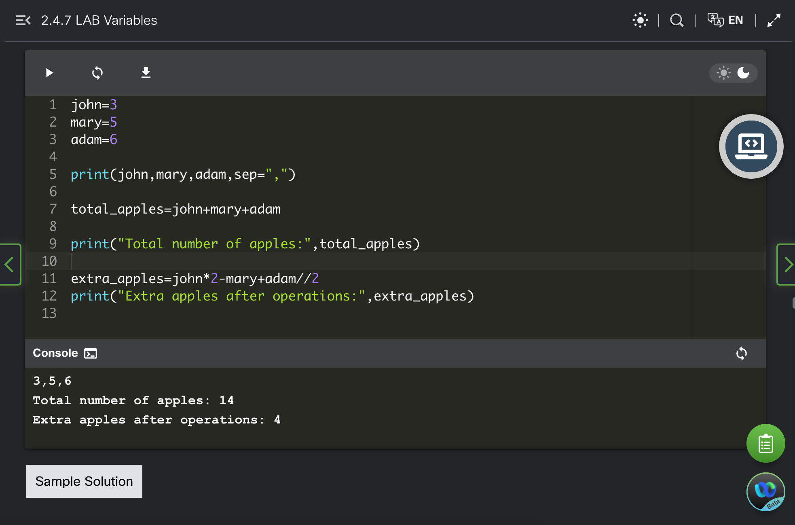

* 2.4.9 LAB Variables ‒ a simple converter

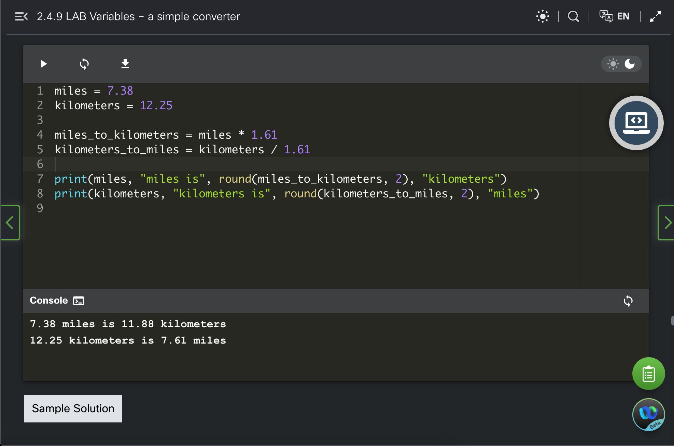

* 2.4.10 LAB Operators and expressions

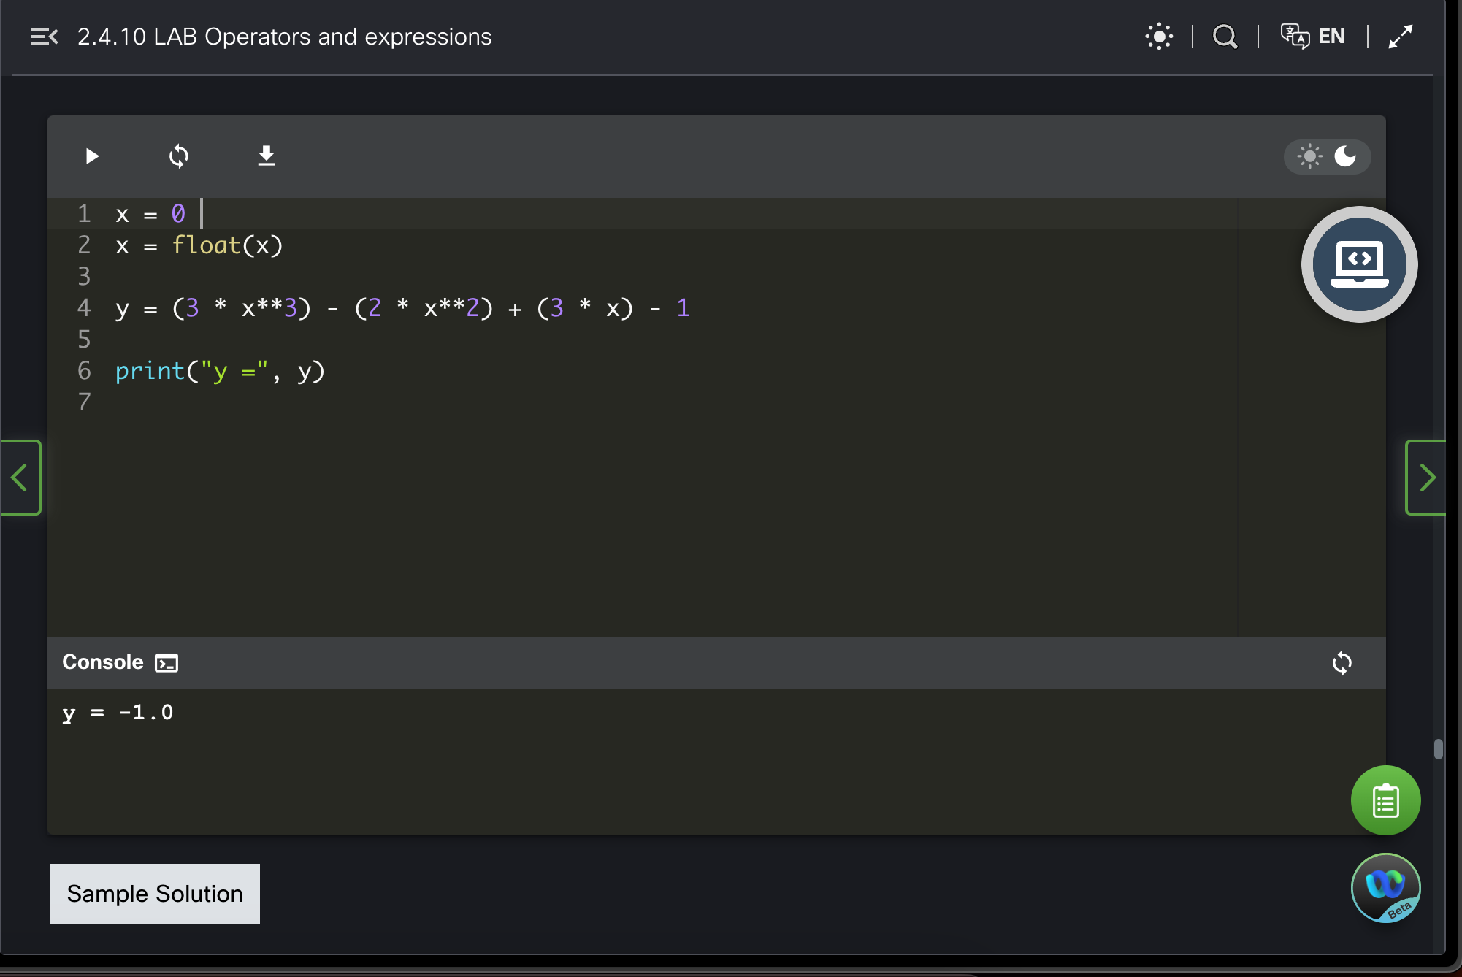

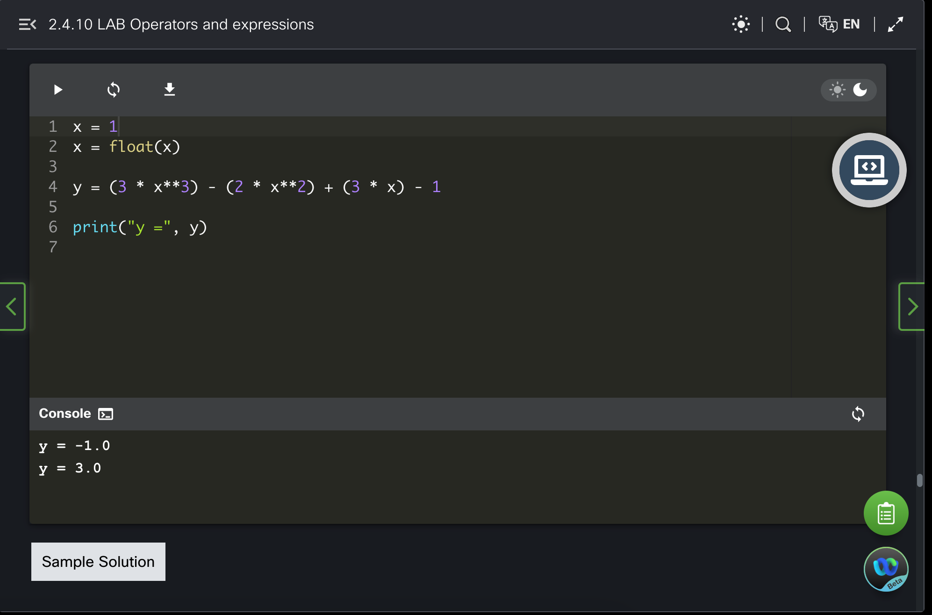

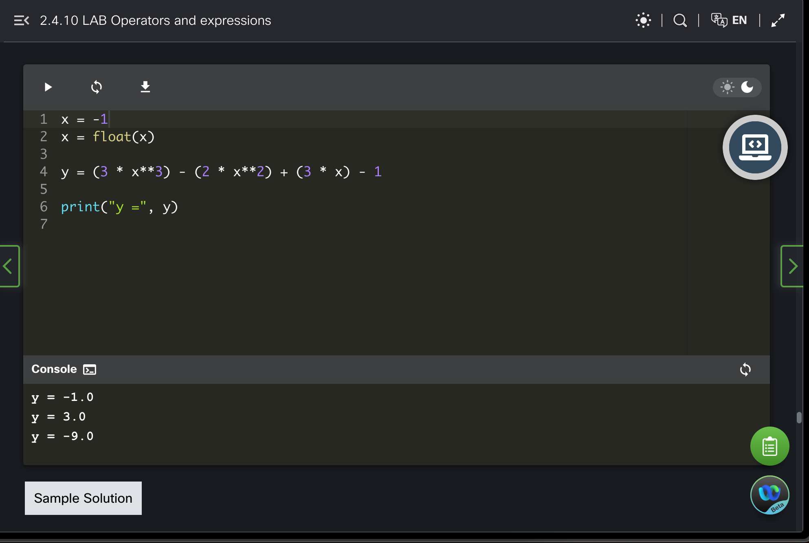

* 2.5.3 LAB Comments

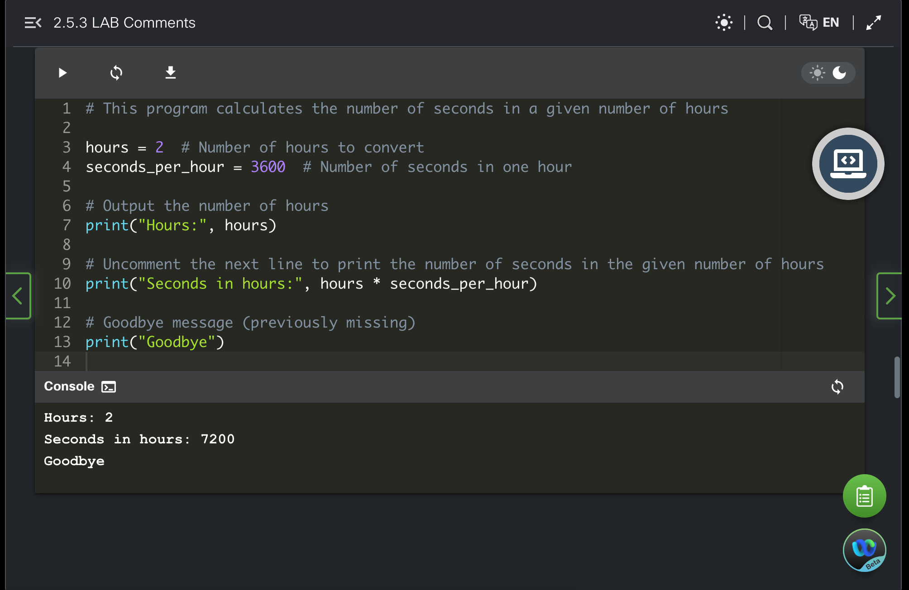

* 2.6.9 LAB Simple input and output

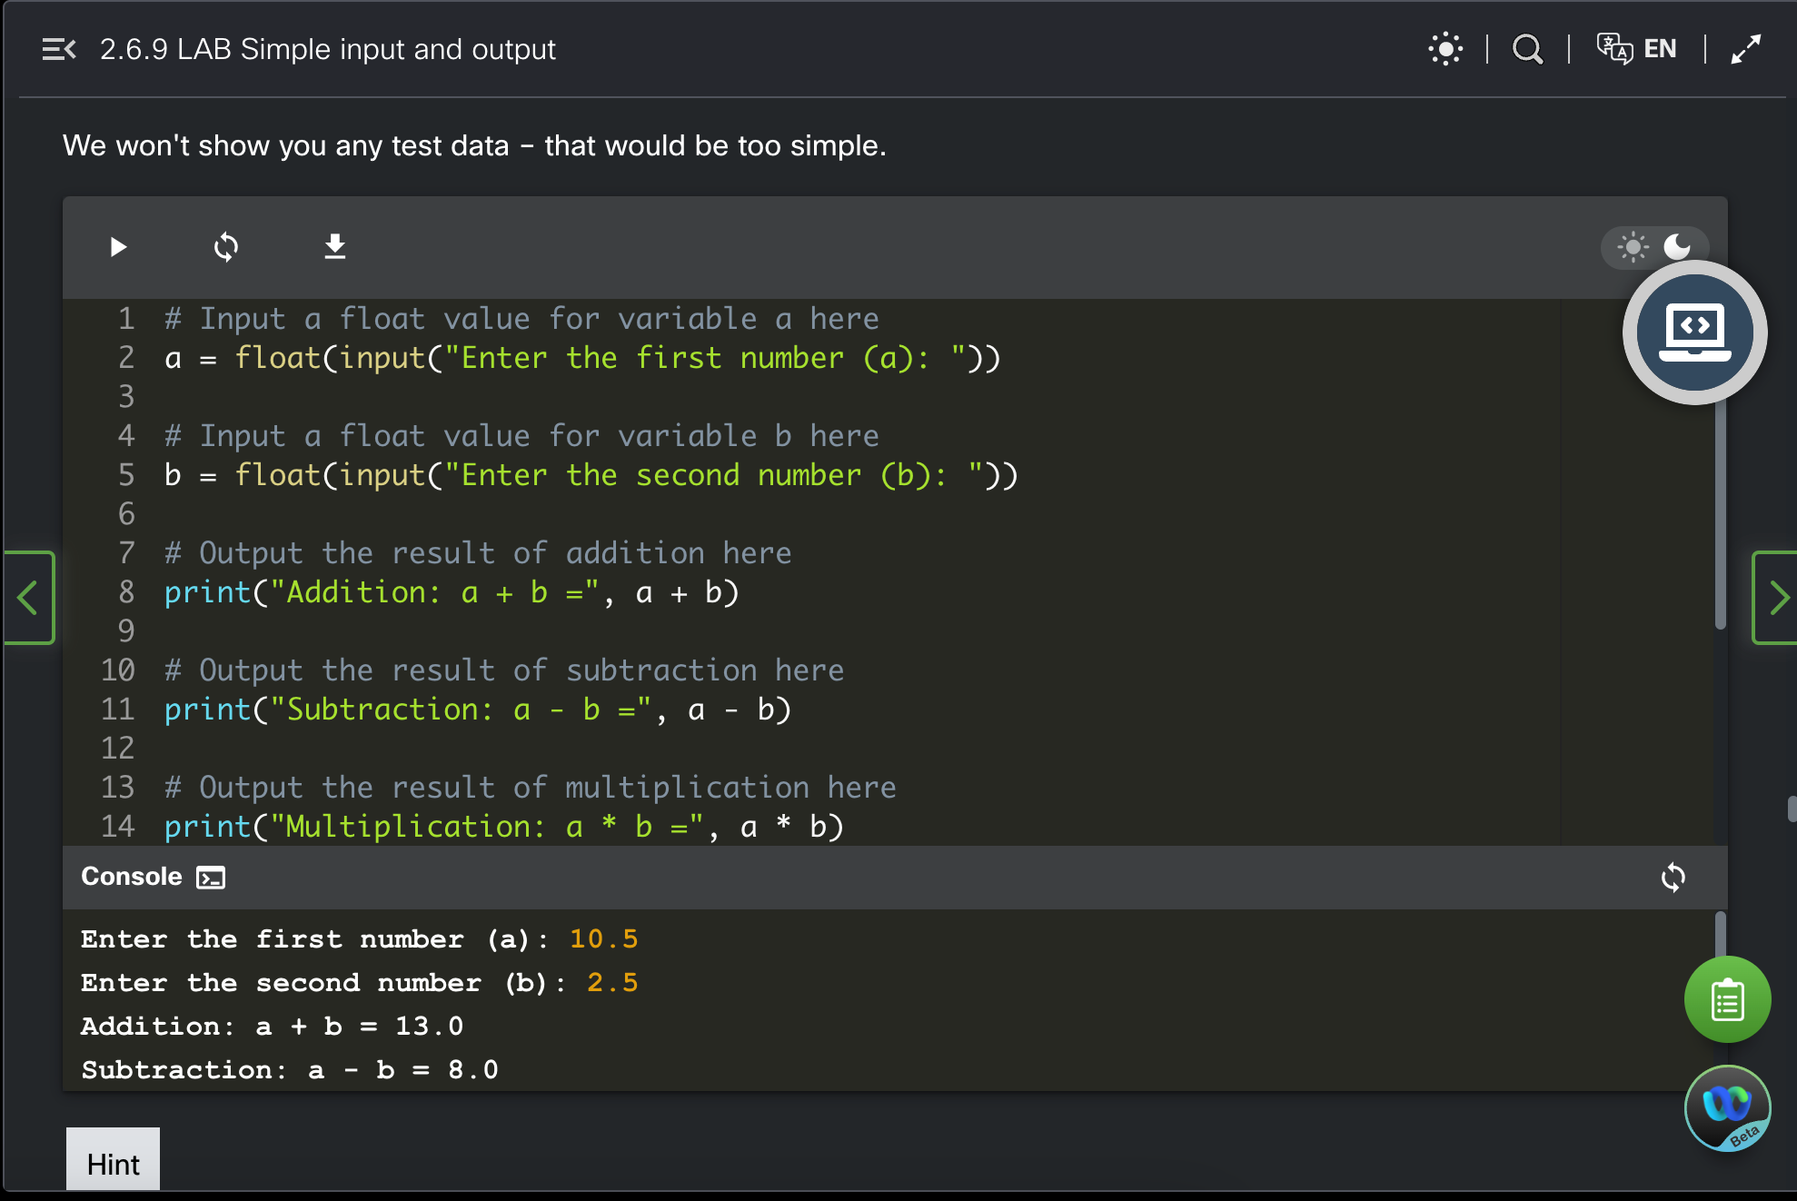

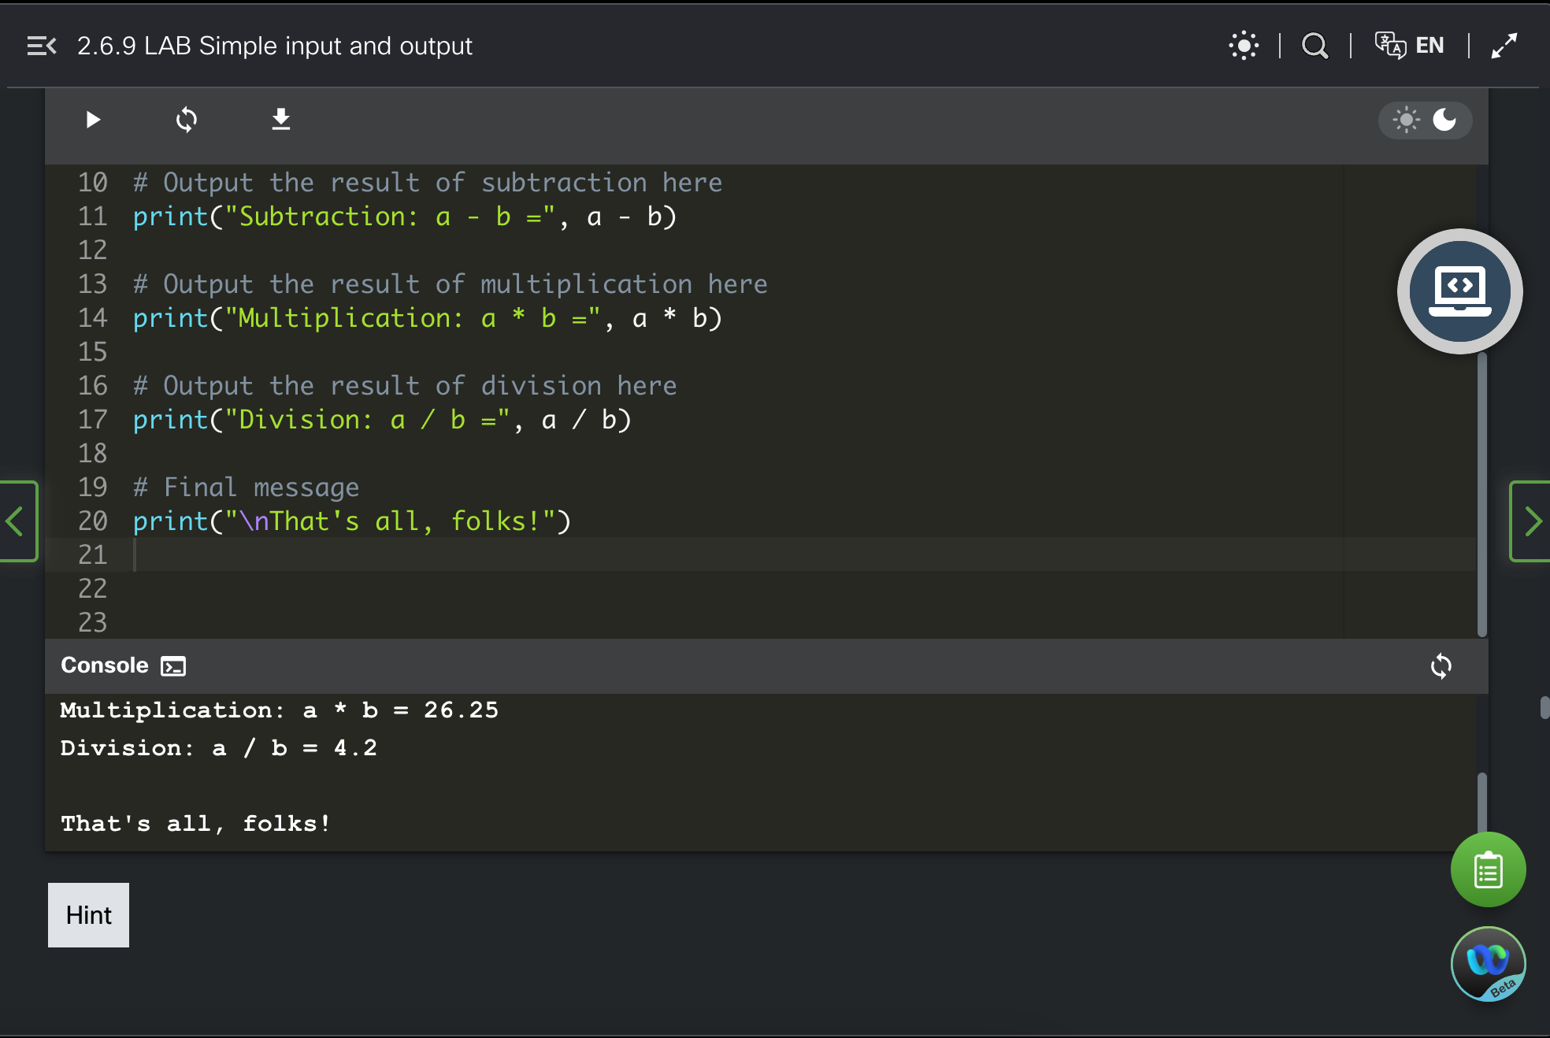

* 2.6.10 LAB Operators and expressions

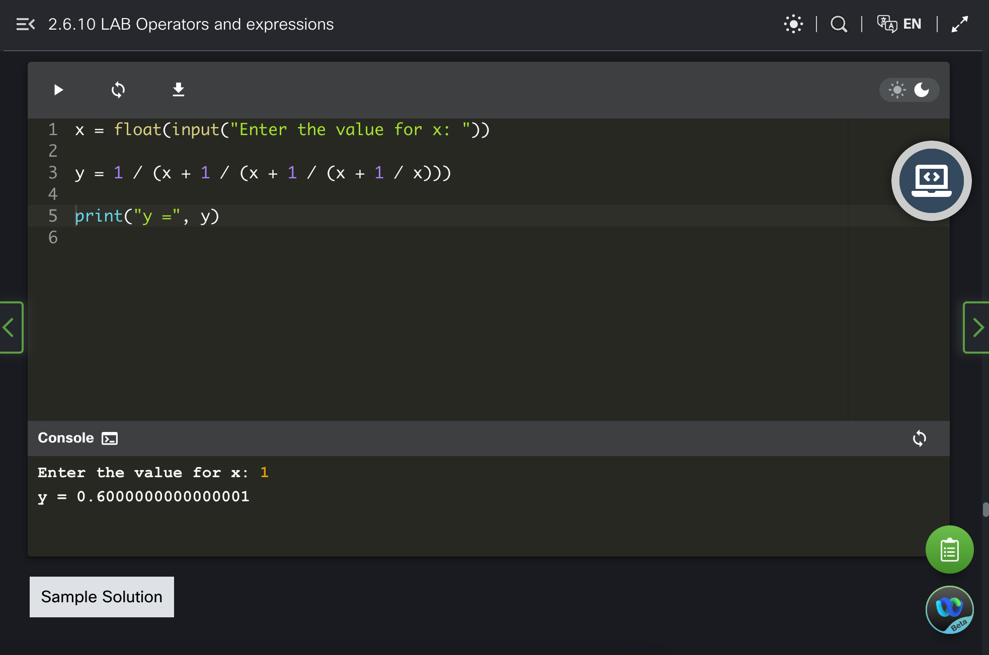

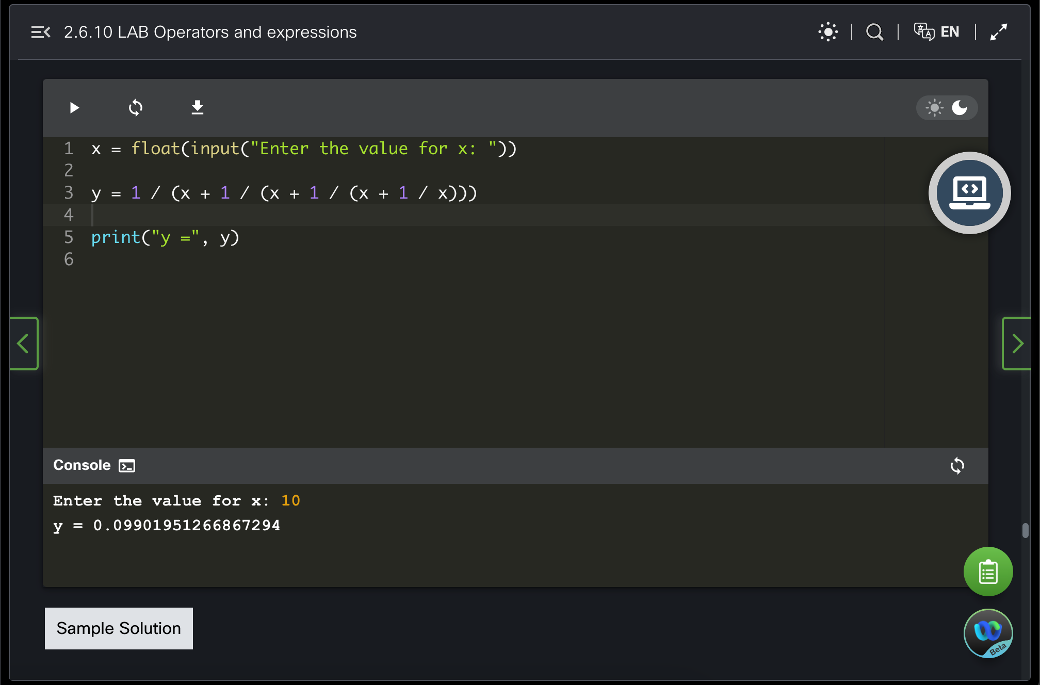

* 2.6.11 LAB Operators and expressions – 2

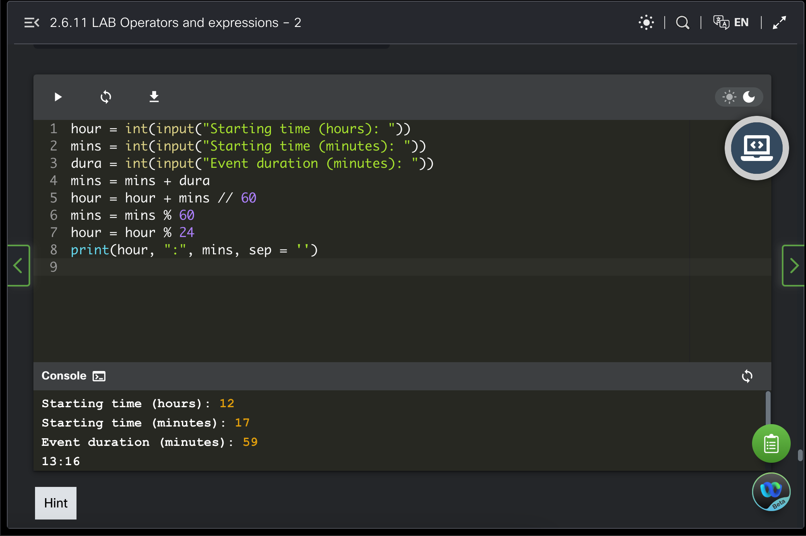

**Task 5. Sum up your report in several sentences in CONCLUSION (page 4 in this file).**

**Task 6. Please, name your file like in an example Surname_Name_Group**

**Task 7. Upload your REPORT of week 2 in Teams (Folder week 2)**

# **CONCLUSION**

Thanks to the second module, I learned the basics of Python. In the 6 sections that I went through, I wrote my first code, learned about Python literals, applied operations to solving mathematical problems, and learned how to apply variables. I also learned how to interact directly with the terminal using input and output.