Rehabilitation Systems

Submitted by
Adil Bin Azmoon

Department of Electrical and Computer Engineering

In partial fulfilment of the
requirements for the Degree of
Bachelor of Engineering
National University of Singapore
B. Eng Dissertation



Rehabilitation Systems

By
Adil Bin Azmoon
National University of Singapore
2019/2020

Project ID: H232100
Project Supervisor: Ravi Suppiah

Deliverables:
Report: 1Volume

Department of Electrical and Computer Engineering
National University of Singapore
2019/2020
Abstract
To improve a patient’s mobility and quality of life, physiotherapy is often the primary form of rehabilitation employed by clinicians. It often involves the use of mechanical equipment that encourages the patient to carry out repetitive exercises. Many of these exercises require consistent monitoring of the patient by the attending physiotherapist for data collation as well as maintenance of equipment. This paper proposes the use of a motion capture through depth sensor cameras that would allow patients to carry out their routine physiotherapy exercises outside of the confines of the physiotherapy sessions conducted by their attending physiotherapist.
This proposed system would allow data on the patient’s progress to be collected continuously for easy monitoring. It consists of the use of a Microsoft Kinect to track patient’s motions as well as Python, MongoDB, Express, React and node.js for software development.

Contents
1. List of Figures 6
2. List of Tables 7
3. Abbreviations 8
4. Introduction 9
4.1. Project Background 9
4.2. Problem Statement 9
4.3. Objectives 10
5. Literature Review 11
5.1. Sensors 12
5.2. Proposed Systems 13
5.3. System Architecture 15
5.4. Data Acquisition and Processing 20
5.5. Results and Discussion 21
5.6. Table 24
6. Gantt Chart 26
7. BOM 27
8. Implemented Design 28
8.1. Hardware 28
8.1.1. Depth Image Capturing 28
8.2. Software 29
8.2.1. Database 29
8.2.2. Server 31
8.2.3. Client 32
8.2.4. Machine Learning 37
9. Results and Analysis 38
10. Conclusion 43
10.1. Improvements 43
References 44

List of Figures
Figure 1: System employed by Baqai et al. [1] 16
Figure 2: System employed by Ortiz-Vigon Uriarte et al. [13] 19
Figure 3: Data Processing Block of Ortiz-Vigon Uriarte et al. [13] 19
Figure 4: Results Visualisation Block of Ortiz-Vigon Uriarte et al. [13] 19
Figure 5: Development Roadmap 26
Figure 6: System Architecture 28
Figure 7: Patient Schema Example 31
Figure 8: Doctor Schema Example 31
Figure 9: Data Submission Page 34
Figure 10: Data Visualisation Page 36
Figure 11: Convolutional Neural Network Architecture 37

List of Tables
Table 1: Table of proposals 24
Table 2: Bill of Materials 27
Table 3: Schema Format 30
Table 4: Back-end Package Dependencies 32
Table 5: Front-end Package Dependencies 33
Table 6: Metric Analyses of Systems 39

Abbreviations
CNN Convolutional Neural Network
BOM Bill of Materials
VR Virtual Reality
API Application Programming Interface

Introduction

Project Background
The advancement in both software and hardware technologies contribute greatly in the development of various industries on a global scale. This paper narrows in on the healthcare industry. In particular, the rehabilitative process experiences by patients and victims that have suffered loss of motor control. Such patients commonly undergo routine physiotherapy check-ups to ensure they recover control of their affected systems properly and efficiently.

Problem Statement
The effectiveness of physiotherapy relies heavily on the consistency of treatment sessions. Many patients are required to undergo a set physiotherapy schedule at the recommended pace as advised by their residing physiotherapist. Said sessions also encourage exercises to be continued at home by the patient to increase the rate of recovery.
This current system hinges on the discipline of the patients in adhering to the schedule. In cases where they are expected to visit the clinic for their sessions, it is more common for patients to miss sessions due to the need to commute. Furthermore, it is largely difficult for physiotherapists to ensure that their patients are carrying out the prescribed exercises at home, and also to record their patients’ progress. Therefore, there is a need to address this problem of inconsistency in physiotherapy treatments stemming from this pain points.

Objectives
The proposed system aims to tackle the abovementioned problems by developing an end-to-end rehabilitation monitoring system. This system will be easily accessible to both patients and physiotherapists via web application. Patients will be able to upload exercise snapshots and physical progress that can be easily downloaded and viewed by their physiotherapist.
The software of the application will incorporate machine learning:
- Convolutional Neural Network will be used in processing the patients current progress in rehabilitation
To complement the software, a depth sensing camera, such as the Microsoft Kinect, will be used to ensure highest levels of accuracy in training and validating the models as well as in tracking the patients’ progress.

Literature Review
VR equipment has advanced considerably in recent years. The Microsoft Kinect, which was introduced as a game controller, has since gained favour in the health care industry for its potential uses in physiotherapy. The use of VR has been proven to be beneficial in the treatment of diseases such as dementia [6] and Parkinson’s disease [8,9] in the rehabilitation of motor functions such as arm and hand movements. There have also been various applications that were developed utilizing VR to aid in rehabilitation [9].
Likewise, motion capture technology has seen much use in physiotherapy sessions as a way to accurately obtain insightful data on the progress of patients’ rehabilitation. Of recent development is the use of the Microsoft Kinect, initially released as a game controller, in such situations. Galna et al. [8] have conducted rigorous tests to ascertain the feasibility and accuracy of the Kinect against industry standard motion capture equipment such as the Vicom three dimensional motion analysis system (gold standard) and found that the Kinect has potential to be a low-cost, home-based substitute. Similarly Chang et al. [14] compared the fidelity of the OptiTrack optical system with the Kinect and showed that the Kinect can achieve competitive performance.
Over the years, the increased use of Microsoft Kinect to aid in physiotherapy and rehabilitation has been noticeable [1, 6-12]. Baqai et al. [1] utilizes Bio-feedback sensors connected to Arduino, Kinect and Oculus Rift (providing VR environment) connected to a PC running Unity. Their setup allowed for the measurement of head, neck, upper and lower limbs, and back motions together with step size by simulating an apple to be picked off of a tree. On the other hand, Baldominos et al. [12] opted to utilize the Intel RealSense, a similar motion capturing device, paired with the Oculus Rift to allow the patient to play a virtual soccer game that focused on abduction and adduction of movements of the right shoulder. Vigon Uriarte et al. [13] also measures upper limb motions using only the Kinect allowing the user to steer a car.
Other notable uses of motion capture technology, albeit without the use of the VR environment, are de Urturi Breton et al. [6] and Gonzlez-Ortega et al. [9], both utilizing a Kinect based system for rehabilitation.

Sensors
Baqai et al. [1] employed the use of bio-feedback sensors consisting of a Pulse Oximeter, galvanic skin response (GSR), temperature and respirations sensors, a Kinect sensor for motion capture, an Oculus Rift for VR display, a PC running Unity and providing interface to the Arduino and sensors.
Both De Urturi Breton et al. [6] and Gonzalez-Ortega et al. [9] utilized only a Kinect sensor as a form of data input together with a standard PC for data processing.
Baldominos et al. [12] used the Oculus Rift DK2 for VR display and the motion capturing sensor Intel RealSense in their approach.
Ortiz-Vigon Uriarte et al. [13] opted to use a Tobii Eye Tracker and a Kinect Sensor as user input devices together with bio-feedback sensors consisting of a Zephyr BioHarness 3, GSR sensor and electromyogram for recording EMG.

Proposed Systems
Baqai et al. [1]
Threshold values will be set on startup according to information entered by user. Following that, the user will enter the VR environment through the use of the Oculus Rift headset. Within the VR environment, the user will be able to see their avatar mimicking their movements. This is achieved by using the Microsoft Kinect Software Development Kit (SDK). As the user’s relative height is calculated on initialisation, the game arena will be set up accordingly. In this proposed setup, users are expected to pick fruits from trees, with the fruits being at varying heights requiring the user to both bend down and stretch upwards to complete objectives. Successful collection of fruits are indicated by auditory signals, and the user’s scores are available on screen as well. The user is given verbal instruction at the start of each game. Bio-feedback sensors read vital signs to ensure patient’s safety. If any threshold limits are exceeded, the patient will be recommended to take a break.
De Urturi Breton et al. [6]
The primary goal of the system is to improve memory, focusing specifically on the language area of the brain. A range of exercises of varying levels of difficulty are available so that an appropriate exercise will be given depending on the patient’s mental state. For example, there is an exercise where patients need to pick two syllables to combine to form a proper word. Another example would be an exercise where the patients must distinguish words that belong in a specific category (ie. supermarket). All the exercises are designed in a graphic way to increase user engagement. The user must utilize their hands, which are represented on the screen, to perform motion controls that will be read by the Kinect sensor. A set of configuration options are available to the user to make the application easier to use, such as changing modes between left hand, right hand or both hands.
Gonzalez-Ortega et al. [9]
The proposed system will need to be initialized by the user before the exercises may begin. This involves the user sitting or standing two meters away with their arms up in a horizontal position and forearms forming a 90 degree angle with the arms. This allows the system to calibrate its skeleton tracking feature. Once done, the user may sit closer, up to one meter from the Kinect. Various exercises will be given to the user involving touching different facial features with either hands. The system will monitor both hands, eyes and ears to distinguish incorrect and correct actions. A depth threshold is set such that if the differences in depth between two body parts are below the threshold, they are considered to be in the same plane. Therefore, the 2D coordinates are used in such a situation to determine if the body parts are in contact. The parameters and variables in the exercises can be adjusted by the attending physiotherapist or recorded for future reference.
Baldominos et al. [12]
The patient takes on the role of a goalkeeper in a simulated VR soccer game. The game will analyse the patient’s posture using the Intel Realsense and determine if the patient’s movements are correct. The rehabilitation session can be either supervised or autonomous. If supervised, the attending physiotherapist may adjust the frequency and position of incoming balls to suit the needs of the patient. The autonomous session will begin at low difficulty settings and will get progressively harder or easier based on the patient’s score.
Ortiz-Vigon Uriarte et al. [13]
The patient will be steering a car around obstacles in a three-lane carriageway. The proposed game can be played in two different modes that utilize different sensors as user input. The patient must first pick between the Kinect mode, which focuses on hand movements, or the Eye Tracker mode, which takes into account the position of the eye gaze. Depending on the mode, the user interface will differ slightly. After this, the patient may assign certain game parameters to their bio-feedback sensors (i.e the speed of their car rises proportionally to their recorded pulse). The game’s difficulty will increase accordingly with the patient’s progress in the game. The speed of the car and the number of obstacles will increase with difficulty. The game comes to an end once the petrol tank is empty.

System Architecture
Baqai et al. [1]
The bio-feedback sensors consist of a respiration sensor, pulse oximeter, temperature sensor and GSR sensor. The vital signs are read using the e-health sensor shield v2.0 for Arduino by Cooking Hacks Libelium. A wifi shield is mounted on the e-health sensor shield to allow for wireless connectivity and transmission of vital signs using the e-health library. TCP/IP is used to transmit the vital signs data packets to the data processing unit. The Kinect V1 serves as a form of skeletal tracking and to monitor upper and lower limbs activity. The Oculus Rift tracks the wearer’s head movements and provides angular measurements through its sensor fusion technology while providing the VR imagery on its stereo screens. Unity 5.5.0 was used as the game development engine and C# was used as the scripting language. All this data is fed to the data processing unit which hosts an algorithm that detects the strong and weak areas of the patients. The data processing unit will handle all processing, recording and visualization of data which can then be exported to the attending physiotherapist.
Figure 1: System employed by Baqai et al. [1]

De Urturi Breton et al. [6]
The application is designed in C# in Windows Presentation Foundation and provides support for multimedia, vector graphics, animations and content composition. It is developed in three layers: the presentation layer, business layer, and the database layer. The presentation layer constitutes the user interface and serves to display and capture the user’s information to be passed on to the business layer. The business layer houses the internal logic which is the core functionality of the system. An independent business layer allows for greater modularity as more exercises can be added into the application without compromises existing exercises. The business layer will receive data from the presentation layer which it can then send back to be displayed or passed down to the database layer to be stored. The database layer stores all patient data, such as personal particulars and progression within the application. This can be exported into a final report for the attending physiotherapist.
Gonzalez-Ortega et al. [9]
The system consists of two processing stages, the skeleton detection stage and the exercises monitoring stage. In the former, 3D skeleton detection is observed. This occurs in the initialization of the system, whereby the patient is required to stay two meters away from the camera with the entire body visible to extract skeletal joints. The 3D detection of the joints and later tracking are fulfilled through a library included in the NITE module of the OpenNI framework. Adjustments to the wrist joint are necessary depending on distance from the Kinect. Once skeleton detection is complete, the system moves forward to the second stage: exercises monitoring. The exercises monitoring stage can be further divided into 3D skeleton tracking, face detection, 3D facial feature detection and monitoring analysis for assessment of psychomotor exercises. With the face joint given by the skeleton tracking, facial detection is achieved using the face detector developed in the framework of the Open Computer Vision Library by Lien-hart et al. with the AdaBoost algorithm and based on Haar-like features [15]. With the face detected, an algorithm is used to differentiate facial features such as the eyes, nose and ears which are then used in the psychomotor assessment phase.
Ortiz-Vigon Uriarte et al. [13]
The system is split into 4 blocks: sensors selection and connection, game, data processing and data display. In the first block, the system makes an initial attempt to connect to all the sensors to determine their availability to the user. All sensors are connected via COM ports. As the pulsometer and respirometer are connected to the port via Bluetooth, the system will be the one that starts communication and will convey what is required of the sensors, after which the sensors start to transmit the relevant data. The Zephyr BioHarness tool will indicate a “ready to receive” status for General Data Packets (GDP). The data packet containing the specific values to enable it to be sent to the sensor will need to be formed. Similarly, the Arduino sensor for GSR and EMG will also communicate via data packets. The Eye Tracker is connected using the specific library from the Tobii SDK. The sensor will be kept waiting until data is required, whereby the data will be transmitted. Lastly, the Kinect sensor is checked to see if it is ready to receive such that once the system requests data, it will start to transmit. Within the game block, sensor data is being saved for subsequent display. Simultaneously, some sensor data can be used to affect the game directly. Therefore there is feedback between the game block and the next data processing block. The data packets received from the sensors will be read within the data processing block. This data will then be passed forward to the data display block to be displayed for the user or sent back to the game black to interact with the game environment directly.
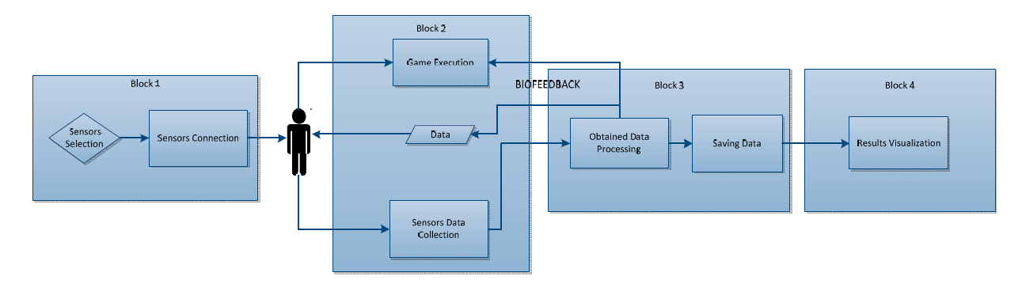
Figure 2: System employed by Ortiz-Vigon Uriarte et al. [13]
Figure 3: Data Processing Block of Ortiz-Vigon Uriarte et al. [13]
Figure 4: Results Visualisation Block of Ortiz-Vigon Uriarte et al. [13]

Data Acquisition and Processing
Baqai et al. [1]
Head and neck movements are measured in terms of yaw, pitch and roll. The Oculus Rift serves to track these axes movements through the integrated 3D gyroscope. 3D accelerometer and 3D magnetometer. The Oculus SDK helps to provide this raw data and also has a SensorFusion class that takes in the raw data and returns it in the form of rotation matrices, quaternions and Euler angles. The data on upper and lower limbs are collected through the Kinect sensor and processed using Matlab by performing simple trigonometric functions such as cosine rule and Pythagoras theorem. Data on back flexion and extension is collected and processed similarly. Data on step size is collected through the difference in depth of the user’s two ankles.
De Urturi Breton et al. [6]
As the Kinect sensor is utilized as an input device to keep the user engaged and motivated, the data from the sensor itself is not stored nor processed.
Ortiz-Vigon Uriarte et al. [13]
In the case of the Eye Tracker, the values of the X and Y exes of each eye are obtained from the sensor, after which the mean for X and mean for Y are calculated. These mean values are used as the input for the interface. As for the Kinect, the data is only processed to show the hand movement needed to control the game, by discriminating the whole body except the hands. The Zephyr BioHarness will send GDPs containing the pulse and breathing values. Within the GDP only positions 12 and 14 are pertinent – heart rate and breathing respectively.
Similarly, the EMG and GSR sensors send data packets in hexadecimal through the Arduino. The data packets are differentiable through the differing headings, A0 and A2. The GSR sensor reading has to be adjusted by calculation to obtain the real value. Once the pertinent data is obtained, it is all saved. In the case of the Eye Tracker, the data is saved in an XML file while the other physiological values are saved in TXT format.

Results and Discussion
Baqai et al. [1]
Tests were conducted with 3 healthy subjects and two Parkinson’s disease patients. All subjects’ vital signs stayed within normal ranges for the duration of the test, with an expected increase during periods of physical activity. The PD subjects’ areas of weakness, primarily their back for both patients and the right leg for one of the patients, were efficiently indicated as areas of weakness by the developed application. Subjects indicated a strong preference of a VR based exercise regimen as opposed to a regular one. Some drawbacks include high cost and high system requirements.
De Urturi Breton et al. [6]
Five experts took part in testing and providing feedback on the developed software. The survey reported positive results (93/140 points).

Gonzalez-Ortega et al. [9]
The system was tested in a research laboratory on 15 subjects: 10 healthy, 2 with frontal lobe injury and 3 with mild dementia. Errors were observed due to tendency for subjects to turn heads when carrying out exercises resulting in facial feature detection failing. Other reasons for failure are die to the depth value around the ears not being as low as the applied approach expected. The overall successful monitoring percentage was 96.28% and the system was considered adequate for rehabilitation experts at INTRAS Foundation. All participants found it easy to understand the exercises they had to do although two individuals with mild dementia said that they would need the support of a person to be ready to do the exercises in the future. Two individuals with mild dementia and one with frontal lobe injury said that they would prefer to have more time to do each exercise. One individual with mild dementia said that the environment with the screen and the Kinect was not comfortable. Two individuals with mild dementia and one with frontal lobe injury enjoyed doing the test and felt confident using the system after the 5 tests.
Baldominos et al. [12]
Four experts in the field of physiotherapy have tested the product. They agree that the motions performed during activity correspond to those required by a treatment of active kinesiotherapy. Furthermore, none of the experts experienced any nausea, dizziness or other side effects from the use of the VR headset. They also pointed out that the game could serve to allow patients to complete exercises on their own, without the need of an attending physiotherapist, although all agreed that there should be one present during the first session using the system. It was suggested that more variations of games be made available to keep patients engaged. During evaluation, all experts agreed on the potential of such technologies to be applied to physical rehabilitation
Ortiz-Vigon Uriarte et al. [13]
The SUS usability test conducted on 15 participants who tested the system returned a score of 72.333, which is considered good taking into account the fact that a core of 68 would be deemed acceptable. Many participants indicated a preference of the Eye Tracker over the Kinect is it was “original” and a “new feature”. The game received a largely positive evaluation in terms of usability and satisfaction.

Table
Table 1: Table of proposals
Literature | Sensors | Type of experiment | Targeted disease | Targeted therapy | Body parts involved
Attiya Baqai et al. (Baqai et al 2018) | - Kinect for Windows  - Oculus Rift  - Arduino e-Health sensor shield v2.0 (pulse, respiration, GSR, temperature) | Intra-subject | Parkinson’s disease | Physical | - Head  - Neck  - Upper limbs  - Lower limbs  - Back  - Step size
Zelai Saenz de Urturi Breton et al. (de Urturi Breton et al. 2012) | - Kinect for Windows | Intra-subject | Dementia | Mental | - Upper limbs
David Gonzalez-Ortega et al. (Gonzalez-Ortega et al. 2014) | - Kinect for Windows | Intra-subject | Dementia | Mental | - Upper limbs  - Head
Alejandro Baldominos et al. (Baldominos et al. 2015) | - Oculus Rift DK2  - Intel RealSense | Intra-subject | - | Physical | - Shoulder abduction and adduction
Inigo de Loyola Ortiz-Vigon Uriarte et al. (Uriarte et al. 2015) | - Tobii Eye Tracker  - Kinect for Windows  - Zephyr BioHarness 3  - Arduino e-Health sensor shield v2.0 (EMG, GSR) | Intra-subject | - | Physical | - Eyes  - Upper limbs

Gantt Chart
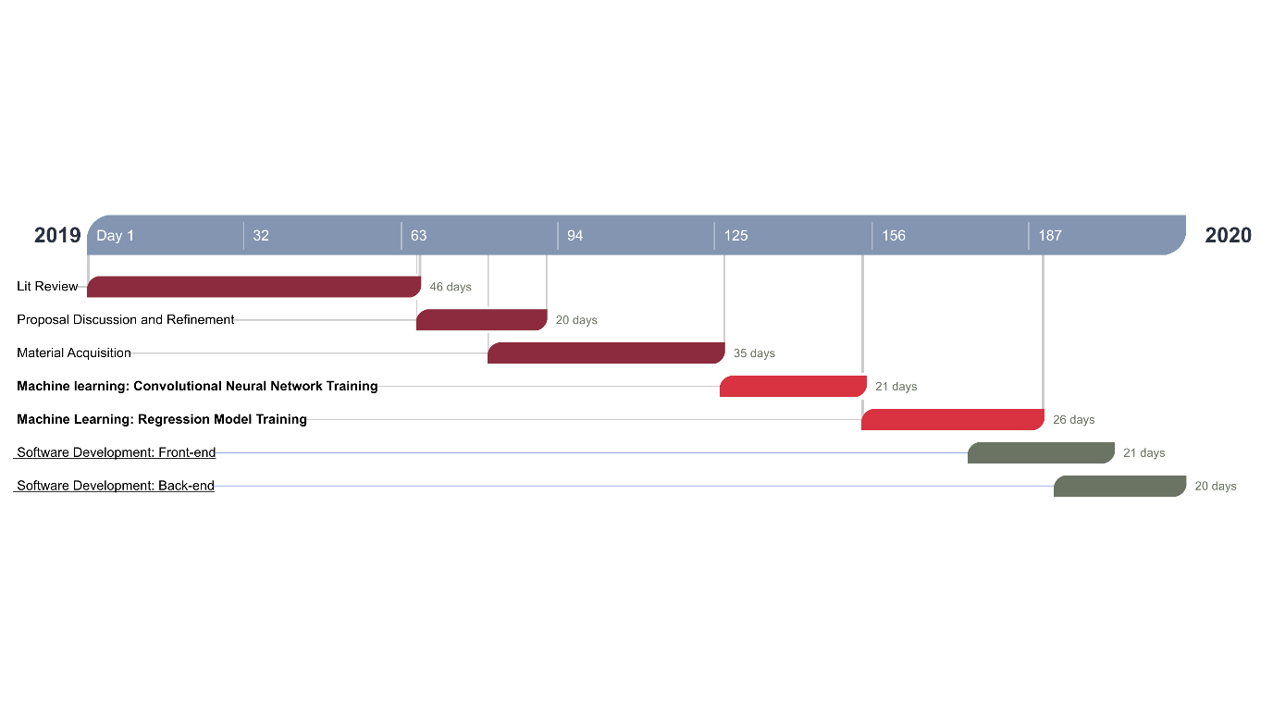
Figure 5: Development Roadmap

BOM
Table 2: Bill of Materials
Part Name | Description | Part Image | Quantity | Units | Supplier | Unit Cost (S$) | Total Part Cost (S$)
Microsoft Kinect | Depth sensor camera with motion capture functionalities | 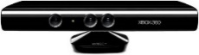 | 1 | 1 | Microsoft | 100 | 100
Total Parts: |  |  | 1 | Total Cost |  |  | 100

Implemented Design
The proposed system aims to integrate existing commercial hardware, such as the Microsoft Kinect, for ease of access.
The software development of the proposed system can be split into two main portions:
- The machine learning algorithms and models that are required to accurately classify patients’ progress and predict their rate of recovery.
- The end-to end full stack web application that will be accessed by both patients and physiotherapists.
Furthermore, the system focuses on shoulder injuries and range of motion exercises for the scope of this project.
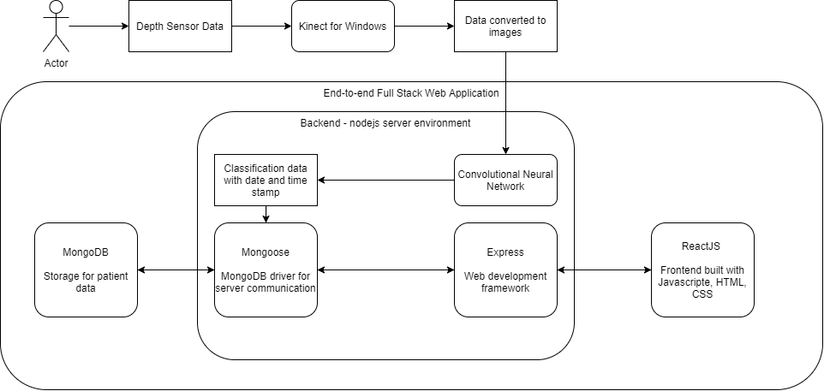
Figure 6: System Architecture

Hardware
For the purposes of maintaining accuracy and consistency for users, capturing of depth images of patients’ progress is necessary. The Kinect for Windows (2012 version) was therefore utilised as the tool for capturing of depth images.

Depth Image Capturing
The capture and processing of abovementioned images required the use of Matlab as a third party software as Matlab’s Image Acquisition Toolbox was compatible with the Kinect for Windows. Using Matlab scripts allow for depth images to be capture both in single images and in bulk for data processing purposes.

Software
As proposed in initial designs, the system was built on the largely popular full-stack: MERN. This comprises of MongoDB as a database, Express as a flexible web application framework, ReactJS as a library for front-end web interface development and node.js as a open source server environment. Outside of the full stack, Python 3.8.2 was used together with relevant packages, elaborated below, for Convolutional Neural Network training and testing.

Database
For the purposes of this system, MongoDB was employed as the database for patients’ and doctors’ data. MongoDB’s data model, called Schema, do not enforce document structure by default and would thus allow flexibility in modelling the data acquired by users. For the purposes of the initial implementation of the system, the following Schema was used.

Table 3: Schema Format
Key | Value structure | Possible values
User | String | “Patient” | “Doctor”
Name | String | Unique strings for each user
Email | String
Password | String
Data | Array of objects | Key | Value structure | Possible values
Data | Array of objects | date | DateTime object | Wed Mar 25 2015 08:00:00 GMT+0800 (Singapore Standard Time)
Data | Array of objects | result | Integer | [0,8] representing 9 possible classified results

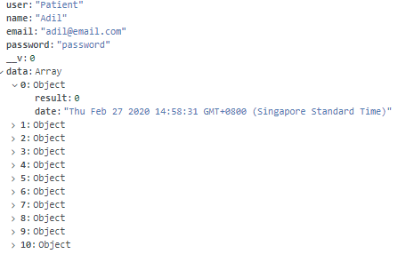
Figure 7: Patient Schema Example
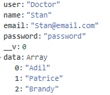
Figure 8: Doctor Schema Example

Server
The back-end server is designed to receive requests from the front-end client, process said requests by accessing the database and returning pertinent data. Data processing is done on the server to ensure security of user data. CNN machine learning model is also hosted and served directly from the server directory.
Back-end server is hosted on a node.js server environment with the following package dependencies.
Table 4: Back-end Package Dependencies
Dependency | Description
express | Web framework for node.js
body-parser | Parses incoming request bodies
concurrently | Runs multiple node commands for development troubleshooting
cors | Provides middleware to enable Cross Origin Resource Sharing
mongoose | MongoDB object modeling tool
morgan | HTTP request logger middleware
nodemon | Development tool that automatically restarts node.js environment when changes to file in the directory are detected.

Client
The front-end client is designed for ease of use, as the system is intended for public use. For this purpose, it handles two main roles for users: data submission and data visualisation.
Front-end client is hosted on node.js server environment with the following package dependencies.
Table 5: Front-end Package Dependencies
Dependency | Description
tfjs | Tensorflow library to serve compiled machine learning models.
axios | Promise based HTTP client for browsers and node.js. Handles HTTP requests from and to client.
bootstrap | Powerful front-end framework for web development.
canvasjs | Charts library for data visualization.
jquery | Feature-rich Javascript library. Necessary for Bootstrap framework.
react | Library for front-end web interface development.
react-router-dom | Library for React Router navigational components.

Data Submission
Patients can submit data in the form of depth images in PNG format through the front-end client. When the client loads the data submission page, it automatically requests the CNN model from the back-end server and hosts the model on the front-end itself. This allows users to upload the image, feed it into the model and receive the appropriate classification for the image. This classification data can then be submitted to the back end which then stores it in the database in the appropriate format.

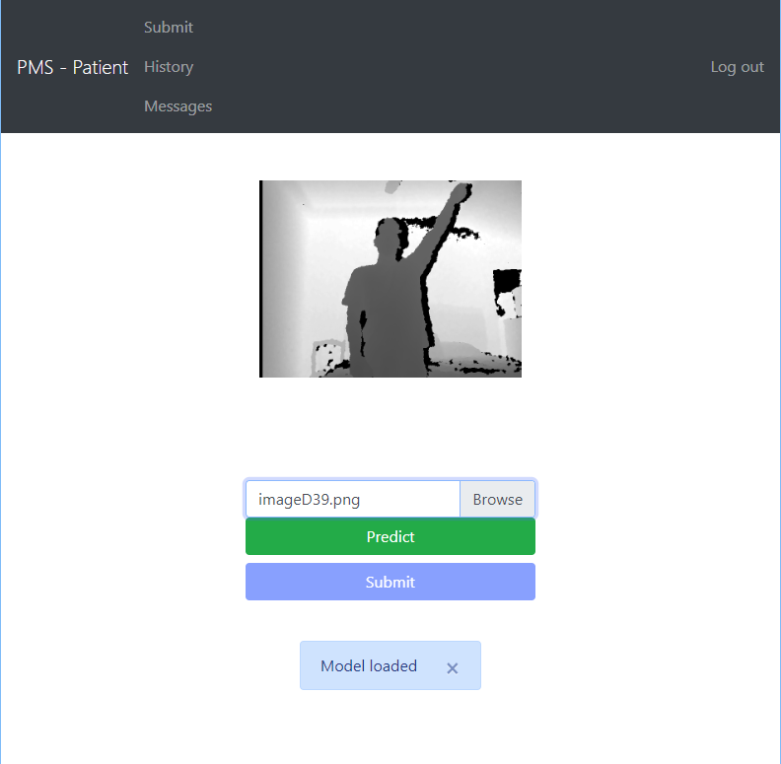
Figure 9: Data Submission Page

Data Visualisation
Patients can access and visualise their history of submitted data in the form of line graphs. Additionally, a best fit line is also displayed to provide users a rough indication of their recovery progress. Physiotherapists can access the data visualisation of all their patients in a similar fashion.

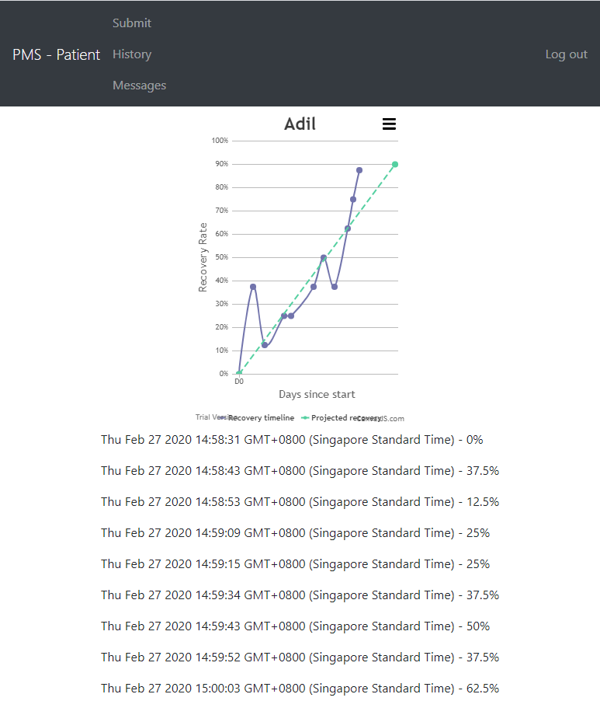
Figure 10: Data Visualisation Page

Machine Learning
The CNN was trained utilising Python 3.8.2 with the keras library, which is a high-level neural networks API. The CNN consists of 3 convolutional layers, 3 pooling layers followed by 2 fully connected layers
A CNN was chosen as the machine learning model of choice as this is the most popular neural network model for image classification. Training and testing were done on a set of 1800 images in a 90:10 ratio split respectively. It has proven to be sufficiently accurate in training and validation, achieving over 94% accuracy consistently. 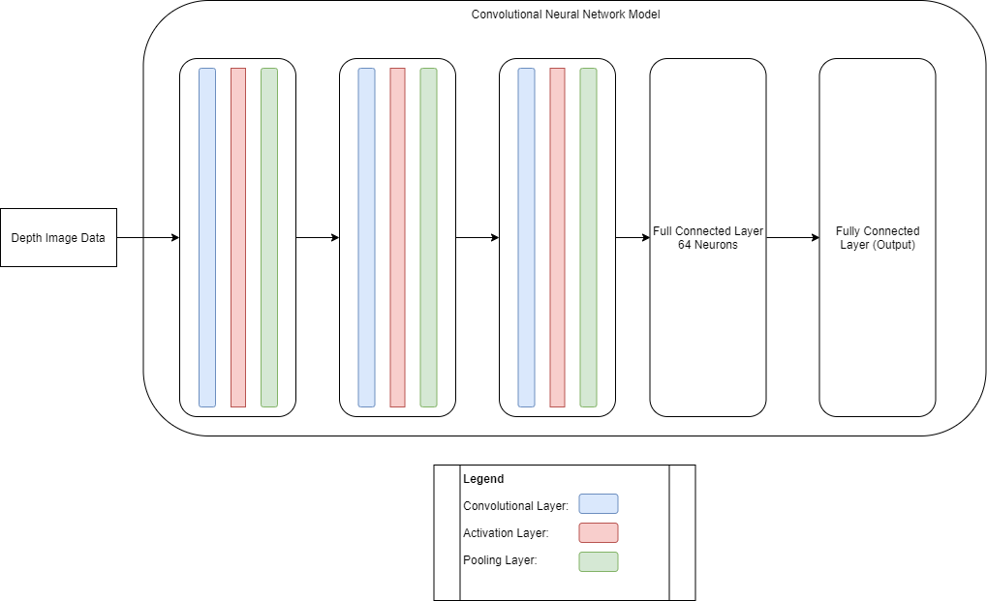
Figure 11: Convolutional Neural Network Architecture

Results and Analysis
To effectively analyse the effectiveness of the system, the following two performance metrics were taken into account: accessibility and efficiency from the perspective of the patient user. These two metrics were chosen as they directly address the problem statement: inconsistency in physiotherapy treatments stemming from patients’ unwillingness to follow a physiotherapy schedule due to inconveniences. An additional metric, effectiveness, will also be considered to measure the system’s viability in being used in various differing fields of physiotherapy. Furthermore, the system will be analysed against existing designs.

Table 6: Metric Analyses of Systems
 | Hardware Sensors | Accessibility | Efficiency | Effectiveness
Proposed and implemented system | - Kinect for Windows | The implemented full stack web application is accessible by most devices with updated browser applications and the Kinect for Windows is also a relatively inexpensive and commercially available product, making this implementation largely accessible. | Current implementation of image capture is slightly inefficient, requiring third party software, and basic understanding of scripts.  Data submission and visualization is kept extremely simple on the web application, allowing efficient use by patients. | The system is limited to only physiotherapy regimes that can see marked improvements through physical improvements in large muscle groups (i.e. limb mobility), due to the hardware limitations.
Attiya Baqai et al. (Baqai et al 2018) | - Kinect for Windows  - Oculus Rift  - Arduino e-Health sensor shield v2.0 (pulse, respiration, GSR, temperature) | The Oculus Rift and e-Heath sensors are high-cost equipment that may be largely inaccessible to patients of lower socio-economic status. | The use of the e-Health sensors can be extremely inefficient as they require an intermediate level of understanding of the equipment and software, and also requires a significant amount of time (>15 mins) to acquire data. | This implementation can find a use in and can be highly effective in a large majority of physiotherapy regimes due to the comprehensiveness of the equipment employed.
Alejandro Baldominos et al. (Baldominos et al. 2015) | - Oculus Rift DK2  - Intel RealSense | The Oculus Rift is a high-cost equipment that may be largely inaccessible to patients of lower socio-economic status. | Both the Oculus Rift and Intel RealSense can be operated by patient users as they are designed for commercial use. Depending on patient users’ own technological understanding, this system can be efficient but would still require a significantamount of time for data acquisition | This implementation can find a use in and can be highly effective in a large majority of physiotherapy regimes due to the comprehensiveness of the equipment employed.
Inigo de Loyola Ortiz-Vigon Uriarte et al. (Uriarte et al. 2015) | - Tobii Eye Tracker  - Kinect for Windows  - Zephyr BioHarness 3  - Arduino e-Health sensor shield v2.0 (EMG, GSR) | - The Oculus Rift, Zephyr BioHarness 3 and e-Heath sensors are high-cost equipment that may be largely inaccessible to patients of lower socio-economic status. | The use of the e-Health sensors and Zephyr BioHarness can be extremely inefficient as they require an intermediate level of understanding of the equipment and software, and also requires a significant amount of time (>15 mins) to acquire data. | This implementation can find a use in and can be highly effective in a large majority of physiotherapy regimes due to the comprehensiveness of the equipment employed.

It should be noted that the existing systems are inefficient mostly since such systems fulfil both physiotherapy rehabilitation monitoring as well as data acquisition while this paper’s system exclusively handles data acquisition and logging. This allows this system to be used in tandem with various differing physiotherapy rehabilitation regimes, where only the CNN is required to be adjusted according to the part of the body which is being rehabilitated.

Conclusion
This end-to-end physiotherapy data monitoring was designed to minimise patients’ pain points and inconveniences. By allowing them to log in their progress remotely through the systems web application, the patients would not have to physically attend supervised sessions with their attending physiotherapist as often. This would, in turn, encourage said patients follow their physiotherapy regimes, at home where applicable, more closely and consistently.

Improvements
Currently, the implemented design features basic functionalities, which is a log in page, data submission and data visualisation. Ideally, the system should be upgraded with beneficial features, such as a message system and a comprehensive editing tool for doctors and physiotherapists to be able to edit data on their end without having direct access to the database.
With regards to the hardware, the current implementation using Kinect for Windows and Matlab is far from ideal. The system can benefit greatly from more modern and advanced depth image capturing tools, such as the Azure Kinect 2019 or latest models of Intel Realsense. Utilising such tools together with their relevant package dependencies for node.js, it is possible for depth image capture to be done directly on the front end client, making for a significant improvement in efficiency, as the entire process can be done directly on the full stack web application.

References

1. Baqai, A., Memon, K., Memon, A., & Shah, S. (2018). Interactive Physiotherapy: An Application Based on Virtual Reality and Bio-feedback. Wireless Personal Communications, 106(4), 1719-1741. doi: 10.1007/s11277-018-5382-5
2. Fung, J. (2017). Gait and balance training using virtual reality is more effective for improving gait and balance ability after stroke than conventional training without virtual reality [commentary]. Journal Of Physiotherapy, 63(2), 114. doi: 10.1016/j.jphys.2017.02.010
3. Padilla-Castañeda, M., Sotgiu, E., Barsotti, M., Frisoli, A., Orsini, P., & Martiradonna, A. et al. (2018). An Orthopaedic Robotic-Assisted Rehabilitation Method of the Forearm in Virtual Reality Physiotherapy. Journal Of Healthcare Engineering, 2018, 1-20. doi: 10.1155/2018/7438609
4. Singh, D., Mohd Nordin, N., Aziz, N., Lim, B., & Soh, L. (2013). Effects of substituting a portion of standard physiotherapy time with virtual reality games among community-dwelling stroke survivors. BMC Neurology, 13(1). doi: 10.1186/1471-2377-13-199
5. Virtual Reality for Physical and Motor Rehabilitation. (2014). Virtual Reality Technologies For Health And Clinical Applications. doi: 10.1007/978-1-4939-0968-1
6. de Urturi Breton, Z. S., Zapirain, B. G., & Zorrilla, A. M. (2012). KiMentia: Kinect based tool to help cognitive stimulation for individuals with dementia. In 2012 IEEE 14th international conference one-health networking, applications and services, Healthcom 2012 (pp. 325–328).
7. Pompeu, J. E., Arduini, L. A., Botelho, A. R., Fonseca, M. B. F., Pompeu, S. M. A. A., Torriani-Pasin, C., et al. (2014). Feasibility, safety and outcomes of playing Kinect Adventures! For people with Parkinson’s disease: A pilot study. Physiotherapy (United Kingdom), 100(2), 162–168.
8. Galna, B., Barry, G., Jackson, D., Mhiripiri, D., Olivier, P., & Rochester, L. (2014). Accuracy of the Microsoft Kinect sensor for measuring movement in people with Parkinson’s disease. Gait and Posture, 39(4), 1062–1068.
9. Gonzalez-Ortega, D., Daz-Pernas, F. J., Martinez-Zarzuela, M., & Antn-Rodrguez, M. (2014). A Kinect-based system for cognitive rehabilitation exercises monitoring. Computer Methods and Programs in Biomedicine, 113(2), 620–631.
10. Gieser, S. N., Metsis, V. & Makedon, F. (2014). Quantitative evaluation of the Kinect skeleton tracker for physical rehabilitation exercises. In Proceedings of the 7th international conference on Pervasive technologies related to assistive environments (p. 48). ACM.
11. Huber, M. E., Seitz, A. L., Leeser, M., & Sternad, D. (2014). Validity and reliability of Kinect for measuring shoulder joint angles. In 2014 40th annual northeast bioengineering conference (NEBEC) (pp. 1–2). IEEE. http://ieeexplore.ieee.org/lpdocs/epic03/wrapper.htm?arnumber=6972818.
12. Baldominos, A., Saez, Y., & del Pozo, C. G. (2015). An approach to physical rehabilitation using stateof-the-art virtual reality and motion tracking technologies. Procedia Computer Science, 64, 10–16.
13. Ortiz-Vigon Uriarte, I. L., Garcia-Zapirain, B., & Garcia-Chimeno, Y. (2015). Game design to measure reflexes and attention based on biofeedback multi-sensor interaction. Sensors, 15(3), 6520–6548.
14. Chang, C.-Y., Lange, B., Zhang, M., Koenig, S., Requejo, P., Somboon, N., Sawchuk, A.A., Rizzo, A., Towards pervasive physical rehabilitation using Microsoft Kinect, in: Proceedings of the International Conference on Pervasive Computing Technologies for Healthcare, 2012, pp. 159–162.
15. R. Lienhart, A. Kuranov, V. Pisarevsky, Empirical analysis ofdetection cascades of boosted classifiers for rapid objectdetection, in: Proceedings of the DAGM-Symposium, 2003,pp. 297–304.

Code
https://github.com/adileyzekmoon/FYP_2020
Rehabilitation Systems

Adil Bin Azmoon
Department of Electrical and Computer Engineering
National University of Singapore
Singapore
e0031995@u.nus.edu

Abstract— To improve a patient’s mobility and quality of life, physiotherapy is often the primary form of rehabilitation employed by clinicians. It often involves the use of mechanical equipment that encourages the patient to carry out repetitive exercises. Many of these exercises require consistent monitoring of the patient by the attending physiotherapist for data collation as well as maintenance of equipment. This paper proposes the use of a motion capture through depth sensor cameras that would allow patients to carry out their routine physiotherapy exercises outside of the confines of the physiotherapy sessions conducted by their attending physiotherapist.
This proposed system would allow data on the patient’s progress to be collected continuously for easy monitoring. It consists of the use of a Microsoft Kinect to track patient’s motions as well as Python, MongoDB, Express, React and node.js for software development.
Keywords—CNN,

Introduction (Heading 1)
The advancement in both software and hardware technologies contribute greatly in the development of various industries on a global scale. This paper narrows in on the healthcare industry. In particular, the rehabilitative process experiences by patients and victims that have suffered loss of motor control. Such patients commonly undergo routine physiotherapy check-ups to ensure they recover control of their affected systems properly and efficiently.
The effectiveness of physiotherapy relies heavily on the consistency of treatment sessions. Many patients are required to undergo a set physiotherapy schedule at the recommended pace as advised by their residing physiotherapist. Said sessions also encourage exercises to be continued at home by the patient to increase the rate of recovery.
This current system hinges on the discipline of the patients in adhering to the schedule. In cases where they are expected to visit the clinic for their sessions, it is more common for patients to miss sessions due to the need to commute. Furthermore, it is largely difficult for physiotherapists to ensure that their patients are carrying out the prescribed exercises at home, and also to record their patients’ progress. Therefore, there is a need to address this problem of inconsistency in physiotherapy treatments stemming from this pain points.
The proposed system aims to tackle the abovementioned problems by developing an end-to-end rehabilitation monitoring system. This system will be easily accessible to both patients and physiotherapists via web application. Patients will be able to upload exercise snapshots and physical progress that can be easily downloaded and viewed by their physiotherapist.
The software of the application will incorporate machine learning:
- Convolutional Neural Network will be used in processing the patients current progress in rehabilitation
To complement the software, a depth sensing camera, such as the Microsoft Kinect, will be used to ensure highest levels of accuracy in training and validating the models as well as in tracking the patients’ progress.

Related Work
VR equipment has advanced considerably in recent years. The Microsoft Kinect, which was introduced as a game controller, has since gained favour in the health care industry for its potential uses in physiotherapy. The use of VR has been proven to be beneficial in the treatment of diseases such as dementia [6] and Parkinson’s disease [8,9] in the rehabilitation of motor functions such as arm and hand movements. There have also been various applications that were developed utilizing VR to aid in rehabilitation [9].
Likewise, motion capture technology has seen much use in physiotherapy sessions as a way to accurately obtain insightful data on the progress of patients’ rehabilitation. Of recent development is the use of the Microsoft Kinect, initially released as a game controller, in such situations. Galna et al. [8] have conducted rigorous tests to ascertain the feasibility and accuracy of the Kinect against industry standard motion capture equipment such as the Vicom three dimensional motion analysis system (gold standard) and found that the Kinect has potential to be a low-cost, home-based substitute. Similarly Chang et al. [14] compared the fidelity of the OptiTrack optical system with the Kinect and showed that the Kinect can achieve competitive performance.
Over the years, the increased use of Microsoft Kinect to aid in physiotherapy and rehabilitation has been noticeable [1, 6-12]. Baqai et al. [1] utilizes Bio-feedback sensors connected to Arduino, Kinect and Oculus Rift (providing VR environment) connected to a PC running Unity. Their setup allowed for the measurement of head, neck, upper and lower limbs, and back motions together with step size by simulating an apple to be picked off of a tree. On the other hand, Baldominos et al. [12] opted to utilize the Intel RealSense, a similar motion capturing device, paired with the Oculus Rift to allow the patient to play a virtual soccer game that focused on abduction and adduction of movements of the right shoulder. Vigon Uriarte et al. [13] also measures upper limb motions using only the Kinect allowing the user to steer a car.
Other notable uses of motion capture technology, albeit without the use of the VR environment, are de Urturi Breton et al. [6] and Gonzlez-Ortega et al. [9], both utilizing a Kinect based system for rehabilitation.
Baqai et al. [1] employed the use of bio-feedback sensors consisting of a Pulse Oximeter, galvanic skin response (GSR), temperature and respirations sensors, a Kinect sensor for motion capture, an Oculus Rift for VR display, a PC running Unity and providing interface to the Arduino and sensors.
Both De Urturi Breton et al. [6] and Gonzalez-Ortega et al. [9] utilized only a Kinect sensor as a form of data input together with a standard PC for data processing.
Baldominos et al. [12] used the Oculus Rift DK2 for VR display and the motion capturing sensor Intel RealSense in their approach.
Ortiz-Vigon Uriarte et al. [13] opted to use a Tobii Eye Tracker and a Kinect Sensor as user input devices together with bio-feedback sensors consisting of a Zephyr BioHarness 3, GSR sensor and electromyogram for recording EMG.

Baqai et al. [1]
Threshold values will be set on startup according to information entered by user. Following that, the user will enter the VR environment through the use of the Oculus Rift headset. Within the VR environment, the user will be able to see their avatar mimicking their movements. This is achieved by using the Microsoft Kinect Software Development Kit (SDK). As the user’s relative height is calculated on initialisation, the game arena will be set up accordingly. In this proposed setup, users are expected to pick fruits from trees, with the fruits being at varying heights requiring the user to both bend down and stretch upwards to complete objectives. Successful collection of fruits are indicated by auditory signals, and the user’s scores are available on screen as well. The user is given verbal instruction at the start of each game. Bio-feedback sensors read vital signs to ensure patient’s safety. If any threshold limits are exceeded, the patient will be recommended to take a break.
Tests were conducted with 3 healthy subjects and two Parkinson’s disease patients. All subjects’ vital signs stayed within normal ranges for the duration of the test, with an expected increase during periods of physical activity. The PD subjects’ areas of weakness, primarily their back for both patients and the right leg for one of the patients, were efficiently indicated as areas of weakness by the developed application. Subjects indicated a strong preference of a VR based exercise regimen as opposed to a regular one. Some drawbacks include high cost and high system requirements.

De Urturi Breton et al. [6]
The primary goal of the system is to improve memory, focusing specifically on the language area of the brain. A range of exercises of varying levels of difficulty are available so that an appropriate exercise will be given depending on the patient’s mental state. For example, there is an exercise where patients need to pick two syllables to combine to form a proper word. Another example would be an exercise where the patients must distinguish words that belong in a specific category (ie. supermarket). All the exercises are designed in a graphic way to increase user engagement. The user must utilize their hands, which are represented on the screen, to perform motion controls that will be read by the Kinect sensor. A set of configuration options are available to the user to make the application easier to use, such as changing modes between left hand, right hand or both hands.
Five experts took part in testing and providing feedback on the developed software. The survey reported positive results (93/140 points).

Gonzalez-Ortega et al. [9]
The proposed system will need to be initialized by the user before the exercises may begin. This involves the user sitting or standing two meters away with their arms up in a horizontal position and forearms forming a 90 degree angle with the arms. This allows the system to calibrate its skeleton tracking feature. Once done, the user may sit closer, up to one meter from the Kinect. Various exercises will be given to the user involving touching different facial features with either hands. The system will monitor both hands, eyes and ears to distinguish incorrect and correct actions. A depth threshold is set such that if the differences in depth between two body parts are below the threshold, they are considered to be in the same plane. Therefore, the 2D coordinates are used in such a situation to determine if the body parts are in contact. The parameters and variables in the exercises can be adjusted by the attending physiotherapist or recorded for future reference.
The system was tested in a research laboratory on 15 subjects: 10 healthy, 2 with frontal lobe injury and 3 with mild dementia. Errors were observed due to tendency for subjects to turn heads when carrying out exercises resulting in facial feature detection failing. Other reasons for failure are die to the depth value around the ears not being as low as the applied approach expected. The overall successful monitoring percentage was 96.28% and the system was considered adequate for rehabilitation experts at INTRAS Foundation. All participants found it easy to understand the exercises they had to do although two individuals with mild dementia said that they would need the support of a person to be ready to do the exercises in the future. Two individuals with mild dementia and one with frontal lobe injury said that they would prefer to have more time to do each exercise. One individual with mild dementia said that the environment with the screen and the Kinect was not comfortable. Two individuals with mild dementia and one with frontal lobe injury enjoyed doing the test and felt confident using the system after the 5 tests.

Baldominos et al. [12]
The patient takes on the role of a goalkeeper in a simulated VR soccer game. The game will analyse the patient’s posture using the Intel Realsense and determine if the patient’s movements are correct. The rehabilitation session can be either supervised or autonomous. If supervised, the attending physiotherapist may adjust the frequency and position of incoming balls to suit the needs of the patient. The autonomous session will begin at low difficulty settings and will get progressively harder or easier based on the patient’s score.
Four experts in the field of physiotherapy have tested the product. They agree that the motions performed during activity correspond to those required by a treatment of active kinesiotherapy. Furthermore, none of the experts experienced any nausea, dizziness or other side effects from the use of the VR headset. They also pointed out that the game could serve to allow patients to complete exercises on their own, without the need of an attending physiotherapist, although all agreed that there should be one present during the first session using the system. It was suggested that more variations of games be made available to keep patients engaged. During evaluation, all experts agreed on the potential of such technologies to be applied to physical rehabilitation

Ortiz-Vigon Uriarte et al. [13]
The patient will be steering a car around obstacles in a three-lane carriageway. The proposed game can be played in two different modes that utilize different sensors as user input. The patient must first pick between the Kinect mode, which focuses on hand movements, or the Eye Tracker mode, which takes into account the position of the eye gaze. Depending on the mode, the user interface will differ slightly. After this, the patient may assign certain game parameters to their bio-feedback sensors (i.e the speed of their car rises proportionally to their recorded pulse). The game’s difficulty will increase accordingly with the patient’s progress in the game. The speed of the car and the number of obstacles will increase with difficulty. The game comes to an end once the petrol tank is empty.
The SUS usability test conducted on 15 participants who tested the system returned a score of 72.333, which is considered good taking into account the fact that a core of 68 would be deemed acceptable. Many participants indicated a preference of the Eye Tracker over the Kinect is it was “original” and a “new feature”. The game received a largely positive evaluation in terms of usability and satisfaction.

Design proposal and implementation
The proposed system aims to integrate existing commercial hardware, such as the Microsoft Kinect, for ease of access.
The software development of the proposed system can be split into two main portions:
1. The machine learning algorithms and models that are required to accurately classify patients’ progress and predict their rate of recovery.
2. The end-to end full stack web application that will be accessed by both patients and physiotherapists.
Furthermore, the system focuses on shoulder injuries and range of motion exercises for the scope of this project.

Hardware
For the purposes of maintaining accuracy and consistency for users, capturing of depth images of patients’ progress is necessary. The Kinect for Windows (2012 version) was therefore utilised as the tool for capturing of depth images.
The capture and processing of abovementioned images required the use of Matlab as a third party software as Matlab’s Image Acquisition Toolbox was compatible with the Kinect for Windows. Using Matlab scripts allow for depth images to be capture both in single images and in bulk for data processing purposes.

Software
As proposed in initial designs, the system was built on the largely popular full-stack: MERN. This comprises of MongoDB as a database, Express as a flexible web application framework, ReactJS as a library for front-end web interface development and node.js as a open source server environment. Outside of the full stack, Python 3.8.2 was used together with relevant packages, elaborated below, for Convolutional Neural Network training and testing.
For the purposes of this system, MongoDB was employed as the database for patients’ and doctors’ data. MongoDB’s data model, called Schema, do not enforce document structure by default and would thus allow flexibility in modelling the data acquired by users. For the purposes of the initial implementation of the system, the following Schema was used.

Key | Value Structure | Possible Values
User | String | “Patient” | “Doctor”
Name | String | Unique strings for each user
Email | String
Password | String
Data | Array of objects | Key | Value Structure | Possible Values
Data | Array of objects | Date | DateTime object | Wed Mar 25 2015 08:00:00 GMT+0800 (Singapore Standard Time)
Data | Array of objects | Result | integer | [0,8] representing 9 possible classified results

The back-end server is designed to receive requests from the front-end client, process said requests by accessing the database and returning pertinent data. Data processing is done on the server to ensure security of user data. CNN machine learning model is also hosted and served directly from the server directory.
Back-end server is hosted on a node.js server environment with the following package dependencies.
Dependency | Description
express | Web framework for node.js
body-parser | Parses incoming request bodies
concurrently | Runs multiple node commands for development troubleshooting
cors | Provides middleware to enable Cross Origin Resource Sharing
mongoose | MongoDB object modeling tool
morgan | HTTP request logger middleware
nodemon | Development tool that automatically restarts node.js environment when changes to file in the directory are detected.

The front-end client is designed for ease of use, as the system is intended for public use. For this purpose, it handles two main roles for users: data submission and data visualisation.
Front-end client is hosted on node.js server environment with the following package dependencies.
Dependency | Description
tfjs | Tensorflow library to serve compiled machine learning models.
axios | Promise based HTTP client for browsers and node.js. Handles HTTP requests from and to client.
bootstrap | Powerful front-end framework for web development.
canvasjs | Charts library for data visualization.
jquery | Feature-rich Javascript library. Necessary for Bootstrap framework.
react | Library for front-end web interface development.
react-router-dom | Library for React Router navigational components.

Patients can submit data in the form of depth images in PNG format through the front-end client. When the client loads the data submission page, it automatically requests the CNN model from the back-end server and hosts the model on the front-end itself. This allows users to upload the image, feed it into the model and receive the appropriate classification for the image. This classification data can then be submitted to the back end which then stores it in the database in the appropriate format.
Patients can access and visualise their history of submitted data in the form of line graphs. Additionally, a best fit line is also displayed to provide users a rough indication of their recovery progress. Physiotherapists can access the data visualisation of all their patients in a similar fashion.
The CNN was trained utilising Python 3.8.2 with the keras library, which is a high-level neural networks API. The CNN consists of 3 convolutional layers, 3 pooling layers followed by 2 fully connected layers
A CNN was chosen as the machine learning model of choice as this is the most popular neural network model for image classification. Training and testing were done on a set of 1800 images in a 90:10 ratio split respectively. It has proven to be sufficiently accurate in training and validation, achieving over 94% accuracy consistently.

Results and Analysis
To effectively analyse the effectiveness of the system, the following two performance metrics were taken into account: accessibility and efficiency from the perspective of the patient user. These two metrics were chosen as they directly address the problem statement: inconsistency in physiotherapy treatments stemming from patients’ unwillingness to follow a physiotherapy schedule due to inconveniences. An additional metric, effectiveness, will also be considered to measure the system’s viability in being used in various differing fields of physiotherapy.

Conclusion and Improvements
This end-to-end physiotherapy data monitoring was designed to minimise patients’ pain points and inconveniences. By allowing them to log in their progress remotely through the systems web application, the patients would not have to physically attend supervised sessions with their attending physiotherapist as often. This would, in turn, encourage said patients follow their physiotherapy regimes, at home where applicable, more closely and consistently.
Currently, the implemented design features basic functionalities, which is a log in page, data submission and data visualisation. Ideally, the system should be upgraded with beneficial features, such as a message system and a comprehensive editing tool for doctors and physiotherapists to be able to edit data on their end without having direct access to the database.
With regards to the hardware, the current implementation using Kinect for Windows and Matlab is far from ideal. The system can benefit greatly from more modern and advanced depth image capturing tools, such as the Azure Kinect 2019 or latest models of Intel Realsense. Utilising such tools together with their relevant package dependencies for node.js, it is possible for depth image capture to be done directly on the front end client, making for a significant improvement in efficiency, as the entire process can be done directly on the full stack web application.
Hardware Sensors | Accessibility | Efficiency | Effectiveness
Kinect for Windows | The implemented full stack web application is accessible by most devices with updated browser applications and the Kinect for Windows is also a relatively inexpensive and commercially available product, making this implementation largely accessible. | Current implementation of image capture is slightly inefficient, requiring third party software, and basic understanding of scripts.  Data submission and visualization is kept extremely simple on the web application, allowing efficient use by patients. | The system is limited to only physiotherapy regimes that can see marked improvements through physical improvements in large muscle groups (i.e. limb mobility), due to the hardware limitations.

References

- Baqai, A., Memon, K., Memon, A., & Shah, S. (2018). Interactive Physiotherapy: An Application Based on Virtual Reality and Bio-feedback. Wireless Personal Communications, 106(4), 1719-1741. doi: 10.1007/s11277-018-5382-5
- Fung, J. (2017). Gait and balance training using virtual reality is more effective for improving gait and balance ability after stroke than conventional training without virtual reality [commentary]. Journal Of Physiotherapy, 63(2), 114. doi: 10.1016/j.jphys.2017.02.010
- 3. Padilla-Castañeda, M., Sotgiu, E., Barsotti, M., Frisoli, A., Orsini, P., & Martiradonna, A. et al. (2018). An Orthopaedic Robotic-Assisted Rehabilitation Method of the Forearm in Virtual Reality Physiotherapy. Journal Of Healthcare Engineering, 2018, 1-20. doi: 10.1155/2018/7438609
- Singh, D., Mohd Nordin, N., Aziz, N., Lim, B., & Soh, L. (2013). Effects of substituting a portion of standard physiotherapy time with virtual reality games among community-dwelling stroke survivors. BMC Neurology, 13(1). doi: 10.1186/1471-2377-13-199
- Virtual Reality for Physical and Motor Rehabilitation. (2014). Virtual Reality Technologies For Health And Clinical Applications. doi: 10.1007/978-1-4939-0968-1
- de Urturi Breton, Z. S., Zapirain, B. G., & Zorrilla, A. M. (2012). KiMentia: Kinect based tool to help cognitive stimulation for individuals with dementia. In 2012 IEEE 14th international conference one-health networking, applications and services, Healthcom 2012 (pp. 325–328).
- Pompeu, J. E., Arduini, L. A., Botelho, A. R., Fonseca, M. B. F., Pompeu, S. M. A. A., Torriani-Pasin, C., et al. (2014). Feasibility, safety and outcomes of playing Kinect Adventures! For people with Parkinson’s disease: A pilot study. Physiotherapy (United Kingdom), 100(2), 162–168.
- Galna, B., Barry, G., Jackson, D., Mhiripiri, D., Olivier, P., & Rochester, L. (2014). Accuracy of the Microsoft Kinect sensor for measuring movement in people with Parkinson’s disease. Gait and Posture, 39(4), 1062–1068.
- Gonzalez-Ortega, D., Daz-Pernas, F. J., Martinez-Zarzuela, M., & Antn-Rodrguez, M. (2014). A Kinect-based system for cognitive rehabilitation exercises monitoring. Computer Methods and Programs in Biomedicine, 113(2), 620–631.
- Gieser, S. N., Metsis, V. & Makedon, F. (2014). Quantitative evaluation of the Kinect skeleton tracker for physical rehabilitation exercises. In Proceedings of the 7th international conference on Pervasive technologies related to assistive environments (p. 48). ACM.
- Huber, M. E., Seitz, A. L., Leeser, M., & Sternad, D. (2014). Validity and reliability of Kinect for measuring shoulder joint angles. In 2014 40th annual northeast bioengineering conference (NEBEC) (pp. 1–2). IEEE. http://ieeexplore.ieee.org/lpdocs/epic03/wrapper.htm?arnumber=6972818.
- Baldominos, A., Saez, Y., & del Pozo, C. G. (2015). An approach to physical rehabilitation using stateof-the-art virtual reality and motion tracking technologies. Procedia Computer Science, 64, 10–16.
- Ortiz-Vigon Uriarte, I. L., Garcia-Zapirain, B., & Garcia-Chimeno, Y. (2015). Game design to measure reflexes and attention based on biofeedback multi-sensor interaction. Sensors, 15(3), 6520–6548.
- Chang, C.-Y., Lange, B., Zhang, M., Koenig, S., Requejo, P., Somboon, N., Sawchuk, A.A., Rizzo, A., Towards pervasive physical rehabilitation using Microsoft Kinect, in: Proceedings of the International Conference on Pervasive Computing Technologies for Healthcare, 2012, pp. 159–162.
- R. Lienhart, A. Kuranov, V. Pisarevsky, Empirical analysis ofdetection cascades of boosted classifiers for rapid objectdetection, in: Proceedings of the DAGM-Symposium, 2003,pp. 297–304.

