Lab No. 09

Name: Adil Khan | Submitted to: Sir.Mubasshir
Subject: OOP labs | Date: 9-10-2025

Part-01
Objective: To implement and understand the working of Run Time Polymorphism

Method Overriding in C++
Function overriding, in object-oriented programming, is a language feature that allows a subclass or child class to provide a specific implementation of a method that is already provided by one of its super classes or parent classes.
OR
Function overriding provides you with a way to override an existing functionality of a class inside a particular derived class. This can be useful when a child class requires its own version of a functionality.

Example of Method Overriding in C++
Here we created a class named Base class and another class named Derived class which inherits all properties of base class publicly. Both classes have same function named show with same function prototype, however both print different message according to their respective class’s. Thus the functionality is different. In the main function we created 2 objects of each of these classes and called their respective show functions. when the function of the derived class show is called, it overrides the base function show and prints “Derived class” instead of Base class. This is Function overriding.

#include<iostream>
using namespace std;
class Base
{
public:
void show()
{
cout << "Base class\t";
}
};
class Derived:public Base
{
public:
void show()
{
cout << "Derived Class";
}
};
int main()
{
Base b; //Base class object
Derived d; //Derived class object
b.show(); //Early Binding Occurs
d.show();
}
Output
Base class Derived Class
Lab Tasks:
1.Write a program that calculates Area of any two 2-D shapes(circle and rectangle) in base class method and area of square in the method of derived class using method overriding.
Output:
2. Consider a class Carvehicle manufacturing company “Ford”. A “Car” manufactured by this company inherits properties like brand name and vehicle type i.e. “Four Wheeler” from it. However, the “Car” can have a more specific vehicle type like “Sports vehicle”. So, the vehicle type function of the class “Ford” can be overridden in the class “Car” having its own definition of the function.
Write a program that implements method overriding by following the discussion given above.
Program:
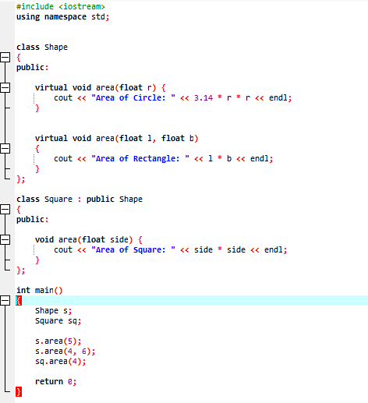

Output:
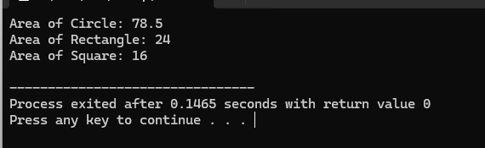

Part-02
Objective: To implement and understand the working of Run Time Polymorphism
- There are different ways of calling overridden function from the child class:
As we have discussed in part 01of this lab ,that when we make the call to function (involved in overriding), the child class function (overriding function) gets called. What if you want to call the overridden function by using the object of child class. You can do that by creating the child class object in such a way that the reference of parent class points to it. Lets take an example to understand it.
#include <iostream>
using namespace std;
class BaseClass {
public:
void disp(){
cout<<"Function of Parent Class";
}};
class DerivedClass: public BaseClass{
public:
void disp() {
cout<<"Function of Child Class";
}
};
int main() {
/* Reference of base class pointing to
* the object of child class.
*/
BaseClass obj = DerivedClass();
obj.disp();
return 0;
}

Function of Parent Class
If you want to call the Overridden function from overriding function then you can do it like this:
parent_class_name::function_name
To do this in the above example, we can write following statement in the disp() function of child class:
BaseClass::disp();

There are two other ways for accessing overridden method:
1.
derived_class obj1, obj2;
// call the overriding function
obj1.display_message();
// call the overridden function of the Base class
obj2.parent_class::display_message();
2. Through Pointer
// create instances of the derived class
derived_class obj;
// pointer of base class type
parent_class *ptr = &obj;
// call the parent class function
ptr->parent_class::display_message();
// call the overridden function
ptr->display_message();

Lab Task:
Write a c++ program that implements one of the above technique/ways for calling overridden function.
Program
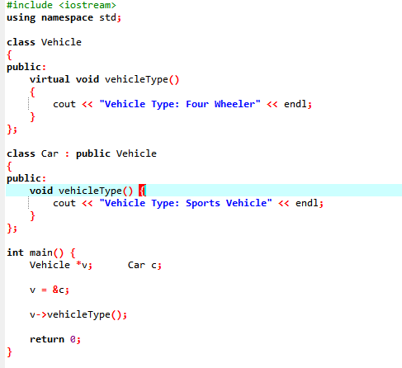:

Output:
