Lab No. 10
Name: Adil Khan | Roll no: BSCE-03
Submitted to: rSir.Mubasshi | Date: 24-12-2025

Objective: To implement concept of virtual function and Late binding

Introduction.
Run Time/Late Binding/Dynamic polymorphism can be achieved using Virtual Functions in C++.
Virtual Function is a function in base class, which is override in the derived class, and which tells the compiler to perform Late Binding / Dynamic Polymorphism on this function. Virtual Keyword is used to make a member function of the base class Virtual.
Late Binding
In Late Binding function call is resolved at runtime. Hence, now compiler determines the type of object at runtime, and then binds the function call. Late Binding is also called Dynamic Binding or Runtime Binding.
Problem without Virtual Keyword
In this program you can see that even when we use the base class object to call the function of child class, it calls the base class function. This results in early binding which is not what we want. This problem can be resolved using the virtual keyword
#include<iostream>
using namespace std;
class Base
{
public:
void show() {
cout << "Base class";
}};
class Derived:public Base {
public:
void show(){
cout << "Derived Class";} };
int main(){
Base* b; //Base class pointer
Derived d; //Derived class object
b = &d;
b->show(); //Early Binding Ocuurs
}
Output
Total Objects: 1
Base class

Using Virtual Keyword
We can make base class’s methods virtual by using virtual keyword while declaring them. Virtual keyword will lead to Late Binding of that method. In this program given below you can see that we have made the base class function show as virtual by using the virtual keyword. Now in the main function we are called the derived class function using the base class pointer object. this is known as late binding or dynamic polymorphism

#include<iostream>
using namespace std;
class Base
{
public:
virtual void show()
{
cout << "Base class";
}
};
class Derived:public Base
{
public:
void show()
{
cout << "Derived Class";
}};
int main()
{
Base* b; //Base class pointer
Derived d; //Derived class object
b = &d;
b->show(); //Late Binding Ocuurs
}
Some important Facts about Virtual Function
1) Virtual functions ensure that the correct function is called for an object, regardless of the type of reference (or pointer) used for function call.
2) They are mainly used to achieve Runtime polymorphism
3) Functions are declared with a virtual keyword in base class.
4) The resolving of function call is done at Run-time.
Pure Virtual Functions
It’s possible that you’d want to include a virtual function in a base class so that it may be redefined in a derived class to suit the objects of that class, but that there is no meaningful definition you could give for the function in the base class. We can change the virtual function area() in the base class to the following:
class Shape {
protected:
int width, height;
public:
Shape( int a = 0, int b = 0) {
width = a;
height = b;
}
// pure virtual function
virtual int area() = 0;
};
The = 0 tells the compiler that the function has no body and above virtual function will be called pure virtual function.
Abstract base classes
Classes which have pure virtual functions(such as the one in the above example) are known as Abstract base classes or simply Abstract class. Abstract base classes cannot be used to instantiate objects. But an abstract base class is not totally useless. It can be used to create pointers to it, and take advantage of all its polymorphic abilities. Pure Virtual Functions & Abstract Class in C++ - Sometimes implementation of all function cannot be provided in a base class because we don’t know the implementation. Such a class is called abstract class.
Some important facts –
1) A class is abstract if it has at least one pure virtual function.
2) We can have pointers and references of abstract class type.
3) If we do not override the pure virtual function in derived class, then derived class also becomes abstract class.
4) Abstract classes cannot be instantiated.

Lab Task:
Create a simple “shape” hierarchy: a base class called Shape and derived classes called Circle, Square, and Triangle. In the base class, make a virtual function called draw( ), and override this in the derived classes.
Program:
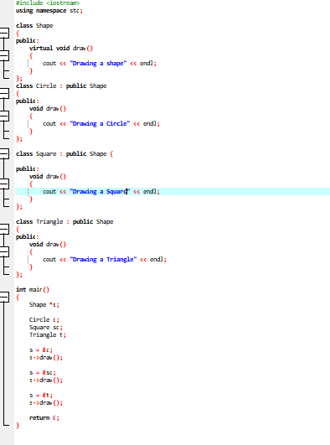

Output:
