Lab 2: Basic Data Structures
You will work in groups of 3.
In this lab, you will process some text data using lists, sets, and dictionaries. Write your program in main.py. The steps below describe tasks you must accomplish, but the coding is up to you. Try to decompose your program into functions to keep it organized.

Step 1: Read data from files
In the data folder of the starter code provided on D2L, you will find 2 “text” documents and 1 “stopwords” document.

The stopwords document contains words that appear frequently in English documents, but don’t add a lot of semantic meaning (words like “a”, “me”, “it”, etc.). Read this document and create a set of all the stop words.

Read the 2 text documents and split each into a list of individual words. Exclude all stopwords from these lists.

Step 2: Calculate term frequencies
Create a dictionary for each file, showing the number of occurrences of each word. Like this (this is just an example, the values may not be right):
{“may”: 2, “without”: 4, “science”: 1 ….}

Now convert these raw counts into term frequency scores. “Term frequency” is just the relative frequency of the word in the document. So the term frequency (tf) for the word w_{i} is:

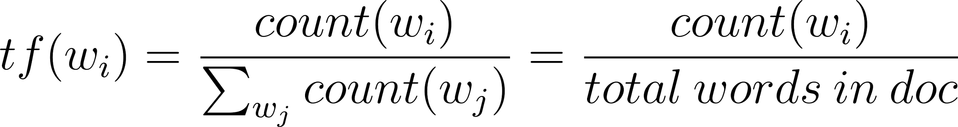

Term frequencies are sometimes used in text analytics, on the assumption that words with high frequency in a document are important for understanding what that document is about.

Step 3: Reduce to unique words
Reduce each dictionary to the words that are unique to that document. That is, remove any words that appear in both documents.

To do this, first compute (and print) the set of words that is common to both documents. Then remove those keys from each dict.

