A

MAJOR PROJECT REPORT
(SYNOPSIS)

ON

“Density Based Traffic Controlling System”



This Project Report is submitted to

Rajiv Gandhi Proudyogiki Vishwavidyalaya

in the partial fulfillment for the award of the degree of

Bachelor of Technology
VIII Sem
(Computer Science & Engg.)

Submitted By:

Adil Kachhi (0228CS221017)
Anshul Sahu (0228CS221035)
Gaurav Sharma (0228CS221069)
Nikhil Shukla(0228CS221116)

Under the guidance of:

Prof. Nitin Shukla

Head of Department

Computer Science
SHRI RAM GROUP OF INSTITUTIONS (SRGI)
&
SHRI RAM GROUP OF INSTITUTIONS (SRGI), JABALPUR
2026

Approved by AICTE New Delhi & Govt. of M.P.
(Affiliated to R.G.P.V.- University of Technology of Madhya Pradesh)

CERTIFICATE

This is to certify that,

Student Name: Adil Kachhi (0228CS221017)
Student Name: Anshul Sahu (0228CS221035)
Student Name: Gaurav Sharma (0228CS221069)
Student Name: Nikhil Shukla (0228CS221116)

Students of 8th Semester, Computer Science & Engineering, SHRI RAM GROUP OF INSTITUTIONS (SRGI), Jabalpur have submitted their major project synopsis entitled “DENSITY BASED TRAFFIC CONTROLLINF SYSTEM” for the completion of 8th semester examination under the requirement for the degree of Bachelor of Technology as per R.G.P.V., Bhopal (M.P.).

This is an original work of these students and is based on their own innovative idea. We, hereby certify this project to be an authentic work by these young minds.

Prof. Nitin Shukla
Head- Computer Science Dept.
S.R.G.I.

Approved by AICTE New Delhi & Govt. of M.P.
(Affiliated to R.G.P.V.- University of Technology of Madhya Pradesh)

CERTIFICATE OF APPROVAL

The foregoing minor project title “DENSITY BASED TRAFFIC CONTROLLING SYSTEM” is hereby approved as a creditable study of an engineering subject carried out and presented in a manner satisfactory to warrant its acceptance as a prerequisite to the degree for which it has been submitted. It is understood that by this approval the undersigned do not necessarily endorse or approve any statement made, opinion expressed or conclusion drawn therein, but approve the project only for the purpose for which it has been submitted.

(Internal Examiner) (External Examiner)

Approved by AICTE New Delhi & Govt. of M.P.
(Affiliated to R.G.P.V.- University of Technology of Madhya Pradesh)

DECLARATION

Here we declare that the project entitled which is being submitted in partial fulfillment of the requirement for the award of the degree of bachelor of Engineering in Computer Science “RAJIV GANDHI PROUDYOGIKI VISHWAVIDYALAYA, BHOPAL [M.P]” is the authentic record of my own work done under the guidance of Prof. Nitin Shukla [ HOD-Computer Science Dept].
The Matter reported in this project has not been submitted earlier for the award of degree.

PLACE: JABALPUR NAME: - ADIL KACHHI (0228CS221017)
DATED: NAME: - ANSHUL SAHU (0228CS221035)
NAME: - GAURAV SHARMA (0228CS221069)

NAME; - NIKHIL SHUKLA (0228CS221116)

Approved by AICTE New Delhi & Govt. of M.P.
(Affiliated to R.G.P.V.- University of Technology of Madhya Pradesh)

FORWARD

I hereby forward project title “DENSITY BASED TRAFFIC CONTROLLING SYSTEM” which is being submitted by
Student Name: Adil Kachhi (0228CS221017)
Student Name: Anshul Sahu (0228CS221035)
Student Name: Gaurav Sharma (0228CS221069)
Student Name: Nikhil Shukla (0228CS221116)
In partial fulfillment of the requirement for the award of Degree of Bachelor of Technology in Computer Science “Rajiv Gandhi Proudyogiki Vishwavidyalaya Bhopal [M.P]”

PLACE: JABALPUR Prof. Nitin Shukla
DATE:
HOD
Computer Science & Eng. Department
SHRI RAM GROUP OF INSTITUTIONS (SRGI) JABALPUR [M.P]

Approved by AICTE New Delhi & Govt. of M.P.
(Affiliated to R.G.P.V.- University of Technology of Madhya Pradesh)

ACKNOWLEDGEMENTS

We would like to extend our gratitude to all those who gave us the possibility to complete this project. We would like to thank the Department of computer science of SHRI RAM GROUP OF INSTITUTIONS (SRGI) for giving us permission to commence this project in first instance, to do the necessary research and to use departmental accessories.
We are deeply indebted to our supervisor Prof. Nitin Shukla [HOD -Computer Science Dept] whose help, simulating suggestions and encouragement helped us in all the times in completing this project.

We are bound to our honorable head of the department Prof. Nitin Shukla his simulating support. We have further more to thank the faculty of our college who helped us in providing the necessary data.
Our former colleagues in the department also supported us in our project. We want to thank them for all their help, support, interest and valuable hints.

PLACE: JABALPUR Student Name: Adil Kachhi (0228CS221017)
DATE Student Name: Anshul Sahu (0228CS221035)
Student Name: Gaurav Sharma (0228CS221069)
Student Name: Nikhil Shukla (0228CS221116)

INDEX

Chapter 1 | INTRODUCTION | 1–4
 | 1.1 Introduction | 1
 | 1.2 Problem Statement | 1-2
 | 1.3 Project Objectives & Goals | 2
 | 1.4 Scope and Limitations | 3
 | 1.5 Report Outline | 3-4
Chapter 2 | LITERATURE SURVEY | 5-6
 | 2.1 Survey and Analysis of Existing Solutions | 5
 | 2.2 Identification of Research Gap | 6
Chapter 3 | REQUIREMENT ANALYSIS AND SPECIFICATION | 7–11
 | 3.1 Functional Requirements | 7
 | 3.2 Non-Functional Requirements | 8
 | 3.3 Software and Hardware Requirements | 8-11
Chapter 4 | SYSTEM DESIGN AND ARCHITECTURE | 12-15
 | 4.1 System Architecture Diagram | 12
 | 4.2 Database Design (Entity-Relationship Diagram, Schema) | 13
 | 4.3 Model Design (Flowcharts, Pseudocode) | 14-15
 | 4.4 Use Case Diagrams | 15
Chapter 5 | IMPLEMENTATION, TESTING, AND MAINTENANCE | 16-17
 | 5.1 Introduction to Languages, IDE’s | 16
 | 5.2 Tools and Technologies used for Implementation | 16
 | 5.3 Coding standards of Language used Project Scheduling using various tools such as PERT, GANTT charts, Open PROJ etc. | 16
 | 5.4 Testing Techniques and Test Plans | 17
Chapter 6 | EXPECTED RESULTS AND DISCUSSION | 18–19
 | 6.1 Expected Results and Discussion | 18
 | 6.2 Expected Performance Results | 19
Chapter 7 | CONCLUSION | 20
 | 7.1 Conclusion | 20
 | REFERNECES | 21
APPENDICES | Appendix A: Source Code (GitHub Repository Link and Snapshot)  Appendix B: Team Member Contributions  Appendix C: Dataset Details and Sources  Appendix D: Relevant Published Papers | 22-30  31  32  32

CHAPTER 1
INTRODUCTION
1.1Introduction

Traffic congestion has become one of the most pressing challenges in modern urban environments. With the rapid growth of population, urbanization, and the increasing number of vehicles on roads, traditional traffic management systems are struggling to cope with dynamic traffic patterns.
Conventional traffic lights operate on fixed time intervals, which means they do not adapt to real-time traffic density. As a result, vehicles often wait unnecessarily at signals, leading to wasted time, excessive fuel consumption, and higher levels of air pollution.
- The density-based traffic control system dynamically adjusts traffic signal timings using real-time vehicle density at intersections, aiming to reduce congestion, idle time, and queue spillovers compared to fixed-time signals.

- It prioritizes lanes with higher vehicle counts and reverts to normal cyclic flow when densities are comparable, improving throughput and fairness.

1.2 Problem Statement

Traffic congestion is one of the most critical challenges faced by rapidly growing urban areas. With the continuous increase in the number of vehicles, existing road infrastructure and conventional traffic management systems are proving inadequate. Traditional traffic lights operate on fixed
time cycles, regardless of the actual traffic density at intersections. This rigid approach often results in inefficient traffic flow — vehicles may be forced to wait at red signals even when the opposite lane is empty, while heavily congested lanes receive insufficient green time.

Consequences of Inefficient Traffic Flow:
- Extended waiting times for commuters, causing frustration and delays.
- Increased fuel consumption due to prolonged idling of vehicles.
- Higher pollution levels, contributing to environmental degradation.
- Poor emergency response, as ambulances and fire trucks may get stuck in traffic.
- Economic losses, since time wasted in traffic translates to reduced productivity.
The Need for Change:
The lack of adaptability in current traffic control systems is the root cause of these issues. A system that can dynamically adjust signal timings based on real-time traffic density is urgently needed to improve mobility, reduce environmental impact, and enhance commuter safety.

1.3 Project Objective and Goal
Project Objective:
Design and implement an intelligent traffic signal control system that dynamically adjusts signal timings based on real-time traffic density, optimizing traffic flow and reducing congestion.
Specific Goals:
- Develop algorithms to analyze traffic density data from sensors/cameras
- Implement adaptive signal control logic to prioritize congested lanes
- Reduce average wait times by X% and improve traffic flow by Y%
- Enhance safety for vehicles and pedestrians
- Minimize environmental impact by reducing emissions and fuel consumption

1.4 Scope and Limitation
Scope:
Geographical Scope: Urban intersections with high traffic density.
Technical Scope: Develop adaptive signal control algorithms using sensors/IoT devices, integrate with existing traffic infrastructure.
Functional Scope: Adjust signal timings based on real-time traffic density, prioritize emergency vehicles.
Testing Scope: Simulate and test the system for a specific intersection or scenario
Limitations:
Technical Limitations: Sensor accuracy, data processing latency, and IoT connectivity issues may impact performance.
Operational Limitations: System may require manual overrides during emergencies or special events.
Scalability Limitations: Complex intersections or large networks may require advanced infrastructure and integration.
Security Limitations: IoT connectivity increases cybersecurity risks, requiring robust protection measures

1.5 Report Outline

Here's a possible report outline for your density-based traffic controlling system project:

- Introduction

- Background on traffic congestion
- Project overview

- Problem Statement

- Issues with traditional traffic signals
- Need for adaptive control
- Project Objectives & Goals

- Develop adaptive signal control system
- Improve traffic flow, safety, and reduce emissions

- Methodology

- System design and architecture
- Sensors/IoT and algorithms used

- Implementation

- System setup and testing
- Results and analysis

- Conclusion & Future Work

- Summary of outcomes
- Potential improvements and scalability

CHAPTER 2
LITERATURE SURVEY
2.1 Survey and Analysis of Existing Solution

There has been a great usage of surveillance systems and video monitoring for traffic control in recent years. Innovations have been made for examining the density of the traffic through image processing. But these techniques require good images whose quality is weather dependent, especially when it is raining or when there is a huge amount of fog. The image captured in the traffic signal is processed and converted into grayscale image, then its threshold is calculated based on which the contour has been drawn in order to calculate the number of vehicles present in the image. But this cannot be used in real time applications as it is very slow and the software is usually not free of cost. Automatic detecting and counting vehicles in unsupervised video on highways are a very challenging problem in computer vision with important practical applications such as to monitor activities at traffic intersections for detecting congestions, and then predict the traffic which assists in regulating traffic. Manually reviewing the large amount of data, they generate is often impractical. There are various vehicle detectors such as radar, ultrasonic, and microwave detector. But these sensors are usually expensive, difficult to implement, have less capacity, and extra maintenance charges will be there. Radar sensors are affected by metal barriers near road. Passive acoustic detector array, Piezoelectric, Photoelectric, Inductive loop detector, magnetic detectors and other similar sensors are some of the commonly used sensors in the field of traffic monitoring systems.

Existing Solutions:

- Fixed-Time Traffic Signals
- Use pre-set timing cycles, regardless of traffic density
- Common in many cities, simple to implement

- Actuated Traffic Signals
- Adjust timings based on vehicle detection (sensors/loops)
- More adaptive than fixed-time, but limited

- Adaptive Traffic Control Systems (ATCS)
- Use AI, cameras, and sensors to optimize signals
- Examples: SCOOT, SCATS, UTOPIA
Analysis:

- Pros:

- Fixed-time: Low cost, easy to implement.
- Actuated: Some adaptability to traffic.
- ATCS: Optimizes flow, reduces congestion.

- Cons:

- Fixed-time: Inefficient for dynamic traffic.
- Actuated: Limited adaptability.
- ATCS: High cost, complex implementation, requires maintenance.

- Gaps:

- Most systems don't fully adapt to real-time density
- Limited prioritization for emergency vehicles
- High implementation costs for advanced systems

2.2 Identification of Research Gap

The main purpose of introducing this smart traffic system is that for every minute the vehicles at the junction will be dense and the traffic lights shall be changed to each side for some fixed time. Even though there are no vehicles at particular side, the traffic signals will glow for a given fixed time. Due to that there is time wastage & vehicles on the other side have to wait for the time to complete the process. So to reduce the wastage of time, we can implement the system that controls the traffic based on the heavy flow of vehicles at any particular side.
- Limited Real-Time Adaptability: Most existing systems (fixed-time, actuated) don't fully adapt to dynamic traffic patterns, leading to inefficiencies.
- Locus of Focus: Most solutions focus on either efficiency or safety; a balanced approach addressing both is needed.

CHAPTER 3
REQUIREMENT and ANALYSIS & SPECIFICATION

3.1 Functional Requirement

- Real-Time Data Collection
- System shall collect traffic density data from sensors/IoT devices (cameras, inductive loops, radar) at intersections.
- Data shall include vehicle count, speed, and lane occupancy.

- Adaptive Signal Control
- System shall adjust signal timings based on real-time traffic density and predefined algorithms.
- Signal phases shall be dynamically adjusted to optimize traffic flow.

- Priority Handling
- System shall prioritize emergency vehicles (ambulance, fire trucks) and public transport (buses).
- Emergency vehicles shall trigger special signal phases or preemption.

- Safety Features
- Ensure pedestrian safety through pedestrian detection and signal adjustments.
- Prevent accidents through conflict monitoring and signal overrides.

- Monitoring & Alerts
- Generate alerts for anomalies (congestion, accidents) and notify authorities.
- Provide real-time traffic updates to commuters via apps/ displays.

- Data Logging
- Log traffic data for analysis
- and future optimization.
- Support data analytics for traffic pattern prediction and planning.

3.2 Non-Functional Requirement

1. Performance

- System shall respond within 2 seconds to changes in traffic density.
- Signal changes shall occur with <100ms latency.

2. Scalability

- System shall handle up to 10,00 vehicles per hour per intersection.
- Support expansion to multiple intersections and cities.

3. Reliability

- System shall operate 24/7 with <1% downtime.
- Implement fail-safe defaults (e.g., revert to fixed timing) in case of failure.

4. Security

- System shall encrypt data transmission and storage.
- Authenticate users and log access attempts.

5. Usability

- System shall provide intuitive interface for operators (web/mobile).
- Display real-time traffic data and alerts.

6. Maintainability

- System shall support remote updates and diagnostics.
- Modular design for easy component upgrades.

3.3 Software and Hardware Requirement

- Hardware requirements

The successful implementation of a density-based traffic system relies on specific hardware components that work together to sense, process, and control the traffic environment. Below are the primary hardware requirements:
1. Microcontroller / Processor
- Examples: Arduino Uno, Raspberry Pi, STM32, or ESP32
- Function:
  - Central processing unit of the system
  - Collects data from sensors

2. Traffic Light Modules
- Components: Red, Yellow, and Green LEDs (or 3-in-1 LED traffic light units)
- Function:
  - Visually indicate when vehicles must stop, prepare, or go
  - Controlled by microcontroller output pins

3. Vehicle Detection Sensors
- Types:
  - Infrared (IR) Sensors
  - Cameras with image processing (optional for advanced systems)
- Function:
  - Detect or count vehicles in each lane
  - Send real-time data to the microcontroller

4. Power Supply
- Components: 5V/12V adapter, battery backup (optional), voltage regulator
- Function:
  - Provides required voltage and current to all system components
  - Ensures stable power delivery

5. Relay Module or Transistor Driver Circuit
- Function:
  - Acts as a switch to control high-voltage traffic lights using low-power microcontroller output
  - Ensures electrical safety and control reliability

6. LCD or Display Module (Optional)
- Examples: 16x2 LCD, OLED screen
- Function:
  - Displays current traffic density, signal status, or system messages

7. Emergency Vehicle Detection Module (Optional)
- Examples: RF receiver, GPS module, Bluetooth, or siren detection sensor
- Function:
  - Detects approaching emergency vehicles and prioritizes signal accordingly

8. Connecting Wires, Breadboard/PCB, and Casing
- Function:
  - Physical support and circuit connection
  - Ensures safe and organized component assembly

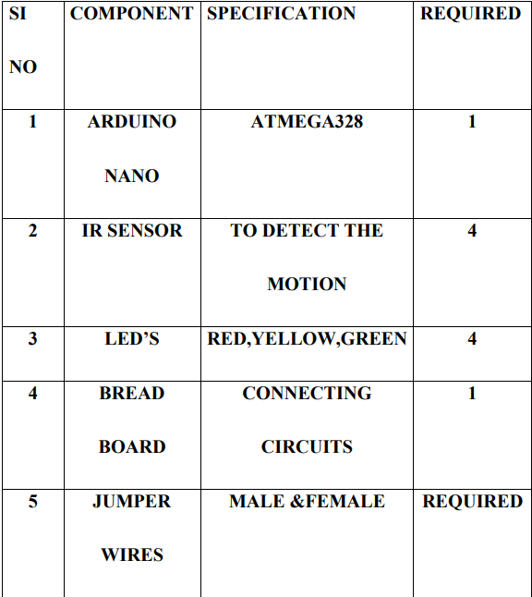

- Software requirements

1. Signal Control Logic
- Description: The system needs to adjust the traffic signal timing based on the real-time vehicle density. The signal control logic determines when to change the traffic lights (red, yellow, green) and for how long each light should remain active.
- Requirement:
  - Implement algorithms that adjust green light duration based on traffic volume.
  - Prioritize lanes with higher traffic density and ensure no lane is blocked for too long.

2. Traffic Flow Optimization Algorithms
- Description: The software must include optimization algorithms to ensure that traffic flows as efficiently as possible. This may involve adapting signal timings dynamically, coordinating signals between adjacent intersections, and managing emergency vehicle priority.
- Requirement:
  - The system must minimize wait times for all vehicles, balancing the needs of each lane.
  - Incorporate features such as Emergency Vehicle Detection and Pedestrian Crossing Control to ensure safety and responsiveness.

3. User Interface (UI)
- Requirement:
  - Provide a graphical representation of traffic flows and signal states for easy understanding.
  - Allow operators to manually override signals if necessary (e.g., in emergencies).
  - Should offer detailed data logs and reporting features to track system performance over time.
  - The interface should be intuitive and user-friendly for operators to quickly interpret traffic data and make adjustments.

CHAPTER 4
SYSTEM DESIGN AND AECHITECTURE

4.1 System Architecture diagram

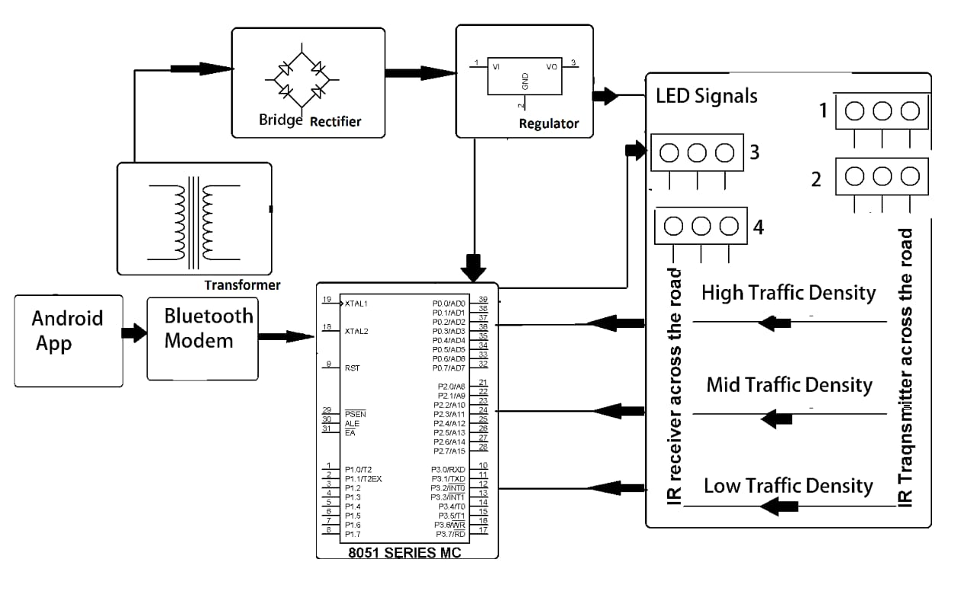

- Input Stage: IR transmitter/receiver pairs or Ultrasonic sensors (HC-SR04) placed on roadsides to detect vehicle density.
- Processing Unit: Microcontroller (Arduino, PIC18F4550) that receives sensor data, processes it, and controls output timings.
- Output Stage: Traffic Light Indicators (Red, Yellow, Green LEDs) indicating the state for each lane.
- Power Supply: A dedicated power circuit (typically +5V/9V DC) converting 230V AC to required levels for electronics
4.2 Database Design (Entity-Relationship Diagram)

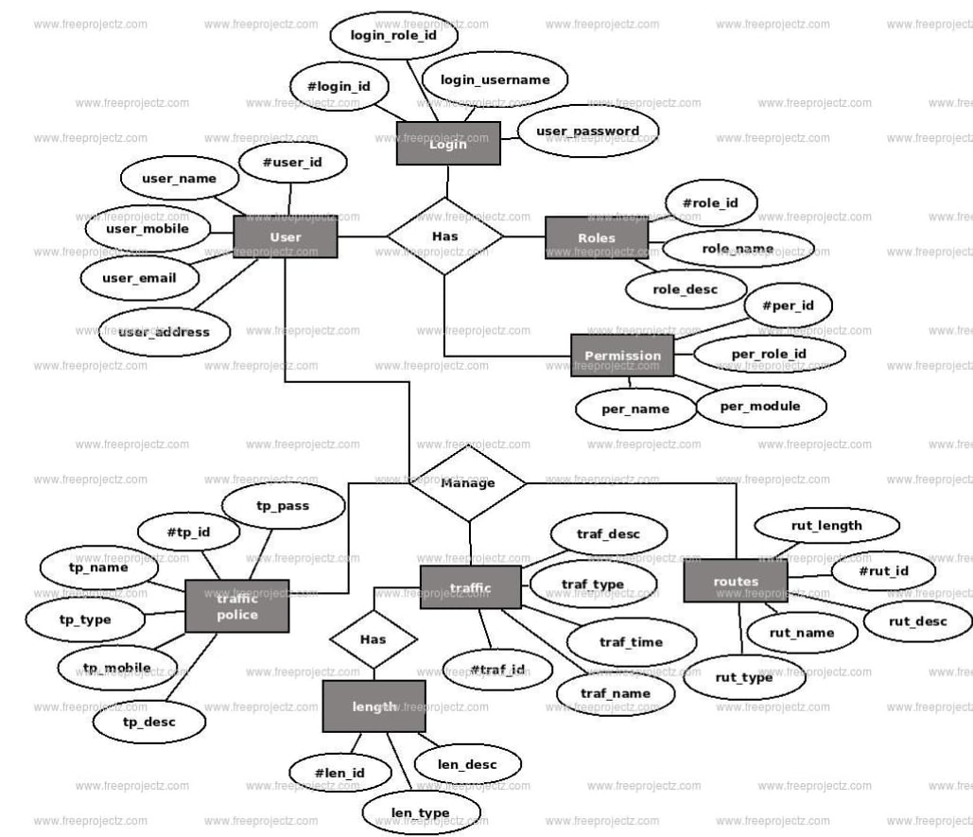

4.3 Model Design

    - Flowchart

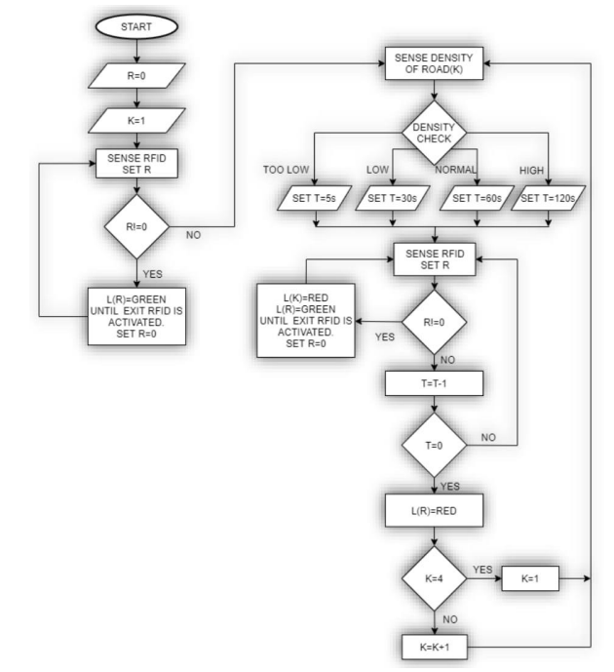

(ii)Pseudocode

BEGIN
INITIALIZE Pins for Lane1_LEDs, Lane2_LEDs, Lane3_LEDs, Lane4_LEDs
INITIALIZE Pins for Sensor1, Sensor2, Sensor3, Sensor4
WHILE (True):
FOR each Lane (i = 1 to 4):
READ Sensor(i) to get Density Value
IF (Density Value == HIGH):
Timer = 60 seconds
ELSE IF (Density Value == MEDIUM):
Timer = 30 seconds
ELSE:
Timer = 10 seconds
ACTIVATE Green LED for Lane(i)
ACTIVATE Red LED for all other Lanes
WAIT for Timer duration
ACTIVATE Yellow LED for Lane(i)
WAIT for 3 seconds
ACTIVATE Red LED for Lane(i)
END FOR
END WHILE
END

4.4 Use Case Diagram

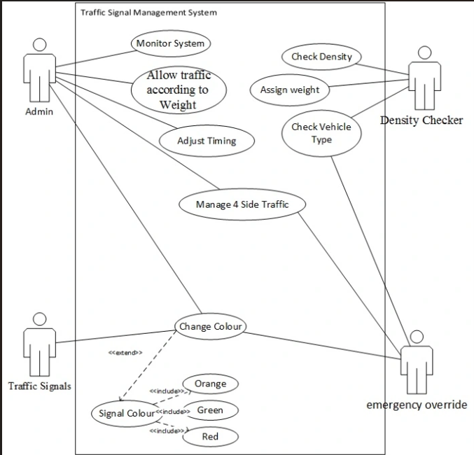

CHAPTER 5
IMPLEMENTATION, TESTING AND MAINTENANCE
  - Introduction to Languages and IDE's

- Languages: Embedded C/C++ is used for programming microcontrollers to interact with sensors and traffic lights. Python is often used for prototype simulation or advanced image-based density detection.
- IDEs: Arduino IDE for hardware-level programming, Proteus for circuit simulation

5.2 Tools and Technologies for Implementation
- Hardware: IR sensors/Ultrasonic sensors (for density detection), LEDs (for traffic lights), Arduino Uno/Raspberry Pi (Controller).
- Software/Simulation: Proteus ISIS (simulation), MATLAB or OpenCV (image processing algorithms), and Proteus/Arduino IDE for compiling.
5.3 Coding Standards and Project Scheduling

- Coding Standards: Use meaningful variable names (e.g., sensorPin_N_Lane), consistent indentation, modular functions (e.g., calcDensity (), setSignal ()), and comments for hardware pin mappings.
- Project Scheduling Tools:
  - Gantt Charts: Used for scheduling tasks like sensor assembly, coding, testing, and documentation.
5.4 Testing Techniques and Test Plans

- Unit Testing: Testing individual IR sensors and traffic light LEDs for functionality.
- Integration Testing: Ensuring the microcontroller correctly interprets sensor input to trigger the correct signal timing.
- System Testing: Simulating various traffic densities (light, moderate, heavy) to evaluate the automatic timing adjustment.
- Test Plan Focus:
  - Latency Test: Time taken from detection to signal change.
  - Accuracy Test: Correct signal output for varied density inputs.
  - Sensor Range Test: Effective detection distance of IR/Ultrasonic sensors.

CHAPTER 6
EXPECTED RESULT AND DISCUSSION

6.1 Expected Result and Discussion
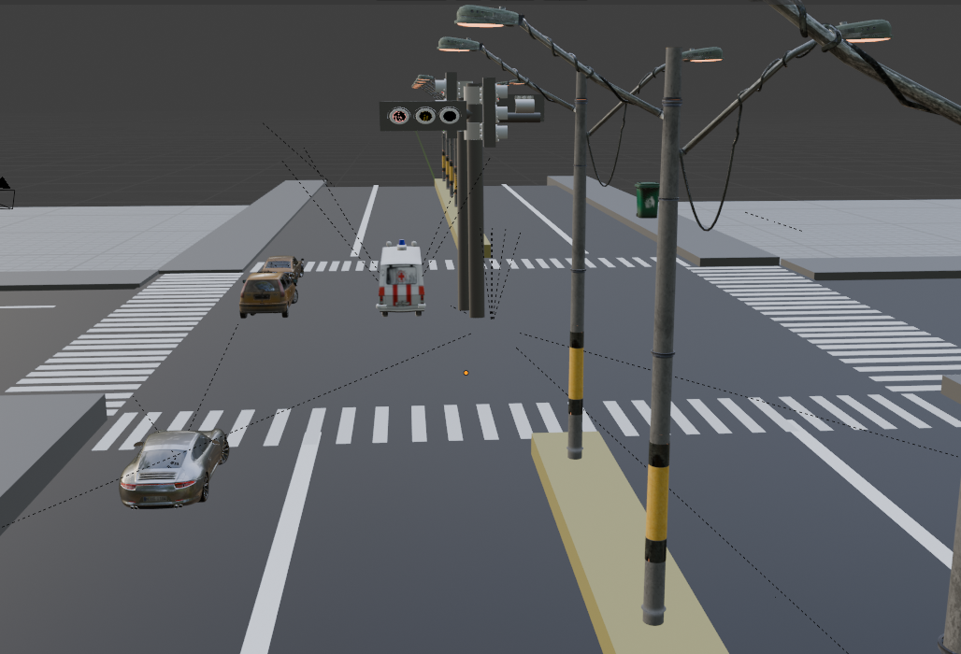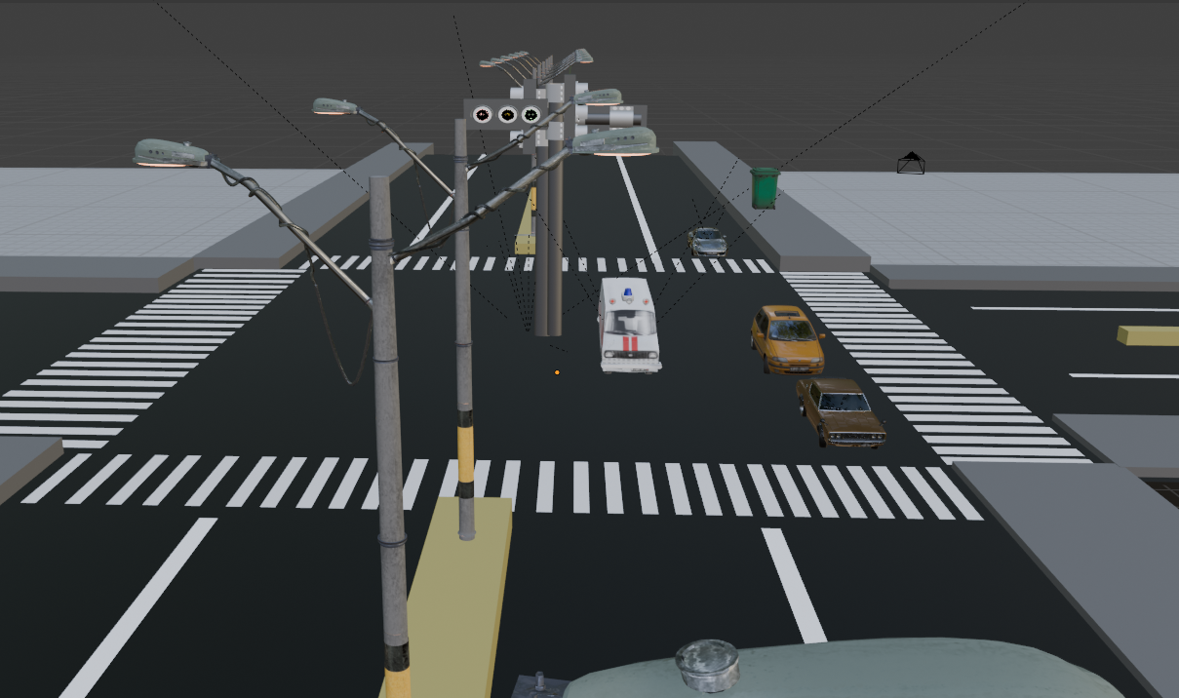
- In 4-way road vehicle having same density. Traffic flow according to priority wise.
- There is no need of traffic police which control traffic.
- If no traffic capture in all sides it flows normally.
- It gives first priority to Emergency vehicle like “Ambulance, fire work etc.”.

6.2 Expected Performance Result

- Significant Reduction in Waiting Time: By analysing traffic density, the system eliminates unnecessary wait times at empty intersections. Studies show this can reduce traffic congestion and decrease average wait times, particularly in dense urban environments.
- Dynamic Timing Adjustment: The green light duration is proportional to vehicle density. As traffic density increases, the system automatically allocates more time to that lane.
- Optimal Flow Efficiency (High/Moderate Demand): Simulation results for adaptive systems (like DT-based algorithms) show control delay reductions ranging from 1% to 52% for low traffic and 1% to 45% for high traffic demands compared to conventional systems.
- Improved Emergency Response: The system typically integrates with emergency vehicles (e.g., using GSM or sensors) to instantly override normal operations and provide a green signal, reducing accident risks and emergency response times.
- Reduced Emissions and Fuel Usage: Lowering the amount of time vehicles spend idling at red lights significantly reduces fuel consumption and exhaust emissions.
- Improved Efficiency Over Fixed Systems: Compared to pre-programmed timers, the system shows superior performance in managing fluctuating, real-time traffic, especially during peak hours.

CHAPTER 7
CONCLUSION
7.1 Conclusion

The density-based traffic controlling system offers a superior, efficient alternative to conventional fixed-time systems by utilizing sensors (IR, cameras) to optimize traffic signal timings in real-time.

Key conclusions regarding this system include:

- Efficiency: By adjusting green light durations based on vehicle density, it significantly minimizes waiting times and reduces congestion.
- Safety & Logistics: The system enhances road safety and offers substantial cost savings for commuters and logistical services through improved traffic flow.
- Technology Integration: It easily integrates with smart city initiatives (IoT, machine learning) to enhance predictive capabilities for future traffic management.
- Limitations & Future Scope: While current solutions work well, future developments aim to integrate advanced sensors to address potential failure points and further improve responsiveness in chaotic situations

References: -

# Kumar, S., & Singh, P. (2017). Density Based Smart Traffic Control System Using Arduino. International Journal of Engineering Research & Technology (IJERT), Vol. 6, Issue 4.
https://www.ijert.org/density-based-smart-traffic-control-system-using-arduino

# Patel, J., & Shah, D. (2016). A Smart Traffic Light Control System Based on Vehicle Density. International Journal of Innovative Research in Science, Engineering and Technology (IJIRSET), Vol. 5, Issue 5.

# National Highway Traffic Safety Administration (NHTSA). Traffic Signal Timing Manual. U.S. Department of Transportation, 2020.
https://ops.fhwa.dot.gov/publications/fhwahop08024
# Ravichandran, T., & Ramakrishnan, B. (2019). Smart Traffic Light Control Using Image Processing. International Journal of Computer Applications (IJCA), Vol. 178, No. 17.

# Agarwal, R., & Saini, M. (2018). IoT Based Density-Aware Traffic Control System Using Raspberry Pi and Ultrasonic Sensors. Journal of Emerging Technologies and Innovative Research (JETIR), Vol. 5, Issue 11.

# Morris, J. (2020). Intelligent Transport Systems: Smart and Green Infrastructure for Urban Areas. Springer Publishing.

# Arduino Official Documentation. https://www.arduino.cc/en/Guide/HomePage

# Raspberry Pi Foundation. Getting Started with Raspberry Pi.
https://www.raspberrypi.org/documentation

# IEEE Xplore Digital Library – Various articles on smart traffic control and real-time systems.
https://ieeexplore.ieee.org
# Open Traffic Data Sources (City or Government databases providing real-time or historical traffic data).
Example: https://data.gov

APPENDICES
APPENDIX A: - GITHUB - https://github.com/adilkachhi25/Density_Based_traffic
Snapshot of source code

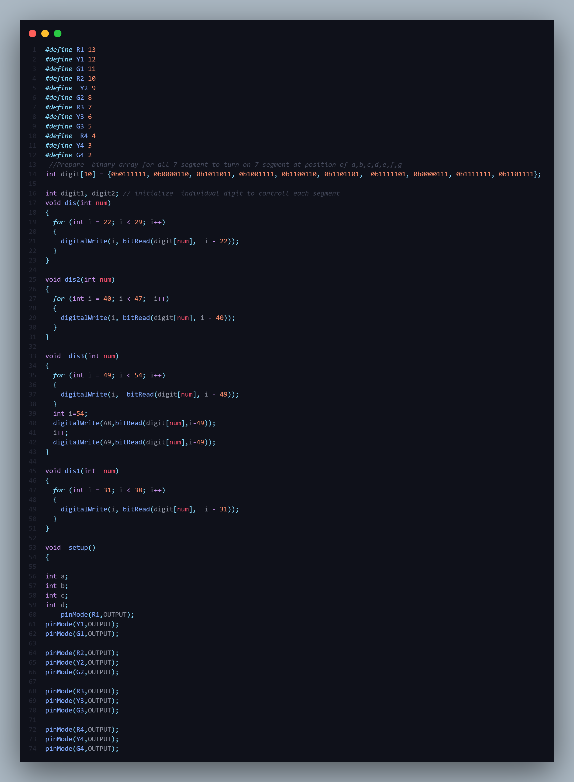

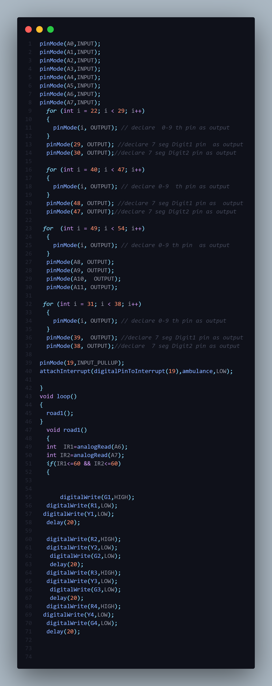

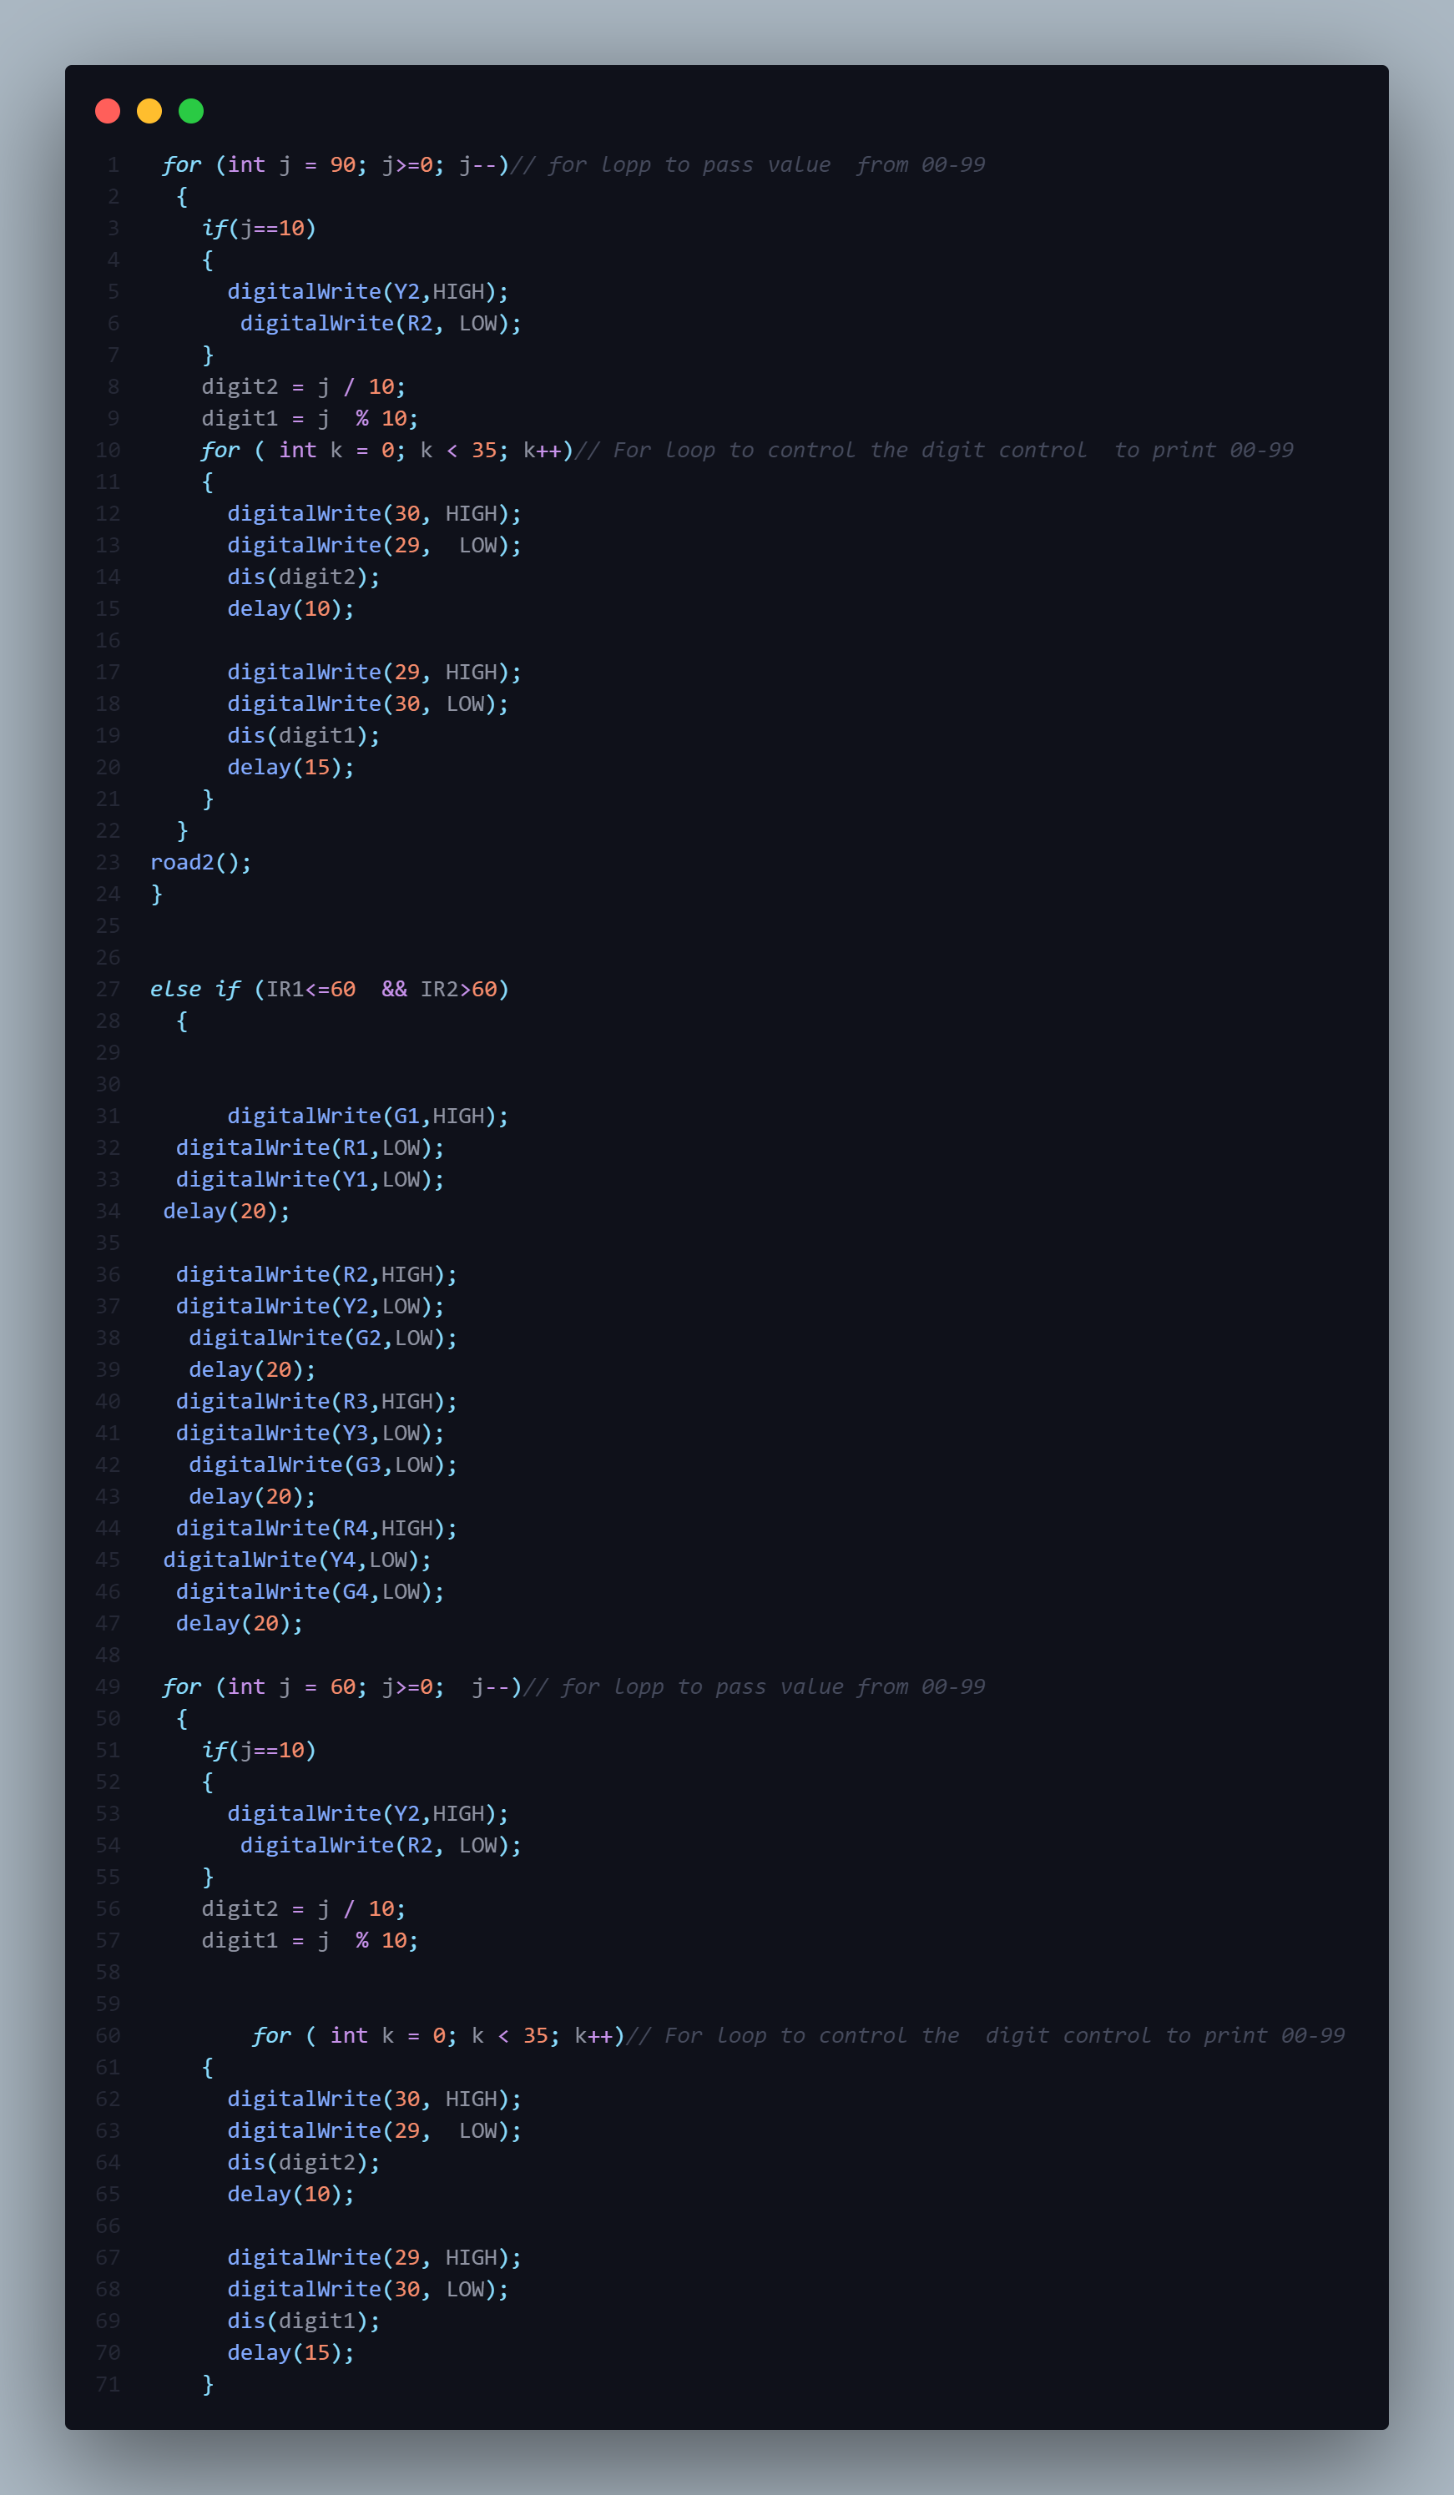
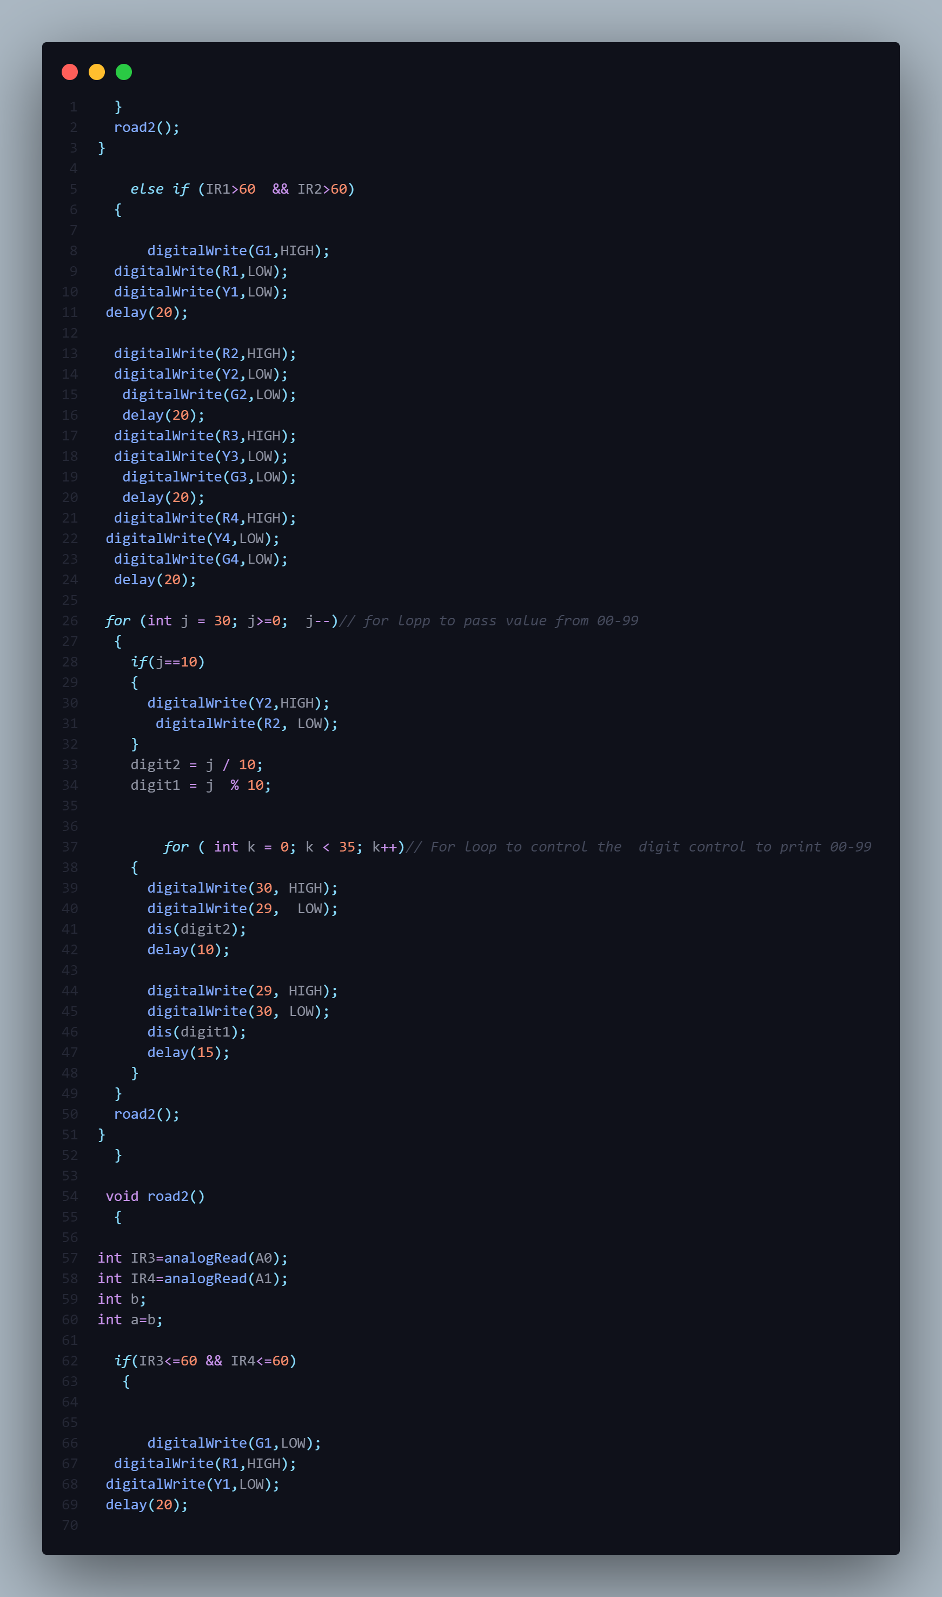
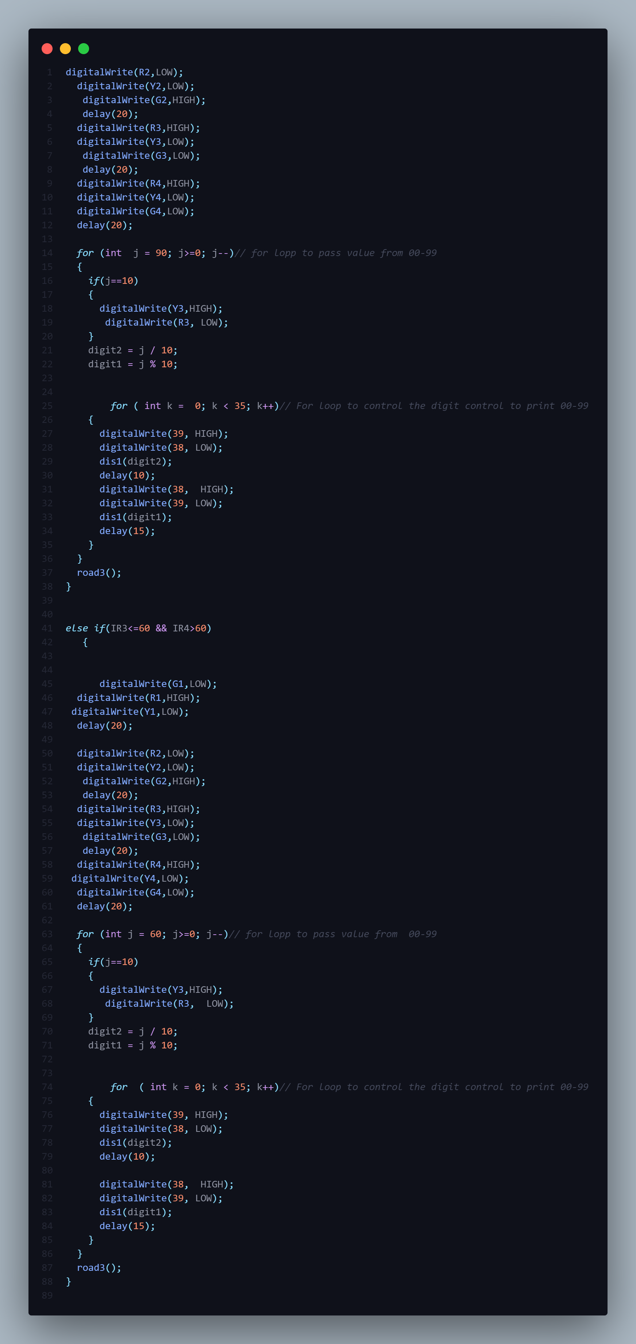
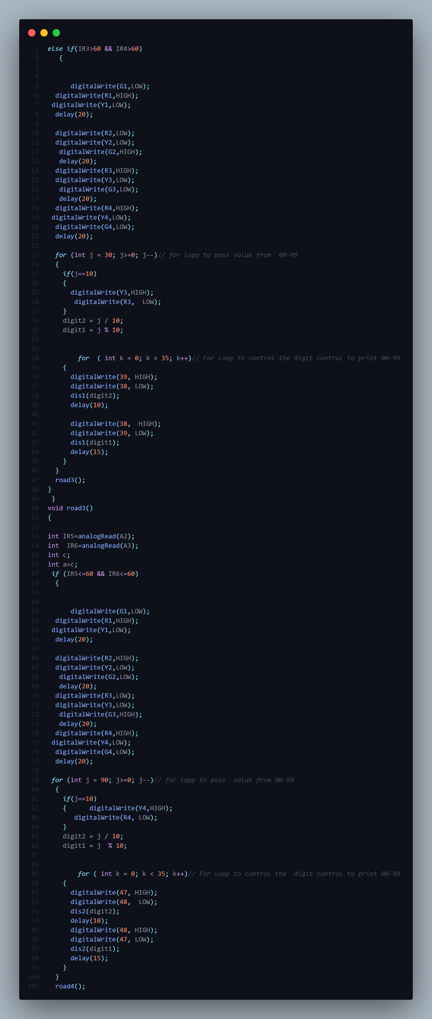
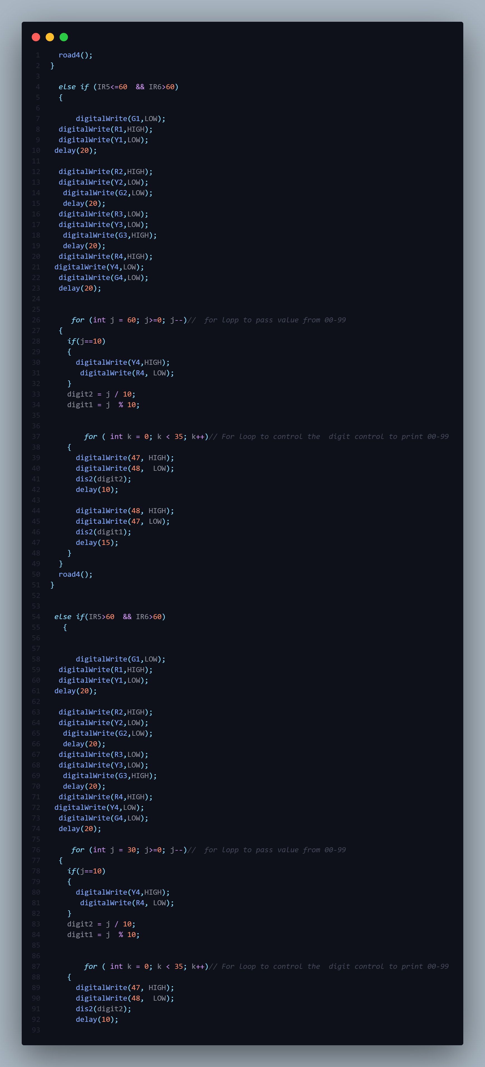
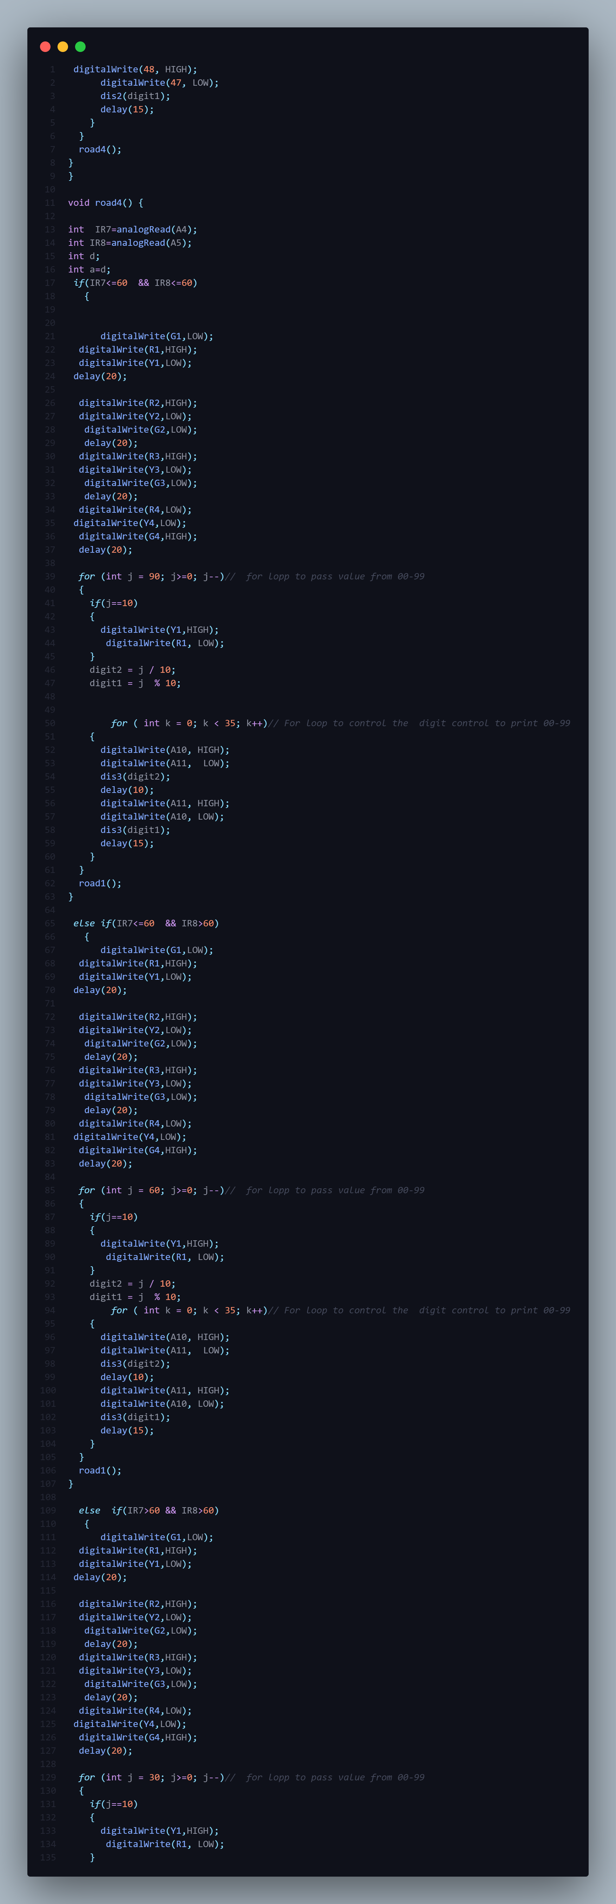
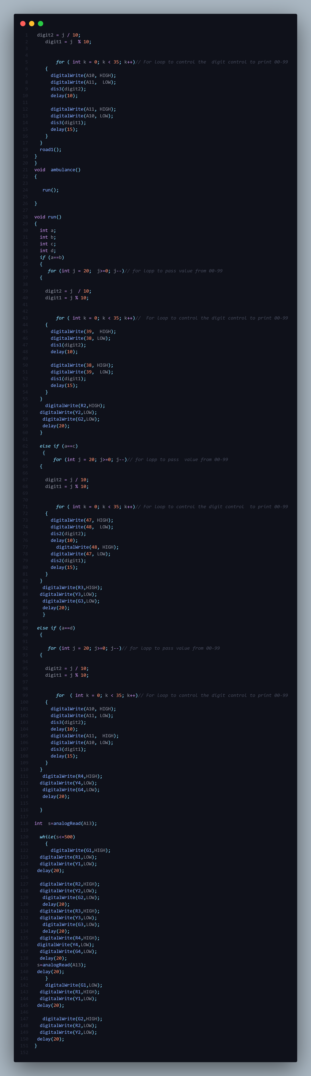
APPENDIX B: - Team Member Contributions
1. Hardware Development Team (Sensor & Circuitry)
- Sensor Installation & Calibration: Placing IR sensors or ultrasonic sensors on each side of the road intersection to detect vehicle presence.
- Circuit Design: Creating the PCB or breadboard layout connecting infrared sensors to the microcontroller (Arduino Nano/Uno/Mega).
- Traffic Light Assembly: Installing LED sets (Red, Yellow, Green) for all lanes.
- Emergency Vehicle Component: Setting up specific sensors to detect emergency vehicles (ambulance, fire engine).
2. Software/Programming Team (Algorithm & Logic)
- Dynamic Timing Control: Coding the logic in C++ (Arduino IDE) or Python (Raspberry Pi) that gives a longer green light to the lane with higher density.
- Round Robin/Flow Control: Implementing a mechanism to ensure a clockwise rotation of signals to prevent one road from being blocked indefinitely.
- Emergency Override Protocol: Programming the system to prioritize
3. Systems Integration & Testing Team
- Microcontroller Integration: Merging the hardware and software by flashing the control code onto the microcontroller.
- Simulation & Real-time Testing: Testing the system in a simulated environment and then validating it on a prototype four-way junction model.
- Performance Evaluation: Analyzing the system’s effectiveness in reducing congestion and optimizing waiting times to traditional fixed-time systems.
Key Components Handled
- Microcontroller: Arduino Uno/Nano/Mega, Raspberry Pi, PIC Microcontroller.
- Sensors: IR sensors (transmitter/receiver pairs) or Ultrasonic sensors.
- Traffic Signals: Red, Yellow, Green LEDs.

APPENDIX C: - Dataset details and Sources
- Traffic Density Singapore (Kaggle): Contains 4054 images labelled into 5 classes: Empty, Low, Medium, High, and Traffic Jam.
- Delhi Traffic Density Dataset: A 40-day dataset (7 AM - 10 PM) containing queue and stop density, processed from camera feeds at intersections, featuring background subtraction mechanisms.
- Smart Traffic Management Dataset (Kaggle): Includes 2000 rows with real-time metrics, such as vehicle counts (cars, trucks, bikes), average speed, and traffic light status.
- Traffic Analysis Dataset (Kaggle): Provides frame-wise traffic data, including vehicle counts and classification (cars, trucks, bikes, buses) generated using YOLOv8.
- Traffic Prediction Dataset (Kaggle): Contains traffic flow data with time-based statistics (hours, days of the week) useful for planning.

APPENDIX D: - Relevant publish paper
- [Density Based Solar Powered Traffic Control System (2026): Proposes an ESP32-based system using IR sensors for density estimation and RFID for emergency vehicles.
- [Density Based Traffic Control Using Machine Learning (2023): Discusses automatic timing adjustments based on junction density using machine learning techniques.
- [Density Based Traffic Control System with Ambulance Detection (IJERT, 2023): Focuses on Arduino-based, real-time traffic signal adjustments and priority for emergency services.
- [Density Based Traffic Signal Controller Using IoT (2024): Utilizes NodeMCU for IoT-enabled, adaptive traffic light systems.
- [Design and implementation of a density-based traffic light control with surveillance system (2026): Provides a prototype design using PIC18F4550 and IR sensors, verified by Proteus simulation.

