Physics Notes from Feynman-Style Screenshots
Source: pg_1_2.pdf. The PDF pages are image-only handwritten scans. I corrected the page orientation before interpreting the contents. Because the handwriting is uneven, uncertain readings are marked as interpreted.

Extracted Handwritten Lines with Detailed Explanation

Page 1
Extracted line: 5/11 - Physics
Explanation: This looks like the date and topic heading. The page starts a list of basic physics and chemistry ideas, especially the molecular view of matter.
Where it is used: Used as the lesson heading for topics connecting atoms, molecules, heat, waves, and matter.
Extracted line: Applications?
Explanation: Applications means practical uses of a concept. In physics, an idea becomes more useful when we can connect it to real systems: heat engines, weather, electronics, light, chemical reactions, medical imaging, and materials.
Where it is used: Used whenever a theory is connected to technology or natural phenomena.
Extracted line: Catalysis?
Explanation: Catalysis is the speeding up of a chemical reaction by a substance called a catalyst. A catalyst changes the pathway of a reaction so the required activation energy is lower, but the catalyst is not used up overall.
Where it is used: Used in car catalytic converters, enzymes in the body, industrial ammonia production, petroleum refining, and pollution control.
Extracted line: Precipitation?
Explanation: Precipitation has two common meanings. In chemistry, it means a dissolved substance forms an insoluble solid. In weather, it means water falls from the atmosphere as rain, snow, sleet, or hail. Both meanings involve particles coming out of a previous mixture or vapor state.
Where it is used: Used in chemical tests for ions, water treatment, crystallization, cloud physics, meteorology, and climate science.
Extracted line: Particle?
Explanation: A particle is a small localized piece of matter or energy. Depending on the scale, it can mean an atom, molecule, ion, electron, proton, dust grain, or photon.
Where it is used: Used throughout mechanics, thermodynamics, chemistry, quantum mechanics, and particle physics.
Extracted line: Tearing?
Explanation: Tearing means breaking material by pulling it apart. At the microscopic level, tearing happens when applied forces overcome the bonds and interactions holding atoms or molecules together.
Where it is used: Used in materials science, fracture mechanics, paper/fabric strength, and engineering failure analysis.
Extracted line: Ion?
Explanation: An ion is an atom or molecule with a net electric charge. Positive ions have lost electrons; negative ions have gained electrons. Ions are important because electric forces between them can create salts, crystals, currents, and reactions.
Where it is used: Used in batteries, electrolytes, plasma, salt solutions, biological nerve signals, and mass spectrometry.
Extracted line: Atoms size: 2 x 10^-8 cm radius; 1 x 10^-8 cm = Angstrom
Explanation: This line gives the approximate atomic scale. One Angstrom is 10^-8 cm, or 10^-10 m. Atoms are usually about 1 to a few Angstroms in size. The exact radius depends on the element and how the radius is defined.
Where it is used: Used in chemistry, crystallography, nanotechnology, and molecular structure.
Extracted line: Atoms and molecules; H2O sketches
Explanation: The drawings show water molecules: one oxygen atom bonded to two hydrogen atoms. A molecule is a stable group of atoms held together by chemical bonds.
Where it is used: Used to explain water, evaporation, condensation, density, phase changes, and chemical reactions.
Extracted line: Heat - the more heat, the more jiggle
Explanation: This is kinetic theory. Temperature is related to the average random kinetic energy of atoms and molecules. When a substance is heated, its particles move, vibrate, rotate, or collide more energetically.
Where it is used: Used in thermodynamics, gas laws, boiling, evaporation, diffusion, thermal expansion, and Brownian motion.
Extracted line: Density?
Explanation: Density is mass divided by volume. Microscopically, density depends on particle mass and how tightly particles are packed. Ice, liquid water, steam, metals, and gases differ in density because their particles arrange and space themselves differently.
Where it is used: Used in buoyancy, fluid mechanics, materials, astronomy, geology, and engineering design.
Extracted line: Amplitude?
Explanation: Amplitude is the maximum displacement of an oscillation or wave from equilibrium. For sound, larger amplitude usually means louder sound. For water waves, it is related to wave height. For light, field amplitude is related to intensity.
Where it is used: Used in waves, sound, optics, electronics, vibrations, and signal processing.
Extracted line: Colloid?
Explanation: A colloid is a mixture containing tiny particles dispersed through another substance. The particles are larger than individual molecules but small enough that they do not quickly settle out.
Where it is used: Used in milk, fog, smoke, paint, gels, emulsions, aerosols, and nanomaterials.
Extracted line: Hybrid?
Explanation: Hybrid means made by combining two different things. In science it can mean hybrid orbitals in chemistry, hybrid materials, hybrid systems, or mixed models that combine multiple descriptions.
Where it is used: Used in chemistry, materials science, biology, electronics, and engineering.
Extracted line: Atomic hypothesis
Explanation: The atomic hypothesis says matter is made of atoms that are constantly moving and interacting. Feynman famously treated this as one of the most important ideas in science because it explains heat, pressure, phase changes, chemistry, and much of ordinary matter.
Where it is used: Used as the foundation of chemistry, kinetic theory, thermodynamics, and modern physics.

Page 2
Extracted line: 5/12 - applications / physics
Explanation: The second page continues the same theme: connecting microscopic particles to larger physical ideas such as elements, radiation, waves, photons, and uncertainty.
Where it is used: Used as a continuation of the physics study notes.
Extracted line: How many elements are there?
Explanation: An element is a pure substance defined by the number of protons in its atoms. Hydrogen has 1 proton, helium has 2, carbon has 6, oxygen has 8, and so on. The periodic table organizes elements by atomic number and chemical behavior.
Where it is used: Used in chemistry, nuclear physics, materials science, biology, and astronomy.
Extracted line: How many atoms or molecules? (large-number estimate near particle sketch)
Explanation: Ordinary objects contain enormous numbers of atoms. A mole contains about 6.022 x 10^23 particles. Even a tiny amount of material can contain billions, trillions, or far more atoms.
Where it is used: Used in stoichiometry, gas laws, molecular counting, thermodynamics, and statistical mechanics.
Extracted line: Positive and negative particle diagram
Explanation: The plus and minus signs suggest charged particles. Matter is held together largely by electromagnetic forces: negative electrons are attracted to positive nuclei, and ions attract or repel each other depending on charge.
Where it is used: Used in atomic structure, electricity, chemical bonding, plasma, and circuits.
Extracted line: Wave formula and frequency
Explanation: For a wave, speed equals frequency times wavelength: v = f lambda. Frequency is the number of cycles per second. Wavelength is the distance between repeated parts of the wave, such as crest to crest.
Where it is used: Used in sound, light, radio waves, water waves, optics, and quantum physics.
Extracted line: Photon?
Explanation: A photon is a quantum packet of electromagnetic radiation. Light behaves like a wave in many experiments, but it exchanges energy in discrete packets. The photon energy is E = h f, so higher-frequency light has higher-energy photons.
Where it is used: Used in lasers, photoelectric effect, solar cells, cameras, spectroscopy, quantum mechanics, and radiation physics.
Extracted line: Gamma ray
Explanation: Gamma rays are very high-frequency electromagnetic radiation. They have very short wavelengths and high photon energy. They can come from nuclear transitions, radioactive decay, cosmic events, and particle interactions.
Where it is used: Used in nuclear physics, radiation therapy, sterilization, astrophysics, and gamma-ray imaging.
Extracted line: X-rays
Explanation: X-rays are electromagnetic waves with shorter wavelength and higher energy than ultraviolet light. They can pass through soft tissue more easily than through bone, which makes them useful for imaging.
Where it is used: Used in medical imaging, airport scanners, crystallography, materials inspection, and astronomy.
Extracted line: Cosmic rays
Explanation: Cosmic rays are high-energy particles from space, mostly protons and atomic nuclei. They are not ordinary light rays, though they can produce gamma rays and other radiation when they collide with matter.
Where it is used: Used in astrophysics, atmospheric physics, radiation studies, and particle detector experiments.
Extracted line: Uncertainty principle: rule about mystery/paradox
Explanation: The uncertainty principle says certain pairs of physical quantities cannot both be known exactly at the same time. For position and momentum, Delta x Delta p >= hbar/2. This is a built-in feature of quantum systems, not just a limitation of bad instruments.
Where it is used: Used in quantum mechanics, atomic structure, electron behavior, tunneling, and nanoscale physics.
Extracted line: Nucleus size is about 10^-13 cm
Explanation: The nucleus is much smaller than the atom. Since atoms are about 10^-8 cm across and nuclei are around 10^-13 cm, most of the atom's volume is empty space. The nucleus contains protons and neutrons and holds most of the atom's mass.
Where it is used: Used in nuclear physics, scattering experiments, radioactivity, fusion, fission, and atomic models.

Detailed Explanation

1. The Atomic Hypothesis
The atomic hypothesis says that matter is made of tiny units called atoms, and atoms combine to form molecules. This is the central idea behind the notes. A glass of water looks smooth and continuous, but at a small enough scale it is a crowd of H2O molecules. Each molecule contains one oxygen atom and two hydrogen atoms.
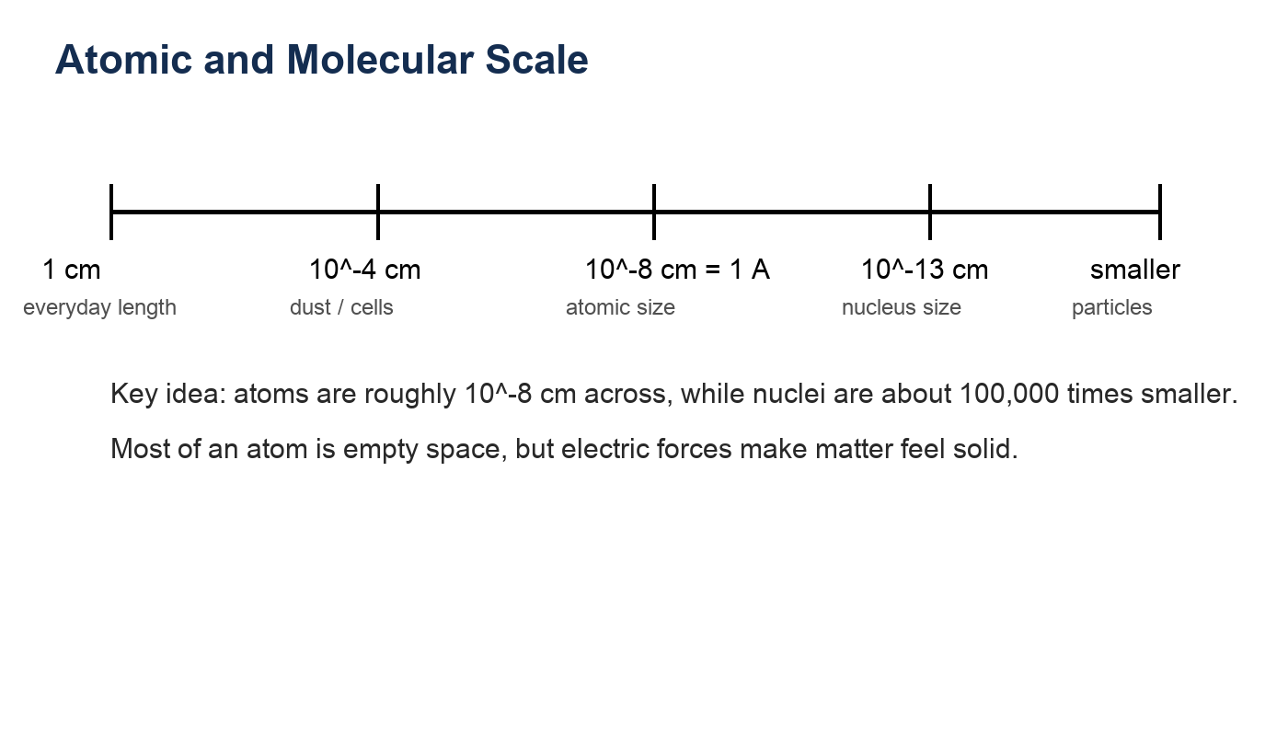
The note 1 x 10^-8 cm = 1 Angstrom gives a practical atomic scale. Atoms are commonly a few Angstroms across. The nucleus is far smaller, around 10^-13 cm, so an atom is mostly empty space by volume. Matter still feels solid because electrons and nuclei interact through electric forces.

Word Meanings and Uses
Apparatus: A set of instruments or equipment arranged for an experiment or task.
Used in: Laboratory experiments, optics benches, electrical circuit setups, vacuum systems, and measurement devices.
Application: A practical use of a scientific idea.
Used in: Engineering, medicine, electronics, chemistry, climate science, energy systems, and everyday technology.
Catalysis: The process of increasing reaction speed using a catalyst.
Used in: Enzymes, catalytic converters, fertilizer production, fuel processing, and green chemistry.
Cataclysm: A sudden violent event that causes major change or destruction.
Used in: Astrophysics, geology, planetary impacts, volcanic eruptions, supernovae, and historical descriptions of disasters.
Precipitation: In chemistry, formation of a solid from solution; in weather, water falling from clouds.
Used in: Chemical ion tests, water purification, crystallization, rain, snow, sleet, and hail.
Particle: A small localized unit of matter or energy.
Used in: Mechanics, atomic physics, particle physics, chemistry, aerosols, and fluids.
Ion: A charged atom or molecule.
Used in: Batteries, saltwater, plasma, acids and bases, nerve signals, electrolysis, and mass spectrometry.
Angstrom: A unit of length equal to 10^-10 m or 10^-8 cm.
Used in: Atomic radii, bond lengths, crystal structures, and molecular dimensions.
Amplitude: The maximum displacement or strength of an oscillation or wave.
Used in: Sound loudness, wave height, alternating current, vibration, and electromagnetic intensity.
Colloid: A mixture with very small particles dispersed through another substance.
Used in: Milk, fog, smoke, paint, gels, cosmetics, food science, and nanotechnology.
Hybrid: A combination of two different types or models.
Used in: Hybrid orbitals, hybrid materials, hybrid vehicles, and combined scientific models.

2. Atoms, Molecules, and Water
A water molecule is not a tiny drop of water. It is one oxygen atom bonded to two hydrogen atoms. The familiar properties of water, such as liquid flow, boiling, evaporation, surface tension, and condensation, come from the collective behavior of huge numbers of H2O molecules.
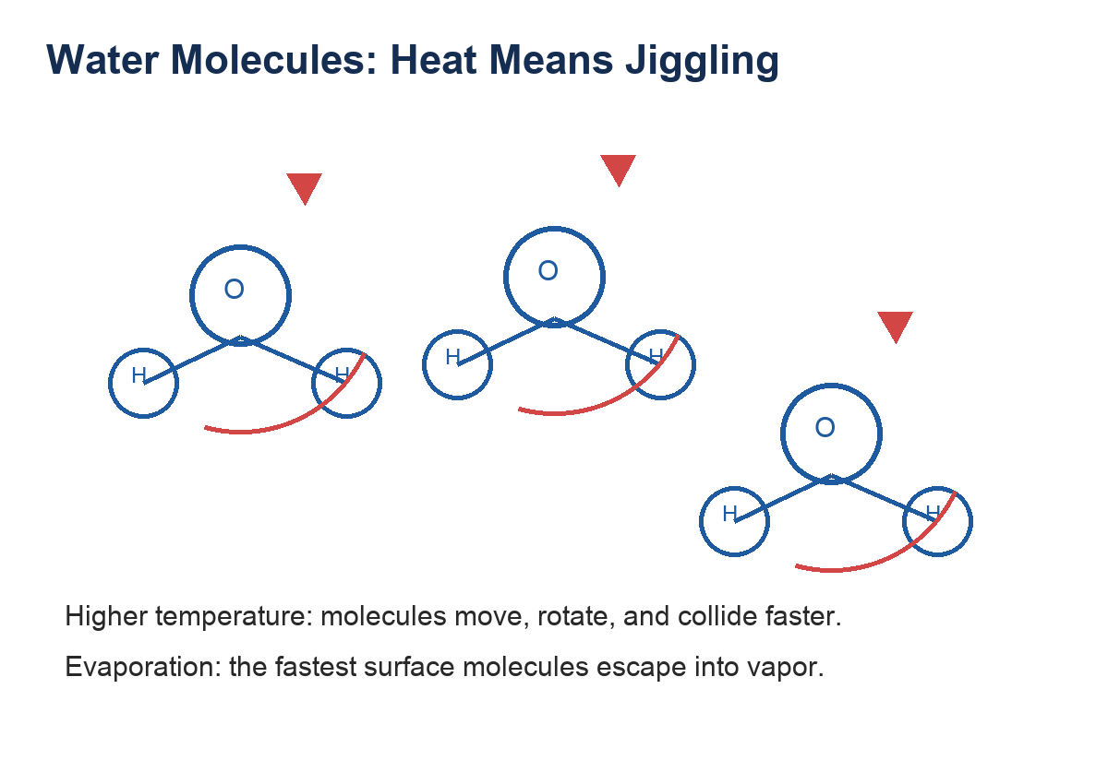
- Solid: molecules are locked into a pattern but still vibrate.
- Liquid: molecules remain close together but slide and rearrange.
- Gas/vapor: molecules are far apart and move freely.
- Evaporation: high-energy molecules at the surface escape into the air.
- Condensation/precipitation: vapor molecules lose energy, cluster, and may form droplets or ice crystals.

3. Heat as Molecular Motion
The handwritten phrase 'heat the more jiggle' is a compact version of kinetic theory: temperature measures the average random kinetic energy of particles. Heating a substance does not add a visible fluid called heat; it increases the microscopic motion of atoms and molecules.
This explains why heating can cause expansion, evaporation, and pressure increase. Faster molecules collide harder and more often. In a gas, this produces higher pressure. In a liquid, it increases the chance that a surface molecule escapes into vapor.

4. Density, Colloids, Catalysis, and Precipitation
Several terms on page 1 point to chemistry and physical chemistry. They are connected by the same atomic view of matter.
- Density is mass per volume. In molecular terms, it depends on how much mass each particle has and how closely the particles pack.
- A colloid is a mixture where tiny particles are dispersed through another substance. Fog, milk, smoke, and some gels are common examples.
- Catalysis is a process where a catalyst speeds a reaction without being consumed overall. It works by giving particles an easier reaction path.
- Precipitation occurs when dissolved particles combine into an insoluble solid, often because ions meet and form a crystal.
These topics look different in a textbook, but they all reduce to atoms and molecules moving, colliding, bonding, separating, and arranging themselves.

5. Ions and Electric Forces
The particle sketches with plus and minus signs suggest ions and electric interactions. An ion is an atom or molecule with net electric charge. A positive ion has lost electrons; a negative ion has gained electrons.
Electric attraction and repulsion organize matter. Positive and negative charges attract; like charges repel. Chemical bonds, dissolving salts, current in electrolytes, and the structure of crystals all depend on electric forces.

6. Waves, Frequency, Photons, and Rays
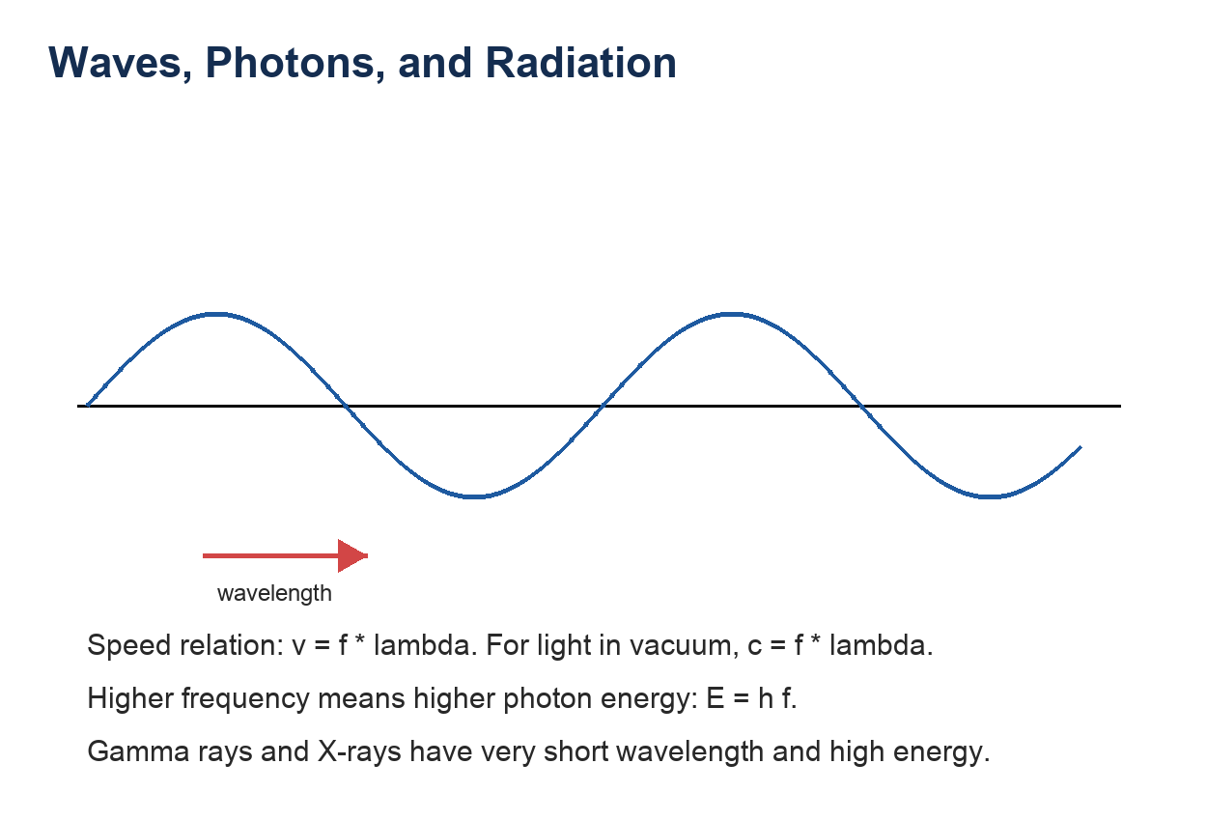
The page 2 notes mention wave formula, frequency, photons, gamma rays, X-rays, and cosmic rays. For waves, speed equals frequency times wavelength: v = f lambda. For light in vacuum, the speed is c, so c = f lambda.
A photon is a quantum of electromagnetic radiation. Its energy is E = h f, where h is Planck's constant and f is frequency. Higher frequency light has higher-energy photons. X-rays and gamma rays are high-frequency electromagnetic radiation; cosmic rays are mostly high-energy particles from space, often protons or atomic nuclei.

7. The Uncertainty Principle
The uncertainty principle is not just an instrument problem. Quantum mechanics says that certain pairs of quantities cannot both have exact values at the same time. For position and momentum, the approximate rule is Delta x Delta p >= hbar/2.
This matters most at atomic scales. To locate an electron very precisely, the uncertainty in its momentum becomes large. That is one reason atoms are not miniature solar systems with electrons moving in ordinary classical orbits.

Study Summary
- Matter is made of atoms and molecules.
- Atomic size is about 10^-8 cm; nuclear size is about 10^-13 cm.
- Heat is random molecular motion.
- Water vapor, condensation, and precipitation are molecular motion plus energy exchange.
- Density, colloids, catalysis, ions, and chemical reactions are atomic-scale behaviors.
- Waves satisfy v = f lambda; photons carry energy E = h f.
- The uncertainty principle limits simultaneous knowledge of position and momentum.

Merged Q&A Study Guide
Physics — Q&A Study Guide

Q1. Can sound waves travel through plasma?

Short Answer
Yes. Sound (acoustic/pressure) waves can travel through plasma, because plasma — like any gas or fluid — has pressure and density, the two physical properties necessary for a compression wave to propagate.

Detailed Explanation

What is plasma?
Plasma is the fourth state of matter, consisting of a partially or fully ionized gas made up of free electrons and positively charged ions. It is the most abundant form of visible matter in the universe (stars, lightning, neon lights, fusion reactors).

How do sound waves propagate?
Sound waves are longitudinal mechanical waves. They propagate by alternately compressing and rarefying the medium. This requires:
• Inertia — the medium has mass (density)
• Restoring force — the medium resists compression (pressure / elasticity)
Plasma satisfies both conditions, so it can support acoustic waves.

Speed of sound in plasma
The speed of sound in plasma follows the same formula as in an ideal gas:
v = √(γ · k_B · T / m)
• γ = adiabatic index (ratio of specific heats)
• k_B = Boltzmann's constant (1.38 × 10⁻²³ J/K)
• T = temperature of the plasma (in Kelvin)
• m = mean particle mass
Because plasma temperatures are extremely high (millions of Kelvin in the Sun), the speed of sound in plasma can be enormous — millions of m/s.

Additional wave types unique to plasma
Because plasma is electrically charged, it supports several wave types that ordinary gas cannot:
• Langmuir waves — high-frequency oscillations of electrons relative to ions
• Ion acoustic waves — low-frequency acoustic waves modified by ion–electron coupling
• Alfvén waves — transverse waves propagating along magnetic field lines (requires B-field)
• Magnetosonic waves — compressional waves propagating perpendicular to a magnetic field
• Plasma acoustic waves — sound-like waves but with plasma dispersion effects

Real-world examples
1. Helioseismology — Scientists study acoustic oscillations inside the Sun's plasma to map its internal structure (similar to using seismic waves to study Earth's interior).
2. Fusion reactors — Acoustic instabilities in plasma are an active area of research.
3. Earth's ionosphere — Radio and acoustic waves interact with ionospheric plasma.
4. Solar corona — Magnetoacoustic waves travel through coronal plasma and transport energy.

Key Distinction
Sound waves CAN travel through plasma (longitudinal pressure waves). However, electromagnetic waves (light, radio) can ALSO travel through plasma, but only if their frequency exceeds the plasma frequency (ω_p). Below the plasma frequency, EM waves are reflected — this is why AM radio bounces off the ionosphere.

Summary
Plasma supports acoustic (sound) waves because it has mass and pressure. Additionally, its electrical nature gives rise to unique wave types (Langmuir, Alfvén, magnetosonic) that do not exist in neutral gases. The speed of sound in plasma is extremely high due to very high temperatures.

Quick Practice Questions
- Why does heating water make evaporation more likely?
- What does 1 Angstrom represent, and why is it useful for atoms?
- How is an ion different from a neutral atom?
- Why do X-rays have more energy per photon than visible light?
- What does the uncertainty principle say about measuring an electron?

