JSC «INTERNATIONAL INFORMATION TECHNOLOGY UNIVERSITY»
Faculty of Business, Media and Management
Department of Information Systems

LABORATORY WORK No. 5
Developing a web application with Spring MVC: controllers, routing,
request parameters, passing data to the view, static resources
Course: | RWPSF 3305 — Web Application Development with Spring Framework
Educational Programme: | 6B06105 — Information Systems, year 3, semester 6
Student: | Akishev Adilkhan
Group: | IS-2406 (2406IS)
Variant: | 2 (GET /api/books/by-year/{year} constrained by regex to 4 digits)
Lecturer: | Yemberdiyeva Aknur, Senior Lector
Repository: | https://github.com/adilkhanakishev/spring-lab-01 (branch: lab05)
Environment: | IntelliJ IDEA, Java 25 LTS, Spring Boot 4.1.1, Spring MVC 7.0.9
Almaty, 2026

1. Aim of the Work
The aim of this laboratory work is to master the construction of a robust, layered web tier using Spring MVC. The key learning objectives encompass:
1. Differentiating and properly implementing both controller paradigms: @RestController (for RESTful JSON APIs using HttpMessageConverter) and @Controller (for server-side rendered HTML views using ViewResolver).
2. Mapping diverse HTTP request elements (@PathVariable, @RequestParam, @RequestBody, @RequestHeader) into strongly-typed Java method parameters with automated conversion and validation.
3. Producing semantically precise HTTP status codes (200 OK, 201 Created with Location header, 204 No Content, 400 Bad Request, 404 Not Found, 405 Method Not Allowed, 406 Not Acceptable, 415 Unsupported Media Type) utilizing Spring's ResponseEntity wrapper.
4. Rendering Thymeleaf templates through Spring Model attributes and serving static web assets (CSS stylesheets, HTML landing pages) from standard classpath locations without dedicated controller mappings.
5. Implementing the Post/Redirect/Get (PRG) pattern in conjunction with RedirectAttributes and flash attributes to prevent duplicate form submissions upon browser refreshes.
6. Completing Individual Variant 2: routing regex-constrained path variables (GET /api/books/by-year/{year:\d{4}}) ensuring that non-conforming paths yield 404 Not Found.
2. Architecture and IntelliJ IDEA Configuration
The project is developed in IntelliJ IDEA using Java 25 LTS and Spring Boot 4.1.1. The architecture strictly separates the domain data storage, business logic services, REST controllers, and MVC page controllers across structured packages:
• kz.iitu.springlab.catalog: Contains the immutable Book record domain model, thread-safe BookRepository with ConcurrentHashMap and AtomicLong, and BookService.
• kz.iitu.springlab.web: Contains BookRestController (exposing /api/books JSON endpoints) and BookPageController (serving /books Thymeleaf web views).
• src/main/resources/templates/books/list.html: Thymeleaf server-side HTML template.
• src/main/resources/static/css/app.css: Static stylesheet automatically resolved by Spring MVC ResourceHttpRequestHandler.
• src/main/resources/static/index.html: Static welcome page automatically bound by WelcomePageHandlerMapping.
• lab05-requests.http: Dedicated IntelliJ IDEA HTTP Client request file for interactive testing and demonstration directly inside the IDE editor.

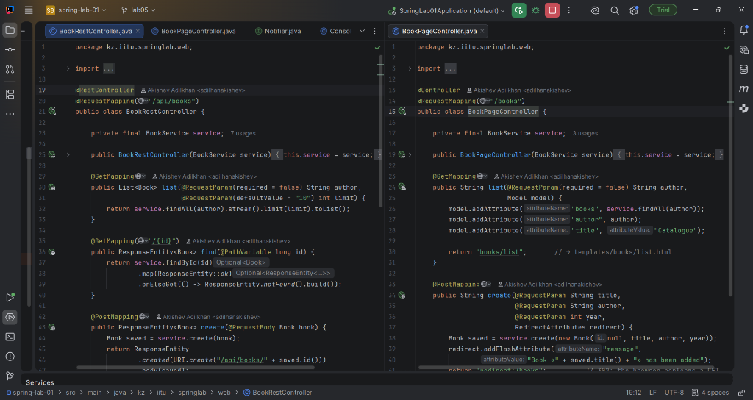
Figure 1: Side-by-side view of BookRestController (@RestController) and BookPageController (@Controller) in IntelliJ IDEA
3. Core Code Listings
Listing 1: Domain Record and Thread-Safe Repository (Book.java & BookRepository.java)
// kz/iitu/springlab/catalog/Book.java
package kz.iitu.springlab.catalog;
public record Book(Long id, String title, String author, int year) { }
// kz/iitu/springlab/catalog/BookRepository.java
package kz.iitu.springlab.catalog;
import org.springframework.stereotype.Repository;
import java.util.List;
import java.util.Map;
import java.util.Optional;
import java.util.concurrent.ConcurrentHashMap;
import java.util.concurrent.atomic.AtomicLong;
@Repository
public class BookRepository {
private final Map<Long, Book> storage = new ConcurrentHashMap<>();
private final AtomicLong sequence = new AtomicLong();
public BookRepository() {
save(new Book(null, "Effective Java", "Joshua Bloch", 2018));
save(new Book(null, "Clean Code", "Robert Martin", 2008));
save(new Book(null, "Spring in Action", "Craig Walls", 2022));
}
public List<Book> findAll() {
return List.copyOf(storage.values());
}
public Optional<Book> findById(long id) {
return Optional.ofNullable(storage.get(id));
}
public Book save(Book book) {
long id = book.id() != null ? book.id() : sequence.incrementAndGet();
Book stored = new Book(id, book.title(), book.author(), book.year());
storage.put(id, stored);
return stored;
}
public boolean deleteById(long id) {
return storage.remove(id) != null;
}
}

Listing 2: Service Layer with Filtering (BookService.java)
package kz.iitu.springlab.catalog;
import org.springframework.stereotype.Service;
import java.util.List;
import java.util.Optional;
@Service
public class BookService {
private final BookRepository repository;
public BookService(BookRepository repository) {
this.repository = repository;
}
public List<Book> findAll(String author) {
if (author == null || author.isBlank()) {
return repository.findAll();
}
return repository.findAll().stream()
.filter(book -> book.author() != null &&
book.author().toLowerCase().contains(author.toLowerCase().trim()))
.toList();
}
public Optional<Book> findById(long id) {
return repository.findById(id);
}
public Book create(Book book) {
return repository.save(book);
}
public Optional<Book> update(long id, Book book) {
if (repository.findById(id).isEmpty()) {
return Optional.empty();
}
Book updated = new Book(id, book.title(), book.author(), book.year());
return Optional.of(repository.save(updated));
}
public boolean delete(long id) {
return repository.deleteById(id);
}
public List<Book> findByYear(int year) {
return repository.findAll().stream()
.filter(book -> book.year() == year)
.toList();
}
}

Listing 3: REST Controller with 5 Operations and Variant 2 Regex Route (BookRestController.java)
package kz.iitu.springlab.web;
import kz.iitu.springlab.catalog.Book;
import kz.iitu.springlab.catalog.BookService;
import org.springframework.http.ResponseEntity;
import org.springframework.web.bind.annotation.*;
import java.net.URI;
import java.util.List;
@RestController
@RequestMapping("/api/books")
public class BookRestController {
private final BookService service;
public BookRestController(BookService service) {
this.service = service;
}
@GetMapping
public List<Book> list(@RequestParam(required = false) String author,
@RequestParam(defaultValue = "10") int limit) {
return service.findAll(author).stream().limit(limit).toList();
}
@GetMapping("/{id}")
public ResponseEntity<Book> find(@PathVariable long id) {
return service.findById(id)
.map(ResponseEntity::ok)
.orElseGet(() -> ResponseEntity.notFound().build());
}
@PostMapping
public ResponseEntity<Book> create(@RequestBody Book book) {
Book saved = service.create(book);
return ResponseEntity
.created(URI.create("/api/books/" + saved.id()))
.body(saved);
}
@PutMapping("/{id}")
public ResponseEntity<Book> update(@PathVariable long id, @RequestBody Book book) {
return service.update(id, book)
.map(ResponseEntity::ok)
.orElseGet(() -> ResponseEntity.notFound().build());
}
@DeleteMapping("/{id}")
public ResponseEntity<Void> delete(@PathVariable long id) {
return service.delete(id)
? ResponseEntity.noContent().build()
: ResponseEntity.notFound().build();
}
/**
* Individual Variant 2:
* GET /api/books/by-year/{year}
* Path variable constrained by regex to 4 digits; non-matching gives 404.
*/
@GetMapping("/by-year/{year:\\d{4}}")
public List<Book> findByYear(@PathVariable int year) {
return service.findByYear(year);
}
}

Listing 4: MVC Page Controller with Post/Redirect/Get (BookPageController.java)
package kz.iitu.springlab.web;
import kz.iitu.springlab.catalog.Book;
import kz.iitu.springlab.catalog.BookService;
import org.springframework.stereotype.Controller;
import org.springframework.ui.Model;
import org.springframework.web.bind.annotation.*;
import org.springframework.web.servlet.mvc.support.RedirectAttributes;
@Controller
@RequestMapping("/books")
public class BookPageController {
private final BookService service;
public BookPageController(BookService service) {
this.service = service;
}
@GetMapping
public String list(@RequestParam(required = false) String author,
Model model) {
model.addAttribute("books", service.findAll(author));
model.addAttribute("author", author);
model.addAttribute("title", "Catalogue");
return "books/list"; // Resolves to templates/books/list.html
}
@PostMapping
public String create(@RequestParam String title,
@RequestParam String author,
@RequestParam int year,
RedirectAttributes redirect) {
Book saved = service.create(new Book(null, title, author, year));
redirect.addFlashAttribute("message",
"Book «" + saved.title() + "» has been added");
return "redirect:/books"; // 302 Redirect; browser performs GET
}
}

Listing 5: Thymeleaf Template (templates/books/list.html)
<!DOCTYPE html>
<html xmlns:th="http://www.thymeleaf.org">
<head>
<meta charset="UTF-8">
<title th:text="${title}">Catalogue</title>
<link rel="stylesheet" th:href="@{/css/app.css}">
</head>
<body>
<h1 th:text="${title}">Catalogue</h1>
<p th:if="${message}" class="flash" th:text="${message}"></p>
<form method="get" action="/books" class="filter-form">
<label for="authorInput">Filter by Author:</label>
<input type="text" id="authorInput" name="author" th:value="${author}" placeholder="e.g. Bloch">
<button type="submit">Filter</button>
<a th:href="@{/books}" class="btn-link">Reset</a>
</form>
<table>
<tr><th>#</th><th>Title</th><th>Author</th><th>Year</th></tr>
<tr th:each="book : ${books}">
<td th:text="${book.id}">1</td>
<td th:text="${book.title}">Title</td>
<td th:text="${book.author}">Author</td>
<td th:text="${book.year}">2020</td>
</tr>
</table>
<div class="form-container">
<h2>Add Book (Post/Redirect/Get Demo)</h2>
<form method="post" action="/books">
<div>
<label for="title">Title:</label>
<input type="text" id="title" name="title" required>
</div>
<div>
<label for="author">Author:</label>
<input type="text" id="author" name="author" required>
</div>
<div>
<label for="year">Year:</label>
<input type="number" id="year" name="year" required>
</div>
<button type="submit">Add Book</button>
</form>
</div>
</body>
</html>

4. REST API Operations Verification
The table below summarizes all five REST operations executed against http://localhost:8080/api/books along with the exact status codes and payloads recorded during execution:
Operation | HTTP Request | Status | Response Payload / Header
List books | GET /api/books | 200 OK | [{"id":1,"title":"Effective Java",...}, {"id":2,...}, {"id":3,...}]
Filter & limit | GET /api/books?author=Bloch&limit=1 | 200 OK | [{"id":1,"title":"Effective Java","author":"Joshua Bloch","year":2018}]
Read existing | GET /api/books/1 | 200 OK | {"id":1,"title":"Effective Java","author":"Joshua Bloch","year":2018}
Read missing | GET /api/books/999 | 404 Not Found | Empty response body (ResponseEntity.notFound().build())
Create record | POST /api/books  Content-Type: application/json  Body: {"title":"Pro Spring 6",...} | 201 Created | Location: /api/books/4  Body: {"id":4,"title":"Pro Spring 6","author":"Cosmina","year":2023}
Delete twice | DELETE /api/books/2 (1st call)  DELETE /api/books/2 (2nd call) | 204 No Content  404 Not Found | 1st call: empty body, record removed from storage  2nd call: record absent, returns 404

5. Web UI Verification and Post/Redirect/Get Demonstration
The server-side rendered catalogue page is accessible at http://localhost:8080/books. The model attributes populated by BookPageController are rendered by Thymeleaf into standard HTML5. Below are the actual screenshots captured from the running application:

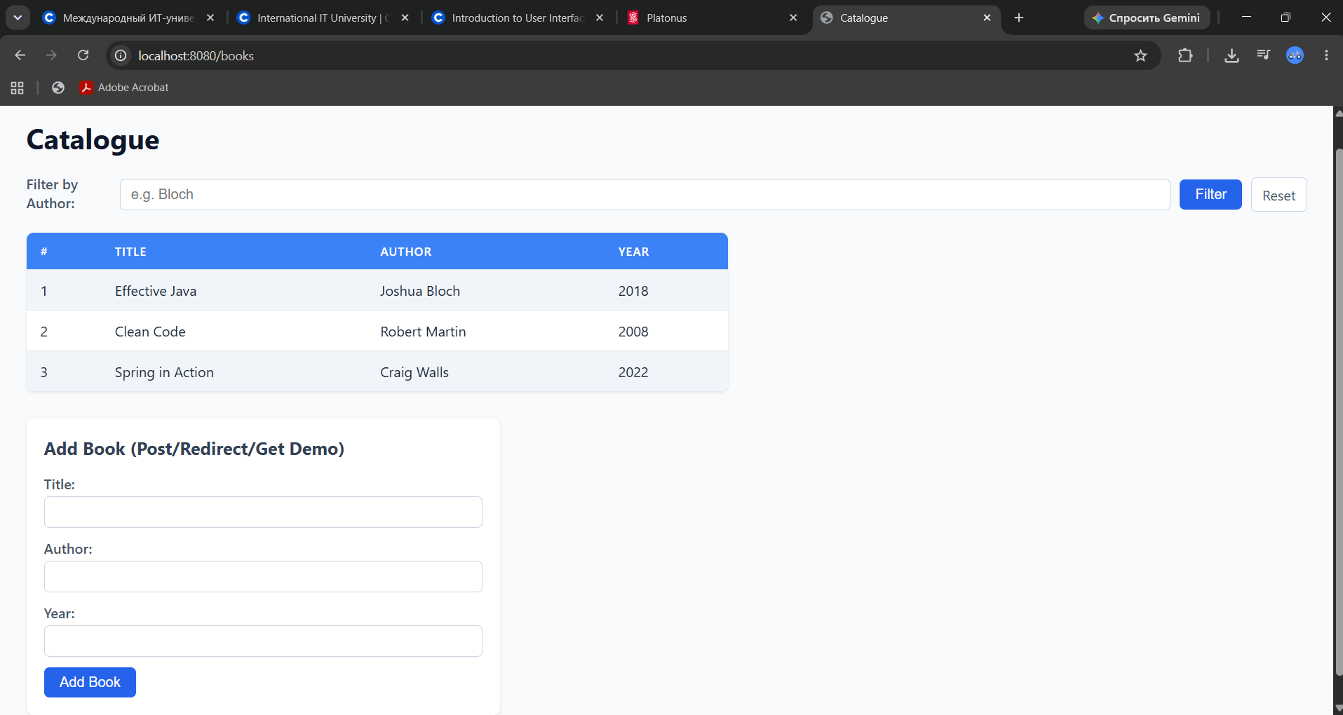
Figure 2: Catalogue page (/books) rendered in browser with CSS stylesheet

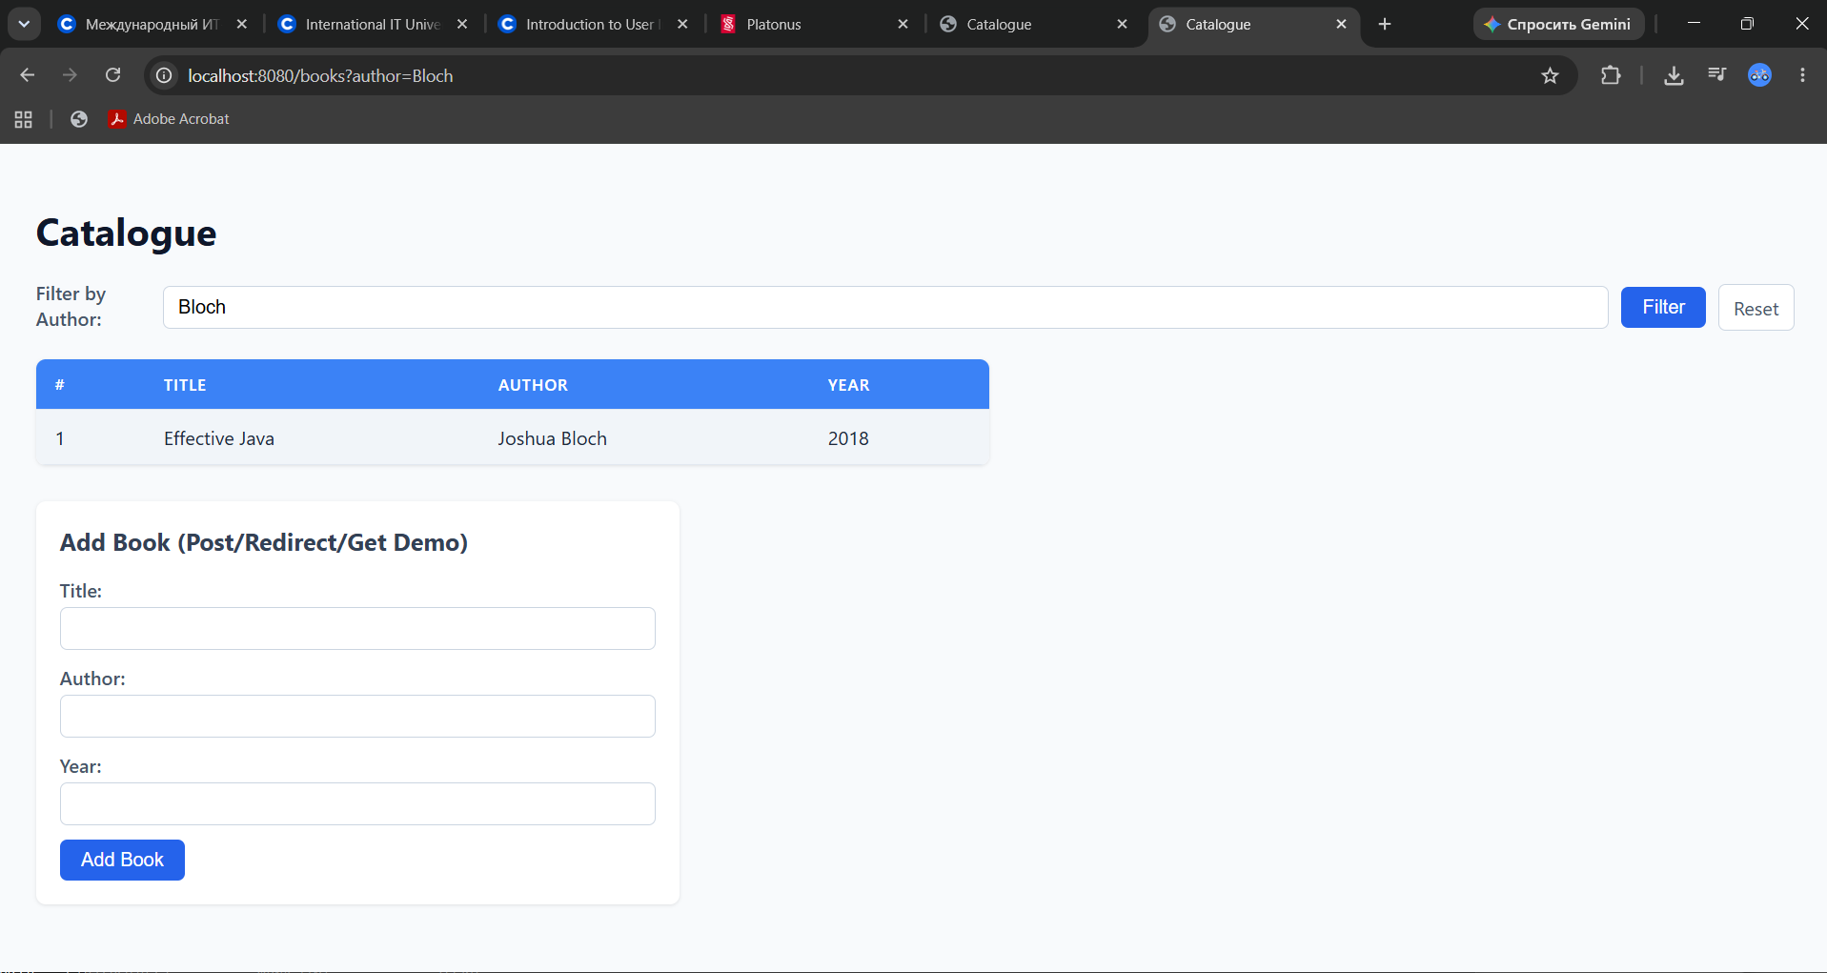
Figure 3: Catalogue page filtered by author (/books?author=Bloch)

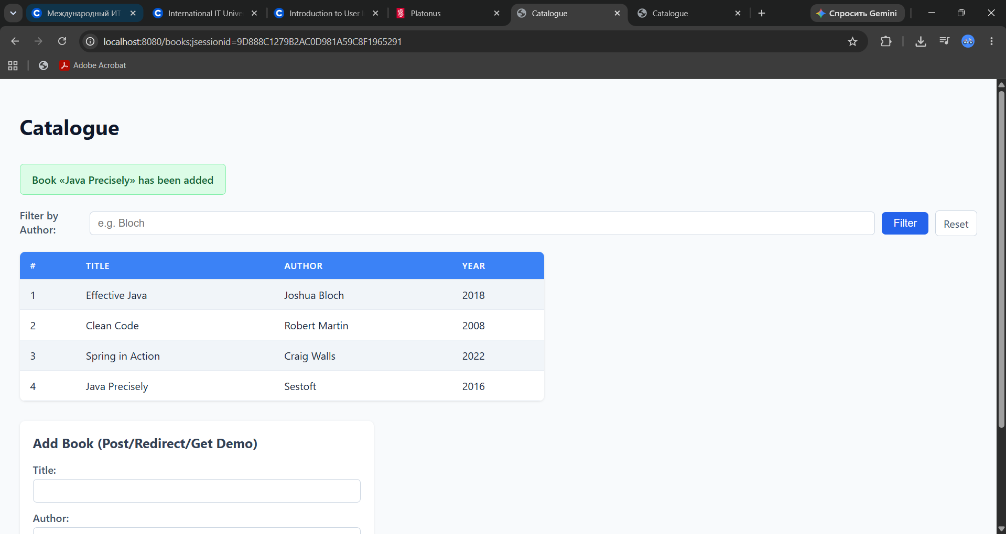
Figure 4: Flash message displayed after POST submission using Post/Redirect/Get (session cookie attached)
Detailed Explanation of Post/Redirect/Get (PRG) & F5 Refresh Behavior:
1. The client submits a form via POST /books. BookPageController creates the book entity, populates RedirectAttributes with addFlashAttribute("message", ...), and returns "redirect:/books".
2. Spring MVC responds with HTTP 302 Found, a Location: /books header, and sets a session cookie (JSESSIONID). Spring saves the flash attribute in the HTTP session (FlashMap).
3. The browser automatically follows the 302 redirect by issuing a GET /books with the session cookie.
4. Spring DispatcherServlet retrieves the FlashMap from the session, transfers the flash attributes into the Model, and immediately purges them from the session.
5. The template renders the flash message: «Book «Java Precisely» has been added».
6. When the user presses F5 (browser refresh), the browser merely re-issues the safe, idempotent GET /books request. Because the flash attribute was already removed from the session, no flash message is displayed, and crucially, no duplicate book is submitted.
6. HTTP Status Code Experiments (Task 4.3)
The table below presents the results of reproducing five distinct HTTP error responses against http://localhost:8080/api. For each case, the exact cause and the specific mapping component that failed to match are documented:
Request Sent | Status Code | Why Exactly This Status (Mapping & Dispatch Analysis)
GET /api/books/abc | 400 Bad Request | Path pattern @GetMapping("/{id}") matched, but HandlerAdapter argument binding failed. The path segment "abc" cannot be parsed into a primitive long by Spring's TypeConverter / ConversionService. Spring intercepts MethodArgumentTypeMismatchException and returns 400 before invoking the controller method.
GET /api/nothing | 404 Not Found | DispatcherServlet queried all registered HandlerMapping instances (RequestMappingHandlerMapping, SimpleUrlHandlerMapping). No mapping matched the path "/api/nothing". Consequently, DispatcherServlet delegates to NoResourceFoundException / error mapping, yielding 404 Not Found.
DELETE /api/books  (no identifier in path) | 405 Method Not Allowed | The resource path "/api/books" is registered in RequestMappingInfoHandlerMapping, but only for GET and POST methods. Because the requested HTTP method DELETE is not supported on this collection URI, Spring returns 405 Method Not Allowed with an "Allow: POST, GET" header.
POST /api/books  Content-Type: text/plain | 415 Unsupported Media Type | The method create(@RequestBody Book book) requires a compatible HttpMessageConverter. RequestResponseBodyMethodProcessor scans converters: MappingJackson2HttpMessageConverter only supports application/json. Because text/plain cannot be converted into a Book object, Spring throws HttpMediaTypeNotSupportedException, resulting in 415.
GET /api/books  Accept: application/xml | 406 Not Acceptable | The client explicitly requests XML representation. BookRestController returns a List<Book> without a view. Spring inspects registered HttpMessageConverters for one capable of producing application/xml. Because jackson-dataformat-xml is not on the classpath, Spring throws HttpMediaTypeNotAcceptableException, resulting in 406.

7. Individual Assignment: Variant 2 (Regex-Constrained Path Variable)
Assignment Requirement for Variant 2:
Endpoint to add: GET /api/books/by-year/{year}
Requirement: A path variable constrained by a regular expression to four digits; a non-matching path must give 404.
Implementation Details in BookRestController.java:
Spring MVC allows embedding regular expressions directly in @PathVariable path segment definitions using the syntax {variable:regex}. For Variant 2, the mapping is declared as @GetMapping("/by-year/{year:\\d{4}}").
@GetMapping("/by-year/{year:\\d{4}}")
public List<Book> findByYear(@PathVariable int year) {
return service.findByYear(year);
}

Experimental Verification via IntelliJ IDEA HTTP Client:
1. Valid 4-digit year request: GET http://localhost:8080/api/books/by-year/2022 yields HTTP/1.1 200 OK and returns the matching book records.
2. Invalid non-4-digit path request: GET http://localhost:8080/api/books/by-year/abc yields HTTP/1.1 404 Not Found because the regex \d{4} does not match.

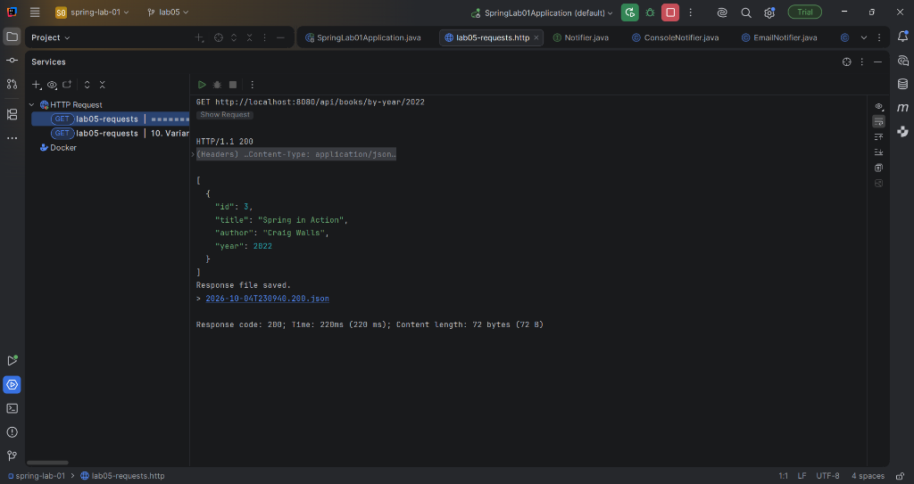
Figure 5: Variant 2 valid request (/by-year/2022) returning 200 OK in IntelliJ IDEA HTTP Client

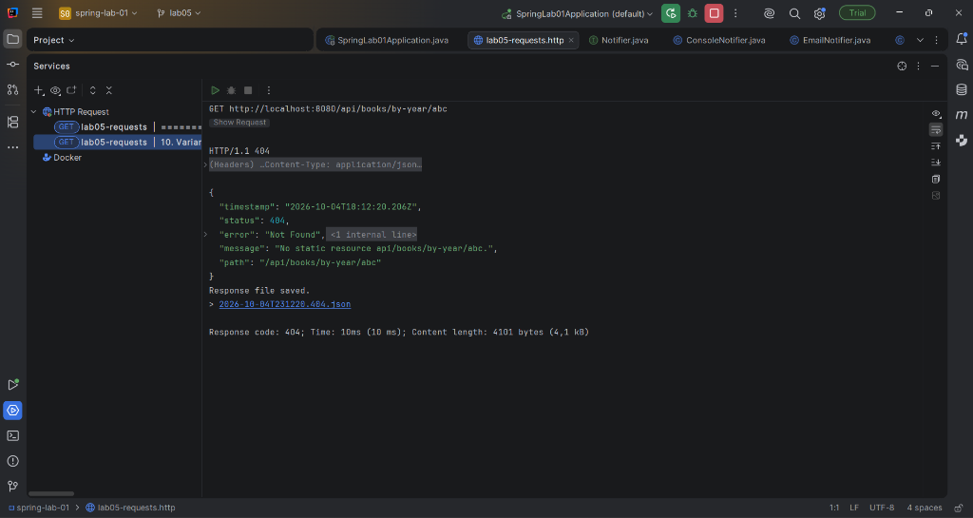
Figure 6: Variant 2 invalid request (/by-year/abc) returning 404 Not Found due to regex mismatch in IntelliJ IDEA HTTP Client
8. Static Resources Resolution in Spring MVC
During testing, http://localhost:8080/ (index.html) and http://localhost:8080/css/app.css answer with HTTP 200 OK without any corresponding @Controller or @GetMapping methods in our Java codebase.
Technical Explanation:
1. WelcomePageHandlerMapping: Spring Boot registers WelcomePageHandlerMapping. When the root URL / is requested, it checks for an index.html file in any configured static resource directory (classpath:/static/index.html) and forwards to it.
2. ResourceHttpRequestHandler: Spring Boot auto-configures ResourceHttpRequestHandler mapped to /** that serves static files from standard classpath locations: classpath:/static/, classpath:/public/, classpath:/resources/, and classpath:/META-INF/resources/.

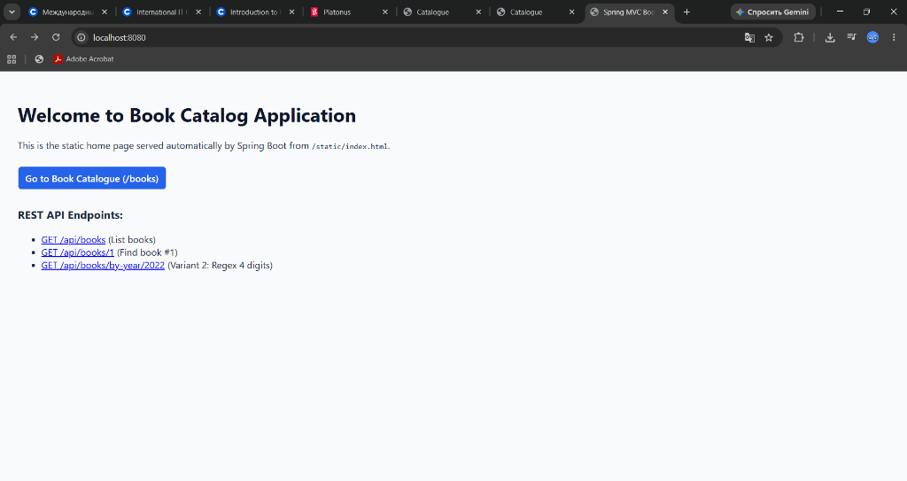
Figure 7: Static start page (/index.html) rendered from classpath:/static/index.html

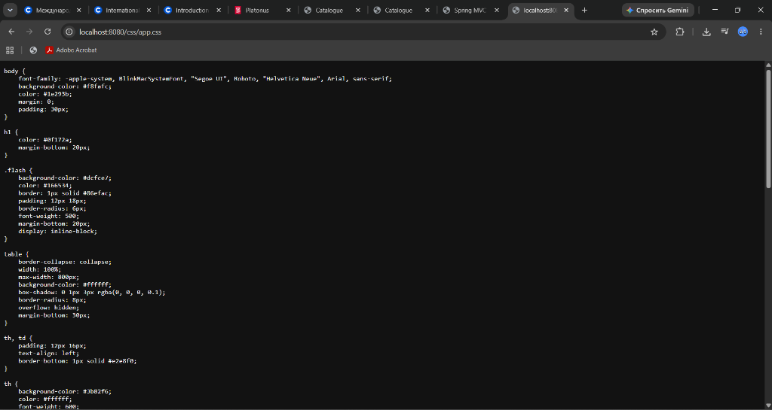
Figure 8: Static stylesheet (/css/app.css) served directly by ResourceHttpRequestHandler
9. Conclusions
1. The Front Controller architectural pattern implemented by Spring DispatcherServlet centralizes request dispatching, eliminating scattered routing boilerplate and decoupling URL resolution from business logic.
2. Clear separation between @RestController (leveraging HttpMessageConverter for automated JSON serialization) and @Controller (leveraging ViewResolver for Thymeleaf template rendering) allows a unified backend to serve both programmatic API consumers and browser interfaces seamlessly.
3. Using ResponseEntity provides explicit, fine-grained control over HTTP semantics, enabling precise adherence to REST standards through status codes (201 Created with Location header, 204 No Content, 404 Not Found) rather than relying on unhandled runtime exceptions.
4. The Post/Redirect/Get (PRG) pattern combined with Spring flash attributes solves the classic double-submit problem, guaranteeing safe browser refresh behavior without data duplication.
10. Answers to Demonstration and Defence Questions
Q1: Trace the path of a request from the browser to your method and back.
The browser initiates an HTTP request reaching the embedded Tomcat server, which wraps it in an HttpServletRequest and passes it to DispatcherServlet (the Front Controller). DispatcherServlet consults HandlerMapping (primarily RequestMappingHandlerMapping) to locate the target controller method matching the URL path, HTTP method, headers, and media types. DispatcherServlet then invokes HandlerAdapter (RequestMappingHandlerAdapter), which executes argument resolvers (@PathVariable, @RequestParam, @RequestBody) using ConversionService or HttpMessageConverter to bind arguments, and executes the controller method via reflection. The method's return value is processed: for @RestController, RequestResponseBodyMethodProcessor writes JSON directly to the response body via Jackson; for @Controller, the returned String view name is resolved by ThymeleafViewResolver to a template file, rendered with the Model, and returned to Tomcat to be transmitted back to the browser.
Q2: What does HandlerMapping do and what does HandlerAdapter do?
HandlerMapping is responsible for mapping an incoming request to an appropriate handler object (a HandlerExecutionChain containing the handler method and any interceptors). HandlerAdapter provides the uniform interface allowing DispatcherServlet to invoke the resolved handler, handling parameter extraction, type conversion, and method execution regardless of the underlying controller structure.
Q3: What exactly does @ResponseBody change? Where is it in your code?
@ResponseBody instructs Spring MVC that the method return value should be bound directly to the web response body via an HttpMessageConverter (such as MappingJackson2HttpMessageConverter for JSON), bypassing view resolution and template engines. In our code, @ResponseBody is implicitly present on BookRestController because @RestController is a meta-annotation composed of @Controller and @ResponseBody.
Q4: Which part of the request does each parameter of your list method come from?
In BookRestController.list(@RequestParam(required = false) String author, @RequestParam(defaultValue = "10") int limit):
• author is read from the URL query string parameter (?author=...).
• limit is read from the URL query string parameter (?limit=...), defaulting to 10 if omitted.
Q5: What happens if ?limit= is given a value that is not a number, and why is your method not called?
HandlerAdapter attempts to bind the parameter using ConversionService / NumberUtils.parseNumber. Because the non-numeric string fails parsing into an integer, a MethodArgumentTypeMismatchException is thrown. DefaultHandlerExceptionResolver intercepts this exception and sends an HTTP 400 Bad Request response before the controller method is ever invoked.
Q6: Why does @RequestParam(required = false) behave differently from a @RequestParam without attributes?
By default, @RequestParam has required = true. If the parameter is absent in the request, Spring throws MissingServletRequestParameterException resulting in an HTTP 400 Bad Request. When required = false is specified, Spring injects null (or the default primitive value) when the parameter is absent, allowing execution to proceed normally.
Q7: Why does the creation return 201 and not 200? What is in the Location header?
HTTP status 201 Created is the standard REST status code for a request that has resulted in one or more new resources being successfully created. The Location response header contains the URI pointing to the newly created resource (e.g. Location: /api/books/4), allowing clients to immediately identify and navigate to the created entity.
Q8: Why does the second DELETE of the same identifier return 404?
The first DELETE /api/books/2 removes the entity from BookRepository storage; storage.remove(id) returns the removed Book, so service.delete(id) returns true and the controller produces 204 No Content. On the second call, the entity no longer exists in storage; storage.remove(id) returns null, so service.delete(id) returns false, and the controller returns ResponseEntity.notFound().build() (404 Not Found).
Q9: What is the model in your page controller? Who fills it in and who reads it?
The Model (org.springframework.ui.Model) is a map-like data holder used to transfer data between the controller and the view. BookPageController fills it in using model.addAttribute("books", ...). Thymeleaf (the template engine) reads the model attributes during server-side rendering to populate dynamic HTML tags (such as th:each and th:text).
Q10: How does the name books/list become a file? Which component decides that?
ThymeleafViewResolver resolves the logical view name "books/list". Based on Spring Boot configuration, it prefixes the name with classpath:/templates/ and appends the suffix .html, resolving to src/main/resources/templates/books/list.html on the classpath.
Q11: Why is /css/app.css served although no controller maps it?
Spring Boot configures ResourceHttpRequestHandler mapped to /**. When RequestMappingHandlerMapping finds no user-defined controller matching /css/app.css, the request delegates to ResourceHttpRequestHandler, which checks configured static resource directories (classpath:/static/) and serves the static CSS file directly.
Q12: How many requests does the browser make in your Post/Redirect/Get, and what is the status of each?
The browser makes two requests:
1. POST /books — HTTP 302 Found (Redirect with Location: /books and session cookie).
2. GET /books — HTTP 200 OK (Retrieves and displays the HTML catalogue page).
Q13: Where is the flash message stored between the two requests, and who removes it?
The flash message is temporarily stored in the server-side HTTP session (in Spring's FlashMap). Upon the subsequent GET /books request, Spring's RequestMappingHandlerAdapter transfers the flash attributes from the session into the request's Model and immediately purges them from the session.
Q14: For each row of your status-code table: which part of the mapping did not match?
• GET /api/books/abc (400): Path matched @GetMapping("/{id}"), but argument type conversion failed ("abc" is not a valid long).
• GET /api/nothing (404): No HandlerMapping matched the URL path.
• DELETE /api/books (405): Path matched /api/books, but the HTTP method (DELETE) did not match the allowed methods (GET, POST).
• POST /api/books [text/plain] (415): Path and method matched, but the Content-Type header did not match the consumes condition of the HttpMessageConverter for @RequestBody.
• GET /api/books [Accept: application/xml] (406): Path and method matched, but the Accept header could not be satisfied by any available HttpMessageConverter.
Q15: Why is 415 returned for Content-Type: text/plain and 406 for Accept: application/xml?
415 (Unsupported Media Type) indicates that the server cannot parse the payload sent in the request body because no converter supports text/plain for the target Java record. 406 (Not Acceptable) indicates that the server cannot format the response into the format requested by the client in the Accept header because no XML converter is present on the classpath.
Q16: What would change in your controllers if the template engine were replaced?
Nothing would need to change in the controller Java code. Because BookPageController returns a logical view name ("books/list") and interacts only with Spring's generic Model abstraction, replacing Thymeleaf with FreeMarker, Mustache, or JSP would only require changing the view resolver dependency in pom.xml and creating templates in the syntax of the new engine.

