International Information Technology University

Laboratory work 9
Spring Transaction Management and Database Schema Versioning
Course: RWPSF 3305 Web Application Development with Spring Framework
Student: Akishev Adilkhan
Group: IS-2406
Lecturer: Yemberdiyeva Aknur
Date: 2 November 2026

Aim and implementation
I implemented and tested atomic account transfers, transaction propagation, isolation, optimistic locking, and database schema migrations. The 13 laboratory 9 tests passed with no failures, errors, or skipped tests. The experiments demonstrate both successful commits and deliberate failures with verified database state.
Laboratory 9 extends the spring-lab-01 project from laboratory 8. It uses Spring Boot 4.1.1, Java 25, Spring Data JPA, Hibernate, H2 2.4.240 and Flyway. The lab09 profile uses a separate H2 database and port 8089, while the default profile retains PostgreSQL.

Database and transaction design
Account maps the accounts table with id, ownerName, balance, version and status. Monetary values use BigDecimal and DECIMAL(19,2). The domain methods reject nonpositive amounts, amounts with more than two decimal places, inactive accounts and insufficient funds. A database check also prevents negative balances.
AccountRepository extends JpaRepository. TransferService defines the business transaction boundary. Both managed accounts are changed within one @Transactional method and Hibernate dirty checking persists both at commit. Transfers to the same account are rejected. AuditService is a separate bean, so propagation calls pass through the Spring transactional proxy rather than self-invocation.
spring.jpa.hibernate.ddl-auto=validate
spring.jpa.open-in-view=false
spring.datasource.url=jdbc:h2:file:./data/lab09
spring.flyway.enabled=true

References
Spring transactions: https://docs.spring.io/spring-framework/reference/data-access/transaction/declarative.html
H2 isolation: https://h2database.github.io/html/advanced.html
PostgreSQL isolation: https://www.postgresql.org/docs/current/transaction-iso.html

Task A Atomic transfers and rollback
Each test starts with Alice at 1000.00 and Bob at 500.00. Assertions read the persisted state after the service call, outside the transaction that performed the operation. Tests themselves are not wrapped in a test-managed rollback transaction.
TRANSFER Alice=900.00 Bob=600.00 total=1500.00
INSUFFICIENT FUNDS rejected; Alice=1000.00 Bob=500.00
ROLLBACK after SQL flush: Alice=1000.00 Bob=500.00 version=0
The successful transfer moved 100.00 and preserved the total balance. The insufficient-funds transfer failed without changing either account. failAfterDebit explicitly flushes the debit SQL before throwing an unchecked exception; the final balance and version confirm that the SQL changes were rolled back.
By default, an unchecked RuntimeException or Error causes rollback. A checked IOException does not. The checkedDefault experiment therefore committed the debit, leaving Alice at 900.00. The checkedRollback method declares @Transactional(rollbackFor=IOException.class), and the same failure restored Alice to 1000.00. These deliberately unsafe demonstrations are service methods used by tests, not public HTTP endpoints.

Task B Propagation
REQUIRED outer rollback: audits=0 Alice=1000.00
REQUIRES_NEW outer rollback: audits=1 Alice=1000.00
The outer method debits Alice, invokes the audit bean, and then throws an unchecked exception. REQUIRED joins the existing physical transaction, so both the debit and audit roll back. REQUIRES_NEW suspends the outer transaction and commits the audit in a separate transaction. Its record remains after the outer debit rolls back. The audit uses an independent table with no account foreign-key dependency, avoiding a lock dependency on the suspended transaction.

Task C Isolation on H2
DATABASE 2.4.240
READ_COMMITTED first=1000.00 second=1100.00
REPEATABLE_READ first=1000.00 second=1000.00
A reader transaction selects Alice, remains open while another independent transaction commits a 100.00 credit, and then selects Alice again. TransactionTemplate with REQUIRES_NEW suspends the reader while the writer runs. JDBC reads bypass the JPA first-level cache, so the result reflects database isolation. No timing-dependent sleeps are used.
READ_COMMITTED observed the newer committed value on the second read. REPEATABLE_READ retained the first value. After the reader ended, a new transaction saw 1100.00 in both cases. This is a non-repeatable-read experiment on H2 2.4.240; it does not measure phantom reads or establish identical behavior for other database engines.

Task D Optimistic locking
Two independent EntityManagers begin transactions and load Alice with version 0. The first credits 10.00 and commits, producing balance 1010.00 and version 1. The stale second copy attempts a 20.00 credit and fails at commit. The test verifies a RollbackException containing Hibernate StaleObjectStateException and checks the surviving database state.
OPTIMISTIC LOCK stale version=0 rejected;
Alice=1010.00 version=1; no lost update
Hibernate includes the loaded version in the UPDATE predicate and increments it when the update succeeds. The stale update matches no row, which signals a conflict. Silently overwriting the first commit would lose a valid update. A safe application response is to report a conflict and refresh the data. The REST controller maps Spring optimistic-lock failures to HTTP 409. Automatic retry is appropriate only when the operation is safe to repeat and starts a fresh transaction.

Task E Schema versioning
V1__create_accounts.sql creates accounts, audit_records and the existing catalogue tables, and inserts Alice and Bob. V2__add_status.sql adds the ACTIVE status column. V3__index_owner_name.sql creates the owner-name index. Flyway owns the schema; Hibernate only validates the entity mappings.
MigrationLabTest starts with an empty temporary file-backed database and targets version 2. Fresh Flyway instances then reopen the database, first at version 2 and subsequently at version 3. The test queries flyway_schema_history and INFORMATION_SCHEMA.INDEXES, checks that all three history entries succeeded, and validates migration checksums.
MIGRATION empty database: V1 and V2 applied
MIGRATION restart: 0 migrations executed
HISTORY V1 create accounts success=true
HISTORY V2 add status success=true
HISTORY V3 index owner name success=true
MIGRATION upgrade: only V3 applied; index verified; checksums valid
Already-applied versioned migrations must remain unchanged. Flyway records their checksums; editing one breaks validation and makes environments disagree about how a schema version was produced. Further changes belong in new versioned migration files committed with the source code.

Verification and reproduction
Open spring-lab-01 in IntelliJ IDEA and choose JDK 25. Activate the lab09 Spring profile and run the transaction and migration tests under src/test/java. Run SpringLab01Application with the lab09 profile to start the API. The lab09-requests.http file contains the account listing, successful transfer and insufficient-funds requests. The application database persists across starts; tests use separate databases.
Tests run: 13, Failures: 0, Errors: 0, Skipped: 0
BUILD SUCCESS

Answers to the report questions

1 Transaction boundaries
@Transactional instructs Spring to apply transaction management around a proxied method: begin or join a transaction, commit on success, and apply rollback rules on failure. Boundaries normally belong on public service methods that represent complete business operations. Repository-level transactions alone cannot make a multi-repository transfer atomic. Proxy-based self-invocation does not activate another transactional boundary.

2 REQUIRED and REQUIRES_NEW
REQUIRED joins an existing transaction or creates one if none exists. REQUIRES_NEW always starts an independent physical transaction and suspends the existing one. Independent audit commits can therefore survive an outer failure. Extra connections are needed while an outer transaction is suspended, so pool sizing and lock dependencies matter.

3 Isolation anomalies
READ_COMMITTED prevents dirty reads but permits non-repeatable reads and may permit phantoms. REPEATABLE_READ prevents dirty and non-repeatable reads; phantom protection depends on the engine and implementation. H2 retained the first value in this experiment. PostgreSQL implements repeatable read with snapshot isolation and prevents phantoms at that level, but serialization anomalies can still occur. Isolation alone is not a universal replacement for explicit concurrency control.

4 Version detection
@Version records the entity revision read by a transaction. Hibernate updates with a predicate equivalent to WHERE id=? AND version=? and increments the version. If another transaction has already advanced the revision, the affected-row count is zero and the stale update fails.

5 Versioned immutable migrations
Version control allows schema changes to be reviewed and deployed with application code. Immutable applied migrations provide reproducible history and stable checksums. New changes must receive new versions rather than rewriting deployed history.

6 Choosing Flyway or Liquibase
Flyway fits this small SQL-focused laboratory: ordered SQL scripts are easy to inspect and run. Liquibase is useful when structured XML, YAML or JSON changesets, preconditions, contexts and explicit rollback descriptions are valuable. Database portability still requires reviewing each change against the target engine. Only Flyway manages the schema in this project.

Conclusion
I implemented atomic transfers and verified rollback, propagation, isolation, optimistic locking and migration history. REQUIRED shared the outer rollback while REQUIRES_NEW preserved the audit. H2 showed a changed second read under READ_COMMITTED and a stable one under REPEATABLE_READ. Optimistic locking prevented a stale overwrite. Flyway applied V1 and V2 once, skipped them on restart, and applied only the new V3. The main lesson is that transaction boundaries, exception rules, isolation and schema history must be verified through persisted results.

Screenshots from IntelliJ IDEA
Figure 1. Transactional transfer and rollback methods
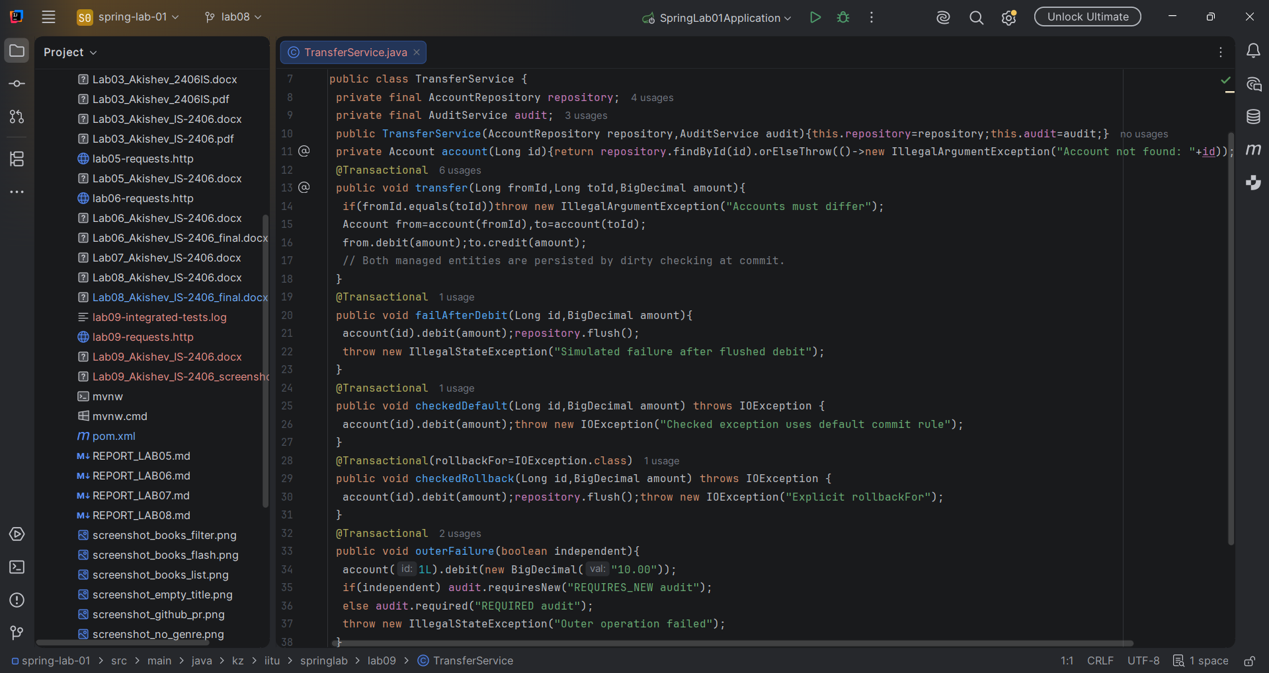
Figure 2. Account entity and optimistic locking with Version
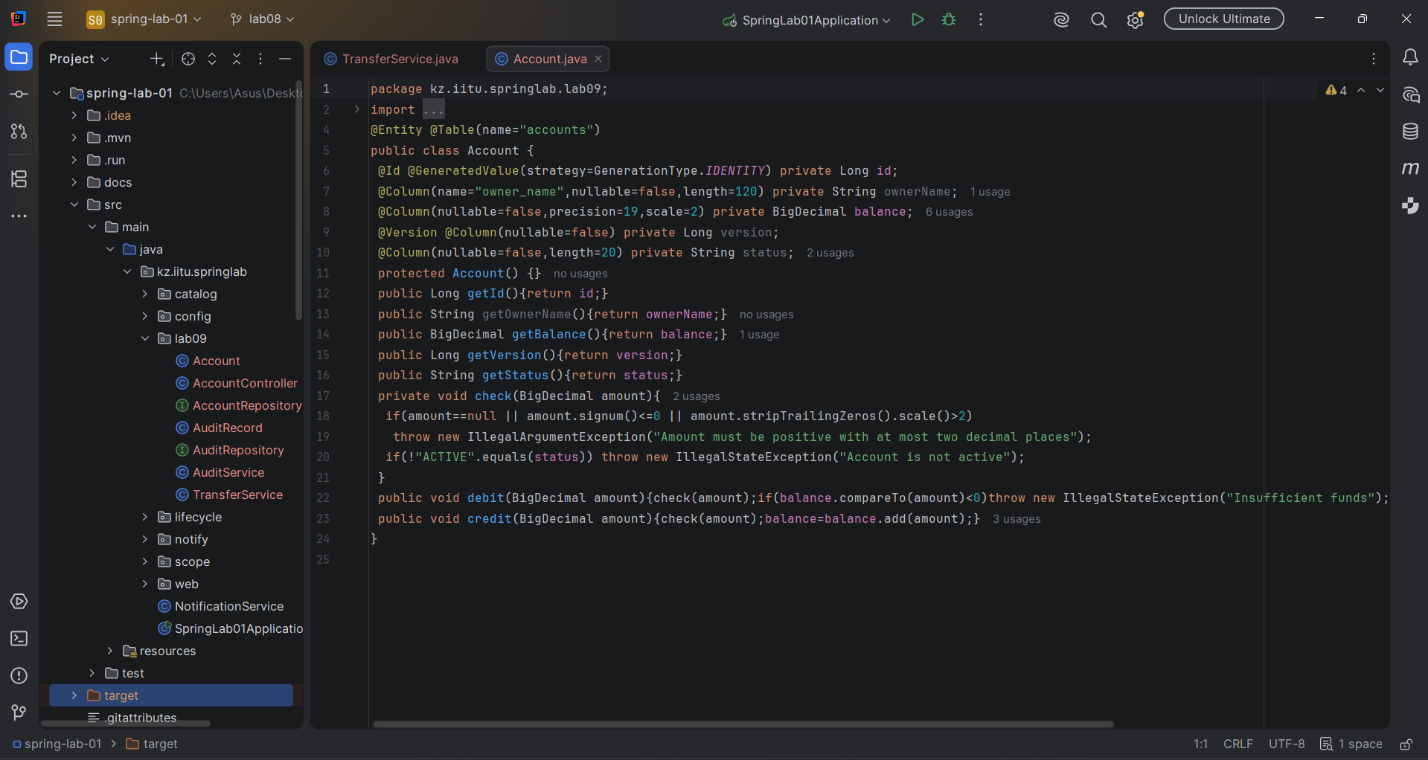
Figure 3. Transaction experiments and successful test results
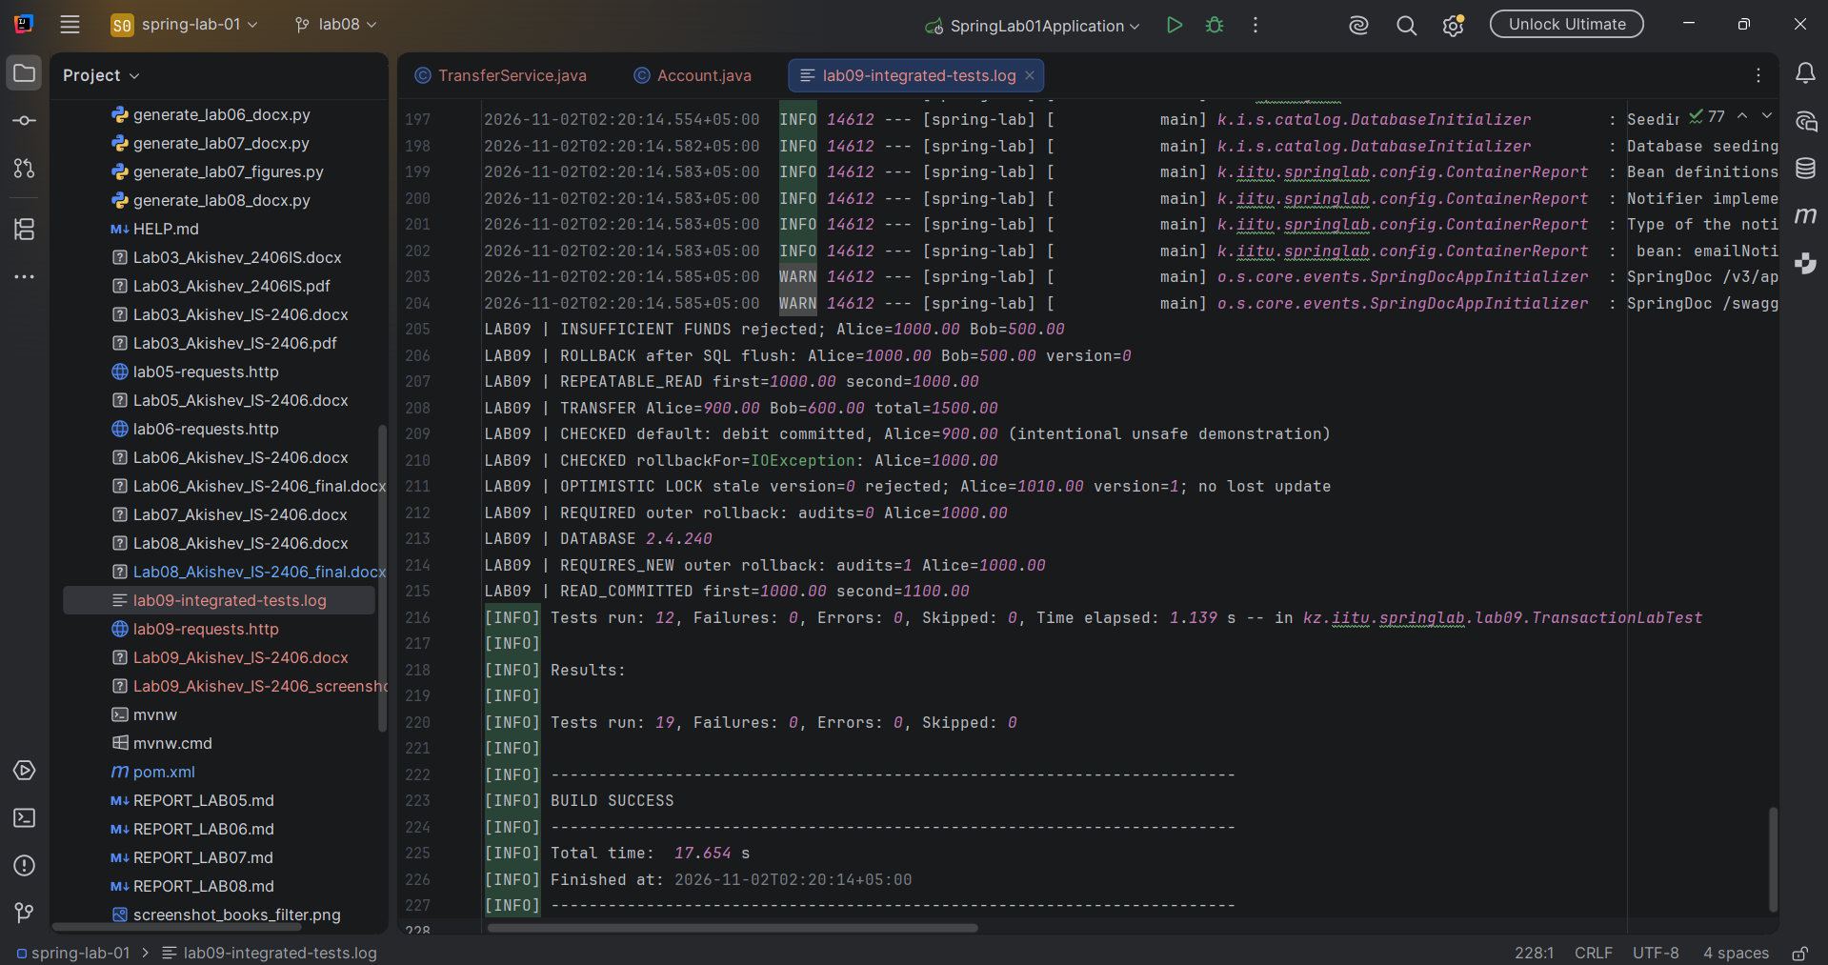
Figure 4. Flyway migration history and validation
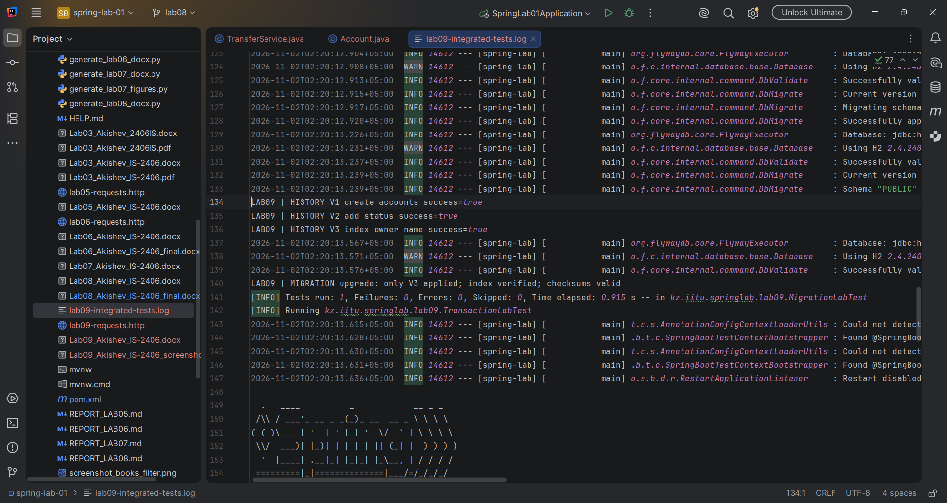
Figure 5. Migration files and initial database schema


