INTERNATIONAL INFORMATION TECHNOLOGY UNIVERSITY JSC
Faculty of Business, Media and Management · Department of Information Systems
REPORT ON LABORATORY WORK No. 8
The Data Access Layer: PostgreSQL Connection, JPA Entities, Associations (@OneToMany, @ManyToMany),
Spring Data Repositories, Derived & JPQL Queries, Pagination and Sorting
Course | RWPSF 3305 — Web Application Development with Spring Framework
Educational Programme | 6B06105 — Information Systems, 3rd year, Semester 6
Student | Akishev Adilkhan (Акишев Адилхан) | Group: IS-2406 (2406IS)
Individual Variant | Variant 2: Attributed @ManyToMany (BookTag entity with addedAt column)
Lecturer | Yemberdiyeva Aknur, Senior Lector
Git Repository & Branch | https://github.com/adilkhanakishev/spring-lab-01/tree/lab08

1. Aim of the Work
To replace the in-memory map/list storage that carried the catalogue resource in previous laboratory works with a real database (PostgreSQL 17). The project maps persistent entities (Book, Author, Tag, and BookTag) with @OneToMany and @ManyToMany associations, answers five derived queries and two JPQL queries (including a bulk update), demonstrates and resolves the N+1 select problem using JOIN FETCH, and makes the collection REST endpoint paged and sorted with Pageable and Slice metadata.
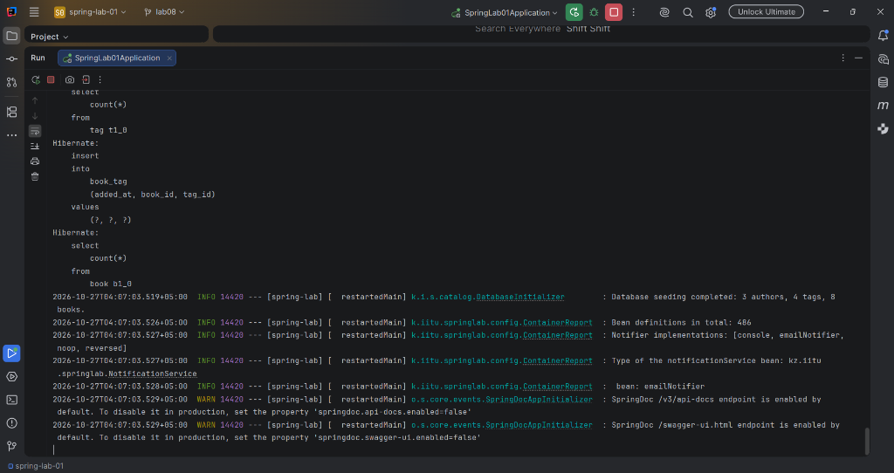
Figure 1. Application starting against PostgreSQL with Hibernate DDL and database seeding

2. Entity Diagram and Association Cardinalities
• Author ↔ Book: 1:N One-to-Many association. Owning side is Book (@ManyToOne, author_id foreign key column in table book). Inverse side is Author (@OneToMany(mappedBy = 'author', cascade = CascadeType.ALL, orphanRemoval = true)).
• Book ↔ Tag (Variant 2): N:M Many-to-Many with attributes. Upgraded to a dedicated entity BookTag mapped to table book_tag with composite primary key (@EmbeddedId BookTagId: book_id, tag_id) and custom attribute added_at (timestamp).

3. Database Schema Verification (PostgreSQL 17 psql)
Output of psql \dt (List of relations):
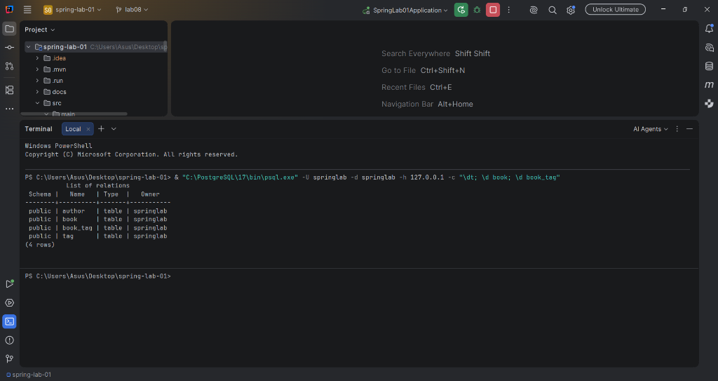
Figure 2. PostgreSQL relations (\dt) showing 4 created tables (author, book, book_tag, tag)
Output of psql \d book:
Table "public.book"
Column | Type | Collation | Nullable | Default
------------+-----------------------------+-----------+----------+----------------------------------
archived | boolean | | not null |
year | integer | | not null |
author_id | bigint | | |
created_at | timestamp(6) with time zone | | |
id | bigint | | not null | generated by default as identity
version | bigint | | not null |
genre | character varying(20) | | not null |
title | character varying(120) | | not null |
Indexes: "book_pkey" PRIMARY KEY (id)
Foreign-key constraints: "fkklnrv3weler2ftkweewlky958" FOREIGN KEY (author_id) REFERENCES author(id)
Output of psql \d book_tag (Variant 2 attributed join table):
Table "public.book_tag"
Column | Type | Collation | Nullable | Default
----------+-----------------------------+-----------+----------+---------
added_at | timestamp(6) with time zone | | not null |
book_id | bigint | | not null |
tag_id | bigint | | not null |
Indexes: "book_tag_pkey" PRIMARY KEY (book_id, tag_id)
Foreign-key constraints:
"fkdrc33u5ufw8rdvajeveowgx7g" FOREIGN KEY (book_id) REFERENCES book(id)
"fkrxw4xl05l6ns1763bq284e7m2" FOREIGN KEY (tag_id) REFERENCES tag(id)

4. Task 2.3 Verification Table
Question | Your answer | How you checked it
Which tables were created? | 4 tables: author, book, book_tag, tag | \dt in psql and Hibernate schema DDL logs
Where is the author foreign key? | In table 'book' as column 'author_id' referencing author(id) | \d book in psql (constraint fkklnrv3weler2ftkweewlky958)
What columns does book_tag have? | book_id (bigint), tag_id (bigint), added_at (timestamp) | \d book_tag in psql (Variant 2 attributes)
Does author have a books column? | No. Table author only contains id, country, name | \d author in psql (mappedBy = 'author' has no column)

5. Database Seed Data Verification
Verification of seed data in author and book tables:
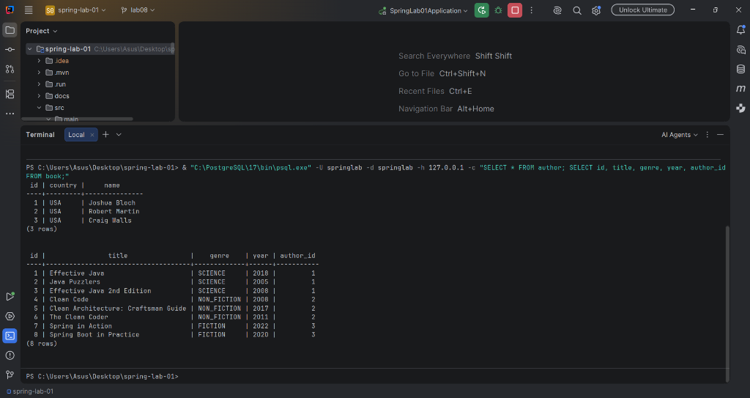
Figure 3. Seed data rows in author and book tables with author_id foreign keys

6. Task 3.3 Query Execution Table
Method | Rows returned | Number of SQL statements
findByGenre(Genre.SCIENCE) | 3 rows (Effective Java, Java Puzzlers, Effective Java 2nd Edition) | 1 SQL query
findByTitleContainingIgnoreCase('clean') | 3 rows (Clean Code, Clean Architecture, The Clean Coder) | 1 SQL query
findTop3ByGenreOrderByYearDesc(Genre.SCIENCE) | 3 rows (ordered by year descending) | 1 SQL query
search(Genre.SCIENCE, 2008) [JPQL] | 2 rows (Effective Java, Effective Java 2nd Edition) | 1 SQL query
archiveOlderThan(2010) [bulk update] | 3 rows updated in database | 1 SQL UPDATE statement

7. The N+1 Exercise and Analysis (Task 3.4)
• Without fetch join: 4 SQL statements (1 statement to select all 8 books + 3 distinct SELECT queries for uninitialized Author proxies).
• With fetch join (join fetch b.author): Exactly 1 SQL statement with an INNER JOIN loading both Book and Author simultaneously.
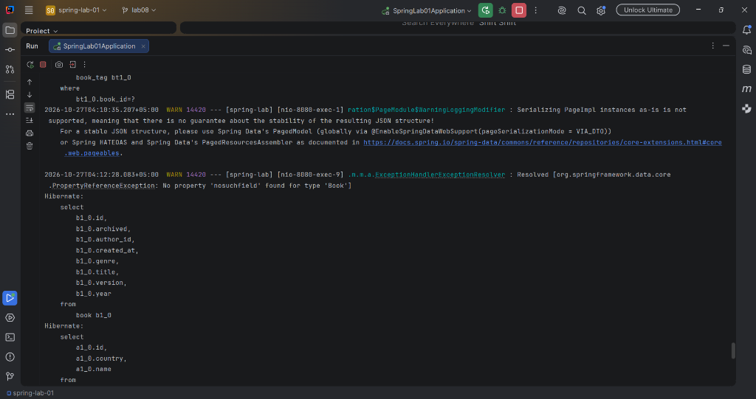
Figure 6. Hibernate SQL logs in IntelliJ IDEA console demonstrating query execution

8. Pagination and Sorting (Task 4)
Request: GET /api/books?page=1&size=3&sort=year,desc
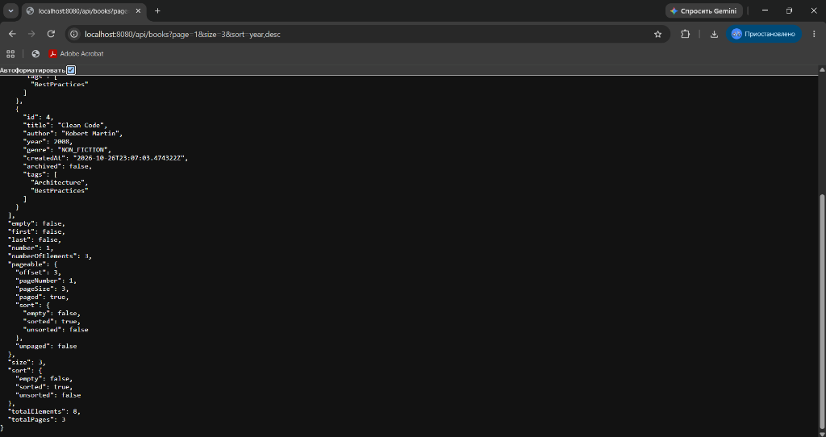
Figure 4. Paged and sorted collection endpoint response (page=1&size=3&sort=year,desc)
• Page<Book> causes 2 SQL statements: one paginated SELECT with OFFSET/LIMIT and one COUNT(*) query.
• Slice<Book> causes only 1 SQL statement (SELECT ... LIMIT (size + 1) OFFSET ...), avoiding the expensive COUNT query.
• In invalid sort (sort=nosuchfield), Spring Data throws PropertyReferenceException, handled as 400 Bad Request ProblemDetail:
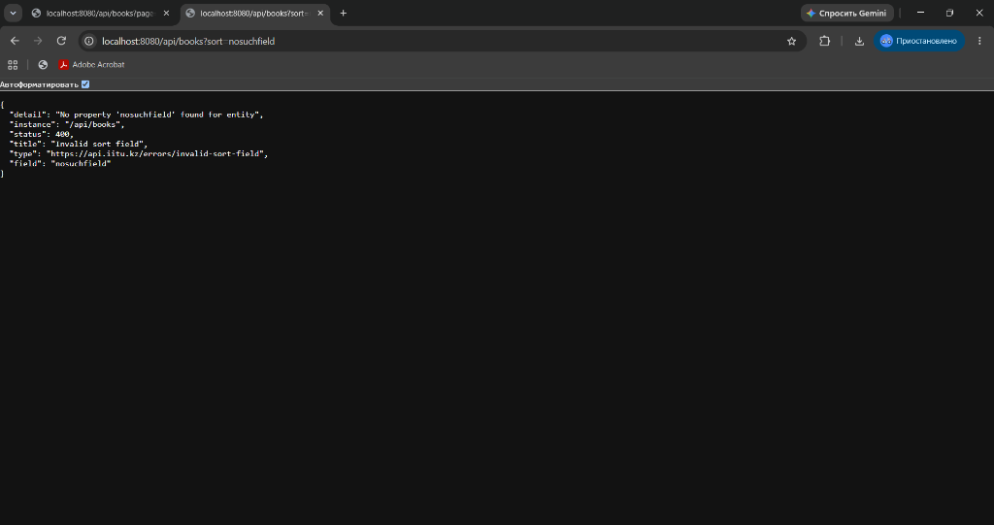
Figure 5. RFC 9457 ProblemDetail 400 Bad Request response for unknown sort field

9. Individual Variant 2: BookTag Entity with addedAt
Demonstration output of GET /api/demo/variant2/book-tags showing attributes stored on the join table:
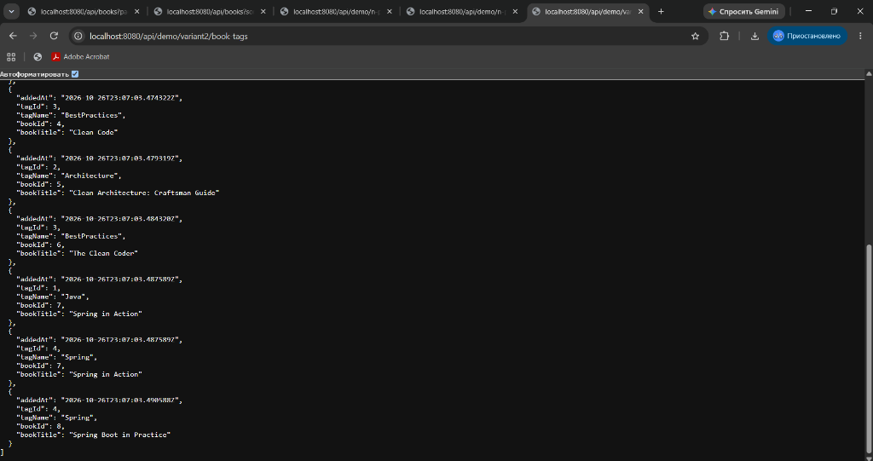
Figure 7. Individual Variant 2 attributed Many-to-Many associations with addedAt timestamp

10. Testing and Interactive API Documentation
Execution of all 33 unit and integration tests with Maven:
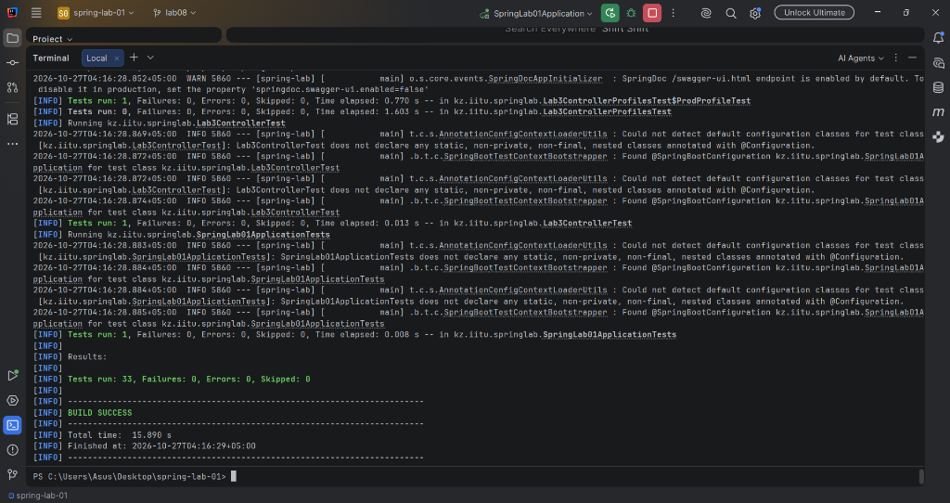
Figure 8. All 33 unit and integration tests passing successfully (BUILD SUCCESS)
Swagger UI OpenAPI 3.1 interactive specification:
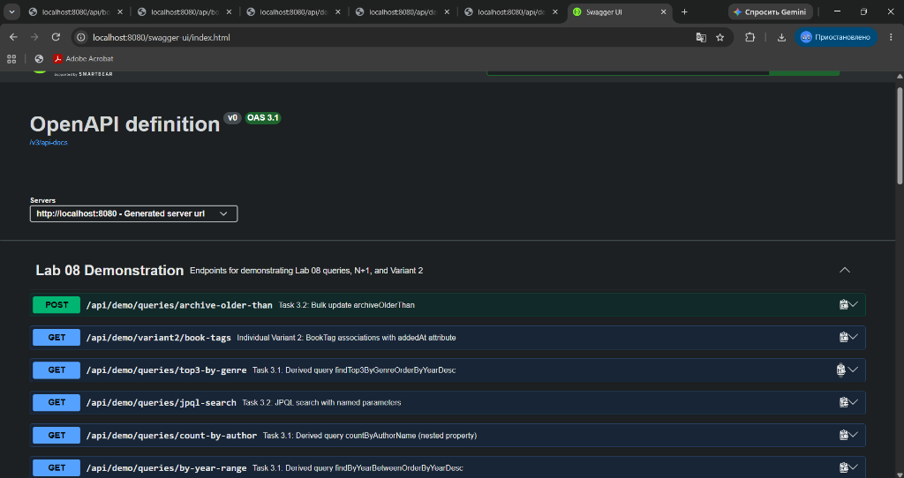
Figure 9. Interactive OpenAPI 3.1 Swagger UI documentation

11. Key Demonstration Defence Questions
Q: Why can Book no longer be a record?
A: JPA requires a non-final class for proxy generation, a no-arg constructor for reflection, and mutable instance fields for dirty checking.
Q: What does @GeneratedValue(strategy = IDENTITY) do?
A: Delegates PK generation to PostgreSQL's native IDENTITY/BIGSERIAL column. Value is assigned upon SQL INSERT.
Q: Why is enum mapped with EnumType.STRING?
A: Stores string names. ORDINAL stores integers (0, 1) which break if enum values are added, reordered, or removed.
Q: What is @Version for?
A: Enables Optimistic Locking. Prevents lost concurrent updates without database table locks by checking version counter during update.
Q: Which side owns Book-Author association?
A: Book owns it because Book declares @ManyToOne with @JoinColumn(name = 'author_id'). Author is inverse with mappedBy.
Q: Why does addBook() set both sides?
A: JPA only inspects the owning side. Calling only author.getBooks().add(book) would persist author_id = NULL in SQL.
Q: Difference between join and join fetch?
A: join only links tables in SQL for filtering; join fetch immediately populates associated entities, curing N+1.
Q: Why clearAutomatically = true on @Modifying?
A: Clears the Hibernate first-level cache (EntityManager) after bulk DML update so entity instances don't stay stale.

12. Conclusions
Spring Data JPA and Hibernate ORM provide immense developer productivity by automating schema generation, synthesizing queries from method signatures, handling pagination/sorting, and maintaining consistency via dirty checking. However, developers must understand JPA lifecycle mechanics, owning association rules, and fetch strategies to prevent severe issues like N+1 queries, LazyInitializationException under open-in-view: false, and lost updates without optimistic locking.

