Permutation Importance vs SHAP
for Random Forests
Which Explanation Should You Trust?
A Machine Learning Tutorial
Adil Nawaz | University of Hertfordshire | March 2026
https://github.com/adilnawaz44567-bot/ml-tutorial

1. Introduction

It is not the end of the road to build a machine learning model. When a Random Forest reaches 85% accuracy in predicting income levels the next question to ask is: what is the predictor that makes it do so? This question is of concern to trust, debugging, fairness auditing and domain insight. However, there is no one correct measure of feature importance and results of various approaches may be surprisingly different.

In this tutorial, three of the most popular feature importance algorithms are used on the same Random Forest, which has been trained on the Adult Income (Census) data, including (1) Gini importance (built-in), (2) permutation importance, and (3) SHAP values. We indicate the point of agreement and where there is no agreement and the reasons why there is no agreement. At the end of this, you will be able to choose the appropriate way of explaining things practically to your own work.

Learning Objectives: (1) Learn the mechanism of Gini importance, and its bias. (2) Use permutation importance, using confidence intervals. (3) Use SHAP to explain models globally and locally. (4) Compare the three methods and evaluate which one is more suitable at any time.

2. Background: Three Ways to Explain a Random Forest

The simplest method is the Gini Importance (Mean Decrease in Impurity). Training In training, the reduction in Gini impurity of splitting a node using a feature is noted when the feature is used to split a node. All the trees add up these decreases and they are normalized. It is quick in the sense that no additional calculation is needed after training. Nevertheless, Strobl et al. (2007) showed that Gini importance is skewed towards large-cardinality features: a categorical variable with many distinct values has more chance to be split, over-reporting its perceived importance when in fact it does not have a significant predictive value.

Permutation Importance assumes a very different method. Training is followed by randomizing the columns of each feature in the test data and the reduction in accuracy is recorded. When shuffling a feature has minimal effects on accuracy, it is not important. It is a model-agnostic method that is estimated using held-out data without cardinality bias. Its greatest drawback is that correlated features will be able to cancel each other out: when features A and B are both correlated with the same signal, reshuffling A would not necessarily reduce accuracy due to B offsetting it.

SHAP (Shapley Additive explanations) relies upon cooperative game theory. Secondly, every feature is computed as a "player" the contribution of its prediction will have Shapley values- the only algorithm that satisfies the local accuracy axioms, missingness axioms, and the consistency axioms (Lundberg and Lee, 2017). SHAP has world relevance (mean absolute SHAP value) and national explanations (per-prediction). More importantly, SHAP is directional: not only how important a feature is, but how it influences the prediction a certain way up or down.

3. Experimental Setup

Our Adult Income dataset (48,842 records of 1994 US Census) has 14 features that describe demographics and employment. The binary target shows the property of whether the annual income is greater than 50,000. Once we have dropped rows containing missing values and label-encoded categorical features, 80/20 stratified train-test splitting (random state=42) is done. Our fixed model that we will be using in all the experiments is a Random Forest with 200 trees (maxdepth=15, minsamplesleaf=5).

This dataset is the best fit to our comparison since it has both a combination of numerical characteristics (age, hours-per-week, capital-gain) and categorical characteristics with different cardinalities (native-country has 41 categories, sex has 2). It is at these points that the methods of importance diverge.

4. Results and Analysis

4.1 Method 1: Gini Importance
The inbuilt Gini importance rankings are shown in Figure 1. The characteristics such as relationship, marital-status, and capital-gain rank among the top, which is consistent with domain knowledge, that is, marital status and capital gains are good predictors of income. Note though that certain high-cardinality categorical features can be more significant than they should. What is happening here is the Gini cardinality bias: when features have a high number of split points, further impurity reduction happens more often just by chance, because they have more opportunities to split.
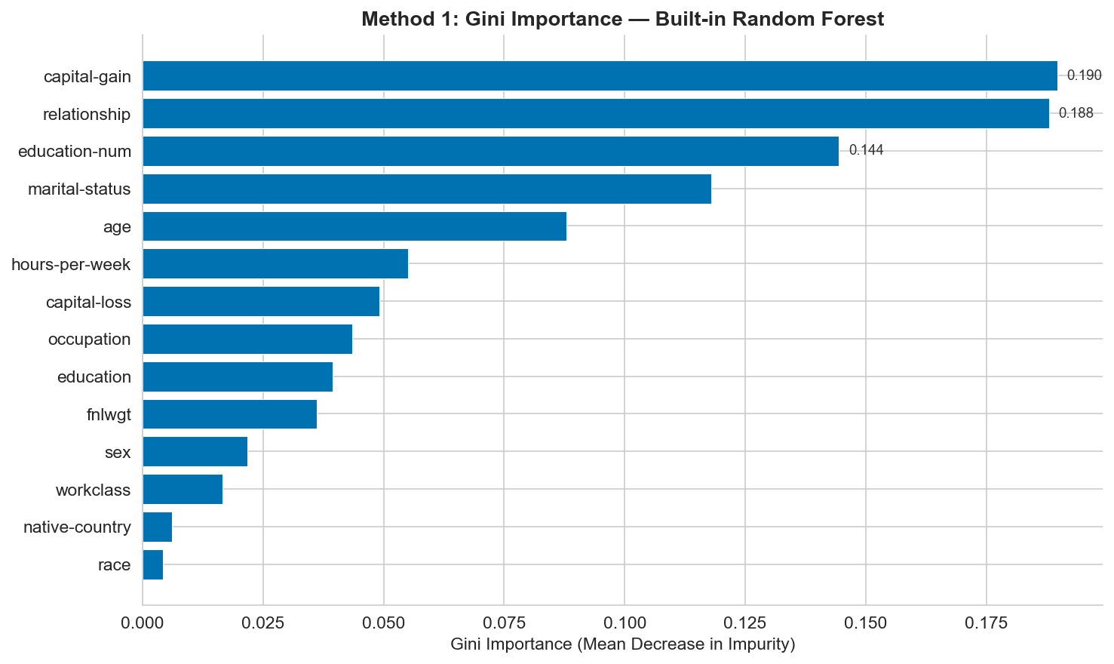
Figure 1: Gini (impurity-based) feature importance from the Random Forest. Note potential bias toward high-cardinality features.

4.2 Method 2: Permutation Importance
Figure 2 presents permutation importance on the 10 repeats test set (error bars indicate standard deviation). The ranking changes significantly as compared to Gini. The predictors with the inflated Gini coefficients due to cardinality (e.g., native country with 41 categories) often decrease in the permutation ranking since their shuffling does not have a major negative impact on the test accuracy. Still, such truly predictive characteristics as capital-gain and relationship will remain prominent.
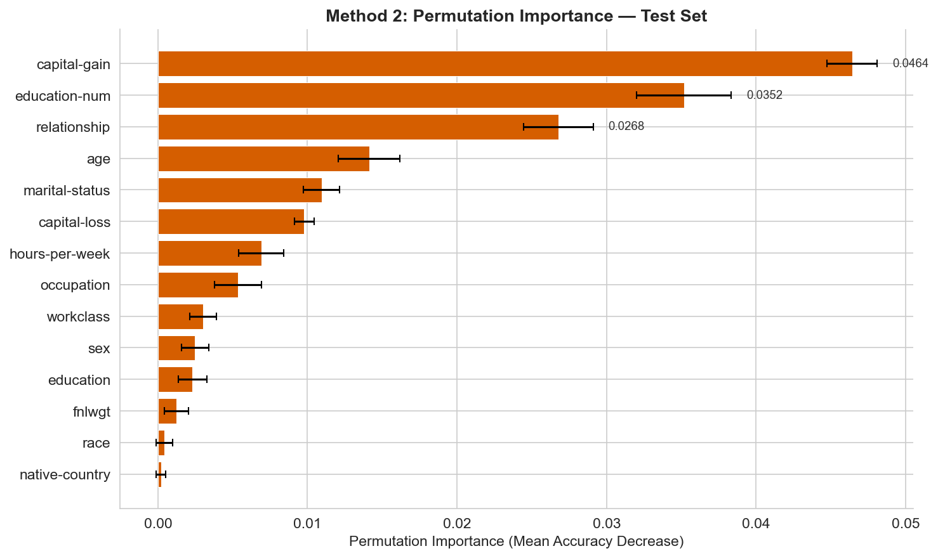
Figure 2: Permutation importance with error bars showing variability across 10 repeats. Measured on held-out test data.

The error bars contain another piece of information that the Gini importance does not offer they measure error in the estimate of the importance. The feature whose mean importance is large and whose error bars are large does not imply a reliable important feature as compared to a smaller but consistent effect. This renders the permutation importance to be more appropriate in the statistical reporting.

4.3 Method 3: SHAP Values
There are two SHAP visualizations in figure 3. The left panel ranks with respect to mean absolute SHAP value (global importance). The right-hand panel is a bee swarm plot (one of the most informative plot visualizations in machine learning). Each of these dots is a single piece of data; the x-axis is the SHAP (the contribution of that feature to the prediction), and the color is the value of that feature in practice (blue = low, red = high).
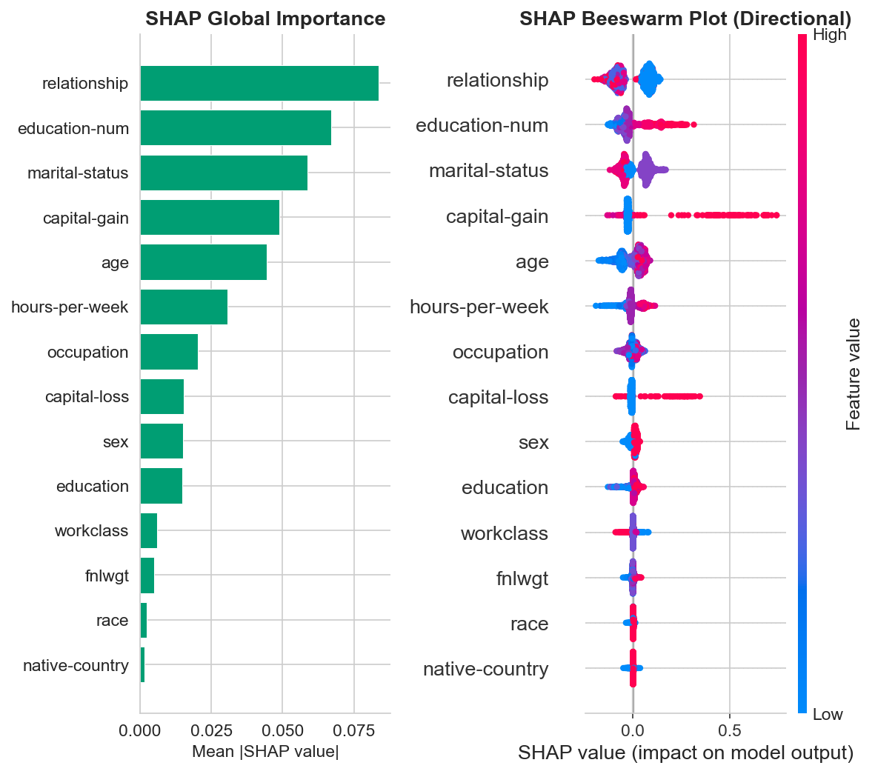
Figure 3: Left — SHAP global importance (mean |SHAP|). Right — bee swarm plot showing directional feature effects.

Bee swarm plot shows trends that cannot be seen by Gini and permutation importance. As an example, when capital-gain values are high (red) they always shift prediction to above 50K income (positive SHAP value), whereas when they are low (blue) they shift to [?] 50K. This directional insight is essential because it not only enables practitioners to grasp the significance of certain features, but also the way in which they affect individual predictions - an essential ability when it comes to fairness auditing and communication to stakeholders.

4.4 Feature Interactions via SHAP
The SHAP dependence plot of the best feature in figure 4 indicates that the relationships and interaction effects are non-linear. The scatter plot indicates the relationship between the actual value of the feature (x-axis) and the contribution of the feature to SHAP (y-axis), a color indicating an automatically discovered interacting feature. The patterns of interaction and threshold effects that are apparent in this case cannot be identified by any importance ranking technique alone.
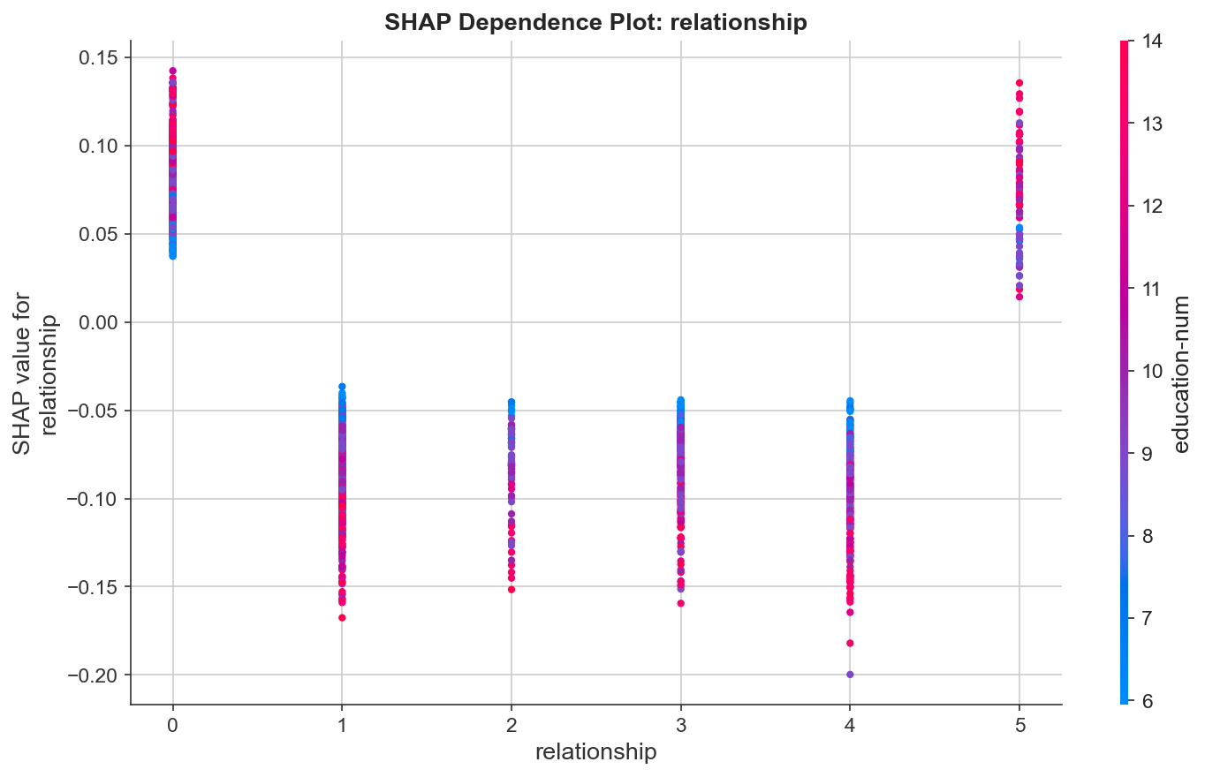
Figure 4: SHAP dependence plot for the top feature, revealing non-linear effects and feature interactions.

4.5 Head-to-Head: Do the Methods Agree?
Figure 5 compares rankings across all three pairs of methods using scatter plots. Points on the diagonal indicate agreement; points far from the diagonal indicate disagreement. We also compute Spearman rank correlations to quantify overall alignment.
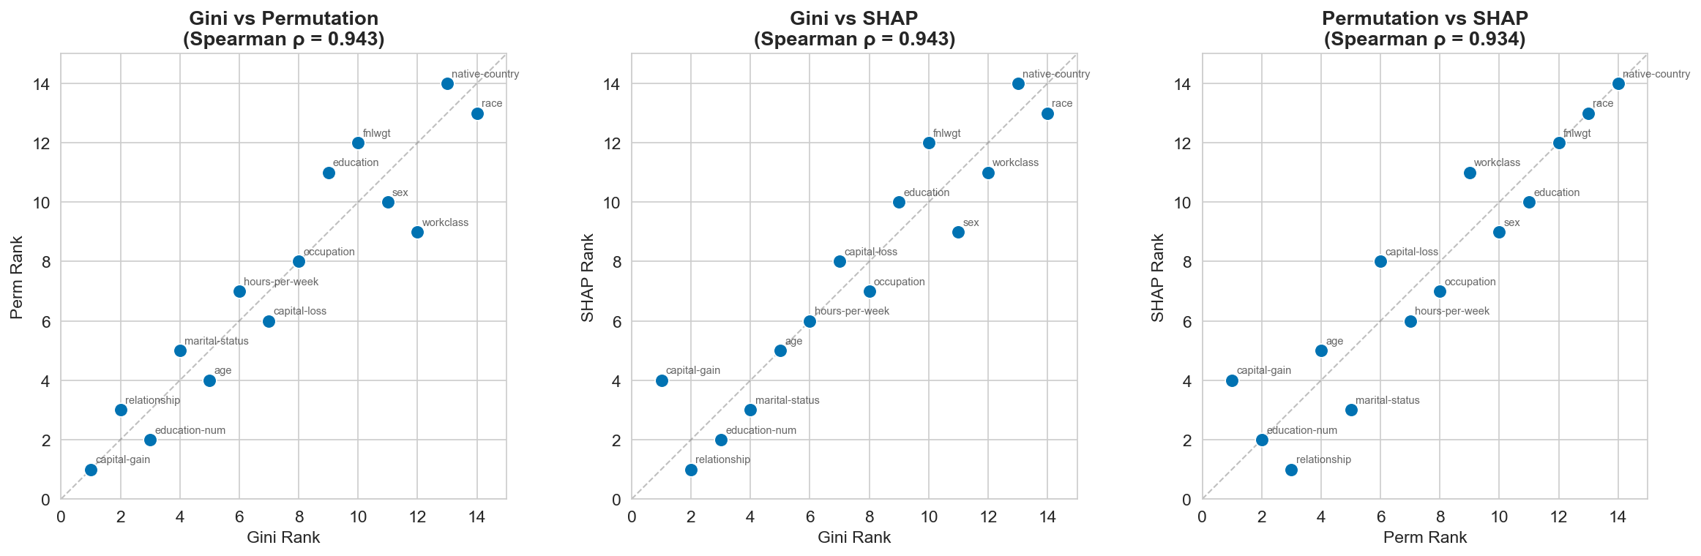
Figure 5: Pairwise rank comparison across all three methods. Diagonal = perfect agreement. Spearman correlations shown in titles.

The comparison shows the same trend: the prevalence of features in the top rank has a high level of agreement across methods, but the middle-rank features show a high degree of deviation. The former, Gini importance tends to overvalue high cardinality categorical, permutation importance tends to undervalue correlated features, and SHAP more equitably distributes credit between correlated predictors. The Spearman correlations of permutation importance and SHAP are generally the most significant, which indicates that these two techniques have a similar logic behind them despite being based on different theoretical principles.

5. Which Method Should You Use?
Scenario | Recommended | Reason
Quick screening | Gini importance | Instant, no extra computation
Stakeholder reporting | Permutation importance | Model-agnostic, easy to explain
Model audit / fairness | SHAP | Directional, local + global
Correlated features | SHAP | Fairer credit distribution
Large data, limited compute | Gini importance | No extra passes over data
Regulatory compliance | SHAP | Individual prediction explanations
Table 1: Practical decision framework for choosing a feature importance method.

Guidelines: You should apply Gini importance to quickly explore your data when developing a model, use permutation importance to robustly validate your model with test information, and use SHAP when you need to explain your model to stakeholders, auditors, or end users. Usually, it is most informative to run all three and compare their rankings, which can often highlight important properties of your data and model.

6. Limitations and Ethical Considerations

There are a few limitations of this tutorial. Only one type of model (Random Forest) was tested using one dataset, and may not be the same with gradient boosting, linear models, or other areas. Label encoding of categorical imposed an artificial ordinal structure; Gini rankings can be manipulated by one-hot encoding. Speed in SHAP computation used 2,000 samples to compute the results; complete results can differ by small values. We were not analytic on the impact of hyperparameters sensitivity or regularisation on importance rankings.

Ethically, the Adult Income data has sensitive data such as race, sex and native country. A paradigm based on such attributes extensively can continue the past discrimination. Analysis of feature importance is a potent fairness auditing method: when the insured attributes have an unexpectedly large rank it is a cause of concern of biasing. The demonstration of the impact of these features on individual predictions of SHAP is especially useful in bias detection and addressing regulatory needs such as the GDPR right to explanation provided by the EU.

7. Reproducibility Notes

Random splits Every experiment split using random state=42, stratified splits, and deterministic preprocessing. The entire code can be found in the Jupiter notebook that comes with it. To reproduce: piping requirements.txt (scikit-learn, shap, matplotlib, seaborn, numpy, pandas) then run the notebook in order, and compare results. A bibliography and a README with instructions on how to set it up is included in the repository.

8. References
[1] Breiman, L. (2001). Random Forests. Machine Learning, 45(1), 5-32.
[2] Lundberg, S. M., & Lee, S.-I. (2017). A Unified Approach to Interpreting Model Predictions. NeurIPS 2017.
[3] Strobl, C., Boulesteix, A.-L., Zeileis, A., & Hothorn, T. (2007). Bias in random forest variable importance measures. BMC Bioinformatics, 8(25).
[4] Molnar, C. (2022). Interpretable Machine Learning. 2nd Edition. christophm.github.io/interpretable-ml-book/
[5] Scikit-learn documentation: RandomForestClassifier, permutation_importance.
[6] SHAP documentation: https://shap.readthedocs.io/

