

|  |
| --- |
| Internship Report – I |
|  |
| July 2025  ADIL IQBAL  Intern – Rasheed Foundations |

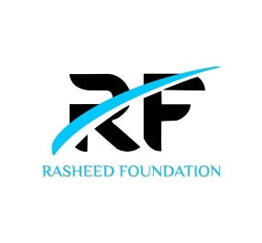

Full Stack Web Development

# Introduction

|  |
| --- |
| This document serves as a comprehensive record of the On-the-Job Training (OJT) undertaken by the student as part of the **B.Sc. Computer Science** curriculum at **SIES (Nerul) College**. The internship was conducted at **Rasheed Foundation** during the academic period of **July – August 2025**.  The primary objective of this internship was to gain practical exposure in the domain of **Full Stack Development**, complementing the theoretical knowledge acquired in college with real-world application. This report outlines the tasks completed, theoretical concepts learned through official course materials, and practical exercises implemented throughout the internship period.  Through this report, the student's technical growth, level of understanding, and ability to apply concepts to actual development work are documented for evaluation and future reference. |
| Student Details  Name – Adil Iqbal  Firm Name – Rasheed Foundations  Role – Full Stack Web Development Intern  College – SIES (Nerul) College of Arts, Science & Commerce  Class – TY  Course – B.Sc. (Computer Science)  Roll No. - S.23.04 |

|  |
| --- |
| [🔗Frontend Development Course](https://github.com/adilnvm/Rasheed-Fundation/blob/main/Frontend%20Developer%20Course%20Syllabus.pdf)  Course Overview  This Course Divided into 7 Subtopics introduces frontend development with HTML, CSS, JavaScript, and React etc Each topic is Serial Wise &  includes 1 hour of theory, 1 hour of practicals, (7x2 = 14 hours total).   1. ****HTML and CSS Basics****   **Introduction**: HTML (HyperText Markup Language) is the foundation of all web pages. It defines the structure of a webpage using elements such as headings, paragraphs, and images. CSS (Cascading Style Sheets) is used to style these elements, control layout, and make the design visually appealing.  **Concepts Learned**:   * HTML document structure: <html>, <head>, <body>, etc. * Common tags: headings (<h1> to <h6>), paragraphs (<p>), divs, spans, lists, etc. * CSS Selectors and Properties * Box Model (margin, border, padding, content)   **Practical Implementation**: I created a basic landing page using HTML and styled it with CSS. Key styles included layout control using flexbox, font styling, and background color adjustments.  **Tools Used**:   * VS Code * Live Server extension * W3Schools for references   **Outcome**: This session helped me understand the structural foundation of web pages and how to design them using CSS. I learned how HTML and CSS work together to define both content and presentation. |

1. **JavaScript Basics**

**Concepts:** variables (let, const, var), functions, event listeners

**Practical:** Button toggle using addEventListener and style.display or classList.toggle  
I created a Landing page with a Toggle button that may change theme from light to Dark and vice versa

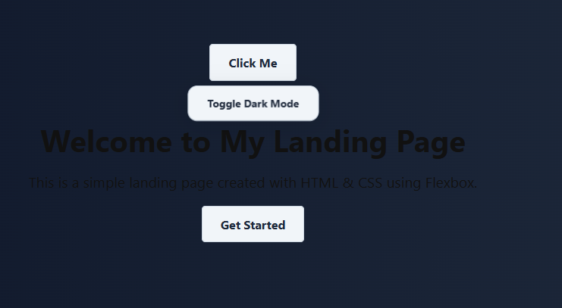 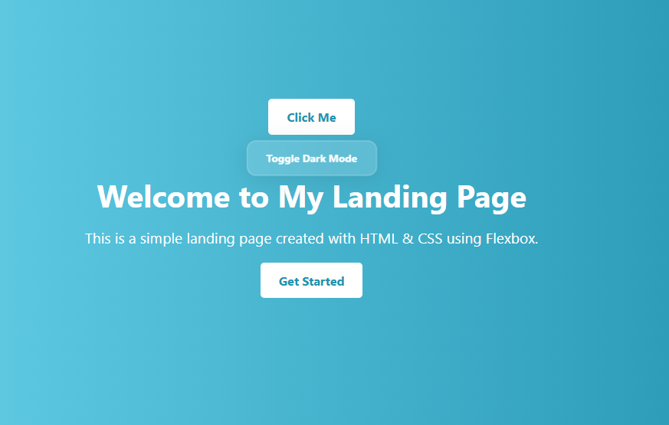

**Outcome:** Understood JS as the logic layer of the web; learned how it adds behavior to static HTML pages.

1. **Responsive Deisign with BootStrap**

**Introduction**:  
Responsive design ensures that a website adjusts its layout and elements to fit different screen sizes and devices, such as desktops, tablets, and smartphones. It enhances usability and visual consistency across platforms.

**Concepts Learned**:

* **Media Queries**: CSS rules that apply different styles depending on the screen size or device characteristics.
* **Responsive Units**: Use of relative units like vw, vh, %, em, etc., instead of fixed units like px.
* **Bootstrap Framework**: A popular CSS framework that provides pre-designed components and a 12-column grid system to simplify responsive web design.

**Practical Implementation**:

// *I will create a fully responsive webpage layout using Bootstrap.  
& also attach screenshot here*

*{****Page Break*** *for completing Frontend Development PDF}, after that would be Backend PDF}****> complete Frontend   
> next Backend  
> lastly Full Stack Development via* 🔗**[**rasheedfoundation.org**](https://rasheedfoundation.org/full-stack-development/) **> below is the Backend Development Section which is not yet started by me yet Day1 from the above link**

[🔗Backend Development Course](https://github.com/adilnvm/Rasheed-Fundation/blob/main/Backend%20Developer%20Course%20Syllabus.pdf)   
Course Overview

This Course Divided into 7 Subtopics introduces frontend development with Node.js and MongoDB , RESTful APIs, CRUD operationsEach topic is Serial Wise & includes 1 hour of theory, 1 hour of practicals, (7x2 = 14 hours total).

* 1. Backend basics

🔗[7 Day Full Stack Development Course](https://rasheedfoundation.org/full-stack-development/)

This course, provided by the Rasheed Foundation, serves as the core foundation for this internship. It spans seven days, with each day focusing on essential theoretical concepts delivered through e-study material, practical exercises to apply the knowledge, and a short Q&A session to reinforce learning. Progressing through each day requires consistent effort and dedication to reach the next level

**Day1 :: Introduction to Web Development**

* **theoretical concepts** : *Brief introduction (2 liner) of each term*
* **Practical exercise :** *all the practical Exercisies in the link with screenshot attached wherever necessary*
* **Knowledge check :** *//all the QnA*

## **Day 2 ::**

* theoretical concepts :
* Practical exercise :
* Knowledge check :