

|  |
| --- |
| Internship Report – I |
|  |
| July 2025  ADIL IQBAL  Intern – Rasheed Foundations |

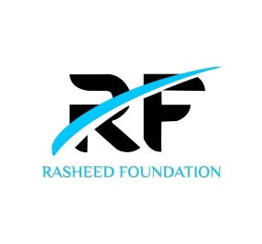

Full Stack Web Development

# Introduction

|  |
| --- |
| This document serves as a comprehensive record of the On-the-Job Training (OJT) undertaken by the student as part of the **B.Sc. Computer Science** curriculum at **SIES (Nerul) College**. The internship was conducted at **Rasheed Foundation** during the academic period of **July – August 2025**.  The primary objective of this internship was to gain practical exposure in the domain of **Full Stack Development**, complementing the theoretical knowledge acquired in college with real-world application. This report outlines the tasks completed, theoretical concepts learned through official course materials, and practical exercises implemented throughout the internship period.  Through this report, the student's technical growth, level of understanding, and ability to apply concepts to actual development work are documented for evaluation and future reference. |
| Student Details  Name – Adil Iqbal  Firm Name – Rasheed Foundations  Role – Full Stack Web Development Intern  College – SIES (Nerul) College of Arts, Science & Commerce  Class – TY  Course – B.Sc. (Computer Science)  Roll No. - S.23.04 |
|  |