**Aditya Logishetty**

**Michael Gilden** Web Technologies  
 MSIS_517L  
 april27,2017

**Assignment 09**

1. Main page framework with the grid.

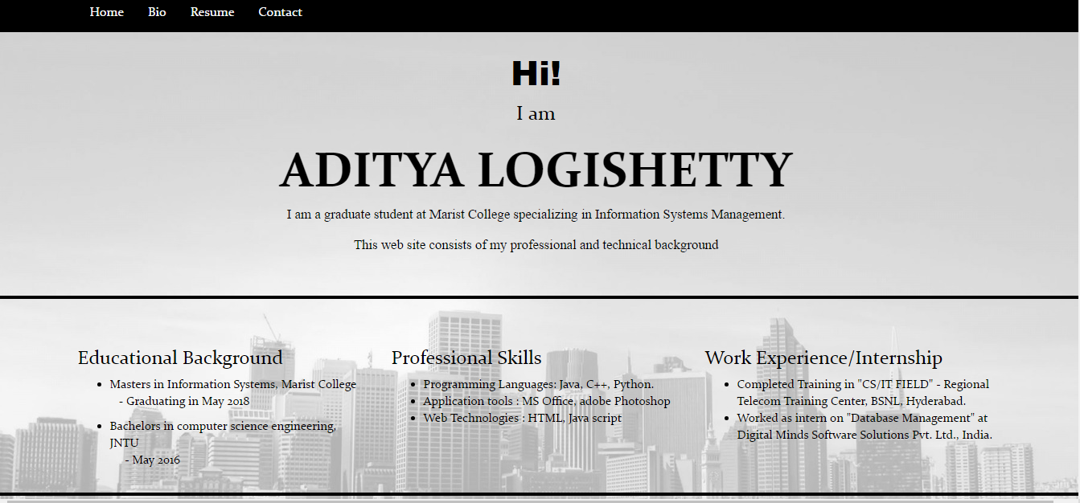

1. Social account buttons.

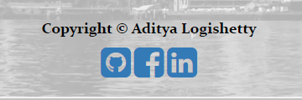

1. Button options

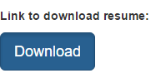



1. Navigation bar



1. Footer

