**Aditya Logishetty**

**Michael Gilden** Web Technologies  
 MSIS_517L  
 april17,2017

**Assignment 08**

**Before minifying -**

**1)**Screenshots –

**Mobile -**

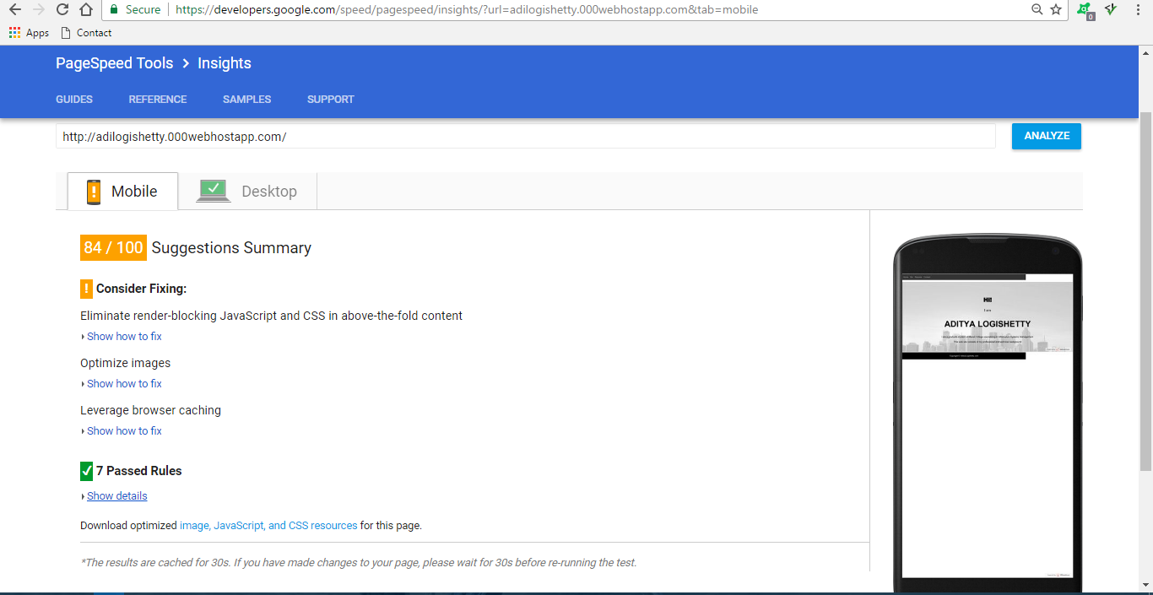

**Desktop –**

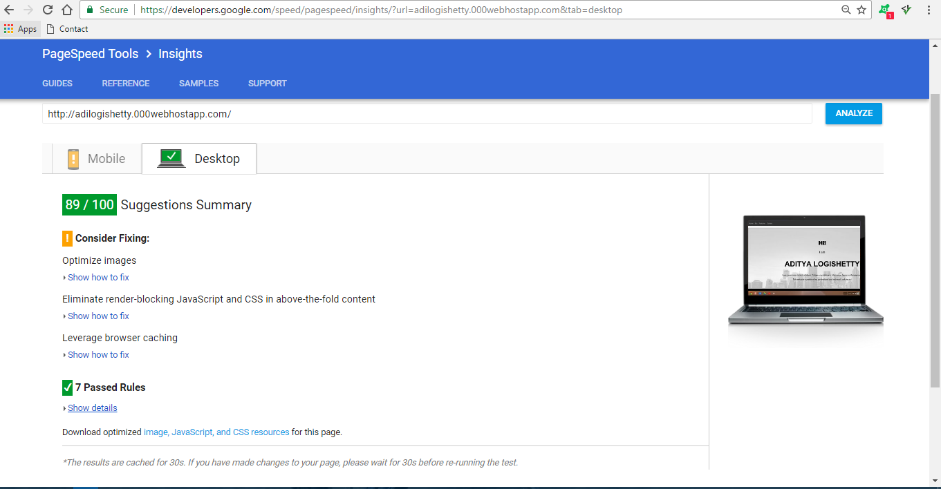

**Network –**

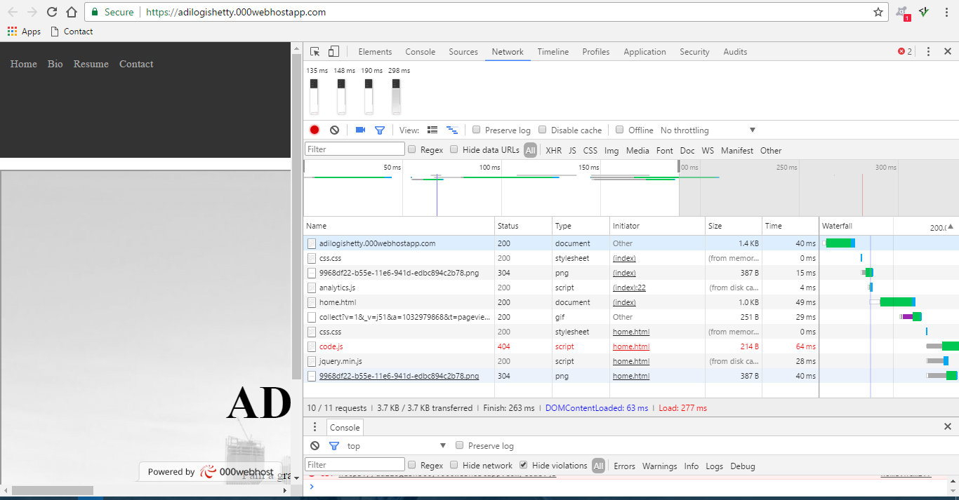

**After minifying –**

**Mobile –**

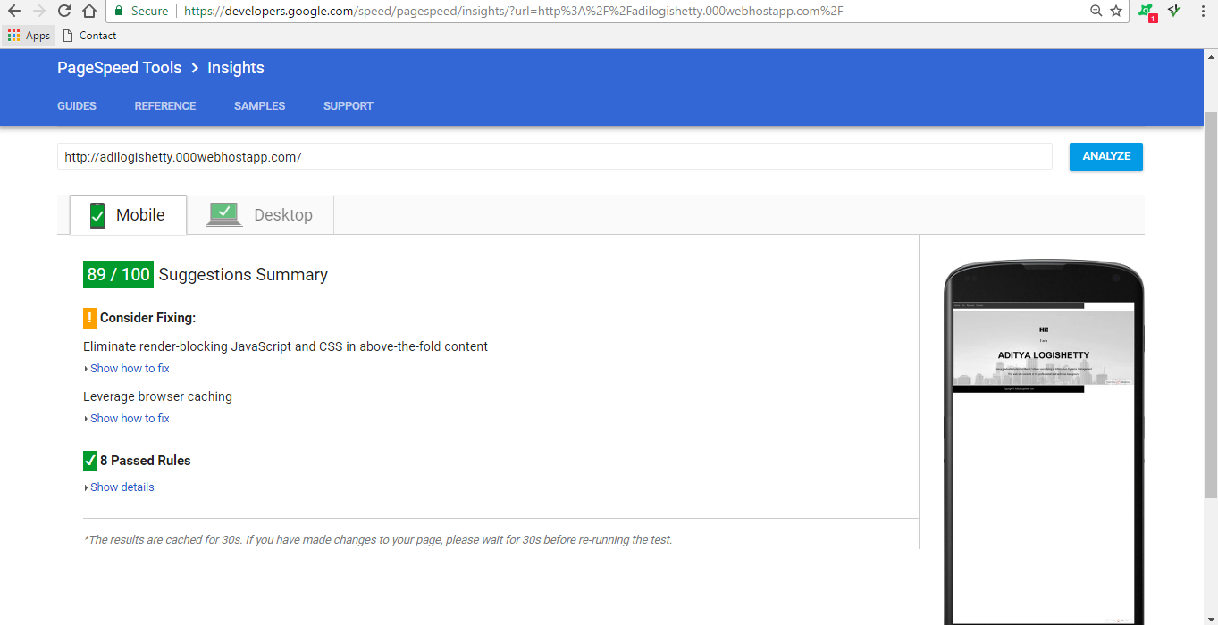

**Desktop –**

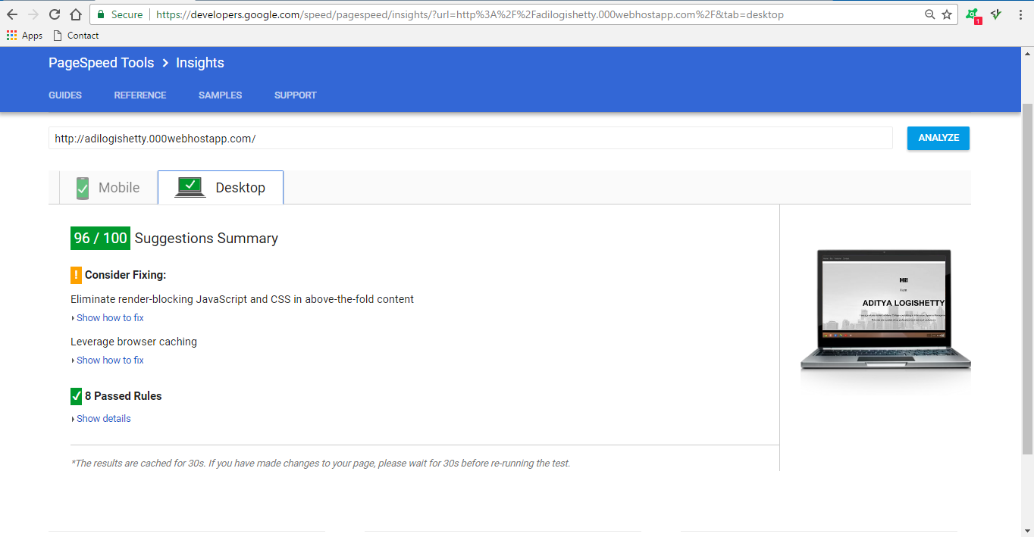

**Network –**

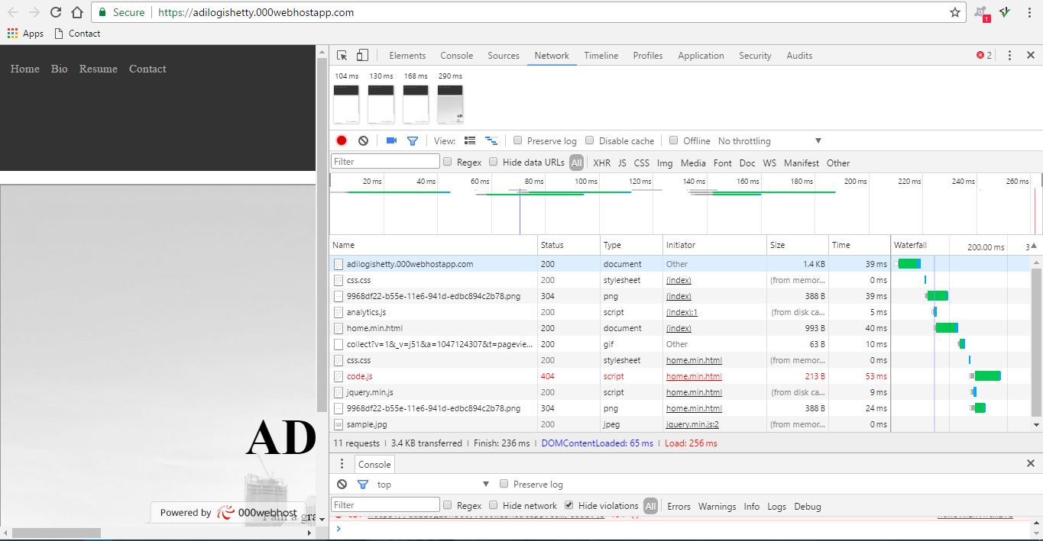

**Changes noticed –**

* Before minifying –

DOM content load – 63ms

Load -277ms

Finish – 263ms

* After minifying-

DOM content load – 65ms

Load – 256ms

Finish – 236ms