**Aditya Logishetty**

**Michael Gilden** Web Technologies  
 MSIS_517L  
 April 11, 2017

**ASSIGNMENT – 07**

* When user first opens the webpage.

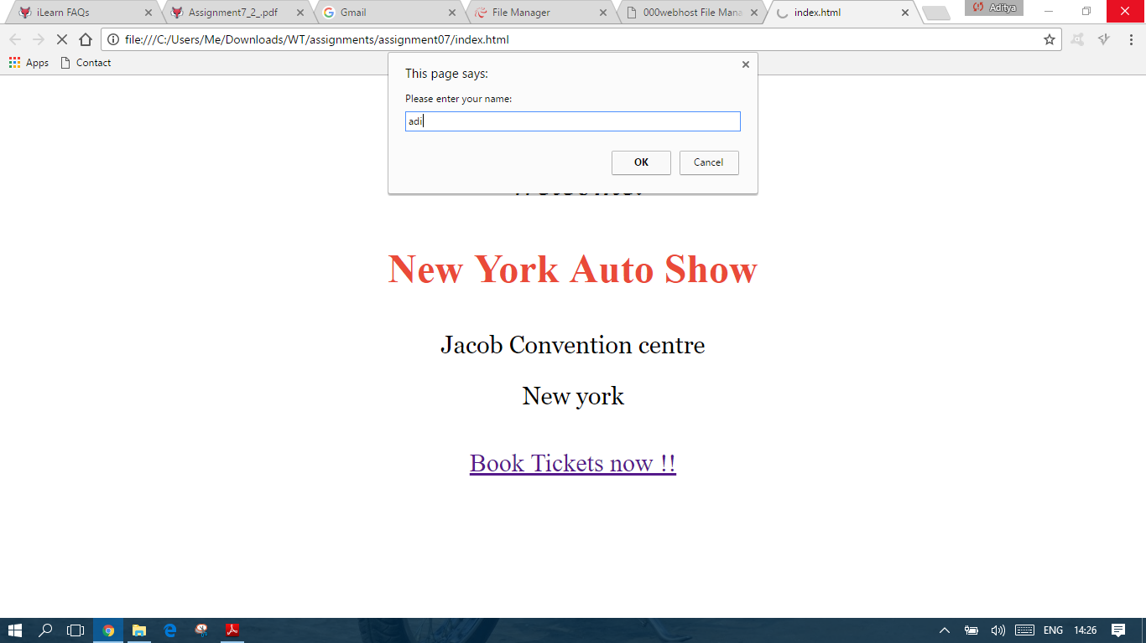

* When user opens the same page again .

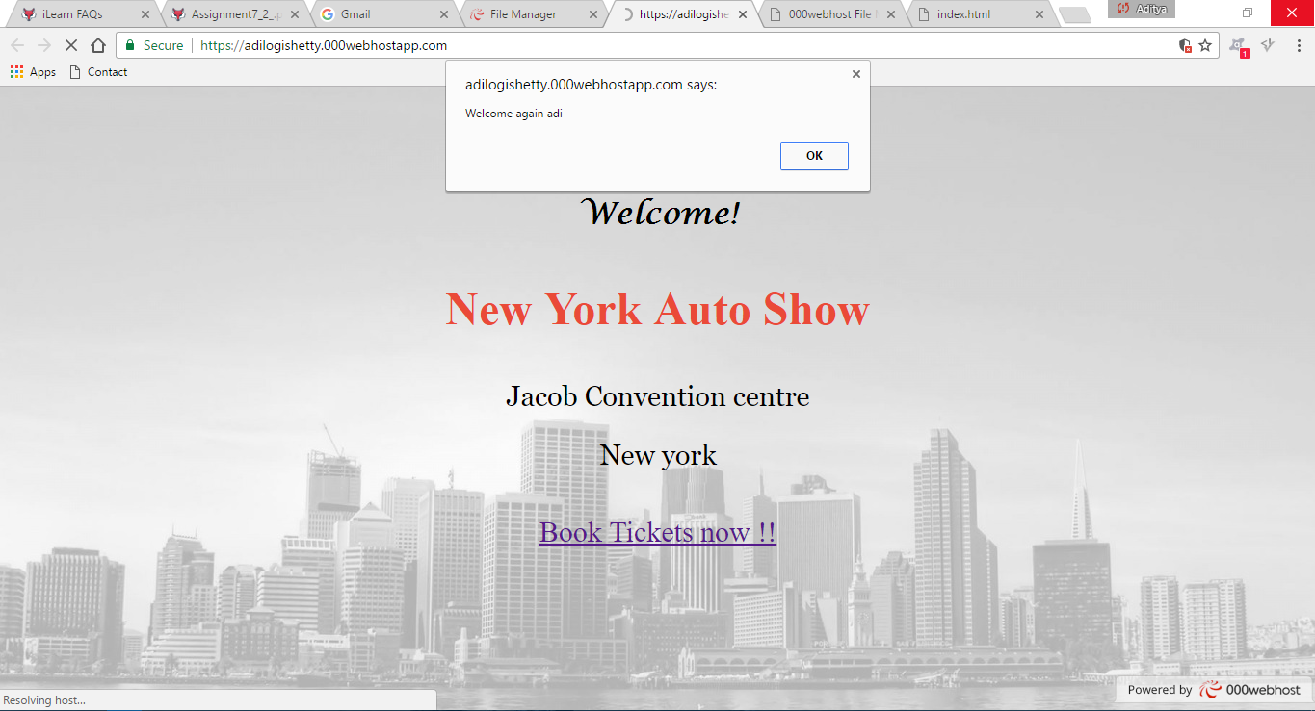

* Cookie storage details.

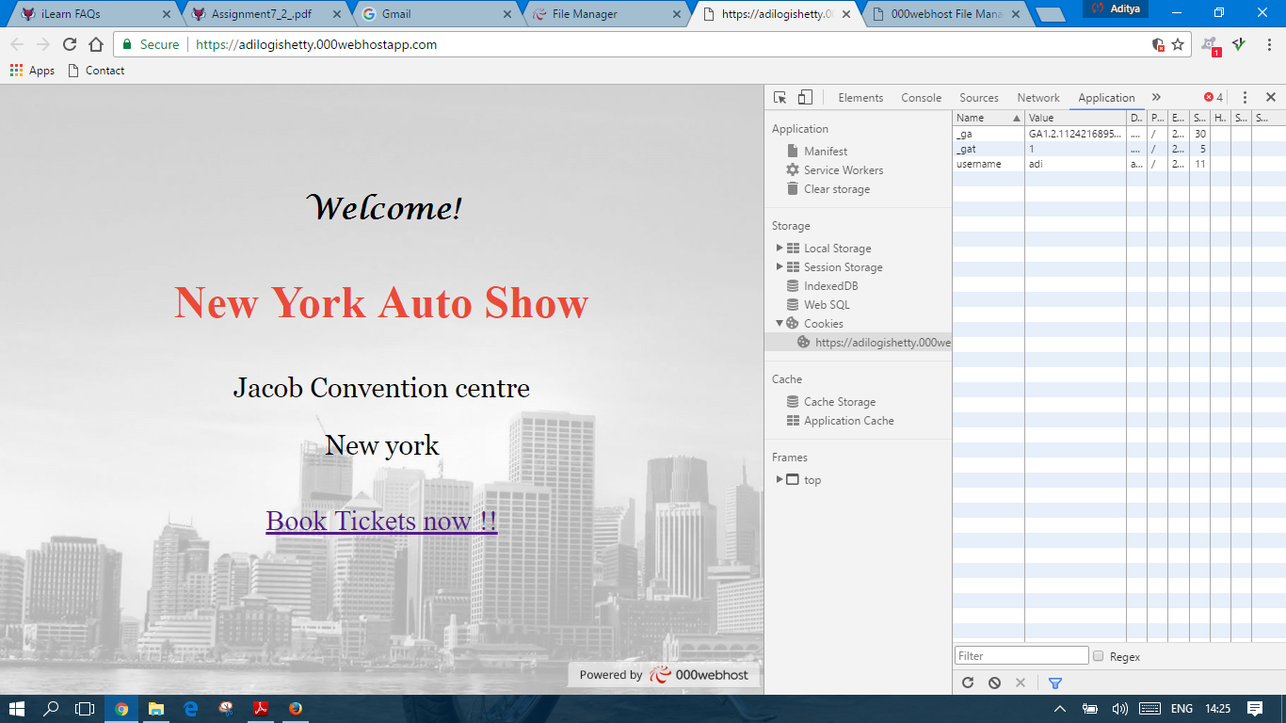

* Cookies stored.

