**Aditya Logishetty**

**Michael Gilden** Web Technologies  
 MSIS_517L  
 May02,2017

**Development project 3**

**1)**Screenshots –

Home page-

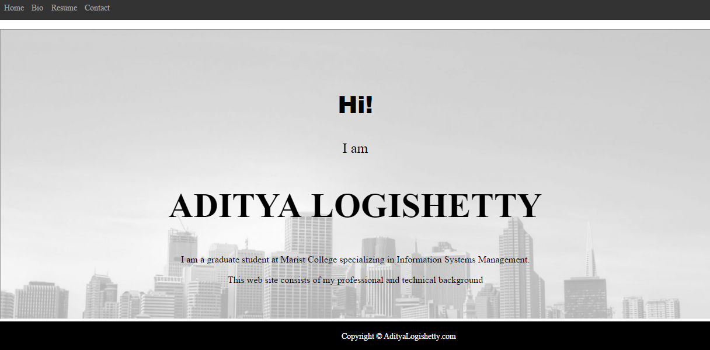

Contact page-

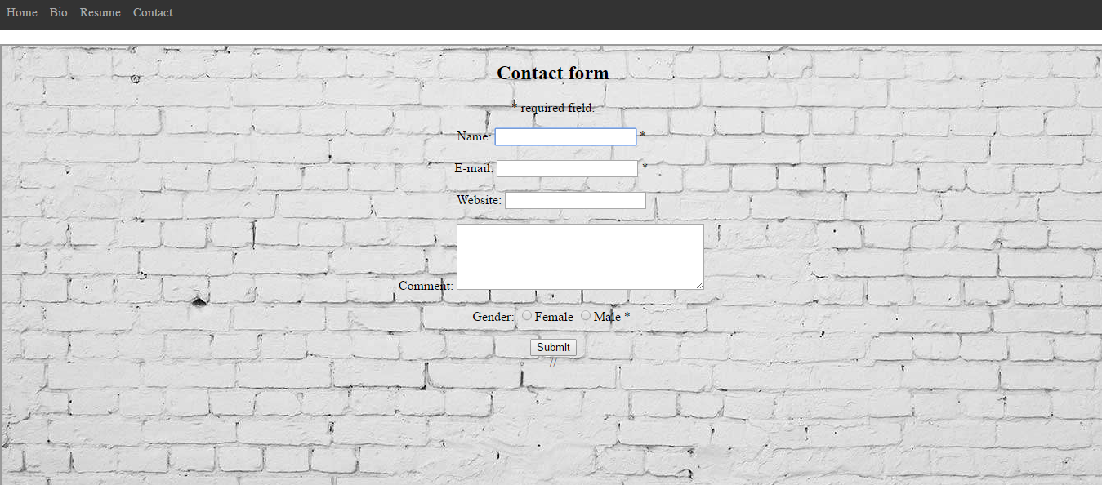

Data entry -

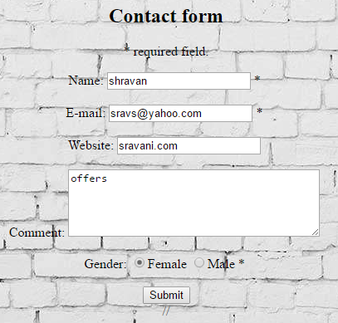

Created records -

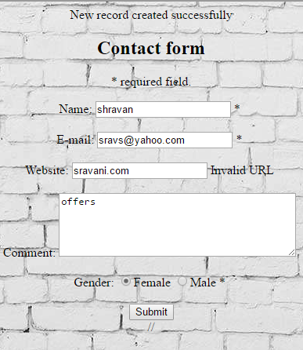

Sql data connected with php -

