**Aditya Logishetty**

**Michael Gilden** Web Technologies  
 MSIS_517L  
 February 21, 2017

**DEVASSIGNMENT PROJECT 1**

1. **Design diagram .**

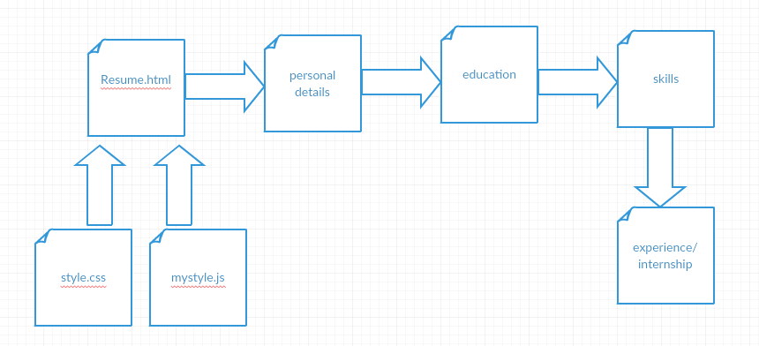

1. **Content outline.**

List of conten included in my project :

* **Header** – it contains my name and my address .
* **Mailtolink**- To contact me thorugh my email address .
* **Objective** – it contains my objective with on click button option
* **Profile image**- it contains my profile image with hover option .
* **Education** – using CSS have created tables for the data insertion.
* **Download** – using my googledrive option to link my file so that it is available for download.

1. Screenshots

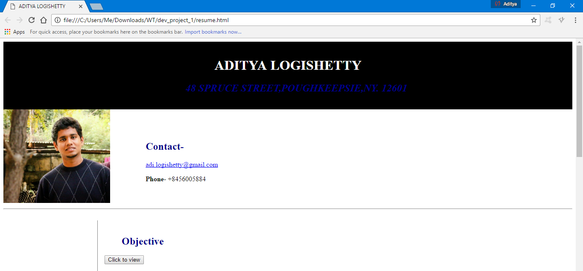

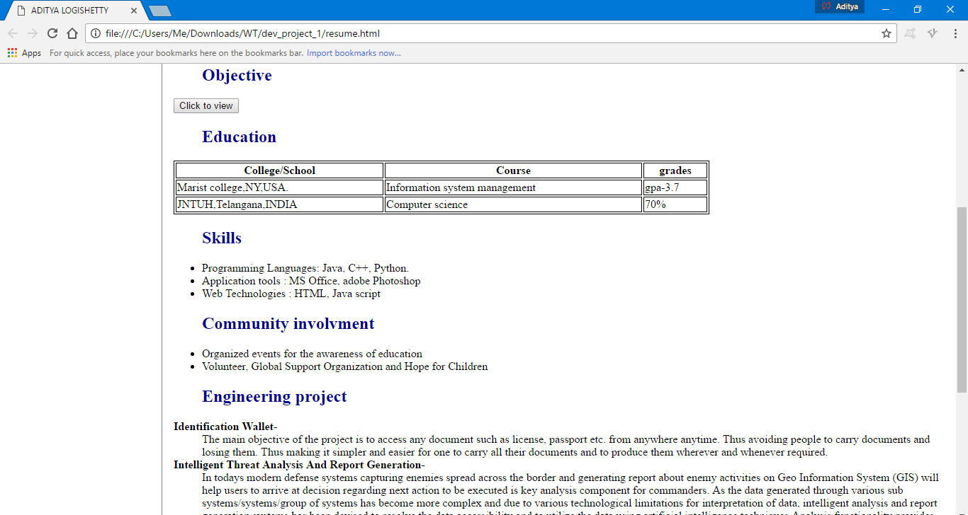

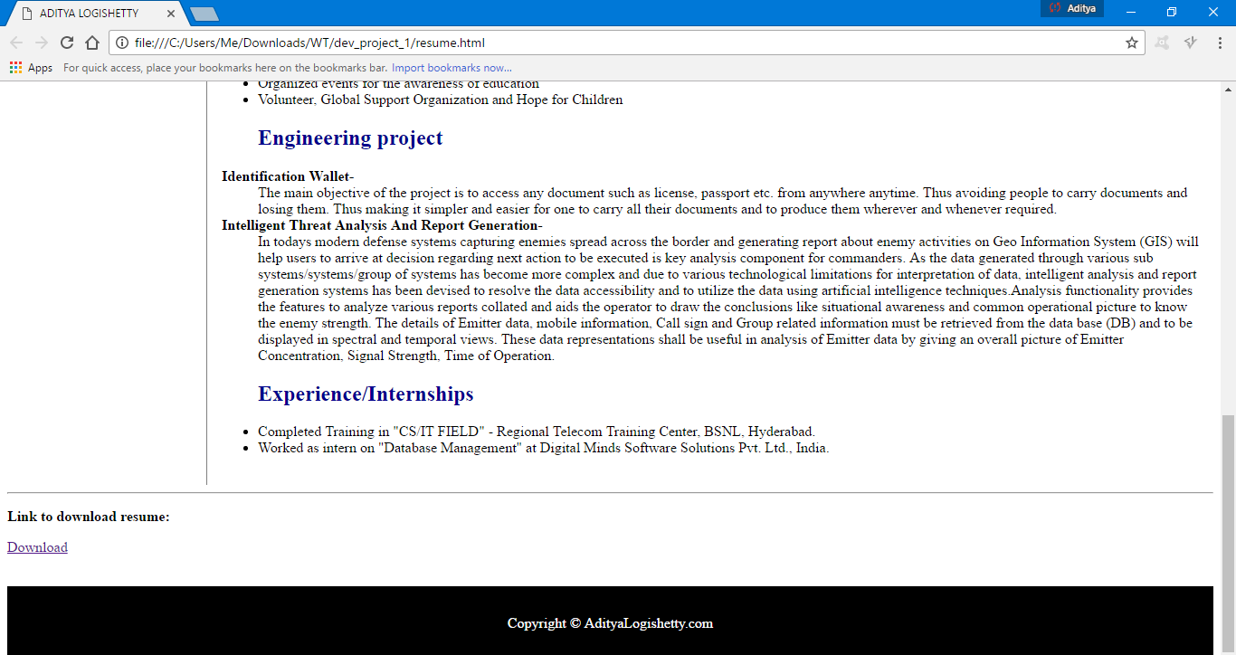

1. **Validations .**

