**Aditya Logishetty**

**Michael Gilden** Web Technologies  
 MSIS_517L  
 March28, 2017

**Development project 2**

I have used the two different css files where css.css is used for bio.html , contact.html,main.html and home.html whereas the style.css is used for resume.html .

I have used son files for the contact form.

**1)**Screenshots –

Home page-



Bio page -

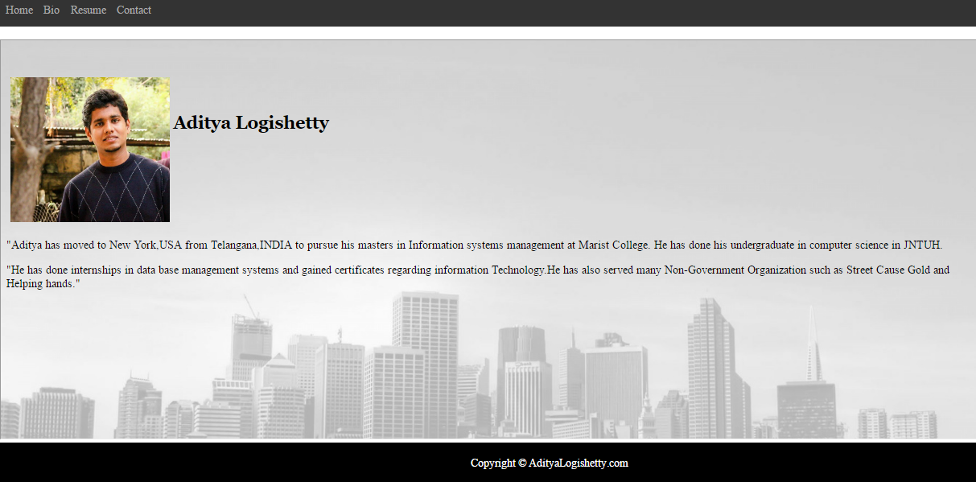

Resume page1-

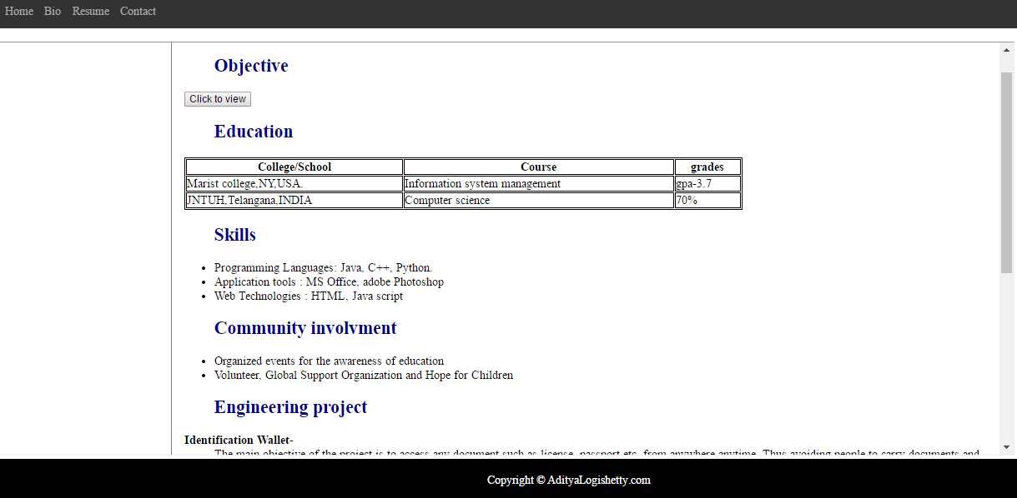

Resume page2-

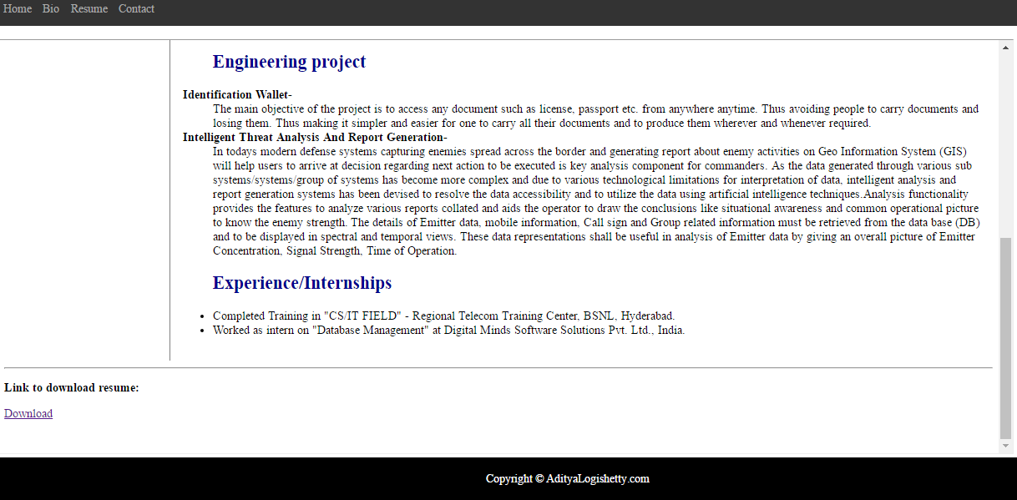

Contact page-

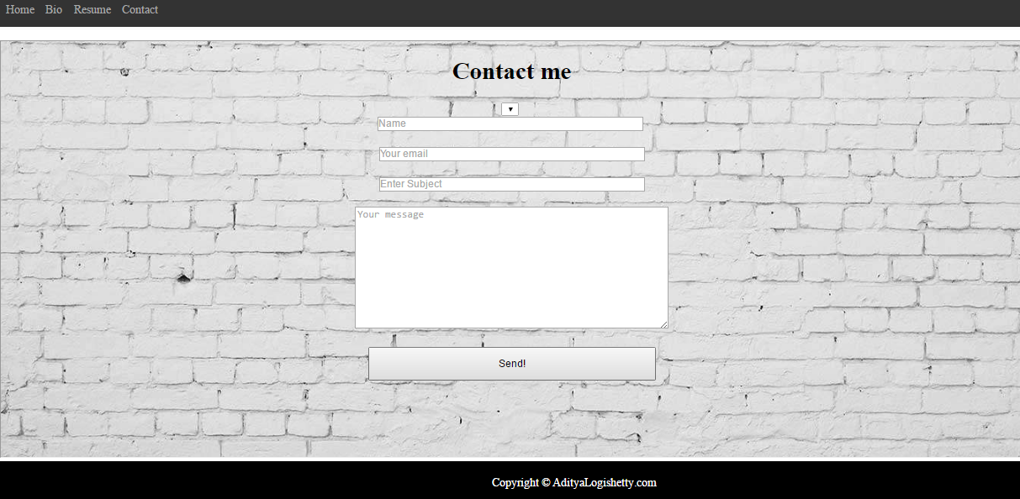

2)Validations :

