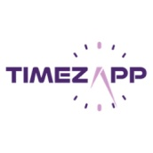 **Date: 27th Dec 2022**

**TIMEZAPP**

**INTRODUCTION**

Classical method of manual record keeping is not totally reliable since there are chances of proxy attendance or the human error of forgetfulness, and for large organizations, this is an issue that needs to be tackled. **TimezApp** is a thoughtfully created application with the ability to track time, attendance and location, combined with an easy UI on both website and mobile application makes it quick to learn and adapt, since the application automates the process, this saves both time and energy while increasing the efficiency of the workplace. As attendance calculation helps to create and maintain trust between the employer and the employee.

Website: <https://timezapp.infraconnect.in/>

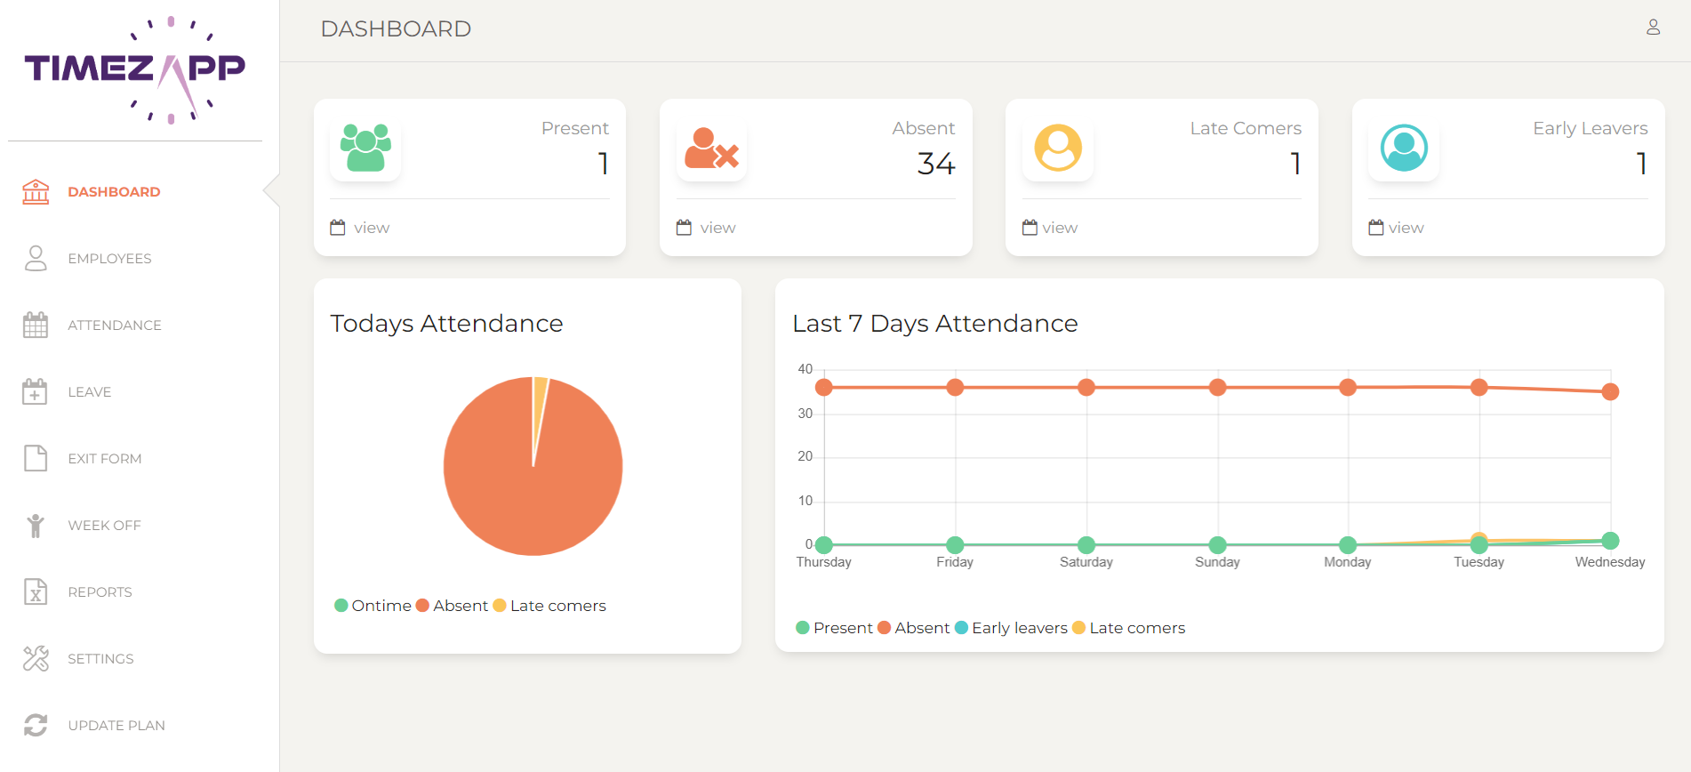

Available in Play store: “**TIMEZAPP** – Attendance Tracker”

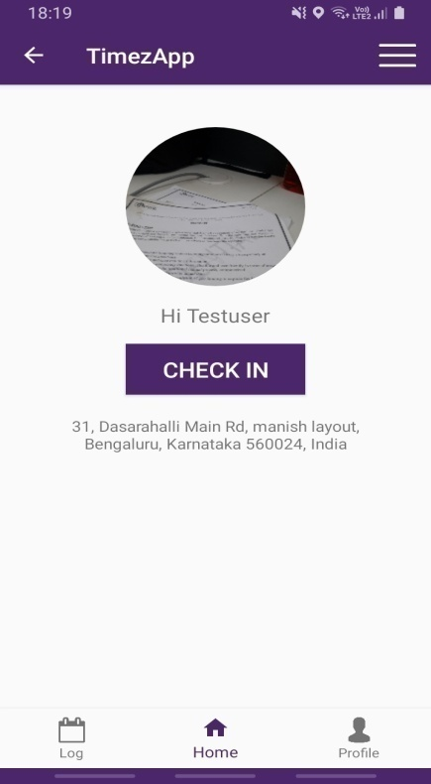

**OBJECTIVE**

* Track employee’s Check In/Out time.
* Calculate employee’s total working hours.
* Collect details about workers attendance.
* Tracking employee’s locations using geo fencing.
* Manage Absence and leave of the employee’s.
* Save time and cost for maintaining large amount employees.
* Avoid proxy attendance.
* Easily access employee’s history details.
* Real-time updates

**Stakeholder**

There are two stakeholders for the **TimezApp** application.

1. **Admin**
2. **User**

**1. Admin**

Admin is entitled to access the system for organizational management and to maintain the overall business functions for infrastructure management, technical support, structure and content evaluation, analyzing the statistics and other functions, taking into account the application’s customization and performance.

**Flow Chart:**

**Start**

**Stop**

**Exit form**

**Login**

**Admin**

No

Yes

**View and alter Attendance**

**Report**

**Week off and leave**

**View, add and edit employees**

**Functional specification - Admin**

1. **Login:**

The admin have the access to log in by using a unique username and password. In any case, the admin forget his password then they can reset password with the help email and mobile number. After successful login, the administrative dashboard appears.

1. **Dashboard:**

In dashboard admin have access to clear understanding about employer attendance like present, absent, late comers, early leave and a few graphics, such as pie-chart and bar charts.

1. **Employees:**

The employee feature will make it easier for the admin to view every employee in on company with their email, id, designation, number etc. and officers of the company can quickly allocate task to the employees with the aid of administration.

1. **Attendance:**

This feature helps admin to show clear and personalized employee’s attendance and the page demonstrates how to apply various colors to a certain condition like present, absent etc., and by clicking each day admin can track the location, check-in image, site time in, work hours etc.

1. **Leave:**

Keep a record of all employee details like name, date; leave types like half day or full day and action. In action, the admin can verify leave of the employees and also check the reason for leave.

1. **Exit form:**

Shows the exit employees, based on the times that employees join and leave, the admin needs to change this data.

1. **Week off:**

Show the holidays.

1. **Report:**

Create report based on attendance, employee master and exit employee. Report helps to admin for easily make detailed report about employee’s activities.

1. **Settings and Update plan:**

Setting shows all the details of client, site, shift of the employees, holidays, department etc., and also checks the exit employees detail and their final settlement. Update plan can modify according to the organization needs and size of the workforce.

**2. User**

Employees of the company utilize this technology, and it is available as an Android application that can be downloaded from the Google play store. Once logged in, the user will reach dashboard on their smart phone. Additionally, this application is made for a number of divisions, like sales, marketing, information technology, etc. This system is constantly monitored by the admin and is able to track users' whereabouts, activities, and more. The employee's selfie is used in this application to mark attendance. Employees must post a selfie from this application after arriving at the location and time in order for their attendance to be recorded automatically.

**Flow Chart:**

**Login**

**User**

**Start**

**Take selfie and checked in**

**Take selfie and checked out**

**View attendance log**

**Profile**

No

Yes

**Stop**

**Change password and logout**

**Feature specification - User**

1. **Login:**

Each employee gets a unique username and password because there are many employees who need to log in and whose attendance is crucial to their pay. There is a feature called “forgot Password” that allows users to reset password if they accidentally forget them. Once logged in successfully, it enters the home page.

1. **Home:**

Employees can access a function called “checked in” that allows them to shoot and submit selfie of themselves. Then the program will review the information in the selfie, such as the time and location, and records the employee’s attendance accordingly. Employees must need to upload a selfie during checkout time and it will review by the program accordingly.

1. **Attendance log:**

Attendance log feature shows to employees their login details, logout detail and total hours of work. It will the users follow their activities and if there any problem they can raise ticket to admin.

1. **Profile :**

Profile shows the employee details like designation, picture, etc.

1. **Other features:**

Other main feature is change password and logout.

**Product Evaluation:**

**Timezapp** is an employee selfie-based attendance management system. Here, our product aids organizations who find it difficult to manage and coordinate a sizable workforce. The key benefit of **Timezapp** is tracking employees once they mark attendance, which is then confirmed by the internal program. Admin can view an employee current location, date, time and they last signed in. The two technologies that enable us identify the personnel are geo fence and geo tagging.

**Comparison Table:**

|  |  |  |  |
| --- | --- | --- | --- |
| **Sr. No.** | **Features** | **TIMEZAPP** | **Competitor’s (Domestic & International)** |
| 1 | Selfie Attendance | Yes | Yes |
| 2 | Thumb Attendance | No | Yes |
| 3 | Biometric attendance | No | Yes |
| 4 | Live updation of employees location | Yes | Yes |
| 5 | Leave request | Yes | Yes |
| 6 | Payment details | No | Yes |
| 7 | Tracking employee work hour | Yes | Yes |
| 8 | Generate general/detailed/custom/employee detail reports | Yes | Yes |
| 9 | Update plan based on the size of company | Yes | Yes |
| 10 | Chat boat-Direct chat with admin | No | Yes |
| 11 | Visualization of attendance | Yes | Yes |
| 12 | Assigning work based on employees designation | No | Yes |
| 13 | Alert message based on workers movement egg : if employee pass the boundary | No | Yes |
| 14 | Geo fencing | Yes | Yes |
| 15 | Geo tagging | Yes | Yes/No |
| 16 | Missed clock in alert (automatic alert will inform admin and user when user forget or skip the join work after break) | No | Yes/No |

**Features that is similar in TIMEZAPP and global level attendance management system:**

* Every employee has their own unique username and password, based on that only employee can access.
* Tracking each and every employee in the organization by the help of geo fencing and tagging and also verifying their login time and logout time. Also track numbers of workers are present, absent, half day absent etc. Admin has access to every employee’s details and can change them based on information. For example, if an employee was fired yesterday, admin would need to remove them from system.
* Admin has access to every employee’s details and can change them based on information. For example, if an employee was fired yesterday, admin would need to remove them from system.
* User and admin will get live update according on their activity.
* Generate report of based on attendance, employee details and exit employees.
* Shows details about how many leave each employee has left based on the number of day they have taken. Also shows company off days.
* Using user’s devices, they can record their attendance and view their working hours.

**Features available in TimezApp:**

* Presentation of product attendance makes it simpler for administrators to comprehend.

Admin can clearly see who is present, absent, etc. with the help of pie chart and line plot.

* Access all the details of attendance in the previous days. Admin can access to the attendance of every employee and also check employee’s previous day’s status by a single click.
* Organization can update their plan based on the level of the firm. If organization employees are increasing day by day then they needs to change their plan accordingly.
* Check-in and check-out process is based on a selfie, after it updates admin can track employees all kind of information.

**Features unavailable in TimezApp:**

* **Timezapp** is not providing payroll-based activities. The payroll method is a good feature in the attendance management system; it will update every employee’s salary packages and their transaction thing of salary.
* Most of the global level products have the biometric method for marking present like facial recognition, thumb etc.
* Global level attendance management system provides admin can directly interact with employees through the system like chat boat.