**Date: 27th Dec 2022**



**IC** Visitor

**INTRODUCTION**

Classical data management process is a time consuming process, especially if there is a high volume of data, additionally, there is a risk of data loss if there is no backup. **IC Visitor Management** application has an easy to understand UI, automates the process with minimum human interface decreasing the registration time and increasing productivity. The application also provides statistical data of visitors.

**Admin dashboard:**

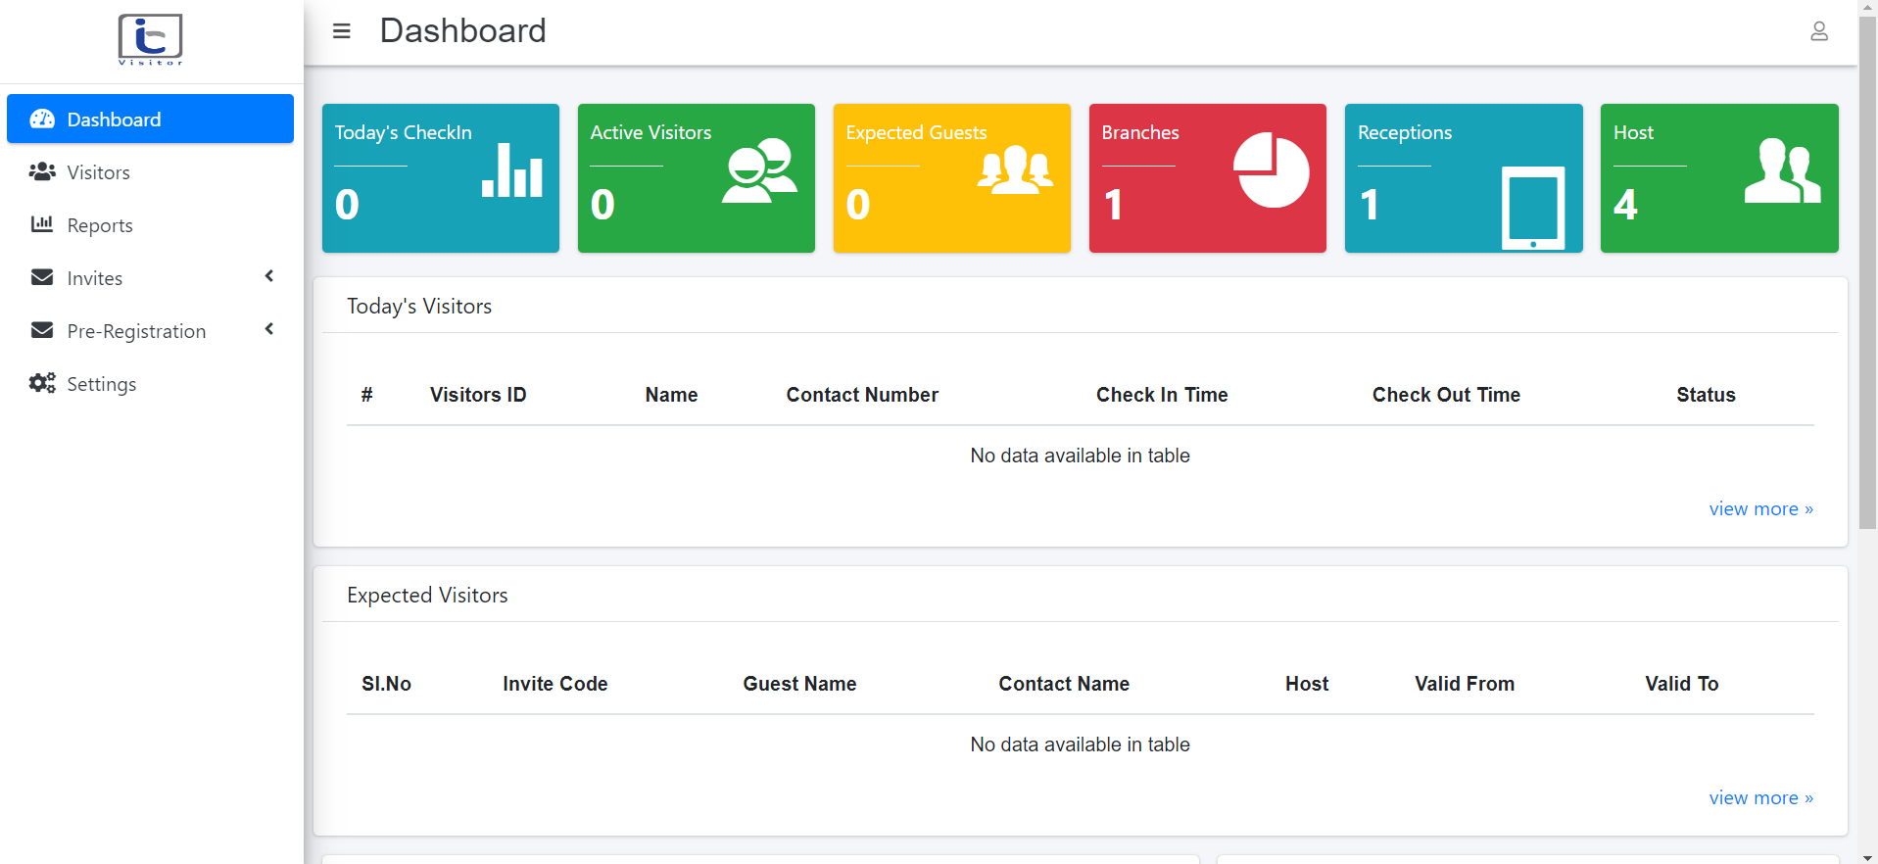

Web site: <https://vms.infraconnect.in/>

**Receptionist dashboard:**

**:**

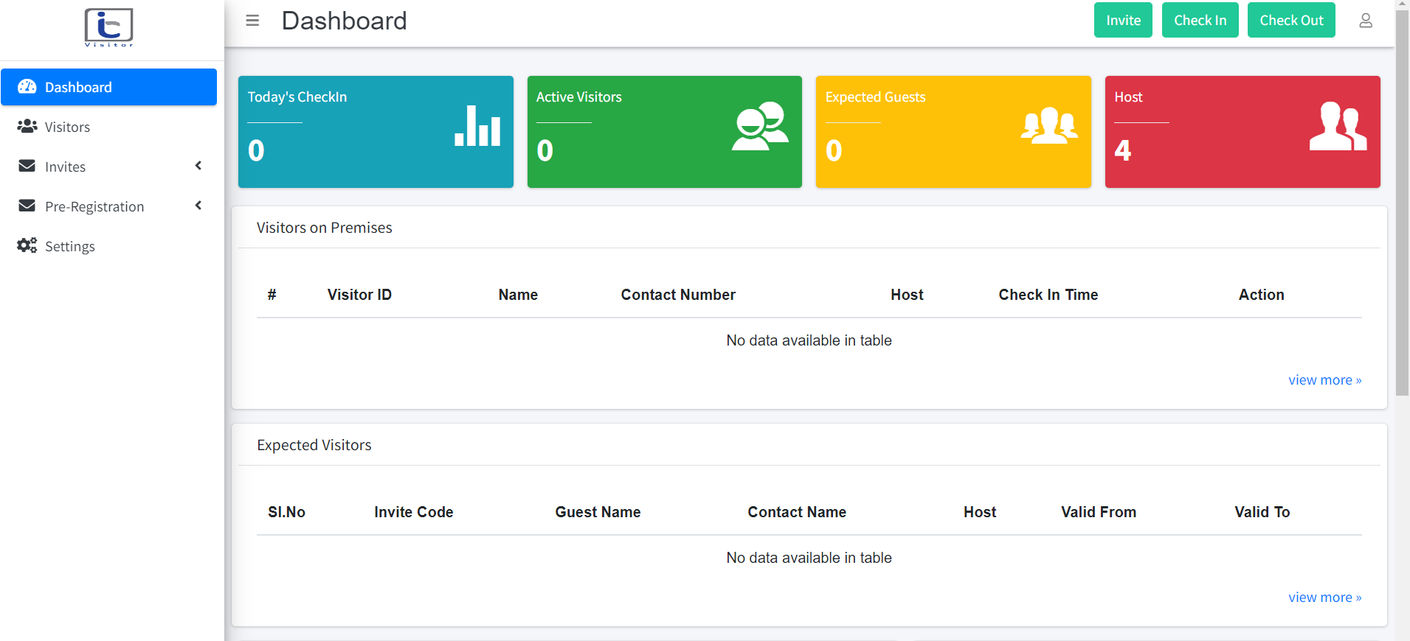

Web site: <https://vms.infraconnect.in/>

User page:

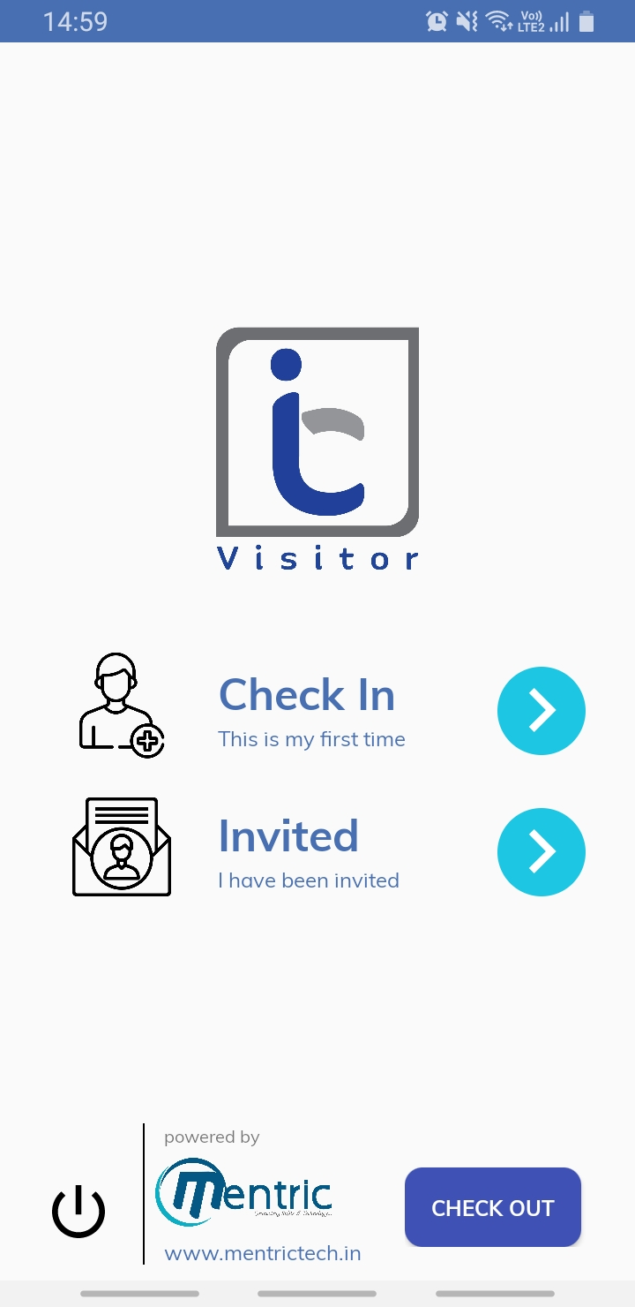

**OBJECTIVE**

* Minimize human interaction
* Manage multiple visitors at a time
* Direct interaction with the administrator
* Contactless and simple sign-in process
* Simple access to historical data
* Help organization reach a new level of efficiency
* Real-time updates

**Stakeholders**

* Admin
* Host
* Receptionist
* Visitors

1. **Admin:**

Admin control and manage all the activities of the system, they have greater authority to direct and coordinate this mechanism. Admin track all activities of reception, host and visitors. They are able to download all the relevant reports, also able to invite visitors both individually and in bulk.

**Functional specification – Admin**

1. **Dashboard:**

Demonstrates all of the operations, including today’s check-in, active visitor, expected guests, number of hosts, etc. and also track visitors and expected visitor's movement.

1. **Visitors:**

Displays all of the visitor’s details like visitor id, name, contact number, host, status, checked-in, checked out and action.

1. **Reports:**

Generate reports as per customer requirements.

1. **Invite and Notification**

Invite visitors individually and bulk.

Receive notifications based on visitors and host action.

1. **Settings:**

Create and allocate branch, reception, host, departments, purpose, zone and visitor types.

**Flow chart:**

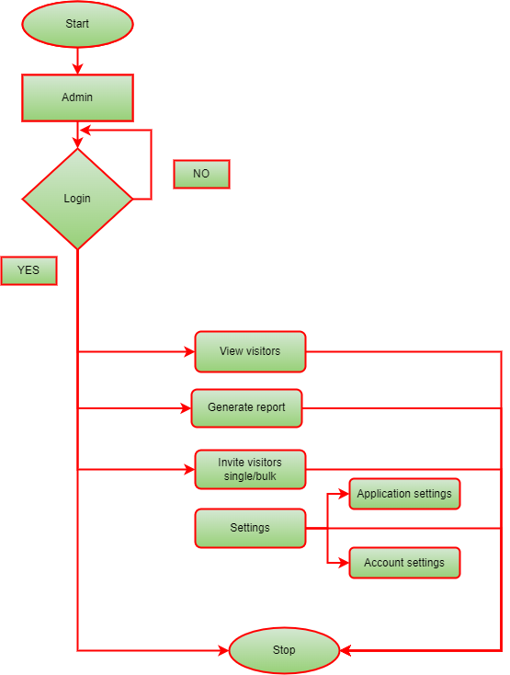

1. **Host:**

When a visitor submits a request-host is notified, and then the host can accept or reject the meetings.

A host can also extend the meeting based on his need.

**Functional specification – Host**

1. **Notification:**

The host will receive a notification when the visitor submits the request.

1. **Host action:**

* Hosts can accept and reject meetings.
* Hosts can extend meetings.

1. **Check-out:**

The host can check out the visitor.

**Flow chart:**

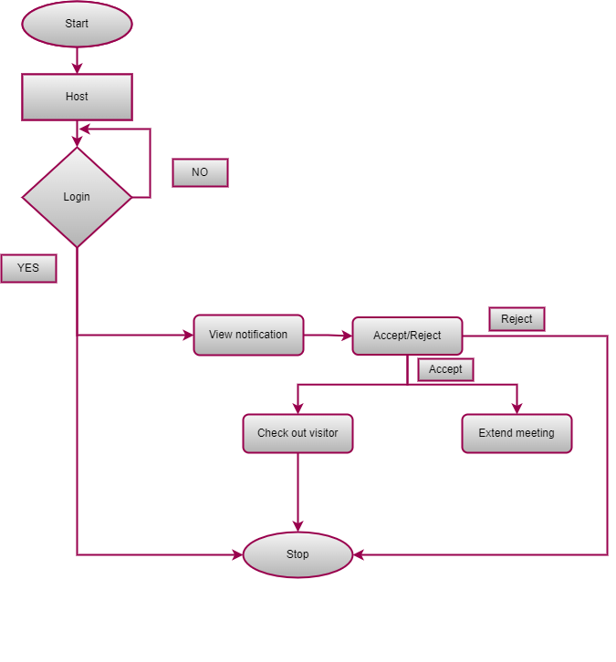

**3. Receptionist:**

The receptionist manages visitor activities such as validating registration forms and acting in accordance with the host’s response if the host allows receptionist entry or not.

**Functional specification – Receptionist**

1. **Dashboard:**

Check the activities as in today’s check-in, active visitors, expected guests and host. There is an additional check-in and check-out option on the receptionist’s dashboard.

1. **Visitors:**

A complete view of visitors with details of Id, name, contact number, host, status, check-in time and check-out time.

1. **Invites:**

Invite visitors individually and bulk.

1. **Notification:**

Receive notifications based on visitors and host action.

**Flow chart:**

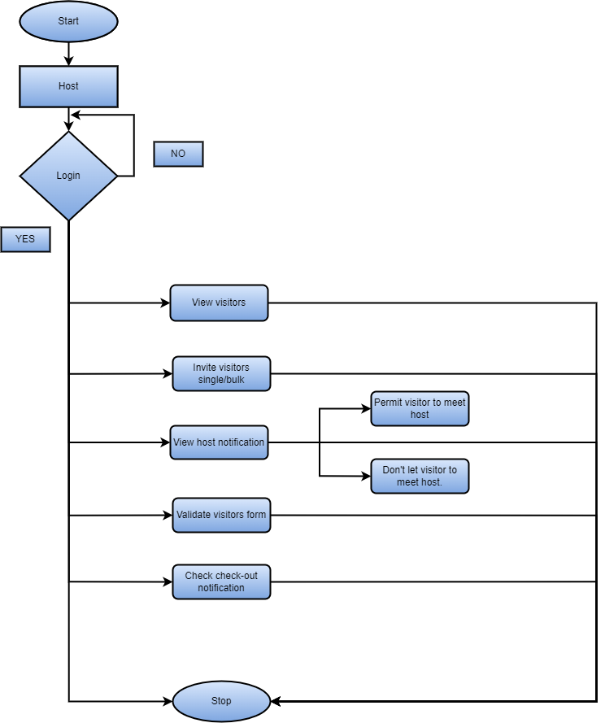

**4. Visitors:**

There is no specific website or application that visitors use. They need to scan QR code shown at the entrance, then enter their information, submit their KYC, and upload a photo before waiting for the host to respond. Then receptionist instructs you according to the host notification. After the meeting is over the visitor will get a check-out notification.

**Product Evaluation:**

**IC Visitor Management System** assists visitors in quickly and safely meeting with officers in the organization. It can manage large number of visitors at a time and also manage to reduce human interaction. **IC VMS** provide maximum security for client information and it offers cloud-based storage so that administrators may access all visitor information at any time. Additionally, there is extremely little possibility of data loss. According to a client request, **IC VMS** offers the possibility to download reports of visitors.

**Comparison Table:**

|  |  |  |  |
| --- | --- | --- | --- |
| **Sr. No.** | **Features** | **IC Visitor Management System** | **Competitor’s (Domestic & International)** |
| 1 | Human interaction | Minimize human interaction. | Minimize human interaction. |
| 2 | Method of request | QR-Code-based request method. | Most of the firms are QR-Code based and some of the firms provide a device for entering the details of visitors. |
| 3 | Safety & Security | Provide a high level of safety and security. | Provide a high level of safety and security. |
| 4 | Visitor’s request | Direct visitor notification to the host, receptionist and admin. | Direct visitor notification to the host, receptionist and admin. |
| 5 | Visitors tracking | Live update of visitor’s movement monitor by admin. | Live update of visitor’s movement monitor by admin. |
| 6 | Delivery People’s | In **IC VMS** delivery people’s also need to do same method like other visitors. | In global level some company provide an extra option for delivery people’s for more easily contact with employees. |
| 7 | Report | Admin customize and download report based on management needs. | Admin customize and download report based on management needs. |
| 8 | Visitor’s verification | **IC VMS** Provide KYC option for verify visitor is genuine or not. | **Global level VMS** also provide high KYC verification for visitors. |
| 9 | Data storage method | Cloud-based platform. | Cloud-based platform. |
| 10 | Access of data | Admin can access the data from anywhere. | Admin can access the data from anywhere. |
| 11 | Dashboard | Provide a user-friendly visitor dashboard. | Provide a user-friendly visitor dashboard. |

**Possible Updates:**

* Adding support for multiple languages
* Allowing for electronic sign-in and sign-out
* facial recognition or other biometric technology for secure identification