**Date: 8th Jan 2023**

**ASSET MANAGEMENT APPLICATION**

**INTRODUCTION**

**IC Asset Management Application** is thoughtfully created to assist in managing and keeping a track of the entire asset’s handled by the organization as the application is easy to learn and adapt. Due to automation of data management, the asset can be used efficiently and maximize the value and improve the overall efficiency of the work. This will also assist the user to keep a track of the monetary flow and assist in strategic decision making.

**OBJECTIVE**

* **Improve visibility:**

This system offers a single, centralized repository for all data regarding an organization's assets.

* **Enhanced efficiency:**

By automating tasks such as asset tracking and maintenance scheduling, an asset management system can help organizations save time and reduce costs.

* **Increased accuracy:**

**IC asset management system** can help organizations maintain accurate, up-to-date records about their assets.

* **Improved asset utilization:**

Help organizations optimize the use of their assets by providing tools for analyzing utilization patterns and identifying opportunities to use assets more effectively.

* **Security:**

An asset management guide for information security professionals managing a business from an information security professional’s point of view means there needs to be some form of asset classification within the operational structures of the company.

**Key features**

* **Lifecycle management**
* **Real-time tracking**
* **In-depth reporting**
* **Seamless workload distribution**
* **User-friendly interface**
* **Mobile compatibility**

**Admin dashboard:**

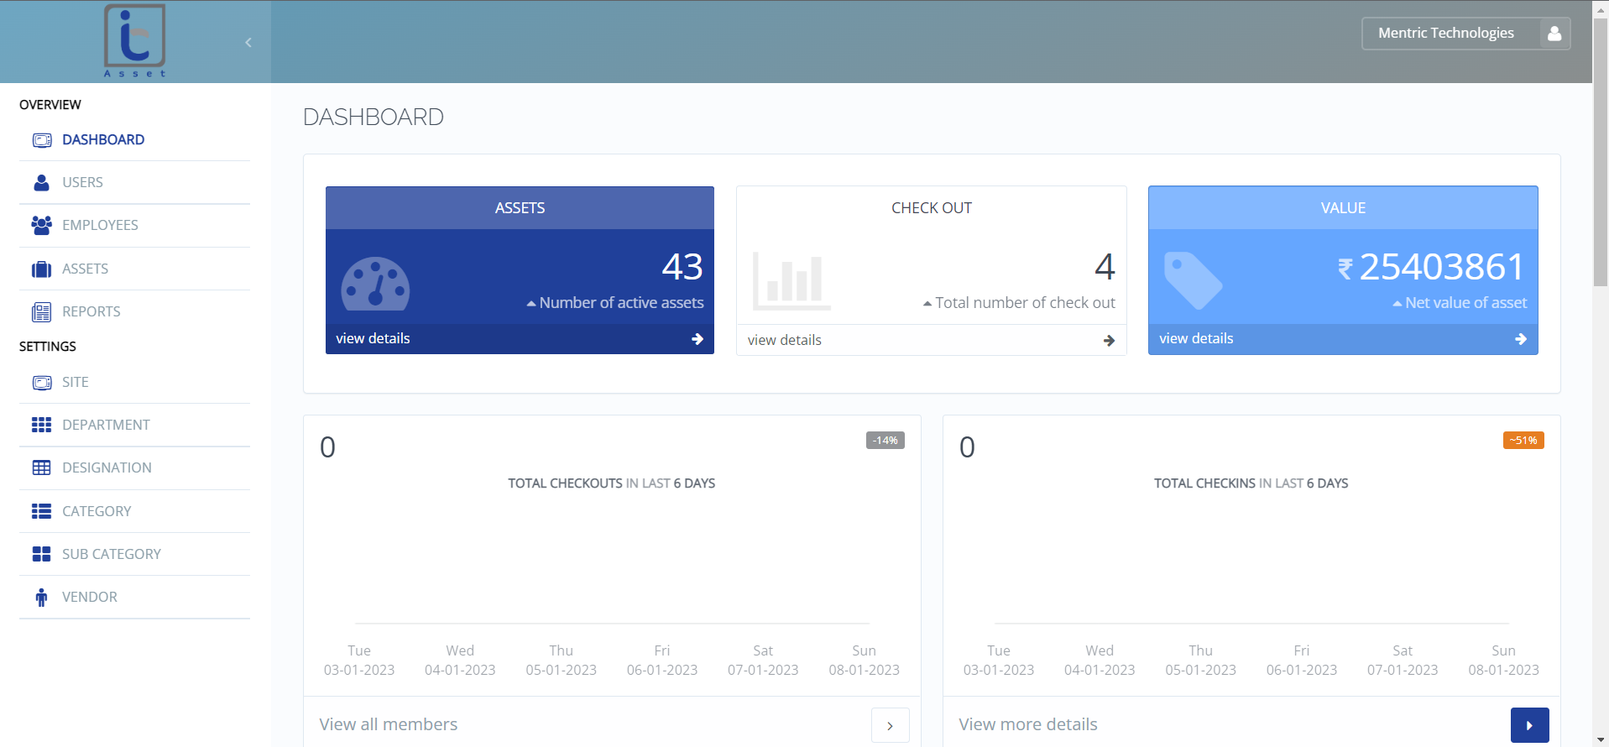

**Website:** <https://asset.infraconnect.in/>

**Admin (Stakeholders)**

Admin will manage the overall function of the application. Admin has the rights to create a new user and have complete access to the overall information in the application wherein the admin can create and maintain a record of all activities related to company assets. Additionally, the admin is in charge of keeping track of and updating information regarding the organization's assets within the system, allocation of the assets to users, and producing reports on asset performance and usage. This application will allow the admin to assist to ensure all work is carried out in compliance of the set rules and standard operating procedure of the business.

**Functional Specification – Admin**

* **Login:**

The admin can log in by using their username and password. The login credentials need to be kept confidential in order to prevent any misuse. In any case, admin forget his password then they can reset the password using email and mobile number.

* **Dashboard:**

A dashboard provides all relevant information regarding the asset management system. The overall number of assets, total check-outs, net asset value, check-ins and check-outs during the last six days and the number of assets are all visible to the admin.

* **Users:**

The “User” function aids the admin in adding new users, updating user data, and viewing all the user details. Administrators can view names, emails, employee id, departments, and designations on this page and update the user details.

* **Employees:**

The “Employees” function aids the admin in adding new employees, updating employee data, and viewing all the employee details. Admin can view name, email, employee id, department, and designation on this page.

* **Assets:**

The “Assets” function is the main feature of the application; it allows users to add new assets, mark assets as checked out or checked in and access all the details. Overall, this feature assists the administrator in keeping tabs on all asset activity. To make it simpler to track and identify all assets, the asset function generates QR codes based on the assets. Additionally useful is product warranty knowledge.

* **Reports:**

A report on asset management contains details on the operation and condition of a company's assets. This can apply to both material assets like machinery. A company's assets and how they are being used to create value are clearly outlined for stakeholders, including shareholders and management, in an asset management report. Admin can download reports related to assets, and check out assets, users, sites, departments, designations, categories, and subcategories using this function.

* **Site:**

Admin can add a new site and review an existing one through the site function. The site details include the name, description, address, and city. Admin can also update the site's information using this feature.

* **Department:**

In the asset management system application, a department refers to a specific unit or division within an organization that is responsible for managing a specific set of assets. Departments may be organized based on the types of assets they manage. In this function, the admin can add a new department, update the current department and view all the details of the department.

* **Designation:**

In an asset management system, designation refers to the classification or categorization of assets based on various criteria, such as type or level of importance. The designation is used to help organizations better understand their assets and how they are being used. In this feature, the admin can check all the designation details as well as add new designations and update existing designations.

* **Category & Sub-category:**

Categories and subcategories in an asset management system refer to how assets are categorized or organized according to their properties or qualities. These can be used to assist businesses in better understanding their assets and how they are being used, as well as in helping them decide how to distribute and manage those assets. In this function, admin can add, update, and view the categories and sub-categories.

* **Vendors:**

A vendor function in an asset management system gives all the vendor's details, including name, specific person of contact (spoc), email, vendor ID, contact information, etc. This function also allows for the creation of new vendors and the updating of existing vendor data.

**Flow Chart:**

Export

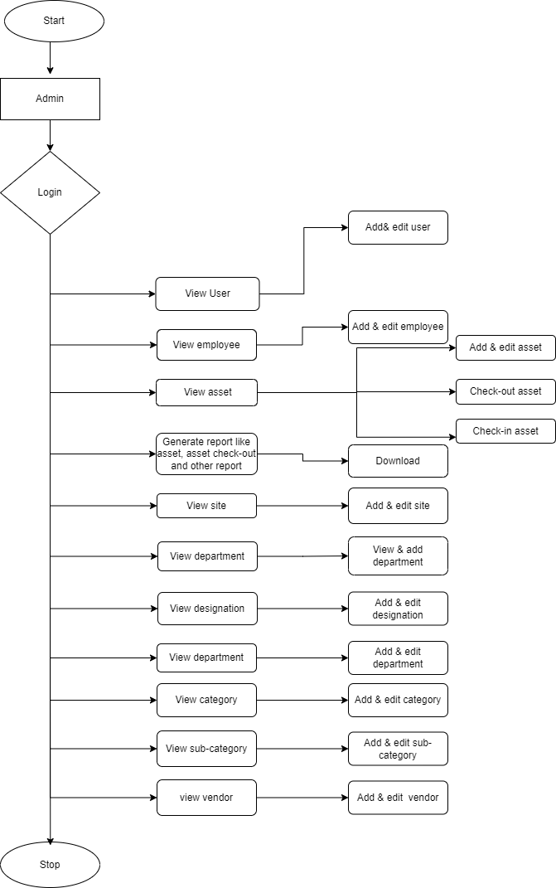

**Users (Stakeholders):**

Users are the individuals or teams responsible for managing the assets in the system. User has to right to make decisions about which assets to buy and sell, and may also be responsible for monitoring the performance of the assets and making adjustments as needed. This feature allows the Admin to delegate the responsibilities and ensure all the work is carried out with respect to the rules and regulations set by the business.

**Comparison Table:**

|  |  |  |  |
| --- | --- | --- | --- |
| **Sr. No** | **Features** | **IC Asset Management Application** | **Competitor’s (Domestic & International)** |
| 1 | Interface | User-friendly interface | User-friendly interface |
| 2 | Assets tracking | Track all the assets and maintain their details of assets | Maintain assets information and track |
| 3 | Bulk Upload | Not possible | “Bulk Upload” feature is available on similar applications globally. |
| 4 | QR-code | Generate a unique QR code for every asset | Generate a unique QR code for every asset |
| 5 | Security | Protect & maintain all the assets in the company | Protect & maintain all the assets in the company |
| 6 | Storage | Cloud-based storage | Cloud-based storage |
| 7 | Access | Easy & any time access to the data | Easy & any time access to the data |
| 8 | Report | Generate all relevant reports, with a download option. | Generate all relevant reports, with a download option. |
| 9 | Mobile Access | Possible | Possible |
| 10 | Notification Alert | Not Available | Available |
| 11 | Installation | Hosted, Local, Cloud | Hosted, Local, Cloud |

**Possible Updation:**

* **Bulk insert:**

The process of adding a large number of assets to an asset management system at one time. This can be useful when an organization has a large number of assets that need to be tracked.

* **Notification alert:**

Notification alerts are messages or notifications that are triggered by a specific event or condition and are designed to inform the recipient about something that requires their attention. This will assist the asset management system in determining the asset's expiration date before it expires.

* **AMC:**

An annual maintenance system helps to ensure that the asset being managed are in good working and are being properly maintained. This method helps extend the lifespan of the assets, which can save money and reduce the need for costly repairs or replacements.