Date: 29th Dec 2022

 **Checklist Management System**

**Introduction**

One of the main difficulties that every business has in its daily operation is task management. Task management helps an organization through various stages from start to end, and an organization can more easily accomplish its goals and objectives with the help of a good task management system. Now with the help of a checklist management system, all the process is automated and work according to a systematic manner efficiently. All processes are now automated and work smoothly and systematically with the help of a checklist management system. The **Infra Connect checklist management** system enables the business to identify roles and direct staff through tasks in the most effective way, and by using this method employees will get real-time information and live strategy.

**Objective**

* To support companies in having transparency on employee's tasks and status.
* Controlling activities or initiatives.
* Ensuring nothing important is forgotten during execution.
* Create multiple checklists at a time.
* By scanning the QR code, staff can quickly understand their responsibilities.
* Help in memorization.
* Reduce errors and omissions and improve safety.

**Admin Dashboard**

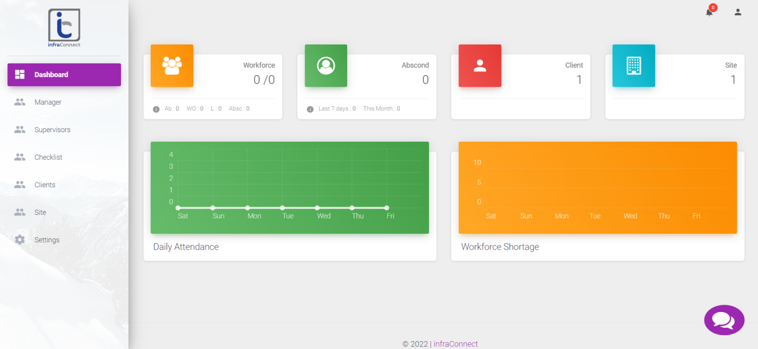

Website: <https://checklist.infraconnect.in>

**Manager Dashboard**

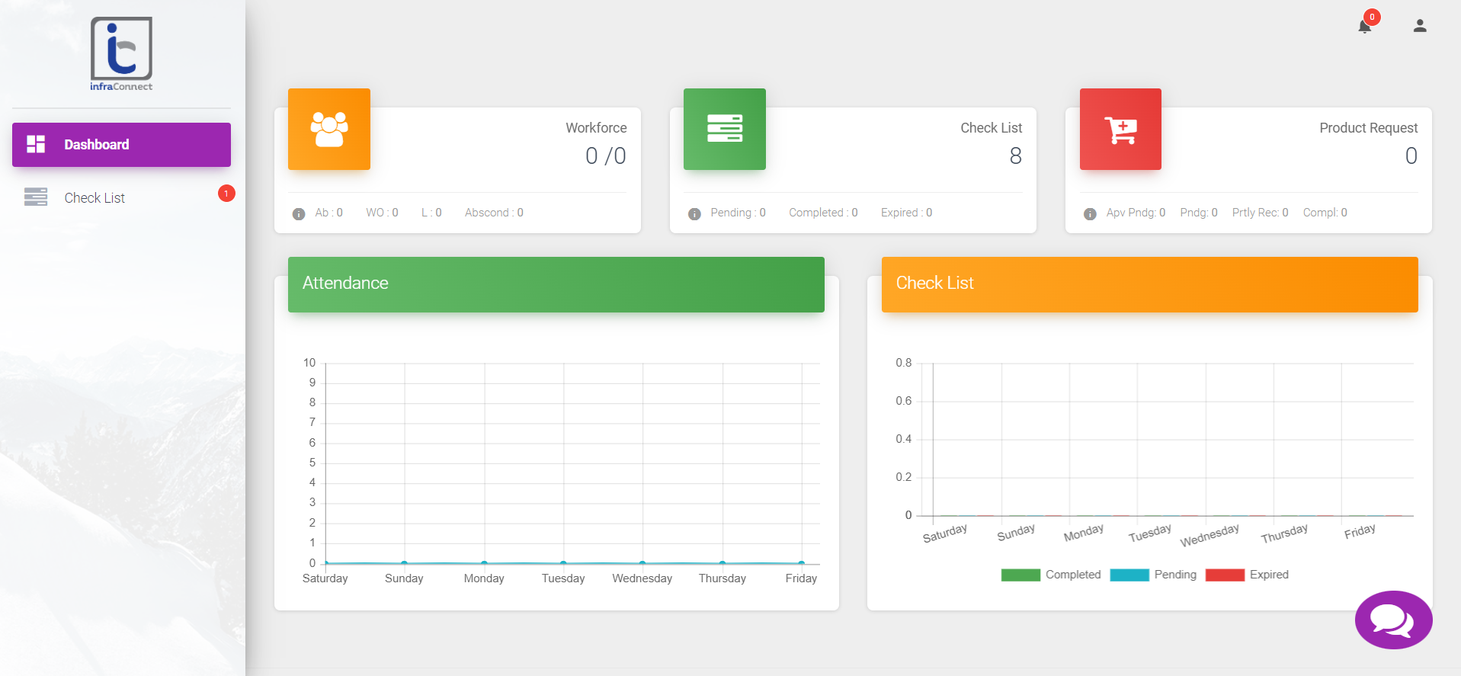

Website: <https://checklist.infraconnect.in>

**Staff Dashboard**

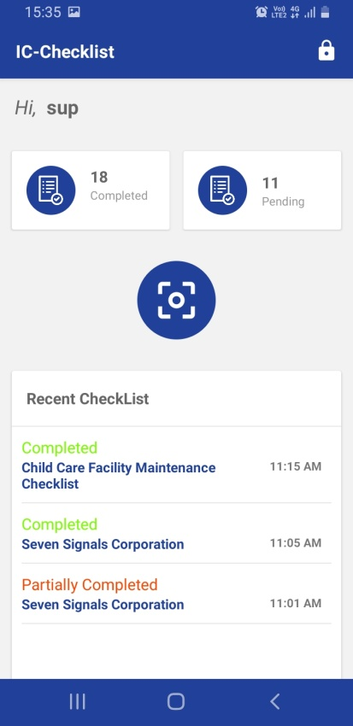

Download the Application from this site: <https://checklist.infraconnect.in>

**Key Features:**

* QR code integration
* Real-time notifications
* Checklist management
* Real-time picture capturing

**When a checklist is required**

* Looking for the root cause of a defect and checking the cause.
* Analyzing and verifying operations.
* Collecting data you need to analyze in the future.

**Stakeholders**

There are three stakeholders for the **IC Checklist** application.

1. Admin

2. Manager

3. Supervisor

4. Client

**1. Admin**

Admin controls the overall process of the system, implementing the modifications,  
performance, content, and issues. The admin will know the total number of clients and sites involved, as well as the overall task performed, and also admin has the power to designate suitable managers who will release the checklist and also include the supervisors in charge of monitoring the tasks. Additionally, the admin has the power to create a new client and the site, also help to create a department and its designation and assign the staff to suitable sites.

**Functional specification – Admin**

**1. Login:**

The admin can log in by using their username and password, It must be very confidential otherwise may have a chance to misuse it. In any case, admin forget his password then they can reset the password with the help email and mobile number.

**2. Dashboard:**

Displays the entire relevant information regards the checklist like workforce, Abscond staff, client and sites. Additionally, shows a graphical representation of daily attendance and workforce shortage and this helps with decision-making.

**3. Manager:**

This function will help the admin to create a manager database and also assign them their corresponding client or site. And also help to view overall details of managers like name, employee id, email, contact number and action, and action provide an editing facility to admin.

**4. Supervisors:**

Admin also has responsibility for creating assign duties to supervisors, and admin has the access to view the details of supervisors like employee code, name, contact information, department and designation.

**5. Checklist:**

The checklist created by the manager is viewable by the admin, and the administrator is notified each time a task is completed/partially completed, the admin receives a notification. Admin can also view the name of the client, supervisor, date and status.

**6. Client:**

Admin has the access to create client account based on their requirements, and admin need details like name, spoc, email and contact information for creating client account.

**7. Sites:**

Admin also can create sites based on client requirements, and admin needs details like site, contact, state, pin code address, supervisors, assigned workforce, etc. for creating sites. Additionally, the admin can track overall site activities.

**8. Settings:**

This function helps the admin access all details about a department and its corresponding employees, including their designation. Additionally, the admin can create or update the designation of the employee, department, and employees under it, etc.

**Flow chart**

Create Site and assign suitable employees

View checklist

Create & track supervisors

Create & track manager

Log in

Admin

No

Yes

**2. Manager**

Managers are the pillars of the system. They can view all the details containing the checklist, and they will assign tasks to the supervisors accordingly. Managers have a unique username and password to log in to the application, after successfully logging in; they can view a dashboard that contains statistical data like the workforce, checklist, product requests, and the visualization of attendance and checklist. Managers also help the supervisor to have clarity on the task and action accordingly.

**Functional specification – Manager**

**1. Login:**

The manager can log in by using their username and password, It must be very confidential otherwise may have a chance to misuse it. In any case, if managers forget their password then they can reset the password with the help email and mobile number.

**2. Dashboard:**

The dashboard provides an overview of the overall workforce, client, and sites connected to each client. To arrive at decisions, this also interprets workforce statistics and daily attendance data.

**3. Checklist:**

One of the main responsibilities of the manager is to execute a checklist, enabling the supervisors to have clarity on the defined task. This feature allows managers to create a checklist with criteria and subdivisions. Managers assign all the tasks in this function, and then a QR code will be generated, which allows the supervisors to scan and view the list of tasks and check mark as  
and when a task is completed.

**Flow chart**

Checklist

View Checklist

Create Checklist & Sub Checklist

Print QR Code

Log in

Manager

No

Yes

**3. Supervisors**

The generated checklist will be placed at their specific location, and their supervisors will scan the QR code while they view the checklist. Based on that checklist, supervisors will start their duty and complete each task in a proper way. Checklists provide supervisors with an accurate picture of the tasks that must be completed.

**Functional specification – Supervisors**

**1. Log in**

The manager can log in using their username and password, which must be kept strictly confidential or else it may be misused. In any case, if managers forget their password, they can reset it using their email address and mobile phone number.

**2. Dashboard**

Supervisors will have the option to scan the QR code, and by scanning the code, supervisors can view their tasks based on the instructions they need to work. Additionally, Supervisors can view the total completed tasks, pending tasks and recent checklist.

**Flow chart:**

Checklist need to complete.

Scan QR code

View checklist’s history

Log in

Supervisors

**4. Client**

Clients are generally the companies using the services. It's important that they have a clear view of the activities going on in their company.

**Functional specification – Client**

**Dashboard**

Clients will be able to view the total completed task status and pending tasks. Also, the dashboard summarizes the data of the number of clients/sites associated with each client.

**Checklist**

Clients have view access to the checklist generated by the manager. Whenever a task is finished or partially finished, the client is notified.

**Evaluation of Product**

**IC checklist Management System** provides companies having transparency on employees’ tasks and the status of their activities. They help the supervisors memorize and a strategic way to complete their tasks easily. **IC checklist** mainly provides 4 stakeholders like admin, manager, supervisors and clients. In this application managers play a critical role, they create the checklist and assign that checklist to suitable supervisors. The admin has the power to choose the appropriate managers to distribute the checklist and to include the supervisors in charge of overseeing the tasks. The admin and managers applications provide an understanding dashboard containing workforce, Absconded staff, clients and sites. Additionally, shows a graphical representation of daily attendance and workforce shortage and this helps in knowing a complete overview of the workflow. This application also includes a client application, which will help businesses gain a clear picture of the types of activities taking place in their organizations. In this application Managers will create a checklist and generate a QR code; that code will be provided to supervisors, and they will work based on that checklist. IC checklist provides standard forms and standard operating procedures and also helps to maintain document information in a proper way. This application provides regular communications with staff on the progress being made, which reinforces the importance of this effort and will help lead to tremendous growth for the company.

**Comparison Table:**

|  |  |  |  |
| --- | --- | --- | --- |
| **Sr. No** | **Features** | **IC Checklist Management System** | **Competitor’s (Domestic & International)** |
| 1 | Checklist providing method | Generate a QR code with the corresponding checklist | Checklists provide mainly through email, messages, etc |
| 2 | Access to the system | Admin has high-level access, but the checklist is created and supplied by the manager. | The administrator has overall access to this system. |
| 3 | Interface | Provide a standard and user-friendly interface. | Provide a standard interface. |
| 4 | Checklist creation | Provide multiple checklist creations at a time | Provide multiple checklist creations at a time |
| 5 | Tracking | Provide live tracking of the checklist | Provide live tracking of the checklist |
| 6 | Revisions history | Archive all the documents with revisions history | Archive all the documents with revisions history |
| 7 | Chat boat | Admin can directly chat with client, manager and supervisor. | Chat boat system is available. |
| 8 | Report | Admin and manager can view all the reports. | View and download are available. |
| 9 | Notification | Automatically notify when the task is done. | Automatically notify the resource identified on their upcoming, delayed task and completed tasks. |
| 10 | Authentication & Security | Provide high-level security, and the admin can control all the application users. | Provide high-level security & authentication. |
| 11 | Installation | Hosted, Local, Cloud | Hosted, Local, Cloud and Saas |
| 12 | Mobile Access | Possible | Possible |
| 13 | Multi - Language | Only English | Some International level Companies providing multi languages, other are giving English only. |
| 14 | Notification- Via | Through application only providing now. | Through SMS, email, etc. |
| 15 | Client Access control | Providing clients to access about knowing their organization checklist | Providing clients to access about knowing their organization checklist |

Possible Updation:

* Collaboration: the ability for multiple users to work on the same checklist or set of checklists.
* Reminders: the ability to set reminders for when certain tasks on the checklist need to be completed.
* Customization: the ability to customize the appearance of the checklist, such as by choosing different colors or adding logos.
* Integration: the ability to integrate the checklist management system with other tools or systems, such as project management software or customer relationship management (CRM) systems.