**Date: 5th Jan 2023**

** INVENTORY MANAGEMENT APPLICATION**

**INTRODUCTION**

The traditional inventory method can't be managed systematically because all processes are done manually and are time-consuming. The **IC Inventory Management** application helps the organization control all inventory actions in a better way and also work in a fast manner. It's a crucial part of the supply chain that follows the inventory from producers to warehouses and from these facilities to the point of sale, and it assists the firm in its intention to sell the products or materials to clients for a profit. The goal of this product is to have the right products in the right place at the right time and also to know when to order, how much to order, and where to store stock. Using **IC inventory management** software, an organization can reduce spending, maintain profitability, analyze sales trends to forecast future sales, and be ready for unexpected situations.

**OBJECTIVE**

* To prevent inventories from being both overstocked and understocked.
* To maintain investment in inventories at the optimum level as required by the operational activities.
* To keep materials cost under control so that they contribute to reducing the cost of production and overall cost.
* To eliminate duplication in ordering or replenishing stocks. This is possible with the help of centralizing purchases.
* Reduce losses due to degradation, theft, wastage, and damage.
* To maintain ongoing inventory control such that the materials depicted in stock ledgers are truly present in the retail spaces.
* To make it easier to provide information for inventory control and short- and long-term planning.
* To provide a functional structure for inventory management. At various levels in the organization, there should be set, clear accountability.

**KEY FEATURES**

* Inventory Management
* Categorization of products in stocks
* Measurement of product
* Live stock report
* Vendor management
* Inventory Tracking
* Product Tracking
* Tagging
* Report and audits
* Inventory Forecasting
* Inventory Alerts
* Security and Backups
* Real-Time Updates (cloud-Based)

**Admin Dashboard:**

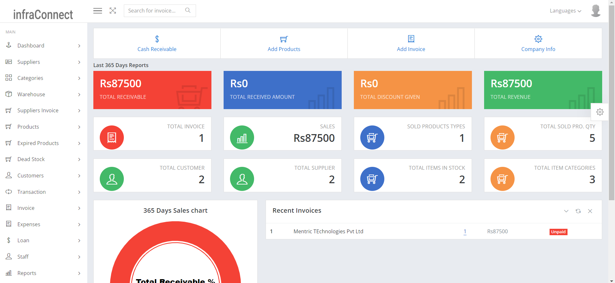

**Web site:** [**https://inventory.infraconnect.in/**](https://inventory.infraconnect.in/)

**Admin (Stakeholders)**

Admin has rights to the Inventory Management System application. This application has been thoughtfully created in order to create and maintain a record to track the flow of stock’s while simultaneously maintaining contact with the vendor’s. The overall information regarding inventory will be present in the form of both visual and graphical chart for ease of understanding.

**Functional Specification – Admin**

* **Login:**

The admin can log in by using their username and password. The login credentials are to be kept confidential to prevent misuse. For changes in login credentials, the modification can be done through using the “Forgot Passowrd” feature and reset the password through email and mobile number.

* **Dashboard:**

Dashboard has been thoughtfully created which provides a generic information of the total sum of exchange for the last 365 day’s. A pie chart provides a graphical representation for the toal sales and a list for recent invoices. Currently, the language options available for the application are English, French, Spanish, and Indonesian.

* **Suppliers:**

The supplier's function provides the inventory application with two features: add and manage suppliers. The feature of Add Suppliers option allows you to add suppliers to the database, which requires some information such as suppliers, contact person, email, phone, and address. The Manage Supplier option displays supplier information, and the admin can export supplier data in Excel, CSV, and other formats, etc. Additionally, the admin can edit and delete the supplier's information in this feature.

* **Categories:**

In the “Categories” tab, the user can Add/Manage categories for the product to the database by entering their information. The user can manage the database by viewing all category information, and export categories in Excel, CSV, PDF, and other formats.

* **Warehouse:**

In the “Store” tab, the user can Add/Manage Store for the store export recodrs to the database by entering their information. The user can manage the database by viewing all category information, and export categories in Excel, CSV, PDF, and other formats.

* **Suppliers Invoice:**

In a supplier’s invoice, there are two options: add and manage supplier invoices. For adding invoices, admins need information like supplier, warehouse, date, item information, quantity, rate, total and a photo of the invoice. Additionally, the admin has the option to manage the invoices of the suppliers.

* **Products:**

The “Product” tab assists the admin in managing all product-related tasks, such as adding new products, adding products to a CSV, and managing products. New product’s can be added in the “Add Products” tab. User can also add a product CSV and also download it. The manage function allows to view all product information and export product data in Excel, CSV, PDF, and other formats.

* **Expired Products:**

The “Expired Products” feature creates a list of products that has been in inventory beyond the shelf life which is unsuitable for any commercial exchange, this will allow the products to be rotated appropriately. Report can be exported in Excel/CSV/PDF/Print format with the respective product details.

* **Dead Stock:**

The “Dead Stock” feature enables to create and maintain a list of all the non-moving or unsold products in the inventory which will assist user in ease of decision making to avoid any inventory surplus. This enables to free up space for the products in the inventory.

* **Customers:**

In the “Customers” feature, the user will be able to Add/Manage customer details and also check the payment status in the “Paid Customer” feature. Additionally, “Credit Customer” feature allows to track the details of products that have been credited to the clients. Report can be exported in Excel/CSV/PDF/Print format with the respective product details.

* **Transaction:**

The “Transaction” feature has two features namely, “Cash Recievable” wherein the payment status for a particular client can be updated. The feature of “Transaction History” creates and maintains a fianancial track record. Report can be exported in Excel/CSV/PDF/Print format with the respective product details.

* **Invoice:**

The “Invoice” feature allows user to add new customer details and or update exisiting customer details and the respective product related information and payment details. The user can Add/Manage invoices. This feature also assist’s the user to keep a track of Paid/Unpaid incovices. Report can be exported in Excel/CSV/PDF/Print format with the respective product details.

* **Expenses**:

The “Expenses” feature allows user to Add/Manage expense types and invoices that are associated with managing inventory. The user can also keep a track of Paid/Unpaid invoice.

This allows the user to better understand the costs of various products and assists in decision making. Report can be exported in Excel/CSV/PDF/Print format with the respective product details.

* **Loan:**

The “Loan” tab allows the user to Add/Manager Loaner’s and also to Add/Manager loans. This feature will assist the user to better understand their financial obligations and forecast a financial flow, which will help avoid over borrowing of funds.

* **Staff:**

The “Staff” feature allows the user to Add/Manage staff data. The employee data will be adeed in the “Add Staff” feature and user type for the respective employee. The “Staff List” feature allows user to Edit/Delete employee details. Report can be exported in Excel/CSV/PDF/Print format with the respective product details.

* **Report:**

The “Reports” feature has the featuresof “Profit/Loss Ledger”, “Sales Ledger” and “Expense Ledger”. The “Date Range” allows the user to acquire data of financial transactions for a specified time frame. This data will assist to track the payment from customers. Report can be exported in Excel/CSV/PDF/Print format with the respective product details.

**Flow chart:**

Admin

Login

Reports: Sales profit/loss ledger, sales ledger and expenses ledger.

Add & manage loaners and loan.

Add & manage expense type and manage paid and unpaid expenses invoice

Add & Manage invoice and Manage paid & unpaid invoice

Add product CSV

Add & Manage suppliers, categories, warehouse, supplier invoice, staff, product

View expired products, dead stock

Add & Manage customers and Manage credit & paid customers

Add cash payment and view transaction history

**No**

**Yes**

**Comparison Table:**

|  |  |  |  |
| --- | --- | --- | --- |
| **Sr. No** | **Features** | **IC Inventory Management System** | **Competitor’s (Domestic & International)** |
| 1 | Interface | User-friendly interface with easy understanding of all actions. | User-friendly interface |
| 2 | Locate stocks | Track and manage all stock updates | Track and manage all stock activities |
| 3 | Live stock report | Live update of stock is the report | Live update of stock is the report |
| 4 | Supplier management | Track all the activities of suppliers | Track all the activities of suppliers |
| 5 | Bar-coding facility | Not Available | Some of the companies are providing and it helps with the efficicency of work. |
| 6 | Reporting | Report all the inventory action in a very efficient way, for example: profit & loss ledger, sales ledger and expenses ledger. | Provide live reporting for inventory actions |
| 7 | Inventory security | Provide safety and security for all inventory action | Provide safety and security for all inventory action |
| 8 | Cloud-based inventory | Provide cloud-based inventory with real-time updates and all easy access to data | Provide cloud-based inventory with real-time updates and all easy access to data |
| 9 | Inventory forecasting | Help the organization for a clear view of the future action that needs to take | Provide inventory forecasting |
| 10 | Generate and download the report | Help to generate and download all kinds of reports like suppliers, warehouses, invoices, products, etc. | Provide generate and download the report |
| 11 | Deadstock | Track dead stock | Track dead stock |
| 12 | Loan | Track and manage all activities related to loan | Some international software provides loan facility |
| 13 | Staff | Help to add and manage all details regarding the staff | Help to add and manage all details regarding the staff |
| 14 | Return stocks | Handle returned stock | Handle returned stock |
| 15 | Transaction | Save all the transactions and it helps to access records. | Save all the transactions and it helps to access all-time records. |

**Possible updates:**

* Inventory Alerts:

The “Inventory Alert function enables direct e-mail, SMS, pop-up notifications etc., alert for any issue or update related to company activities.

* Bar code :

Barcode technology increases the efficieny of the work and avoids any human error which could occur in the event of increase in data volume. This also decreases the time to adapt for employees to train in new technology implementation.

* ERP:

Enterprise Resource Planning (ERP) inventory management is a system that allows businesses to manage all aspects of their business on a single platform, including inventory, finance, planning, logistics and operations.

* HSN code:

Provide an easy and consistent way of identifying all products and services.

* Budget track:

inventory management applications may also allow users to set budgets and track expenses against those budgets, to help ensure that inventory costs are kept under control.

* Automated payment:

inventory management applications may also provide features such as automated payments and due date reminders, so that you can ensure that you never miss a loan repayment

* Financial management tool:

It allow you to link with other financial management tools and easily import the details of loans and other financial transactions into the application.